VIETNAM – Hanoi – Backstreet Adventure by Minsk
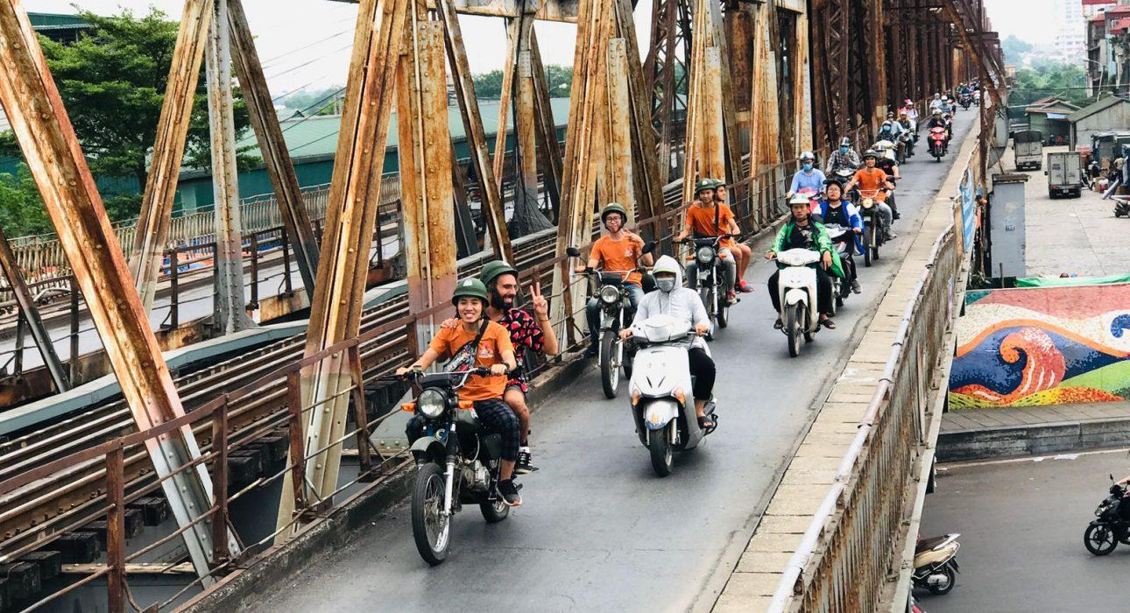

Over View

Theme
Art & Culture, Classic, Family, Honeymoon

Country - City
Vietnam - Hanoi

Market segment
Thematic Leisure

Price Level
$$$$

Max pax
15

Seasonality
All Year Round

Arrival city
Hanoi

Departure city
Hanoi

Description

Venture off on a Soviet Era Minsk through the labyrinth of narrow backstreets and tiny zigzagging alleyways to dive into Hanoian culture and witness moments in the lives of the city’s inhabitants. This tour offers the opportunity to meet local people at their home, at work, at school, at the markets or even at the local park. Experience the real Hanoi, just as it really is; a Hanoi through the eyes of the locals, including, “the good, the bad, the weird, even the ugly”. In addition to seeing the more famous sights of Hanoi, included in the tour is the chance to enjoy some of the unique and authentic food offerings that can be found in this historically and culturally evolved city. A tour to discover another side to Hanoi from the back seat of a Minsk.

Selling points

- A special way to discover the backstreets of Hanoi, feel all the good, bad and weirdly unique habits of local people.
- A genuine experience with a Soviet Era Minsk
- Spontaneous local interactions with a family with teenagers (from 10 years old)
- To experience traditional snacks and food

Sustainability

Level Of The Excursion
Low - This activity impacts local community, culture and/or environment in a small but meaningful way

The Impact Of This Excursion

Economic Impact
Community benefits

Additional Information
Positive Impact:This activity provides jobs to Minsk drivers of the Minsk, as well as financial support to the independent businesses visited on the way (local coffee shop, small stand selling Banh Cuon, local musician, etc.).Negative Impact:The Minsk are Soviet era motorbikes, and therefore are not eco-friendly.

Time And Transportation

Pick up from Hotel or starting point from Opera House3 Departures a day: – Morning tour: (8h – 12h)– Afternoon tour (12h30-16h30)– Evening Tour: ( 17h – 21h30)Note: Due to numerous of booking, all the half day Minsk tour have to start in fix timetable.

Photos

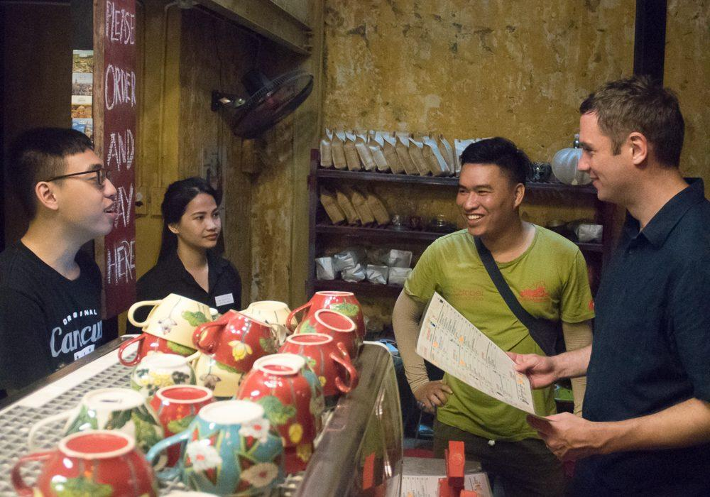
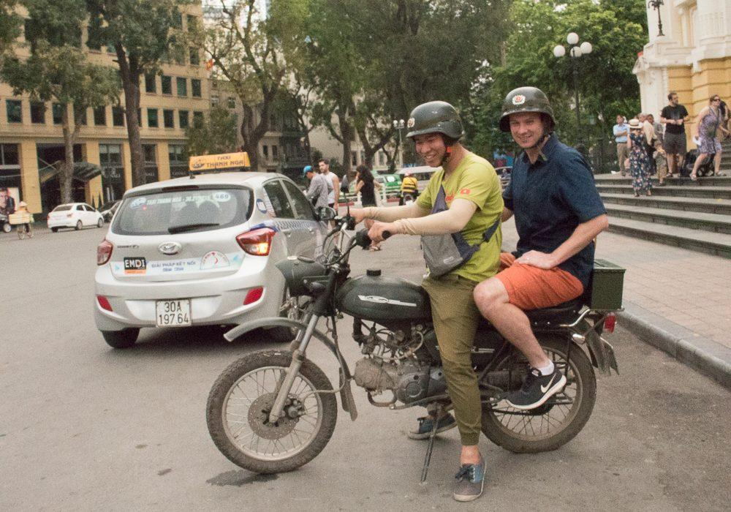
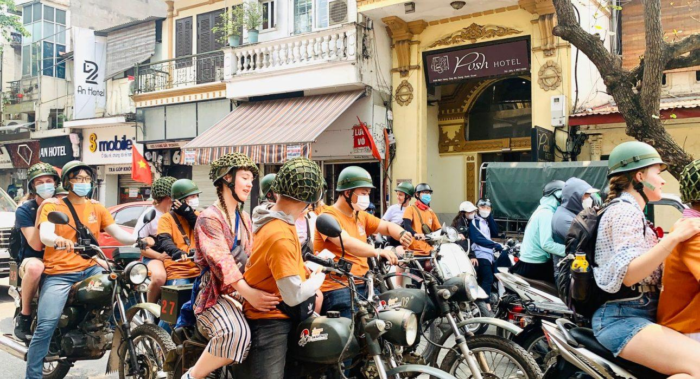
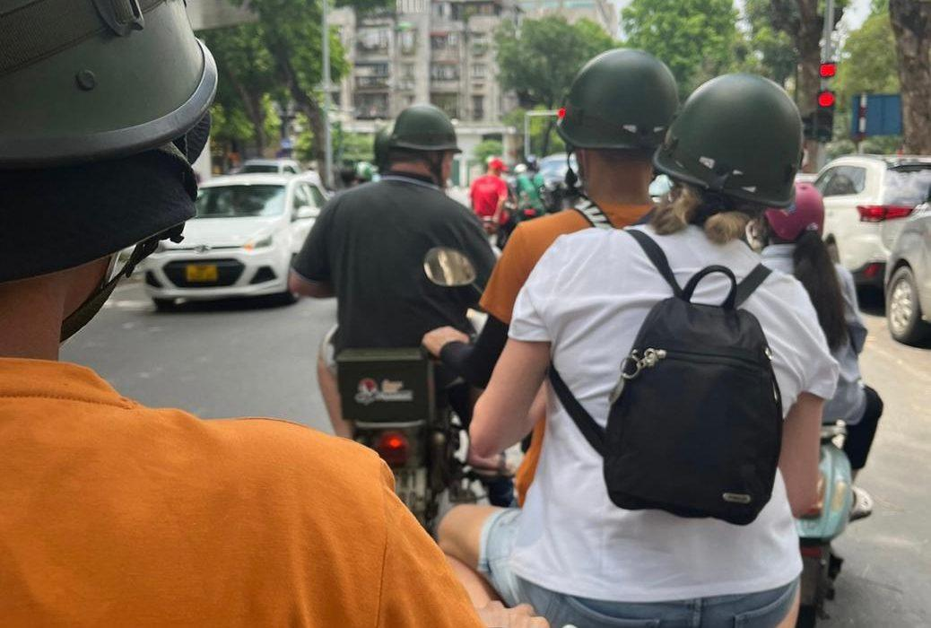
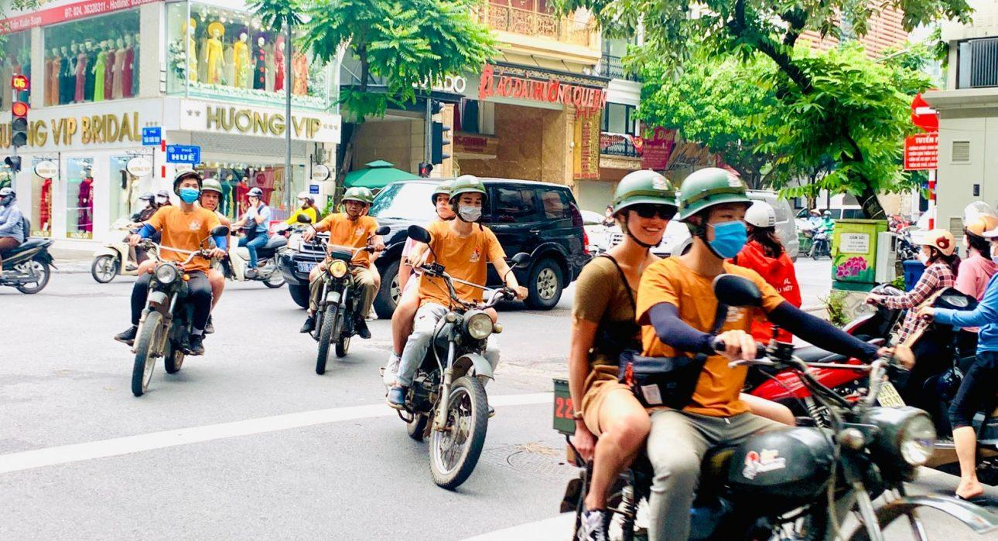
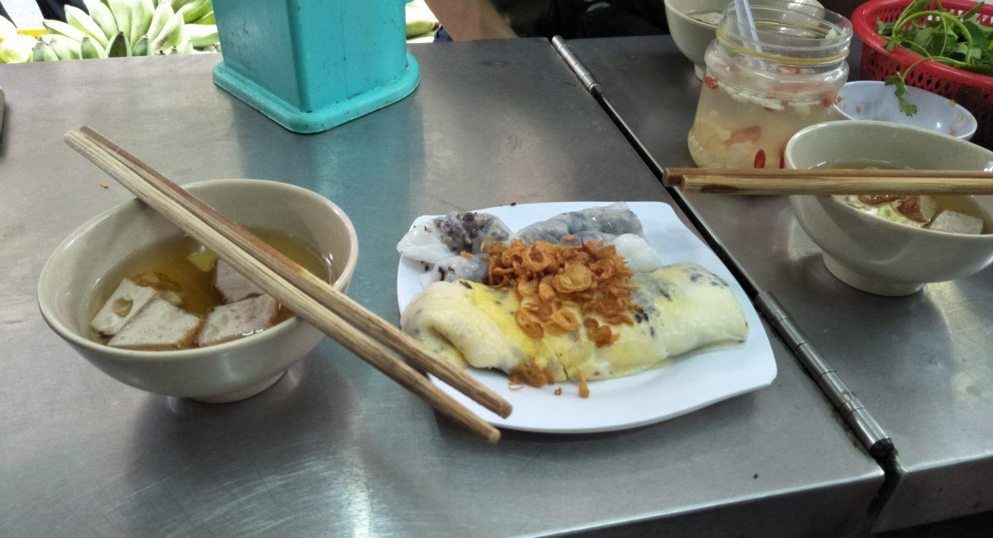
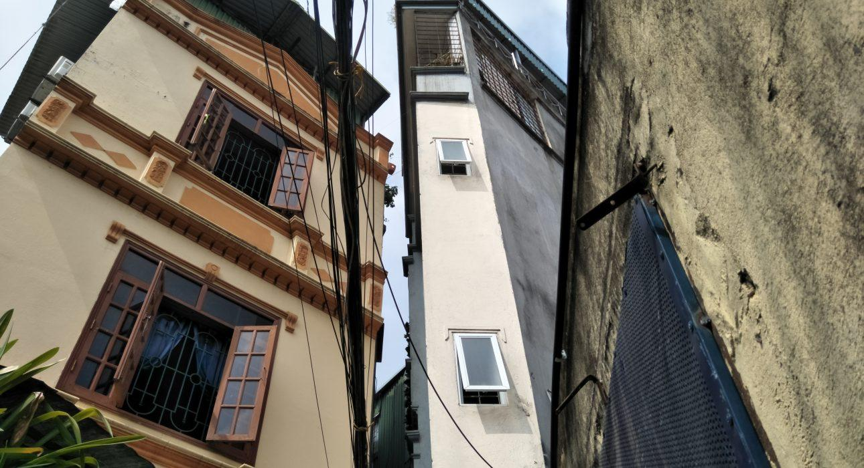
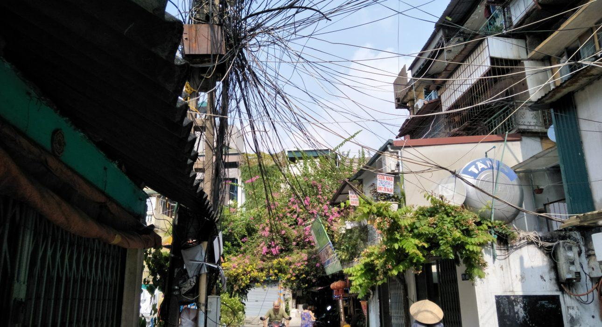

Easia Travel Head Office

Vietnam Head OfficeC/o: ATS Hotel, Suite 326 &327, 33B Pham Ngu Lao Street, Hanoi, VietnamTel: +84 24-39 33 13 62www.easia-travel.com

