VIETNAM – Hanoi – The Quintessence of Tonkin

Over View

Theme
Art & Culture, Classic, Family, Honeymoon, Sustainable

Country - City
Vietnam - Hanoi

Market segment
Groups, Thematic Leisure

Price Level
$$$

Max pax
2300

Seasonality
All Year Round

Arrival city
Hanoi

Departure city
Hanoi

Description

- Located about 25 kilometres (15.5 miles) west of central Hanoi, The Quintessence of Tonkin occupies a space close to Chua Thay, a special National Cultural Heritage site and one of the oldest Buddhist pagodas in Vietnam. The spectacle draws inspiration from the pagoda’s spiritual history, with storyline elements that focus on the founding of the pagoda by a venerable monk, named Tu Dao Hanh, and the ancient union between religion and monarchy.
- Performance art technicians devised a world-class sound and lighting system, but the sounds of the spectacle keep reflecting the peaceful sounds of rural Vietnam, including wooden drums and brass gongs, night crickets, and flowing water. The spectacle also blends different elements of traditional music styles, including Quan Ho and Ca Tru, both of which are now recognized by UNESCO as Intangible World Heritage arts.

Can be combined with
Thematic Leisure
- A stroll in the Old Quarter of Hanoi
- Mai Chau – Hiking In The Enchanted Mai Chau Landscape
- Cycling in the ancient village of Duong Lam
Exclusive
- A marvellous night with a Jeep tour and Lotte Tower (Activity)
- Helicopter service in the North
- Lacquer workshop at Hanoia house
Incentive
- Go on a treasure hunt in the maze of the 36 streets
- A game of football with young Thais in Mai Chau
- Enjoy a Kung Fu Performance
Groups
- Meet a master of calligraphy
- Spend a night with the locals in a traditional stilt house in Mai Chau
- Share a peaceful moment in Vietnamese life: Tai Chi at dawn

Selling points

- The first live entertainment show that combines many types of Vietnamese traditional music, including 2 Intangible World Heritage arts: Quan Ho and Ca Tru.
- A brilliant performance with very impressive visuals: dancing and the state-of-the-art light system.
- The show is performed by not only artists and professional dancers but also the local villagers.
- A perfect show for all the Arts & Culture lovers, as well as families with children older than 5 years.

Sustainability

Level Of The Excursion
Medium – This activity offers tangible positive contributions to the local community, culture and/or environment

The Impact Of This Excursion

Social/cultural Impact
Cultural Conservation, Empowerment and education

Economic Impact
Community benefits

Additional Information
Positive Impact:The Quintessence of Tonkin is a large project on the outskirts of Hanoi, and employs and trains hundreds of people, from the dancers to the cleaner, and from the chefs to the musicians. In general, the activity offers significant income for many Hanoians.Negative Impact:The activity is outside Hanoi, therefore it requires a transfer by car while similar activities also exist in the city center of Hanoi.

Time And Transportation

From | To | Kilometer (Miles) | By | Duration | Road condition
Center of Hanoi | The Quintessence of Tonkin | 25 (15.5) | Car | 47 minutes | good
Duong Lam Ancient Village | The Quintessence of Tonkin | 28 (17) | Car | 50 minutes | good
Mai Chau, Hoa Binh | The Quintessence of Tonkin | 130 (81) | Car | 3 hours 25min | good

Photos

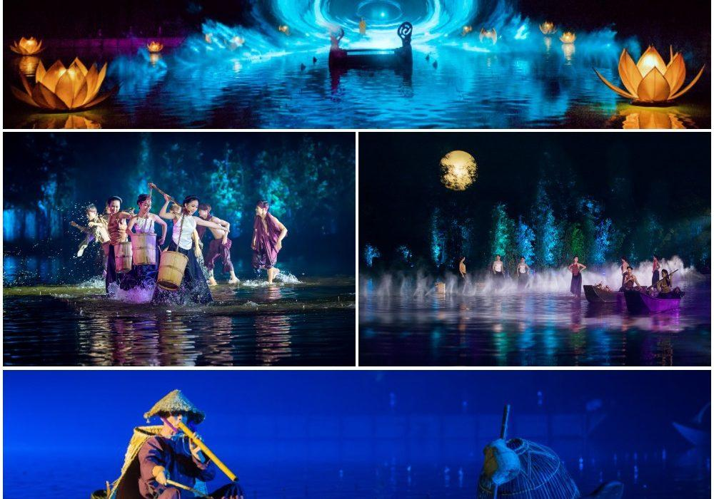
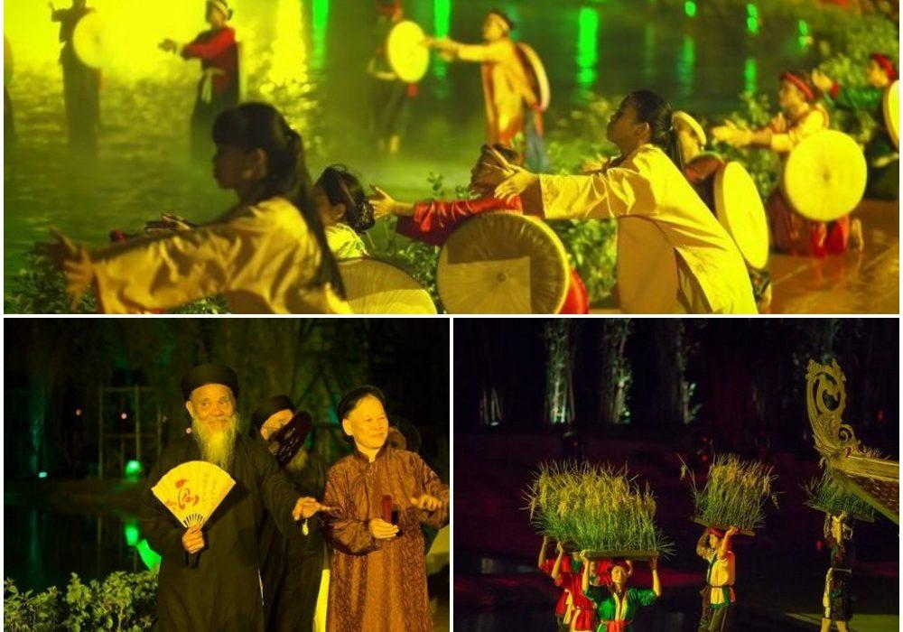
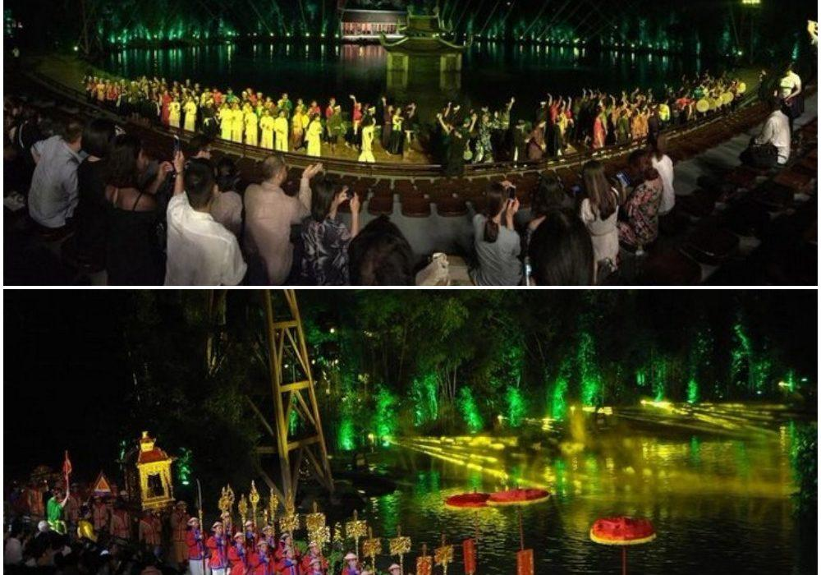

Easia Travel Head Office

Vietnam Head OfficeC/o: ATS Hotel, Suite 326 &327, 33B Pham Ngu Lao Street, Hanoi, VietnamTel: +84 24-39 33 13 62www.easia-travel.com

