MYANMAR – Inle Lake – Adventure on the lake
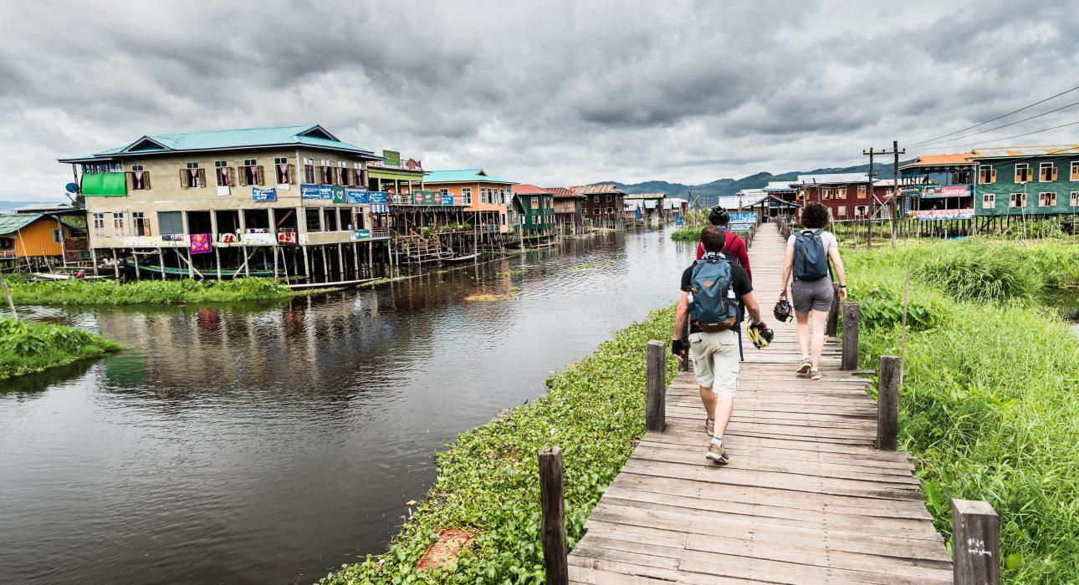

Over View

Theme
Classic

Country - City
Myanmar - Inle Lake

Market segment
Thematic Leisure

Price Level
$$$$

Level of difficulties
LEVEL 2

Max pax
15 persons

Seasonality
September - June

Arrival city
Nyaung Shwe

Departure city
Nyaung Shwe

Description

Inle Lake is mainly known for its stilt villages and floating gardens, but few travelers spend time discovering the villages that can be found nestled in a lush bamboo forest on the shores. This exclusive program combining biking, kayaking and walking allows travelers to experience the lake and its multiple facets in a brand new – and active – way!

Selling points

- An active day to experience other faces of Inle lake rather than the classic sightseeing
- Opportunities to meet and chat with villagers on the shores of the lake (itinerary visits several villages) and explore side routes that are not accessible by boat or car
- A complete tour of the lake by bike, by foot and by kayak
- For adventure clients who have a good sports level
- A different way to experience the life on the lake with other modes of transportation which allow you to reach less visited places
- A day to take a break from cultural sightseeing

Time And Transportation

From | To | Km | By | Duration | Road condition
Nyaung Shwe | Mine Thauk | 23.5 km | Bike | 1h45 | Mostly flat. 50% rocky and dirt roads (bumpy). 50% main tar road
Mine Thauk | Lin Kin | NA | Boat | 20 min | Mix of floating gardens, floating villages and open lake
Lin Kin | Kyay Zar Kone | 2 km | Kayak | 45 minutes | Mix of floating garden, part in a village on stilts and open lake
Kyay Zar Kone | Indein | 18 km | Bike | 1h 30 minutes | Tar road and narrow dirt road across a bamboo forest. Mostly flat with one steep short ascent.
Indein | Indein | 5 km | walk | 45 minutes | Flat dirt paths across the bamboo forest

Photos

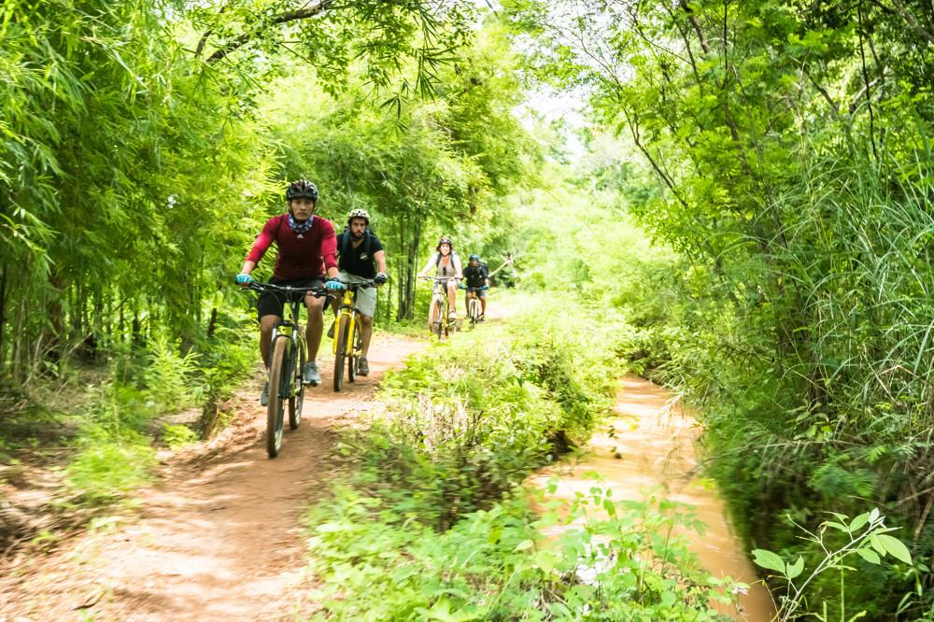
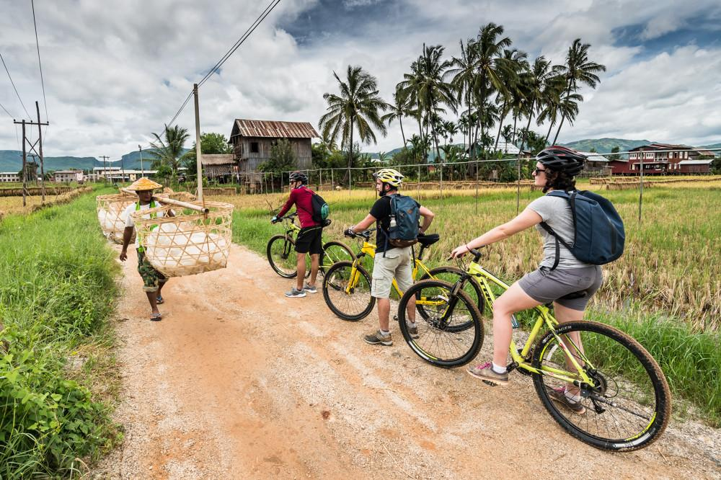
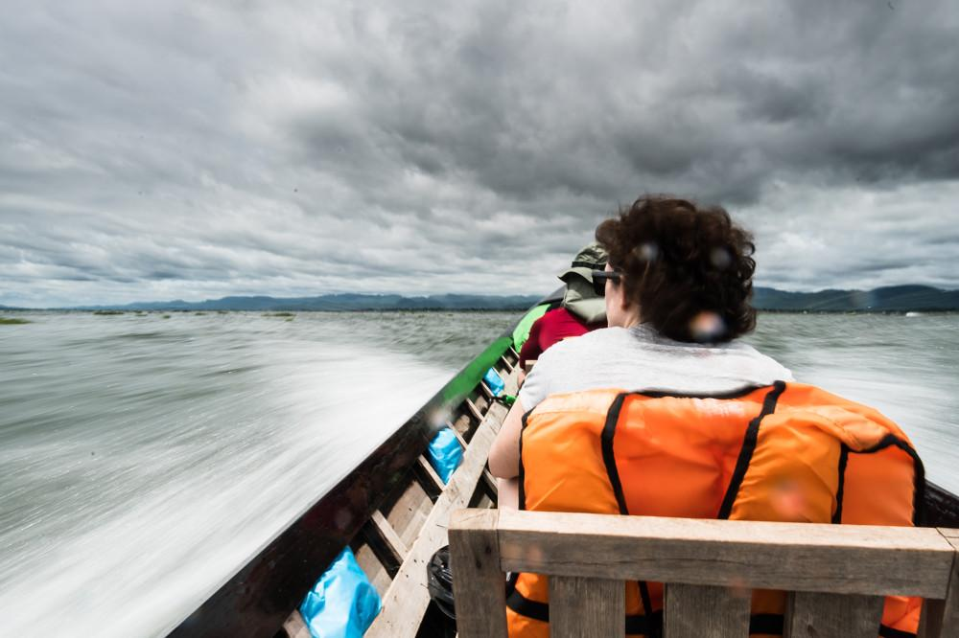
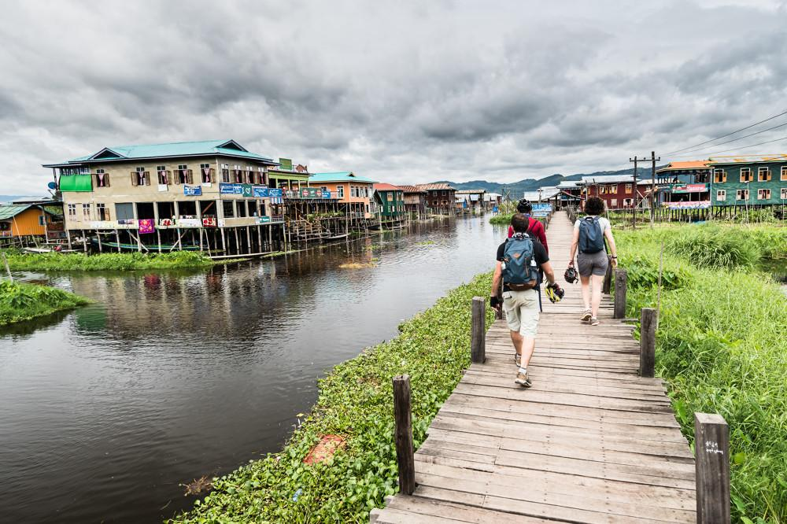
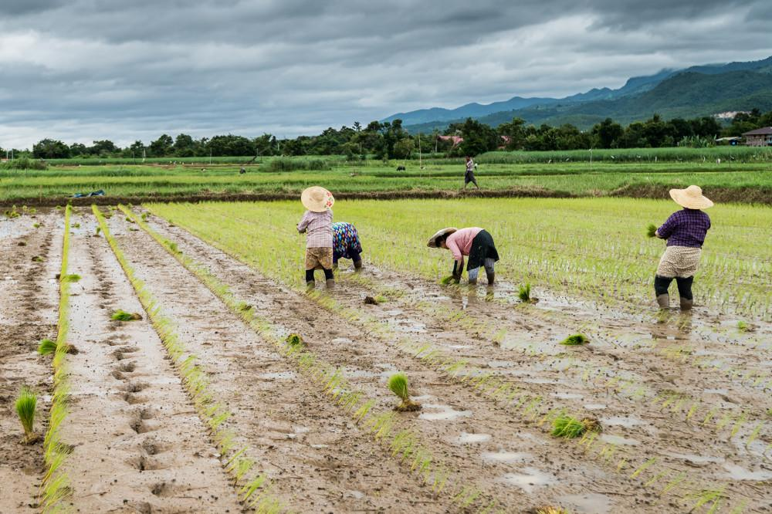
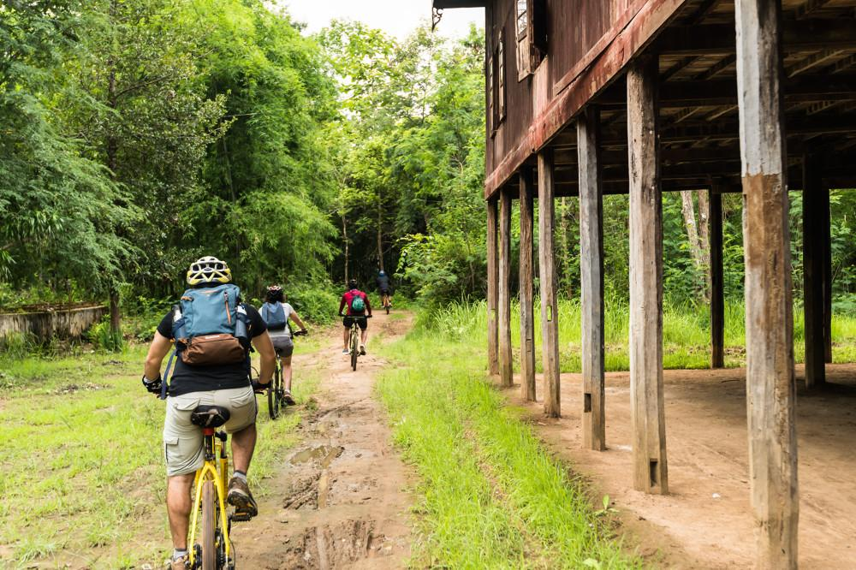
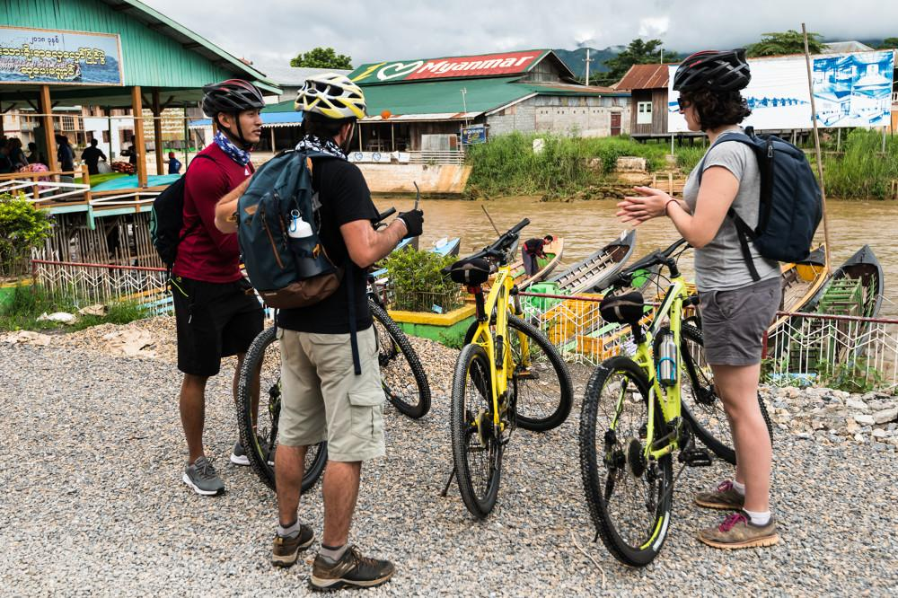
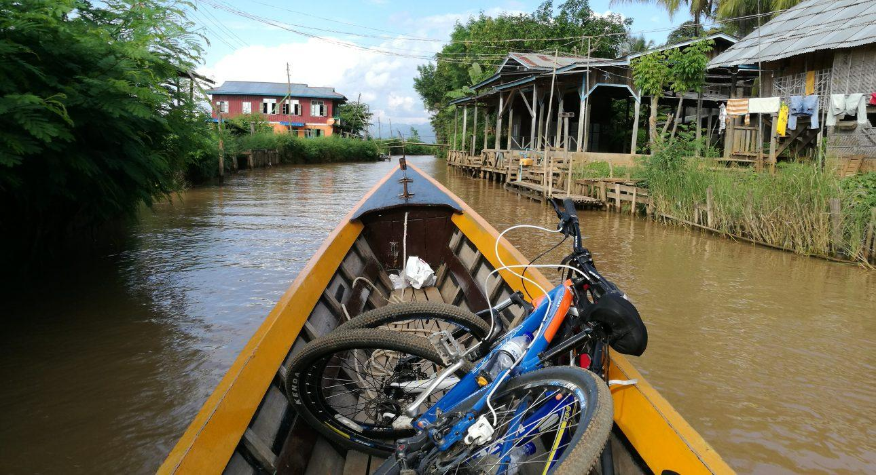
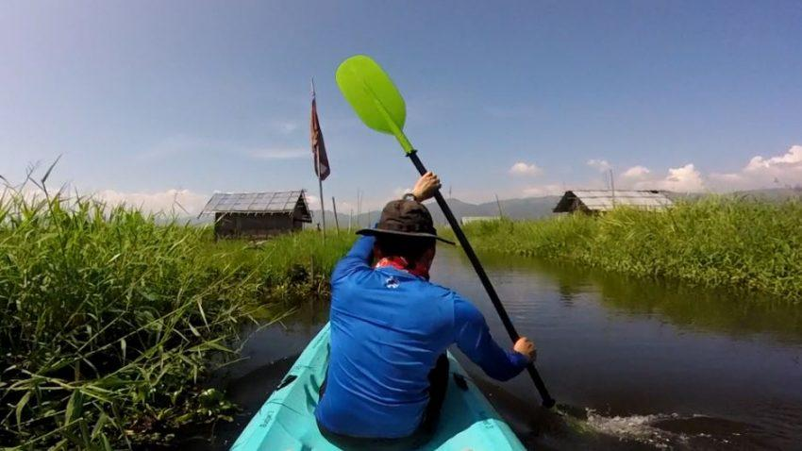

Easia Travel Head Office

Vietnam Head OfficeC/o: ATS Hotel, Suite 326 &327, 33B Pham Ngu Lao Street, Hanoi, VietnamTel: +84 24-39 33 13 62www.easia-travel.com

