VIETNAM – Ho Chi Minh City – Visiting Cu Chi Tunnels

Over View

Theme
Art & Culture, Classic, Family, Honeymoon

Country - City
Vietnam - Ho Chi Minh City

Market segment
Groups, Thematic Leisure

Price Level
$

Max pax
60

Seasonality
All Year Round

Arrival city
Ho Chi Minh City

Departure city
Ho Chi Minh City

Description

The Cu Chi Tunnels are one of the most famous historical sites of the Vietnam War, and proof of Vietnamese people’s resilience during their hardest time. At over 250 kilometers in length, this tunnel system has living rooms, kitchens, working rooms, bedrooms, storing rooms, and emergency rooms, plus some traps to ensnare any intruders. This activity is a great way to understand how life was lived underground during Vietnam’s more tumultuous history.

Can be combined with
Thematic Leisure
Vietnamese Cooking class at a village of organic vegetables in Cu Chi

Selling points

- It is one of greatest and most important historical sites in southern Vietnam and welcomes a lot of visitors every year.
- It is most suitable for those who love history, want to understand how difficult the war was, and how the Vietnamese fought against the Americans.

Sustainability

Level Of The Excursion
Low - This activity impacts local community, culture and/or environment in a small but meaningful way

The Impact Of This Excursion

Social/cultural Impact
Cultural Conservation

Additional Information
Positive Impact:The activity is educates travelers about national culture and how Vietnamese fought for their independence.

Time And Transportation

From | To | Kilometer | By | Duration | Road condition
Ho Chi Minh City | Cu Chi Tunnel | 58 kilometers | Car | 2 hours | Good
Cu Chi Tunnel | Cao Dai Temple (Tay Ninh) | 54 kilometers | Car | 1 hr 30 mins | Good

Photos

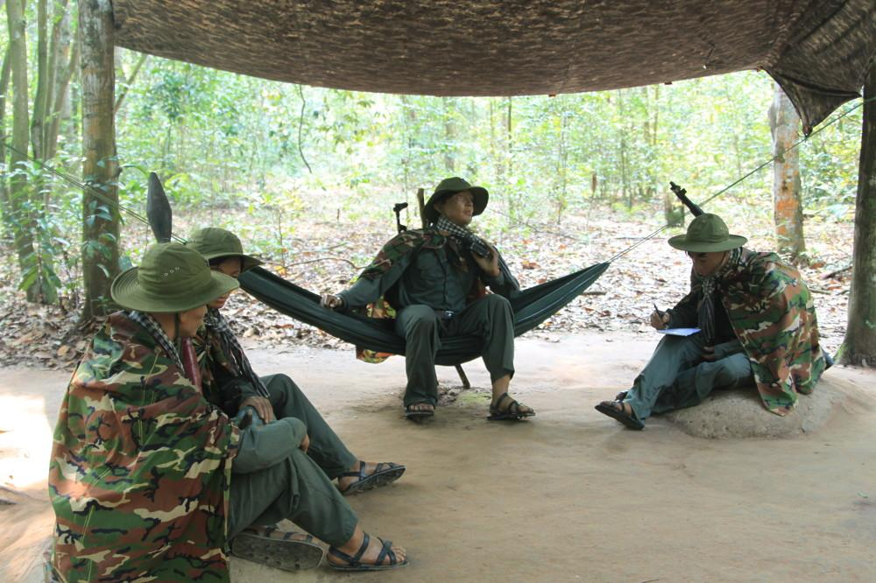
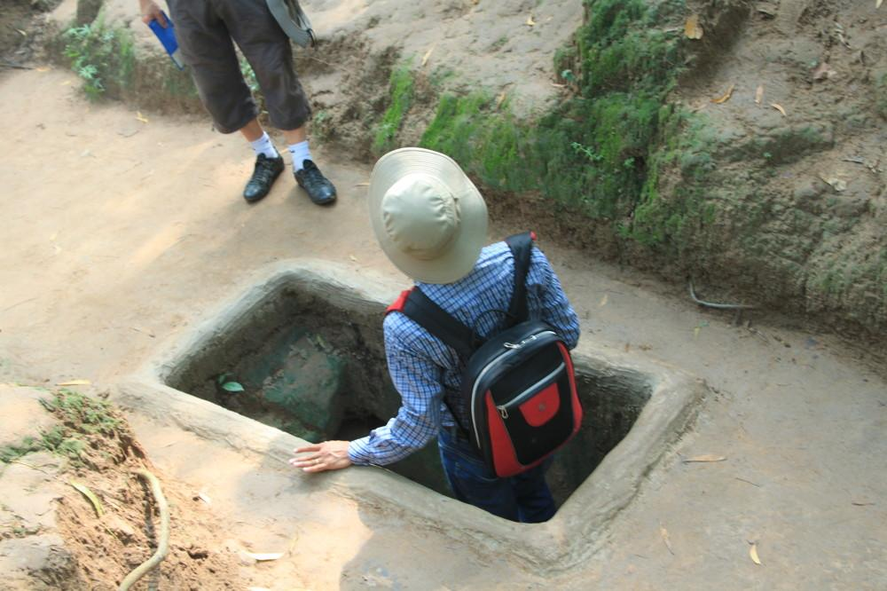
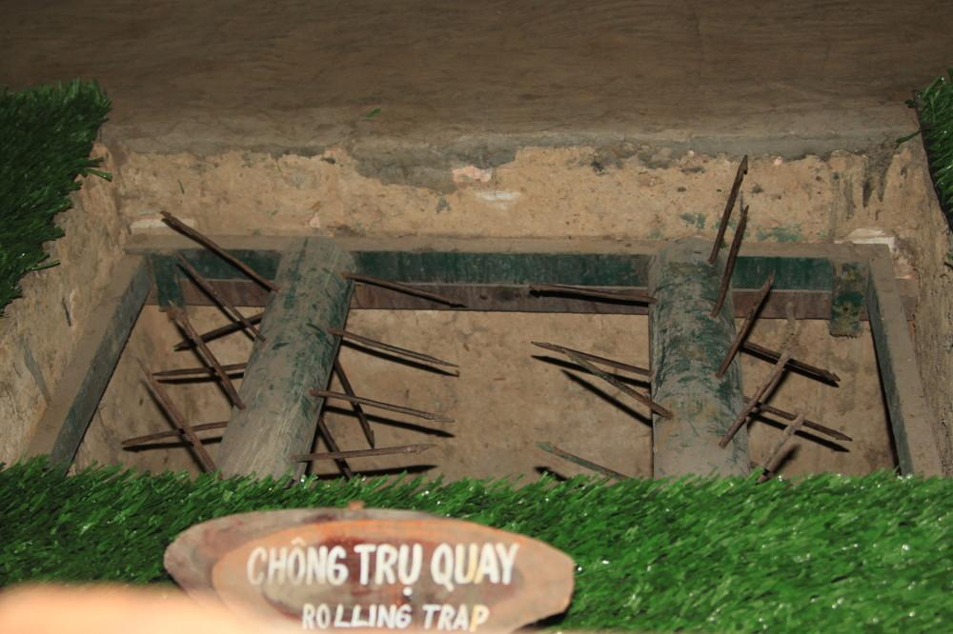

Easia Travel Head Office

Vietnam Head OfficeC/o: ATS Hotel, Suite 326 &327, 33B Pham Ngu Lao Street, Hanoi, VietnamTel: +84 24-39 33 13 62www.easia-travel.com

