LAOS – Luang Prabang – City Tour Luang Prabang
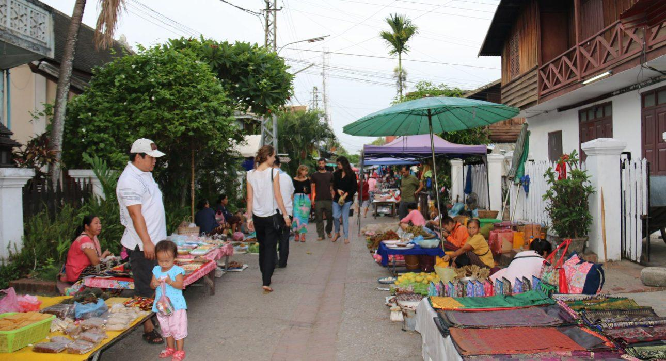

Over View

Theme
Art & Culture, Classic, Family, Honeymoon

Country - City
Laos - Luang Prabang

Market segment
Groups, Thematic Leisure

Price Level
$$

Max pax
60

Seasonality
All Year Round

Arrival city
Luang Prabang

Departure city
Luang Prabang

Description

The city of Luang Prabang with its privileged location at the meeting point of the Mekong and Nam Khan rivers and the foot of an age-old mountain range, making it one of the most beautiful cities in Southeast Asia. A tour of Luang Prabang offers the chance to view its most emblematic temples, the top of the Phousi Mountain, the city centre and later on, the Hmong market. The jewels of the city are the Wat Visoun (the oldest temple in the city), the splendid Royal Palace Museum and the temples of Wat Xieng Thong and Wat May.

Can be combined with
Thematic Leisure
- Luang Prabang – Local morning discovery
Groups
- Luang Prabang – Local morning discovery

Selling points

- To experience the tranquillity of Luang Prabang with its heritage sites
- To discover why the city is called the Jewel of the Mekong
- To explore the rich and diverse culture, history and traditions of Luang Prabang
- To visit the gilded halls with Wat Xieng Thong and Wat Visoun

Time And Transportation

Photos

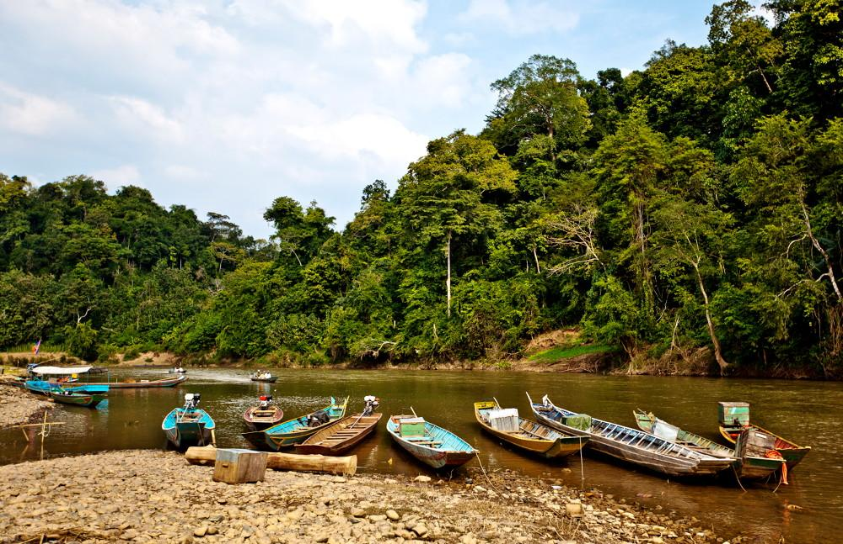
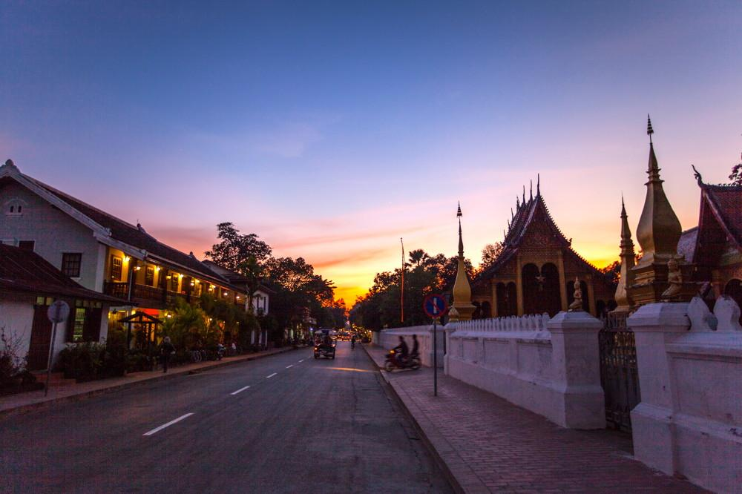
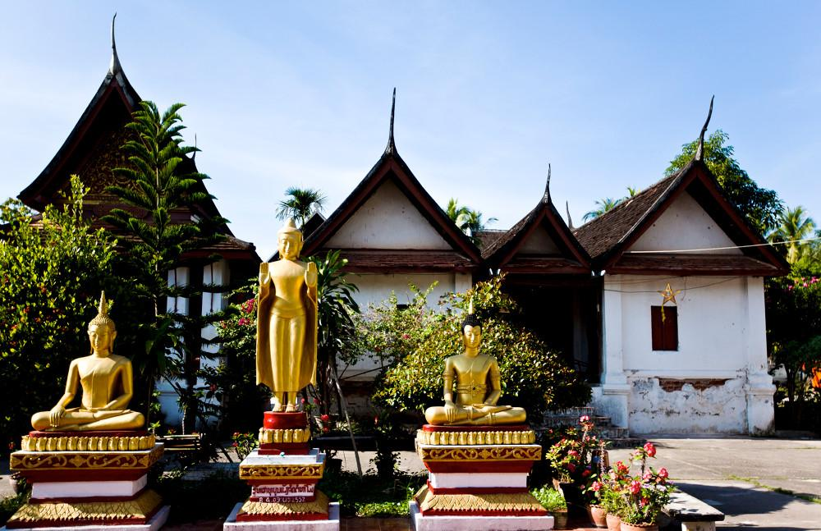
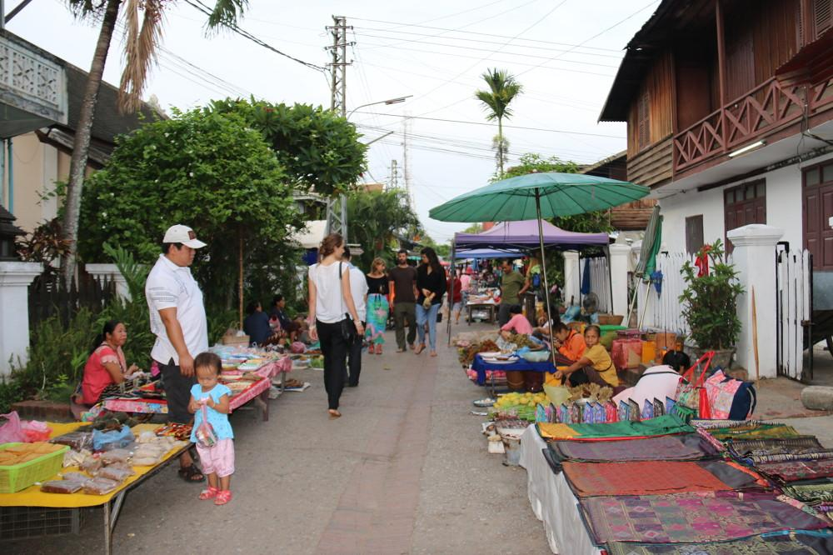
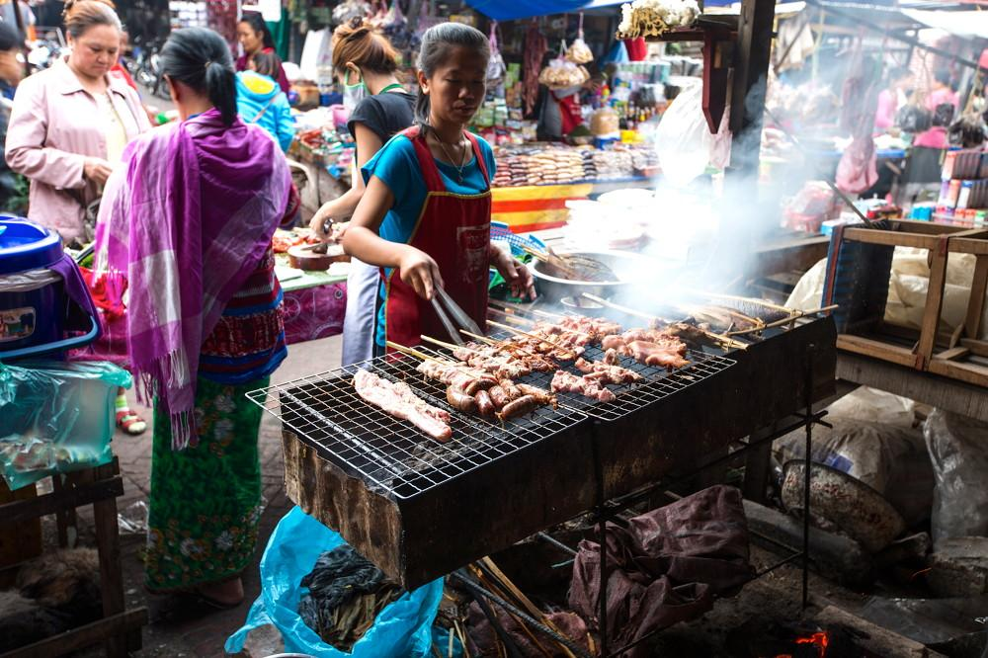
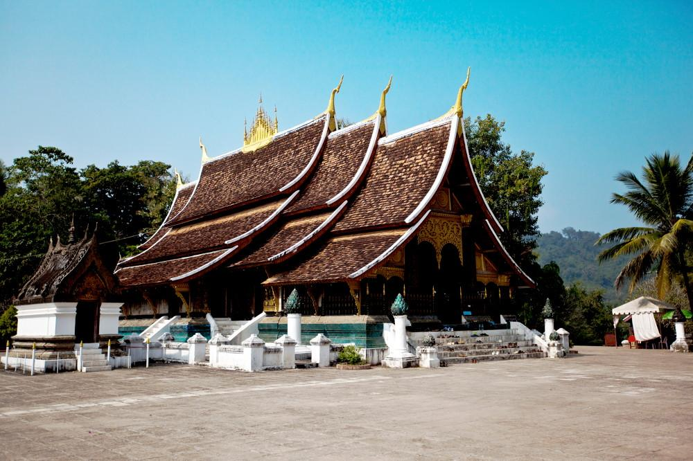

Easia Travel Head Office

Vietnam Head OfficeC/o: ATS Hotel, Suite 326 &327, 33B Pham Ngu Lao Street, Hanoi, VietnamTel: +84 24-39 33 13 62www.easia-travel.com

