LAOS – Luang Prabang – Local Morning Discovery
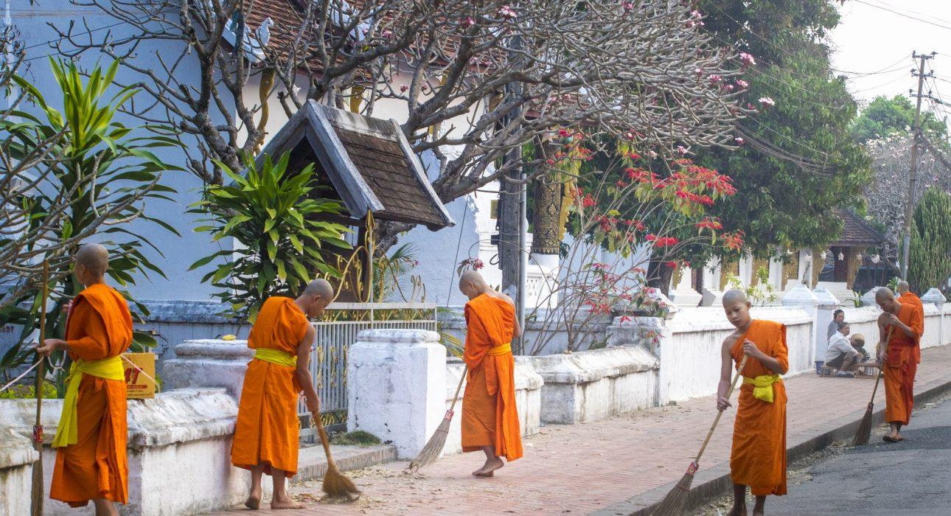

Over View

Theme
Art & Culture, Classic, Family

Country - City
Laos - Luang Prabang

Market segment
Groups, Thematic Leisure

Price Level
$$

Max pax
40

Seasonality
All year round

Arrival city
Luang Prabang

Departure city
Luang Prabang

Description

In the early morning, devoted residents of Luang Prabang kneel on the sidewalk bearing food in their hands, which they offer to the monks as they walk by in a procession of orange robes. The ‘Tak Bat’ ceremony is a culturally significant moment, taking place in a peaceful and respectful manner, with no words exchanged between the monks and the inhabitants making the offerings. After this humbling ceremony, the experience continues with a visit to a local market – a very animated place to be in the morning, to say the least. Each stall offers different kinds of food ranging from fruits and vegetables, meats and fish, to herbs and fragrant spices. The sights, sounds and smells are sure to awaken all the senses. This is a great chance to taste some local snacks before finishing in a welcoming local restaurant on the Mekong riverbank to start the day with a ‘Khao Soy’ soup, a traditional Lao breakfast.

Can be combined with
Thematic Leisure
- Luang Prabang – City Tour of Luang Prabang
- Luang Prabang – Cooking Class at Vanvisa

Selling points

- A religious ceremony followed by a local morning market experience and breakfast.
- A way to be drawn deep into a culturally significant moment in the historic center of Luang Prabang.
- Ideal for those who want to enjoy a very special experience and to learn more about Laos’ culture.
- A great way to experience a peaceful, serene morning.

Time And Transportation

Photos

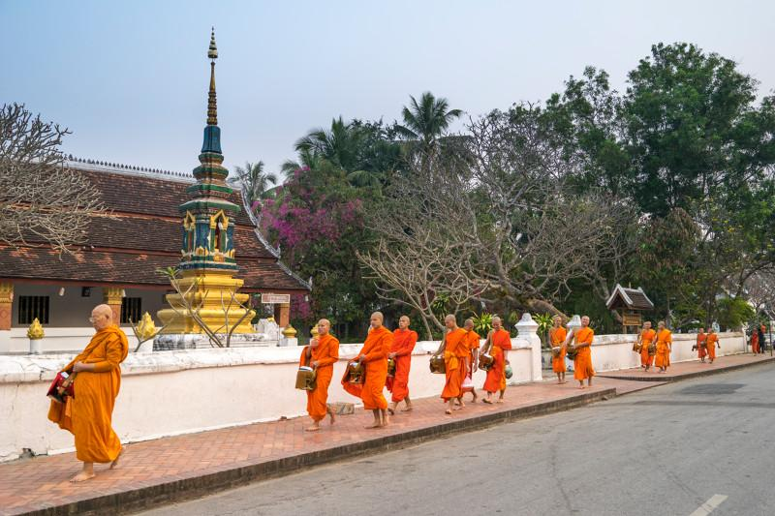
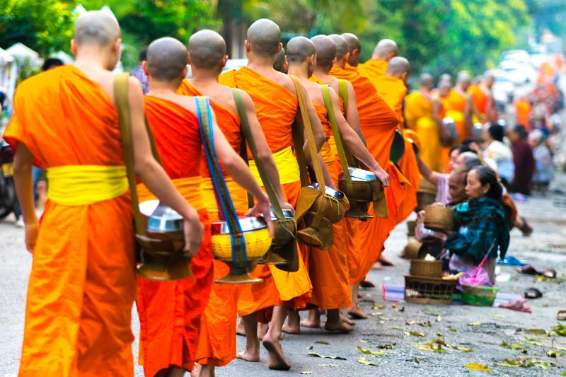
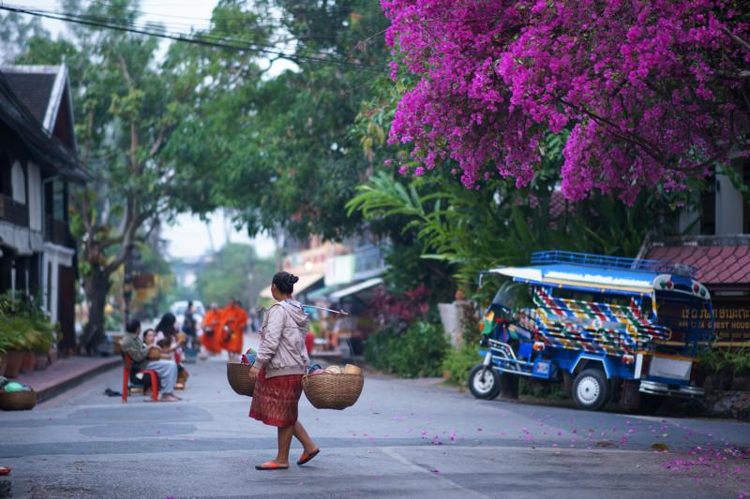
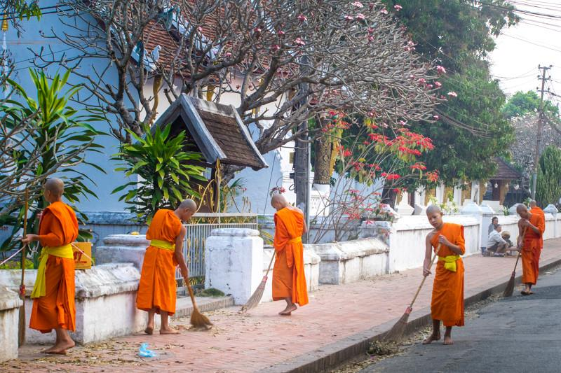
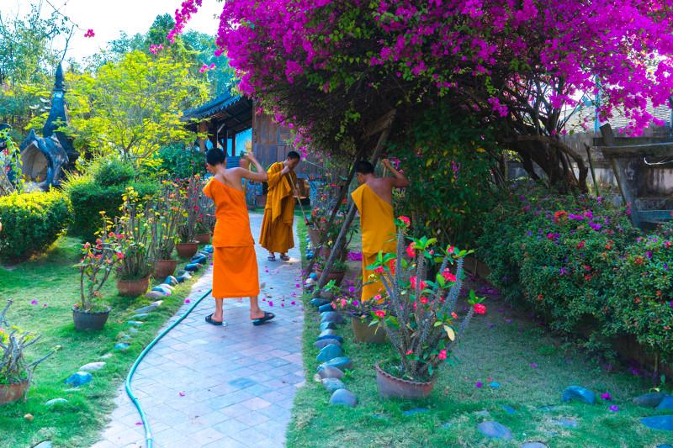
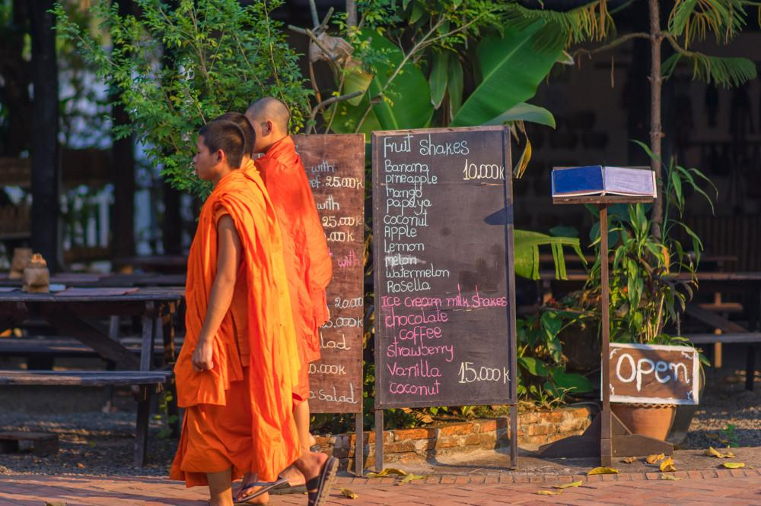

Easia Travel Head Office

