VIETNAM – Hoi An – Full Day Cycling
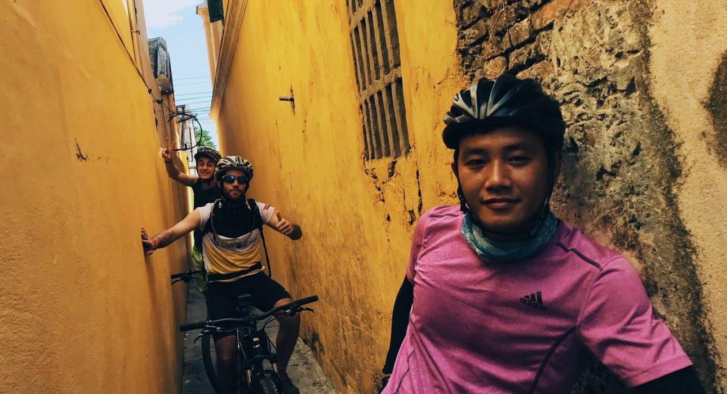

Over View

Theme
Art & Culture, Classic, Family, Sustainable

Country - City
Vietnam - Hoi An

Market segment
Thematic Leisure

Price Level
$$$

Level of difficulties
LEVEL 2

Max pax
15

Seasonality
From December to end of August

Arrival city
Hoi An

Departure city
Hoi An

Description

This light cycling tour allows travelers to get away from the regular tourist itinerary and dive deep into the authentic Vietnam. The best way to immerse oneself in central Vietnam is simply to experience the traditions, culture, and rhythms of life, accessible as travelers cycle around the countryside.The day starts with a ride through the Old Town, and then into the countryside to explore the culture and lifestyle that no tourist usually encounters. After several stops at local houses, the tour finishes in the charming little village of Tra Que, famous for its deliciously aromatic herbs and many kinds of vegetables. Here, guests will be treated to lunch in a local house.Level: 2Distance & duration of cycling: 35 kilometers – 5 h 30min including stops, visits and lunch break Net Elevation gain: None Terrain: Flat, easy to rideTransportation: Road transport – maximum 30 minutes depending on the hotel location

Can be combined with
Thematic Leisure
- Hoi An – Sunset cocktail cruise on the Thu Bon River
- Hoi An – Reaching Out tea house

Selling points

- Fantastic, beautiful, and diverse landscapes throughout the day
- A chance to immerse yourself in Vietnamese culture by cycling through rural areas and meeting local villagers
- An active cycling day of 35 kilometers with an Active team and logistic
- An active tour for families with teenagers 15 years or older
- Goes well as an excursion during a beach stay in Hoi An

Sustainability

Level Of The Excursion
Medium – This activity offers tangible positive contributions to the local community, culture and/or environment

The Impact Of This Excursion

Social/cultural Impact
Cultural Conservation

Environment Impact
Transportation

Economic Impact
Community benefits

Additional Information
Positive Impact:This activity involves a full day of cycling, and helps travelers to understand a variety of aspects of Vietnamese culture (mat weaving, organic farming, shipyards, etc.).Negative Impact:The activity uses motorcycles, which produce high carbon emissions.

Time And Transportation

From | To | Km | By | Duration | Road conditions
Hoi An Old Town | Nam Hai Hotel | 9 kilometers | Car | 20 minutes | Good
Tra Que | Hoi An Old Town | 4 kilometers | Car | 10 minutes | Good

Photos

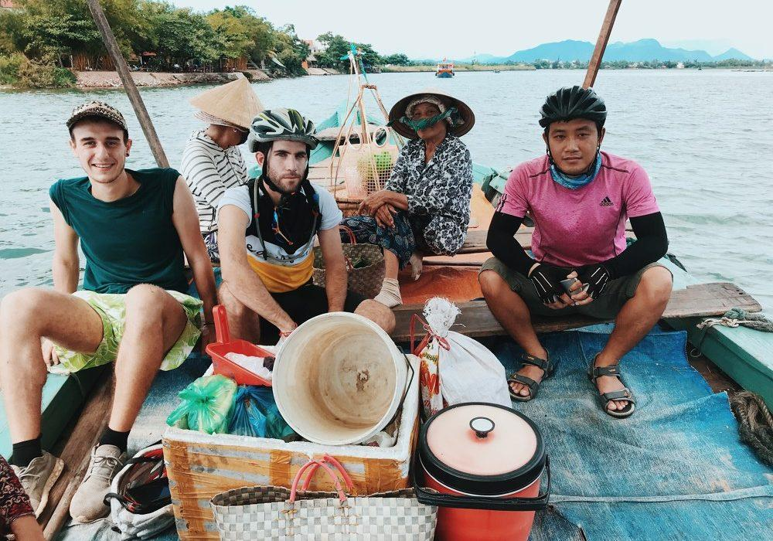
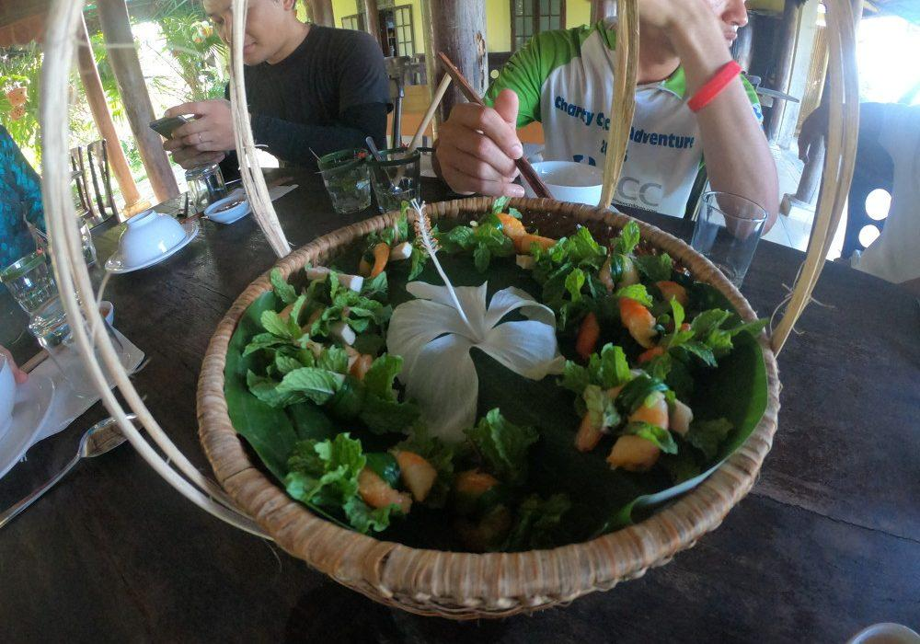
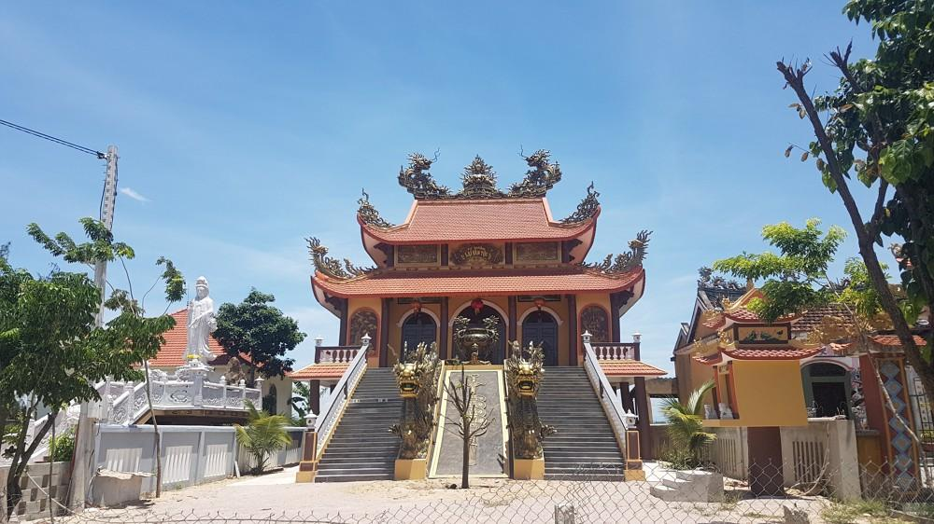
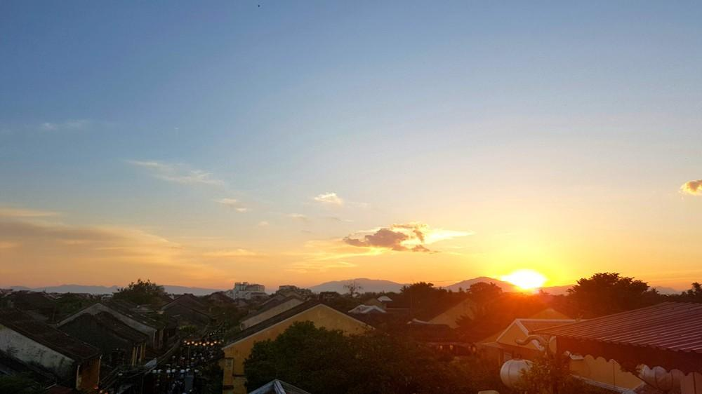
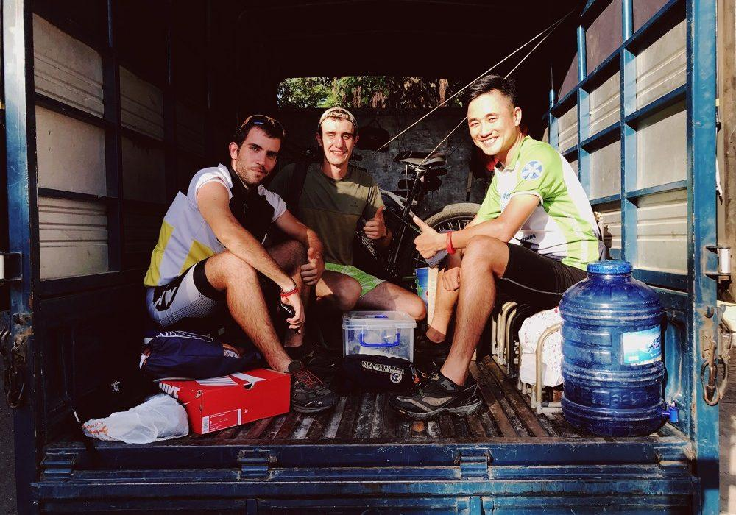
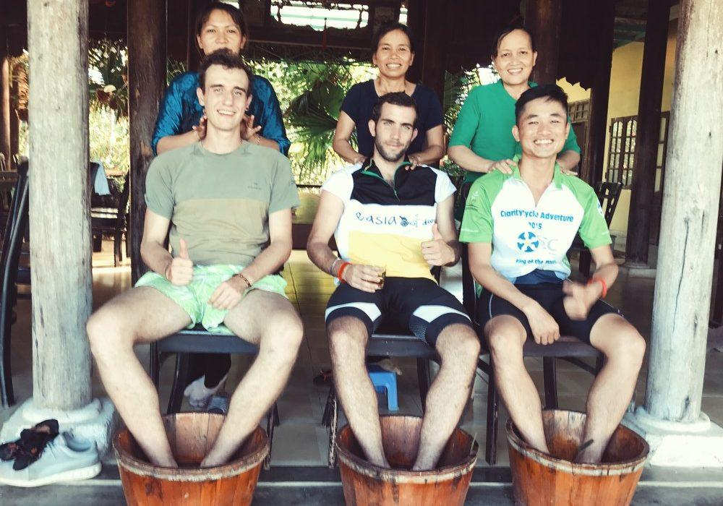
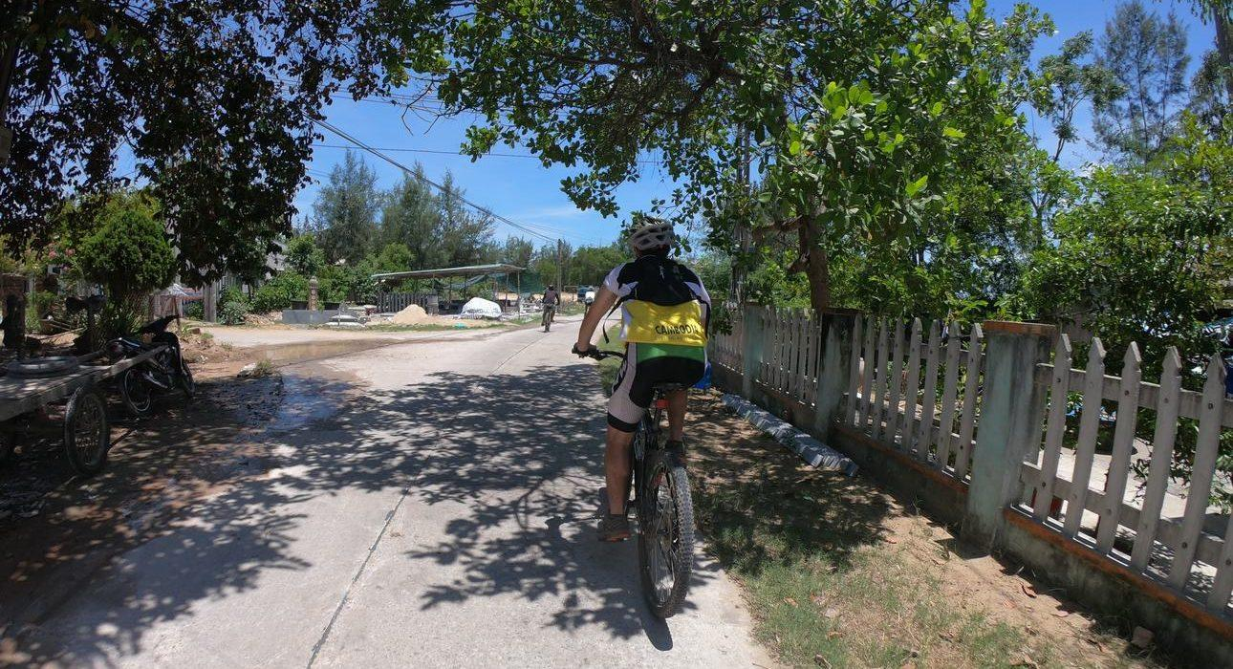

Easia Travel Head Office

Vietnam Head OfficeC/o: ATS Hotel, Suite 326 &327, 33B Pham Ngu Lao Street, Hanoi, VietnamTel: +84 24-39 33 13 62www.easia-travel.com

