VIETNAM – Hanoi – Discover Thang Long culture via Ca Tru
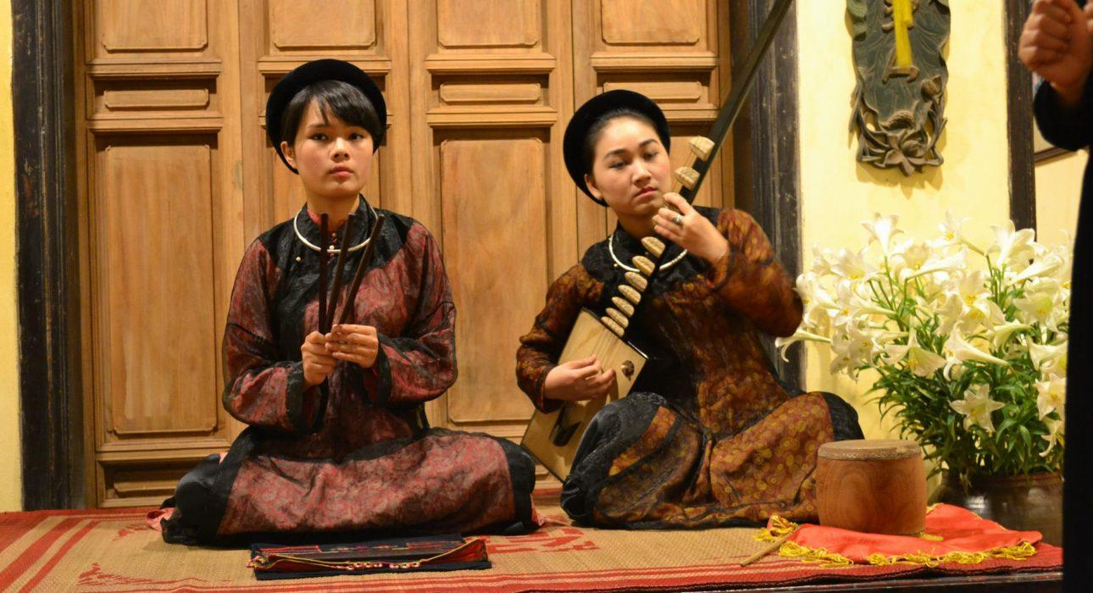

Over View

Theme
Art & Culture, Classic, Family, Honeymoon, Sustainable

Country - City
Vietnam - Hanoi

Market segment
Groups, Thematic Leisure

Price Level
$$

Max pax
20

Seasonality
All Year Round

Arrival city
Hanoi

Departure city
Hanoi

Description

- The performance starts at Pham Thi Hue’s home – a genuine Ca Trù musical artist. At the beginning, she gives a brief introduction of the vicissitudes of Ca Trù’s history, as well as the fate that draws an artist to Ca Trù. Pham Thi Hue is now the only person in Vietnam that can successfully perform Ca Trù vocals while playing the “bottomless stringed instrument” at the same time! The “bottomless stringed instrument” is called “Đàn Đáy” and exists only in Vietnam. By hearing about the life of a Ca Trù’s artist, you’ll learn more about the history of Ca Trù musical art and fully appreciate the value of this aspect of Thang Long culture.
- After Pham Thi Hue and the other artists’ performance, should you feel the desire, you’ll have a chance to chat with the artists and even try playing the instruments yourself.
- As you depart, the sounds of Ca Tra will echo in your ears long after you leave…

Can be combined with
Thematic Leisure
Groups

Selling points

- An interesting program that is suitable for anyone who loves to learn about and explore the art and culture of Vietnam
- The atmosphere and space are very traditional and inspires a passion for the music.
- The artist’s story is simple but very engaging and culturally enriching.

Sustainability

Level Of The Excursion
Medium – This activity offers tangible positive contributions to the local community, culture and/or environment

The Impact Of This Excursion

Social/cultural Impact
Cultural Conservation

Economic Impact
Local individual benefits

Additional Information
Positive Impact:An activity that helps to protect (and promote) the art of Ca Tru, a UNESCO Intangible Cultural Heritage listed art of Northern Vietnam and that provides income to the artists.

Time And Transportation

From | To | Km | By | Duration | Road condition
Hoan Kiem lake | Hong Ha Central Traditional Opera Theatre | 3 | Car | 15 minutes | Good

Photos

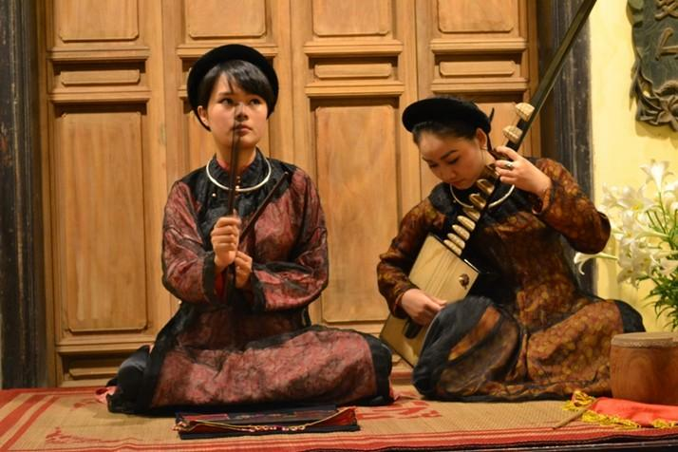
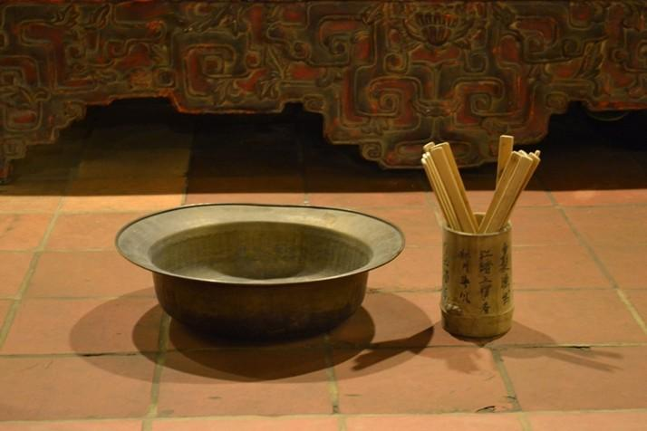
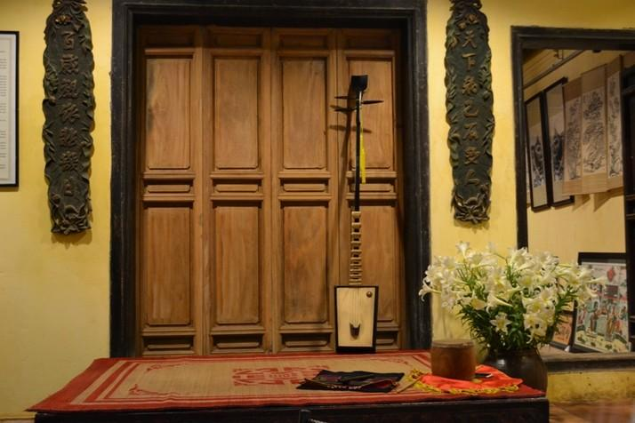
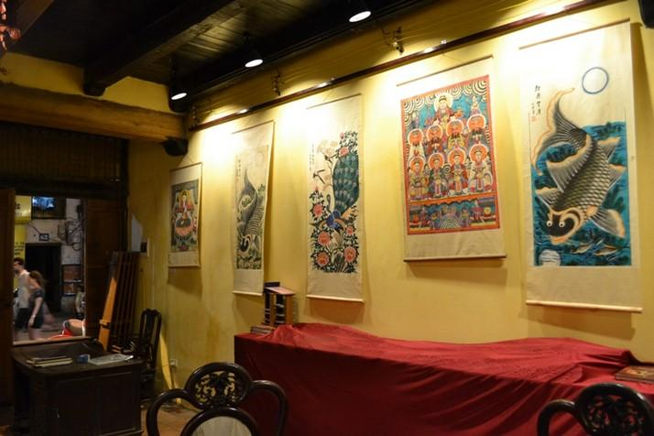

Easia Travel Head Office

Vietnam Head OfficeC/o: ATS Hotel, Suite 326 &327, 33B Pham Ngu Lao Street, Hanoi, VietnamTel: +84 24-39 33 13 62www.easia-travel.com

