LAOS – Hinboun – Full Day Tour on the Other Side of Konglor Cave
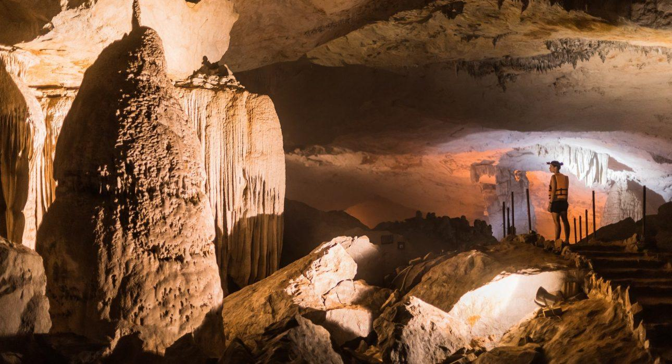

Over View

Theme
Classic, Sustainable

Country - City
Laos - Hinboun

Market segment
Groups, Thematic Leisure

Price Level
$

Level of difficulties
LEVEL 0

Max pax
20

Seasonality
All Year Round (maybe very slippery during rainy season)

Arrival city
Ban Konglor

Departure city
Ban Konglor

Description

After passing through the 7,5-kilometer cave aboard a long tail boat – one of the longest underworld crossings on earth – and admiring the stunning rock formations, a walk begins amid stunning landscapes and through the villages of Ban Natan and Tan Khankeo, lying at the foot of the limestone mountains. Following a trail, cross a shallow river on foot to finally reach the hidden Tam Hom cave, the secret spot where a picnic lunch will be served and one can relax with a view over the valley. Then the hike continues to the boat pier before passing back through the Konglor cave.

Selling points

- A discovery of the famous Konglor Cave, one of the highlights of Laos destination.
- An easy hike in a remote area with unique landscapes than cannot be found elsewhere in Laos.
- A great insight into the Lao countryside lifestyle and to experience interaction with the locals.

Time And Transportation

From | To | Km | By | Duration | Road condition
Spring River Resort | Konglor Cave | 3 | Minivan | 15 minutes | Good

Photos

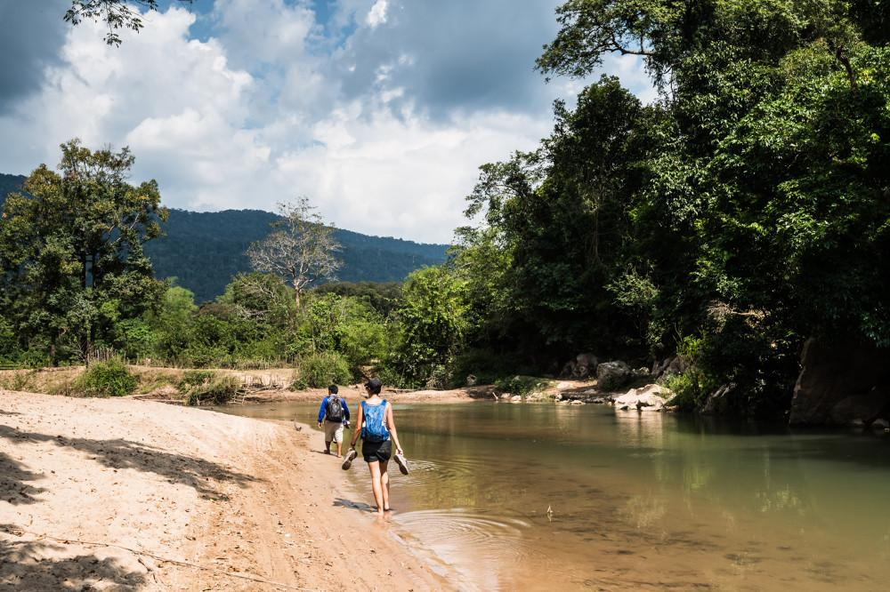
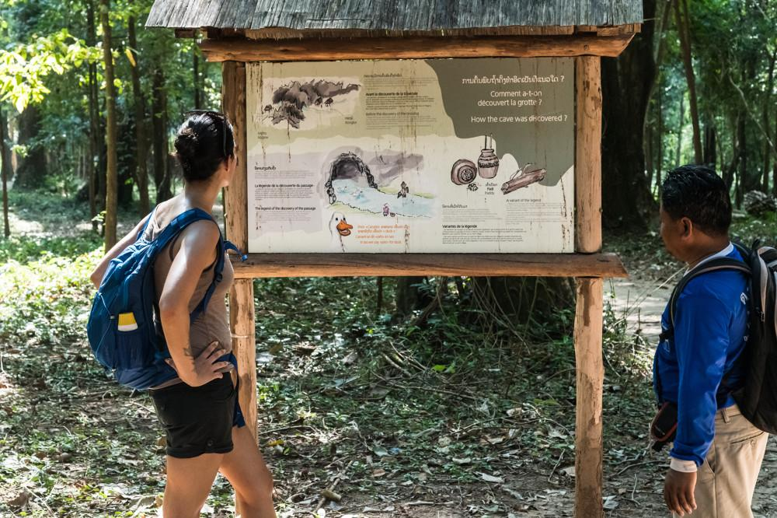
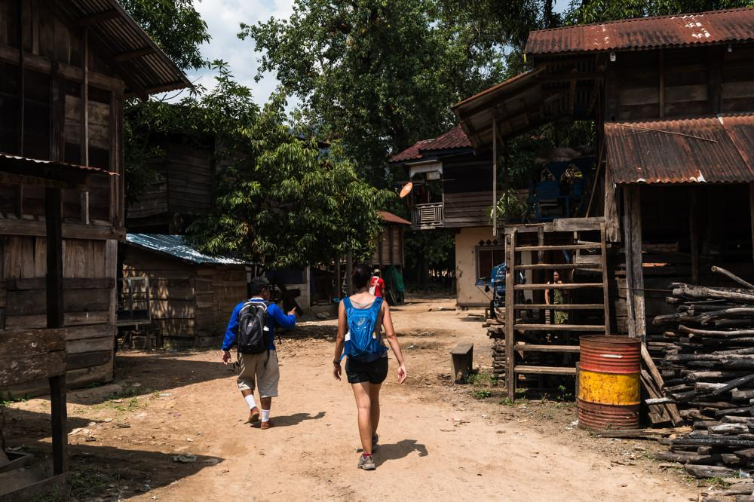
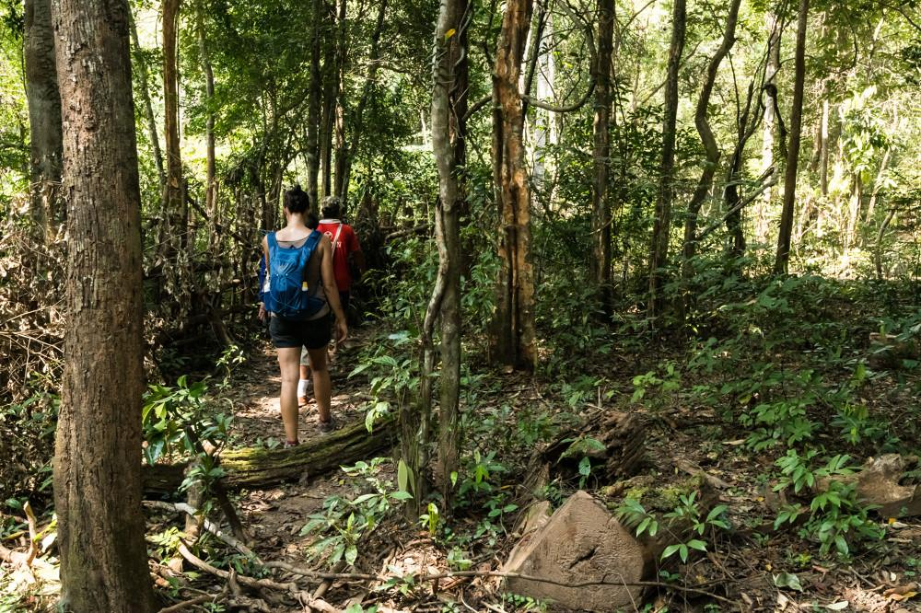
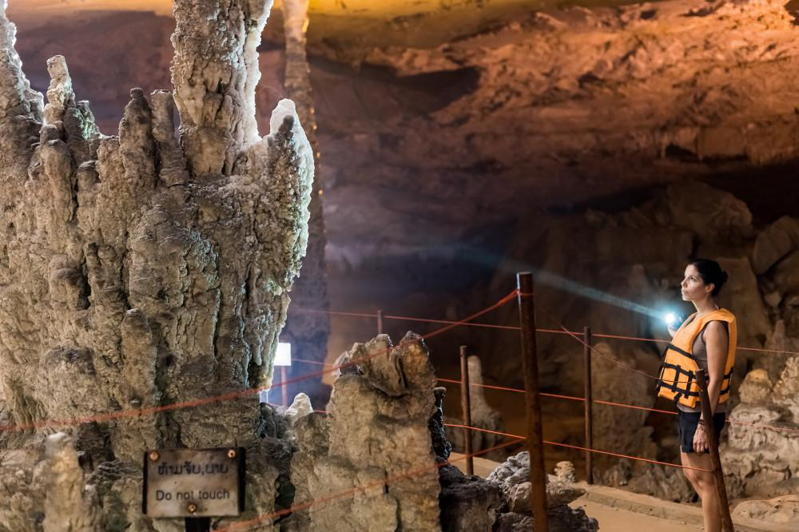
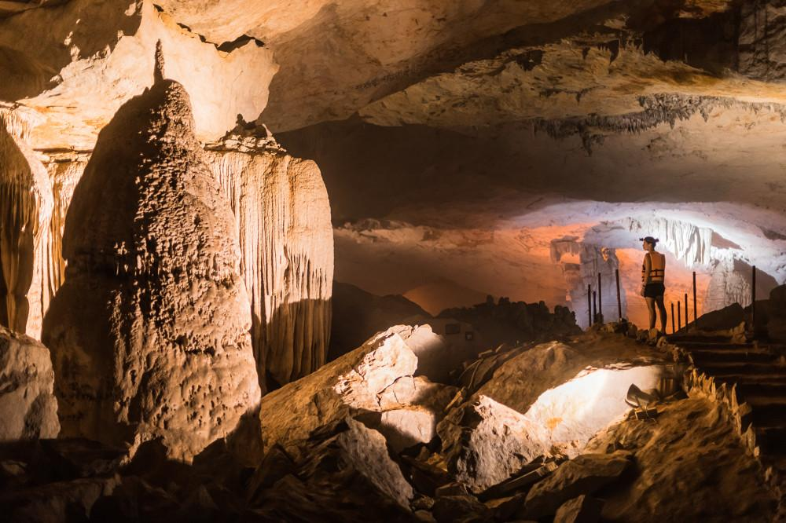
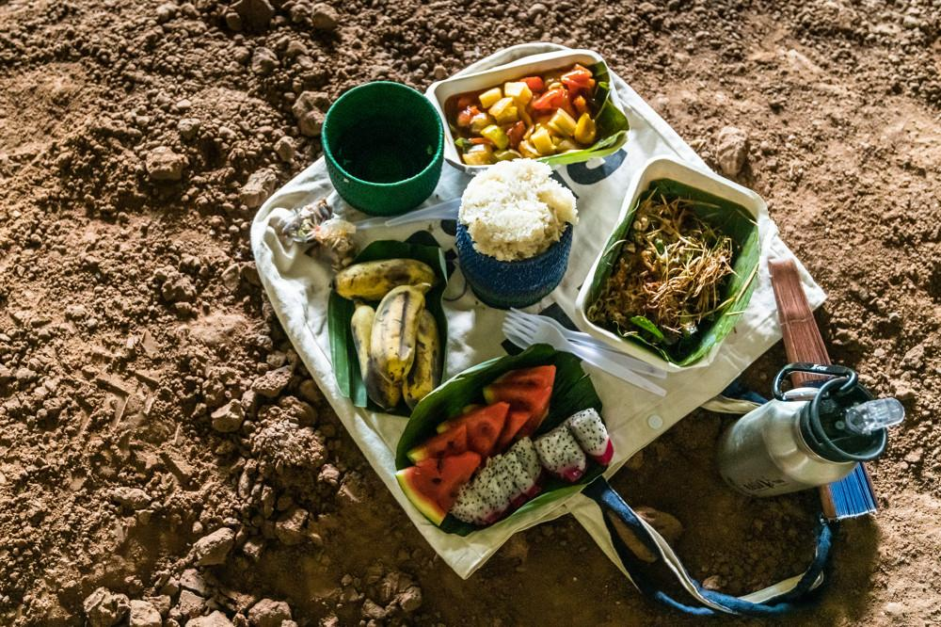

Easia Travel Head Office

Vietnam Head OfficeC/o: ATS Hotel, Suite 326 &327, 33B Pham Ngu Lao Street, Hanoi, VietnamTel: +84 24-39 33 13 62www.easia-travel.com

