LAOS – Luang Prabang – Easy Hike from Ban Nong Heo to Kuang Sy Waterfalls
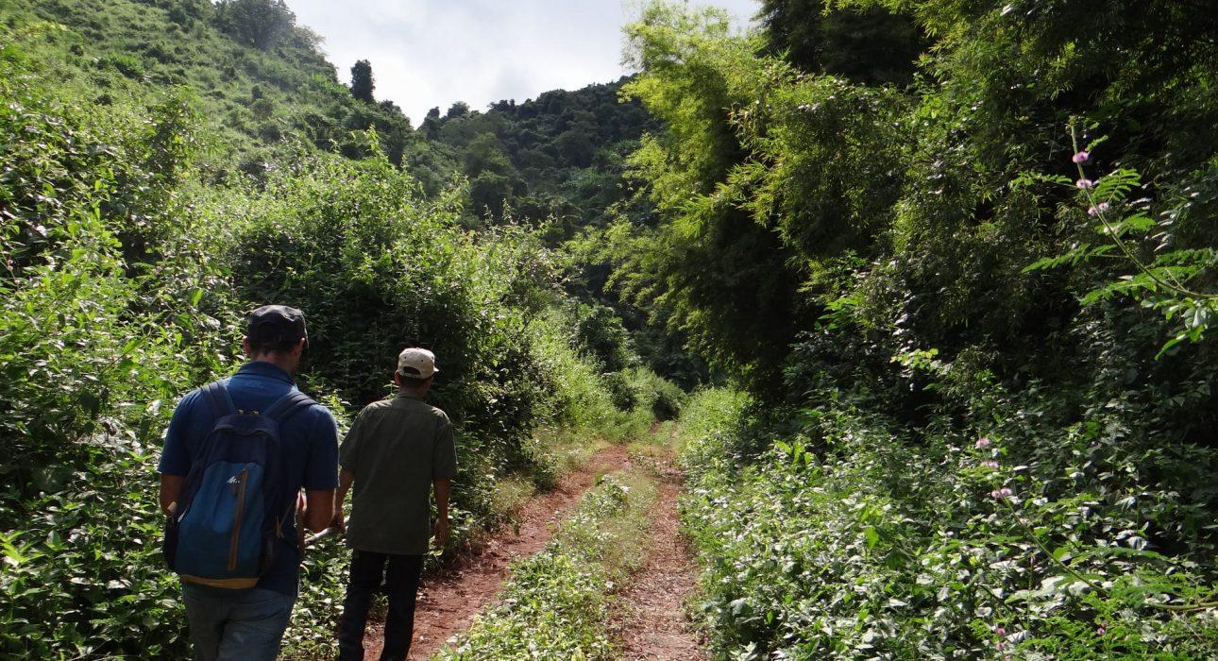

Over View

Theme
Classic, Sustainable

Country - City
Laos - Luang Prabang

Market segment
Groups, Thematic Leisure

Price Level
$$

Level of difficulties
LEVEL 2

Max pax
35

Seasonality
From October to June

Arrival city
LUANG PRABANG

Departure city
LUANG PRABANG

Description

After the trip to Ban Nong Heo, travelers have some time to discover the charming Khmu village, with its traditional houses, its water buffalo and free-range ducks walking around, and even the farmers and master blacksmiths dealing with their daily tasks. Then, travelers have the chance to join in an easy hike in the countryside, pass over hills, and through forests and plantations, with nice viewpoints to stop at along the way. After a one and a half hour walk in the beautiful natural environment, travelers arrive at Ban Thapene, a village which sits at the foot of the stunning Kuang Sy Waterfalls. It is recommended to do this hike in the morning in order to spend some time at the waterfalls in the afternoon.

Can be combined with
Thematic Leisure
- LAOS – Luang Prabang – Buffalo Dairy Farm

Selling points

- To have a perfect combination of easy hiking in beautiful landscapes and relaxation at the waterfalls afterwards.
- An alternate way to visit one of the most famous attractions in Laos.

Sustainability

Level Of The Excursion
Medium – This activity offers tangible positive contributions to the local community, culture and/or environment

The Impact Of This Excursion

Social/cultural Impact
Cultural Conservation, Empowerment and education, Involving minorities

Economic Impact
Local individual benefits, Community benefits

Time And Transportation

From | To | Km | By | Duration | Road condition
Ban Nong Heo | Kuang Sy waterfall | 4 | Walk | 1h 30min | Easy
Kuang Sy | Luang Prabang | 30 | Minivan | 45 minutes | Good
Luang Prabang | Ban Nong Heo | 25 | Minivan | 50 minutes | 30 minutes of good road, 20 minutes of rougher, dirt road

Photos

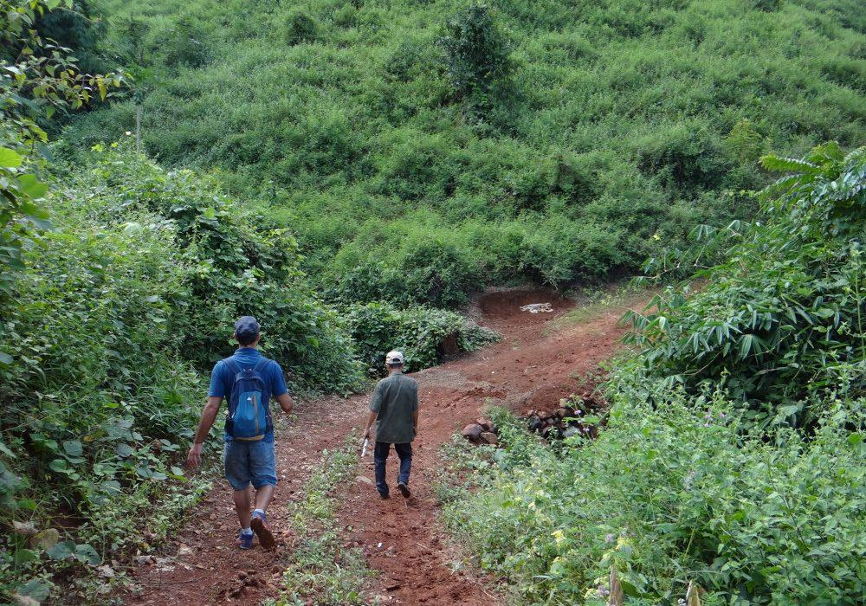
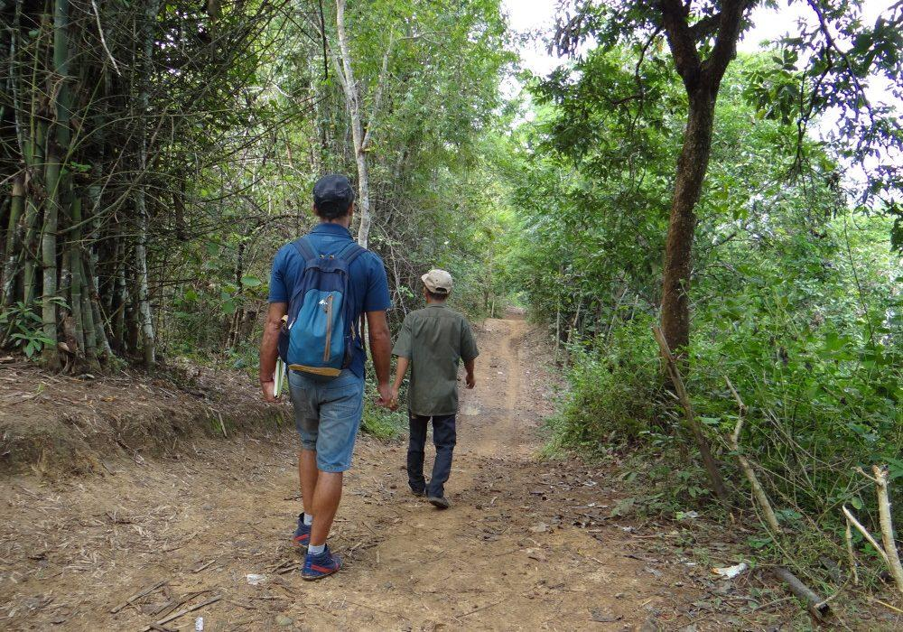
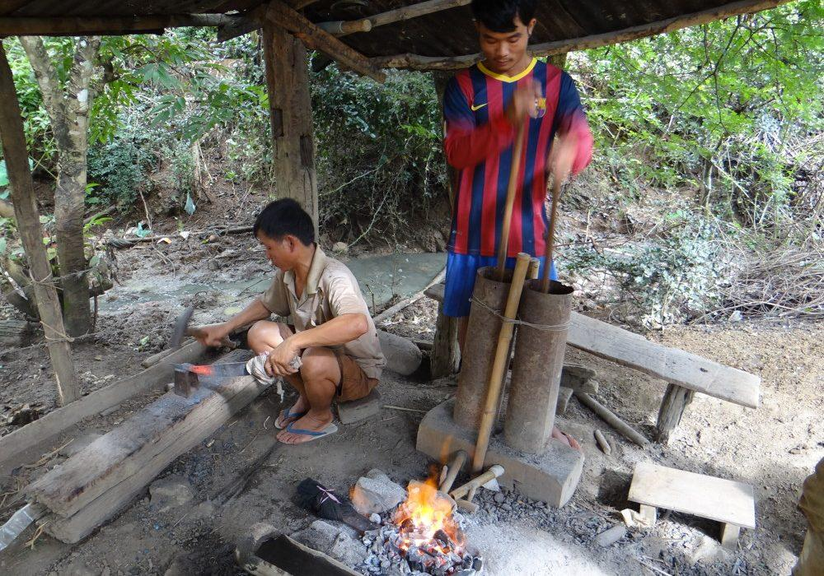
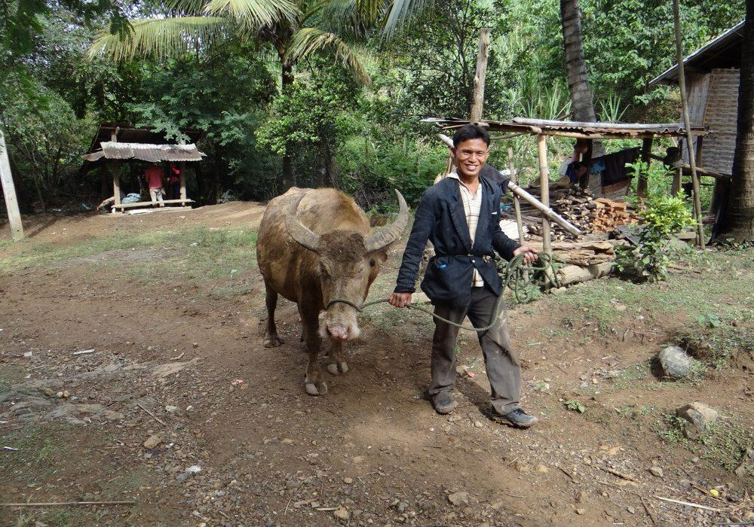
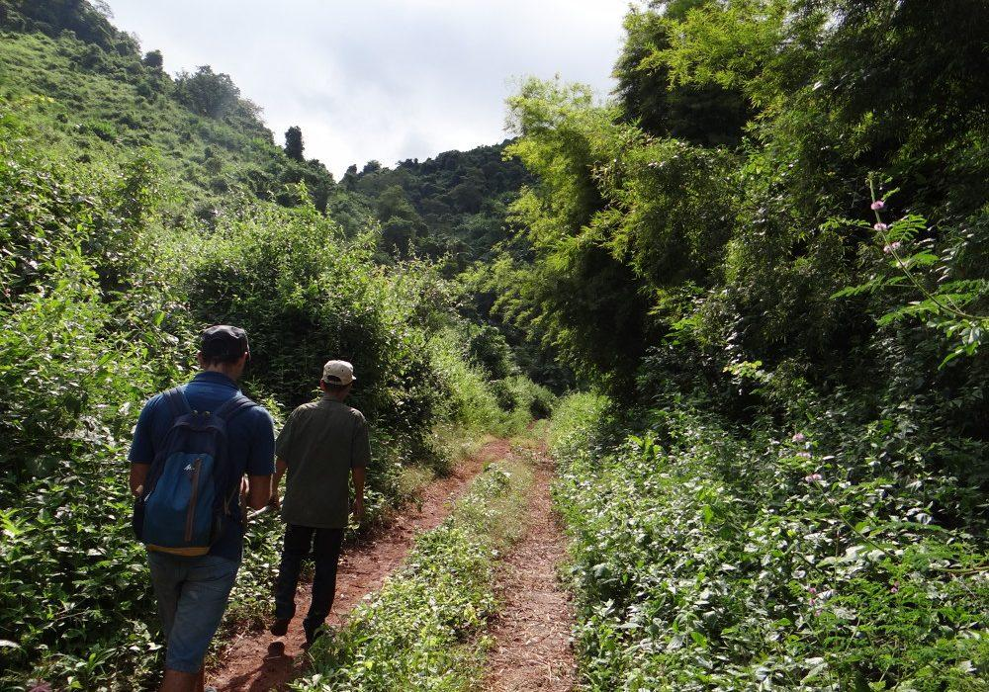

Easia Travel Head Office

Vietnam Head OfficeC/o: ATS Hotel, Suite 326 &327, 33B Pham Ngu Lao Street, Hanoi, VietnamTel: +84 24-39 33 13 62www.easia-travel.com

