MYANMAR – Bagan – On the Sandy Paths of Kyun Thiri
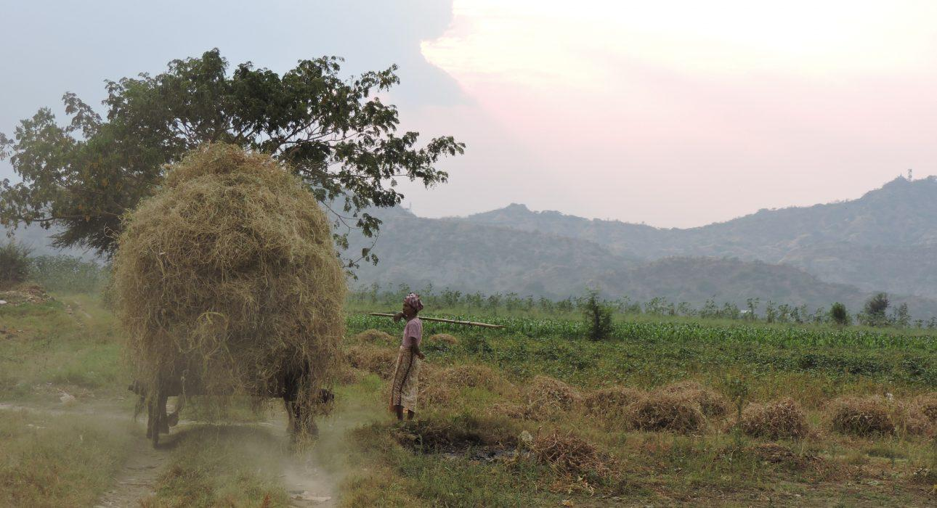

Over View

Theme
Classic, Family

Country - City
Myanmar - Bagan

Market segment
Thematic Leisure

Price Level
$$

Max pax
15 persons

Seasonality
November – March (village flooded between June – September)

Arrival city
BAGAN

Departure city
BAGAN

Description

The village of Kyun Thiri can be reached by half an hour boat. The excursion on the sandy path of the village will be partially on a oxcart and partially by foot. The head of the village will welcome the visitors into his home for a generous tea break. An beautiful excursion out of time in a village threatened by the erosion of the river. On the way back to Bagan, refreshments will be served on board. We advise to visit Kyun Thiri in the afternoon to enjoy a beautiful sunset on the way back to Bagan.

Can be combined with
Thematic Leisure
- Bagan – Visit to Taungbi Library
- Bagan – Half-Day Discovery with Electric Scooters

Selling points

- An excursion to a quaint village where time seems to have stopped
- Use local transportation, go from a wooden boat to an oxcart and walk around the village
- A tea break at the villagers’ house to get a glimpse of the life in the countryside
- Gorgeous views of the river and the surrounding mountains (Tant Gyi Taung and Tuyin Taung)
- Ideal village excursion for families who want to take a break from the temples and cultural sightseeing

Time And Transportation

From | To | Distance | By | Duration | Road condition
Bagan | Kyun Thiri | / | Boat | 25 min | Good

Photos

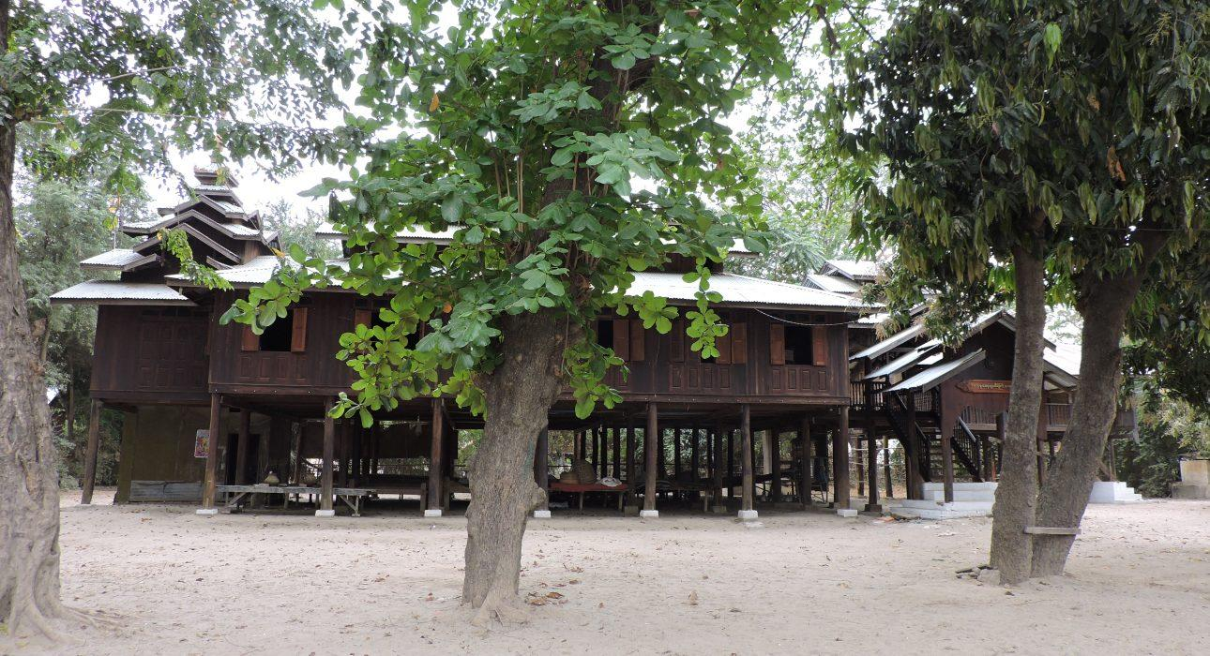
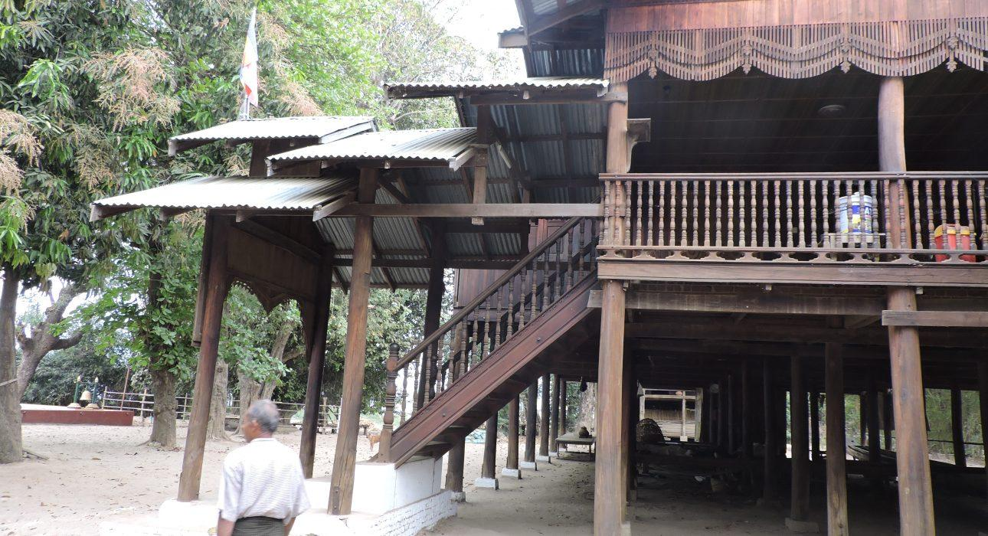
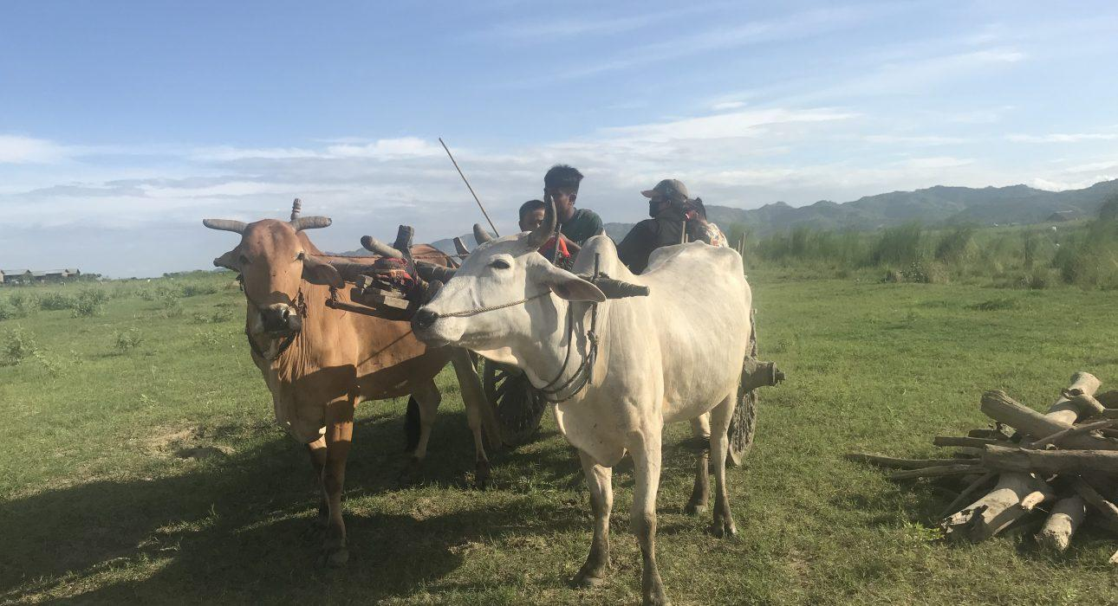
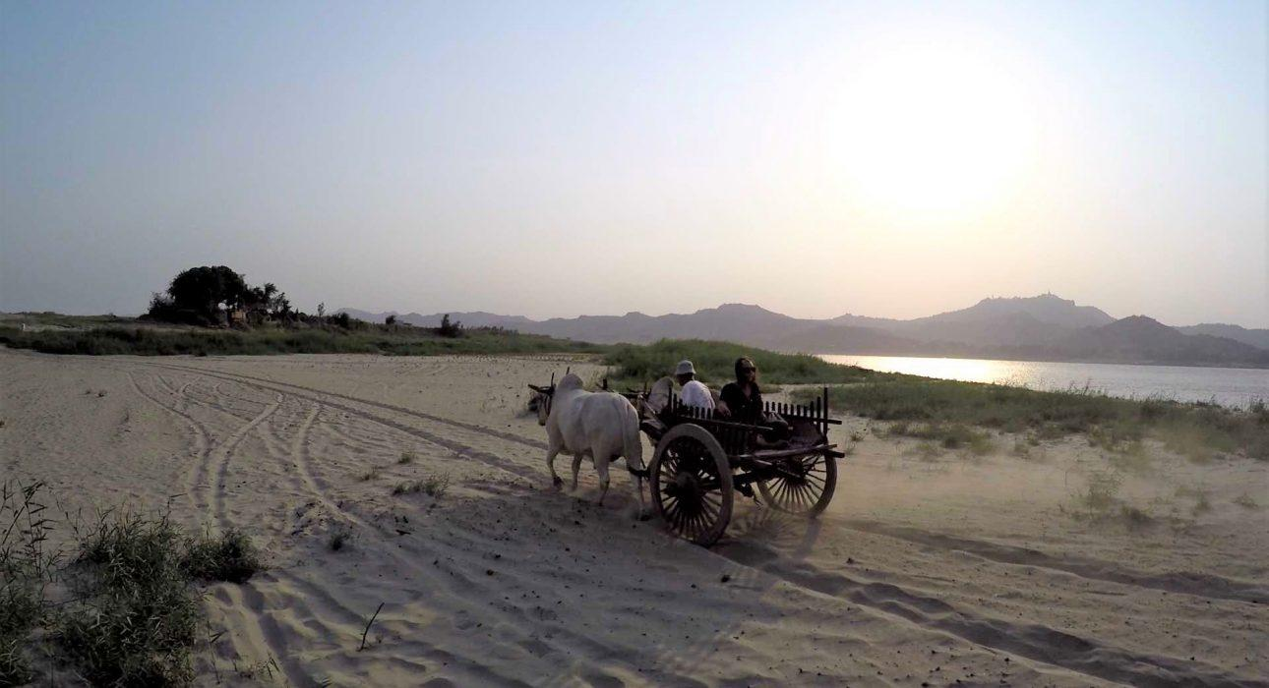
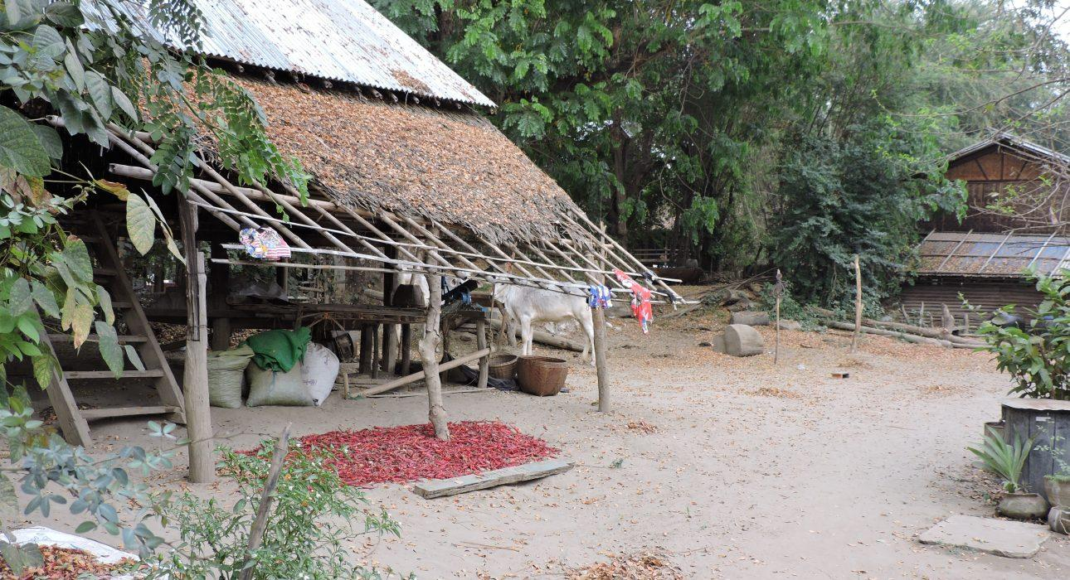
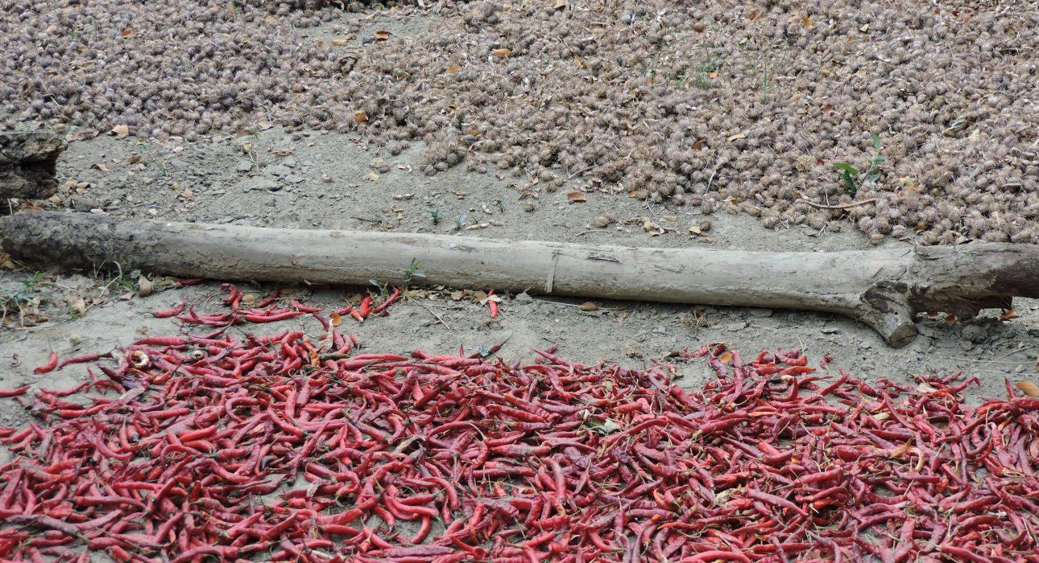
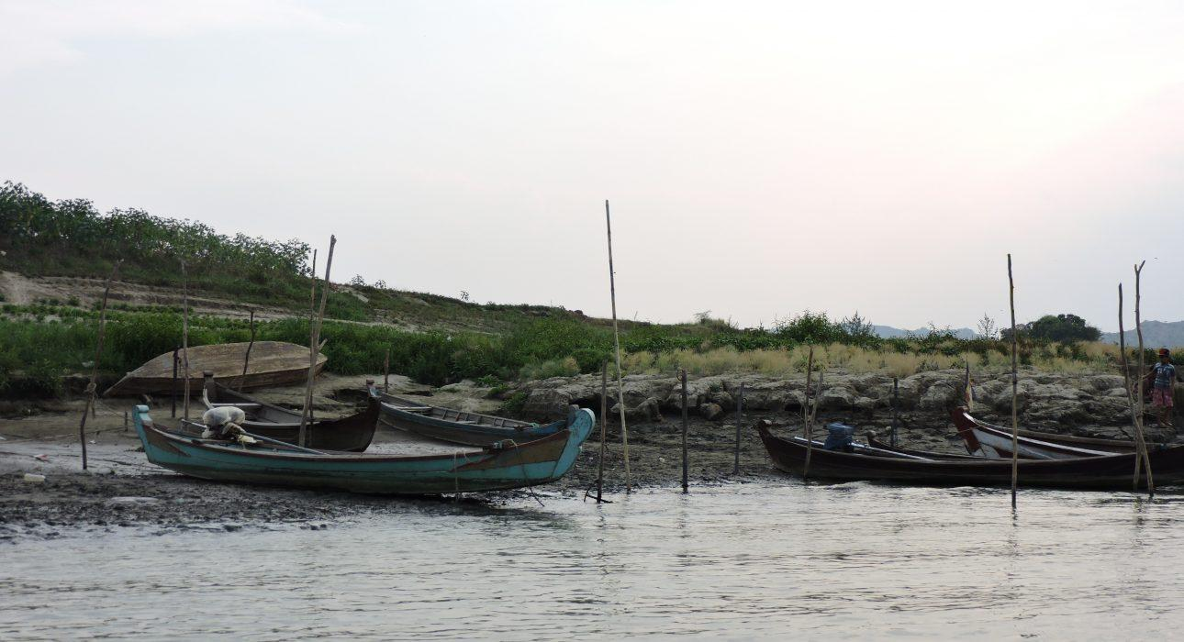
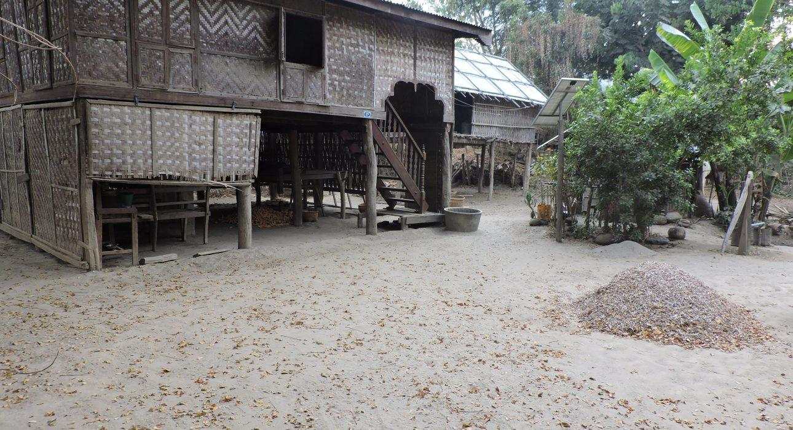
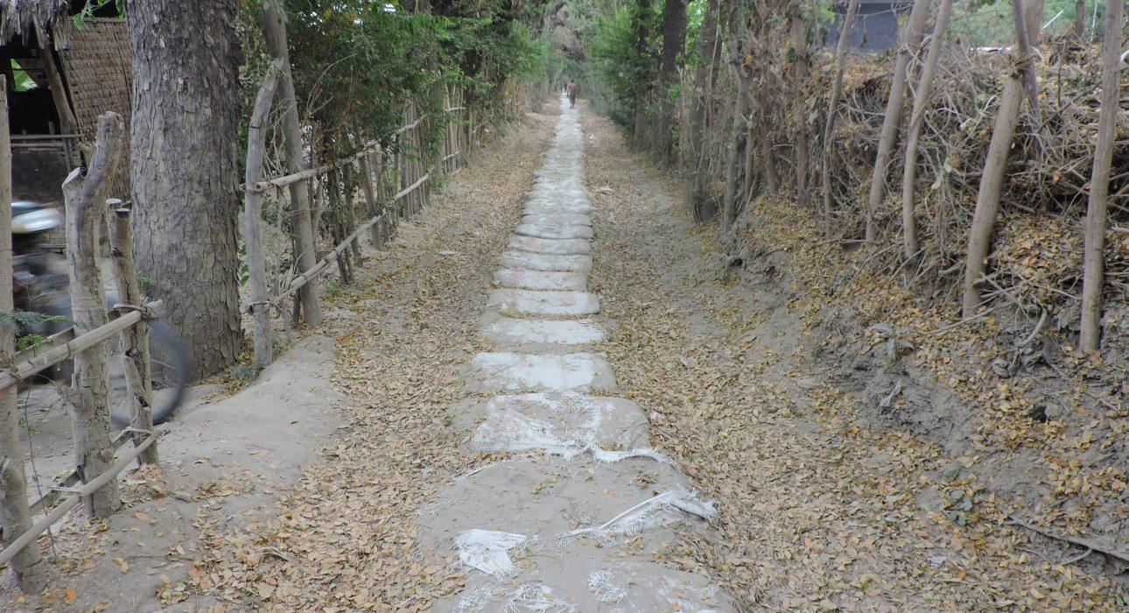

Easia Travel Head Office

Vietnam Head OfficeC/o: ATS Hotel, Suite 326 &327, 33B Pham Ngu Lao Street, Hanoi, VietnamTel: +84 24-39 33 13 62www.easia-travel.com

