LAOS – Luang Prabang – Kayaking on the Nam Khan River
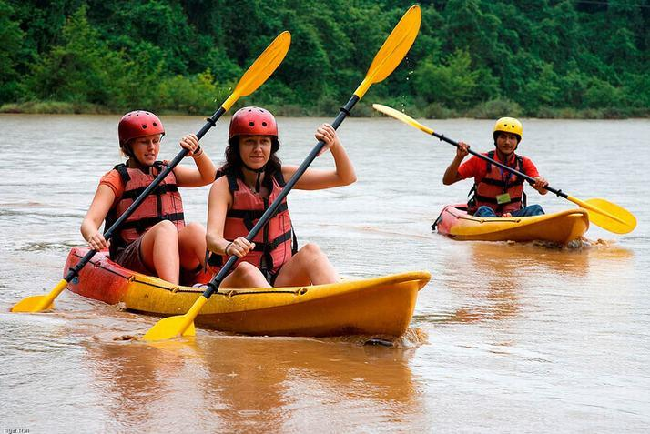

Over View

Theme
Classic, Family

Country - City
Laos - Luang Prabang

Market segment
Thematic Leisure

Price Level
$$

Level of difficulties
LEVEL 2

Max pax
20

Seasonality
July to January

Arrival city
LUANG PRABANG

Departure city
LUANG PRABANG

Description

This activity offers an exciting half-day or full-day kayaking experience on the beautiful Nam Khan River. The tour starts with a short transfer to the starting point on the Nam Khan River, where a short safety briefing is held before boarding one of the kayaks. From here, the kayaking journey takes travelers downstream through lush jungle, rice paddies, local villages, and elephant camps. Some stops may be included on the tour such as Tad Sae Waterfall, local ethnic villages, or the sandy beaches along the banks of the river, depending on feasibility and water levels.

Can be combined with
Thematic Leisure
- LAOS – Luang Prabang – Elephant Village
- LAOS – Luang Prabang – Baci Ceremony at a Local House

Selling points

- Witness the beautiful landscape along the banks of the Nam Khan River.
- Enjoy an active tour complete with a challenging, upstream paddle.
- A mild adventure expedition by kayak with amazing views, cultural history, and exploration.
- See the surroundings of Luang Prabang from a unique perspective.

Sustainability

Level Of The Excursion
Medium – This activity offers tangible positive contributions to the local community, culture and/or environment

The Impact Of This Excursion

Social/cultural Impact
Cultural Conservation, Empowerment and education, Involving minorities, Community welfare and health

Time And Transportation

From | To | Km | By | Duration | Road condition
Luang Prabang | Kayaking Starting Point | 25 | Car / Bus | 40 minutes | Good

Photos

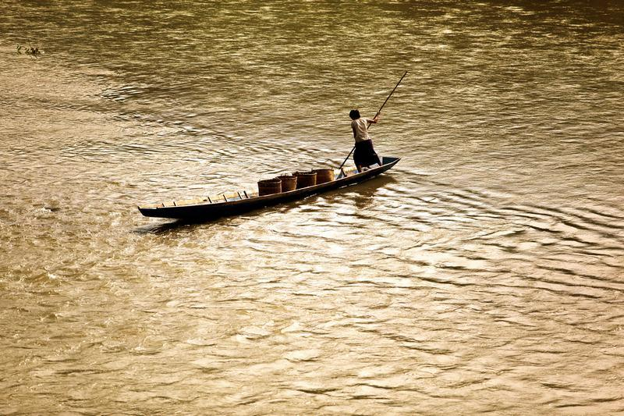
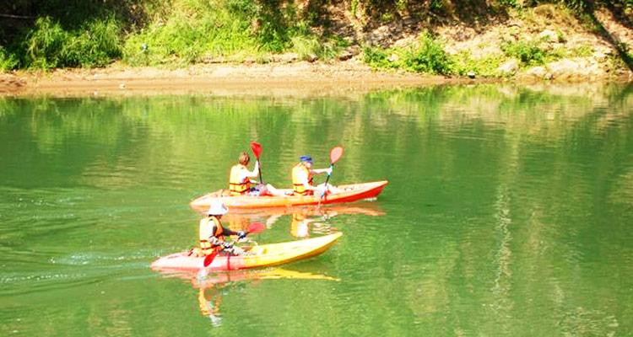
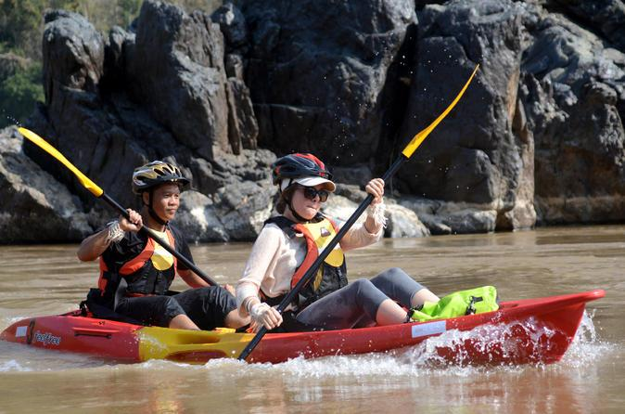

Easia Travel Head Office

Vietnam Head OfficeC/o: ATS Hotel, Suite 326 &327, 33B Pham Ngu Lao Street, Hanoi, VietnamTel: +84 24-39 33 13 62www.easia-travel.com

