CAMBODIA – Siem Reap – Meet Cambodia’s Little Heroes
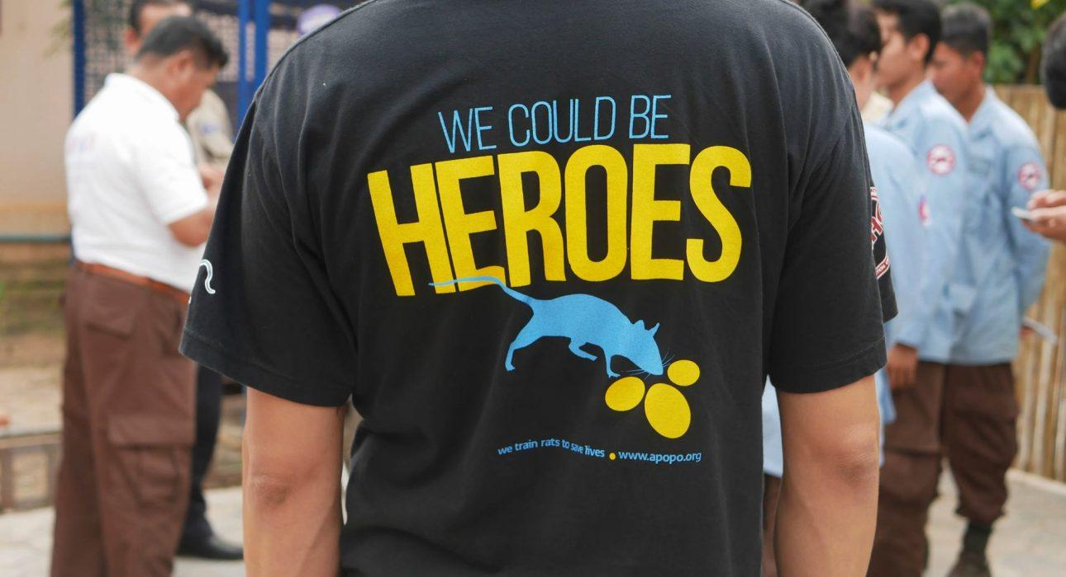

Over View

Theme
Art & Culture, Classic, Family, Sustainable

Country - City
Cambodia - Siem Reap

Market segment
Groups, Thematic Leisure

Price Level
$

Max pax
40

Seasonality
All Year Round

Arrival city
Siem Reap

Departure city
Siem Reap

Description

During the Vietnam-Cambodia War, Cambodia was bombarded by at least 26 million explosive sub-munitions, mainly in the eastern and northeastern areas. Research estimates there were between 1.9 million and 5.8 million cluster munitions remnants remaining right after the war. Hopefully, we are far from this reality, and this is what the APOPO organization and its mine detection rats (MDR), also known as “HeroRats,” are making sure of.During the visit, a private APOPO expert guide shows HeroRats in action in their real-life demonstration area and explains how this organization trains them to save lives through a mine clearance process. It’s not only impressive to see these little heroes in action, but it’s also an excellent opportunity to understand the impact of landmines on the local community and discover this sad history of conflict in Cambodia.

Can be combined with
Thematic Leisure
- Siem Reap – Angkor couple photo Shooting
- Siem Reap – Khmer Family Day

Selling points

- To meet and greet with APOPO’s Expert guide through the whole visit at the center
- To assist in a real-life de-mining demonstration by the HeroRats
- To offer a great opportunity to gain deeper understanding about the history of the conflict in Cambodia

Sustainability

Level Of The Excursion
High – This activity strongly supports local communities and/or helps preserve the culture and environment

The Impact Of This Excursion

Social/cultural Impact
Cultural Conservation

Economic Impact
Community benefits

Additional Information
Positive impact: Raise awareness about mines issue and support NGO

Time And Transportation

Photos

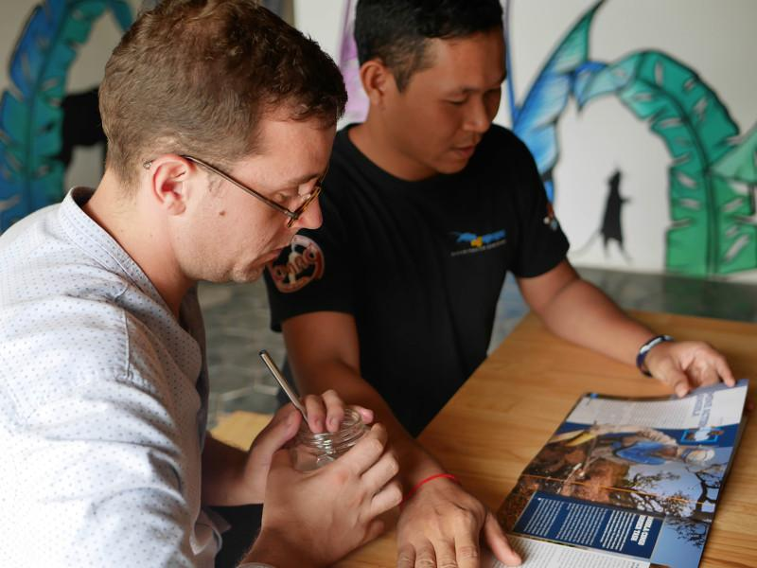
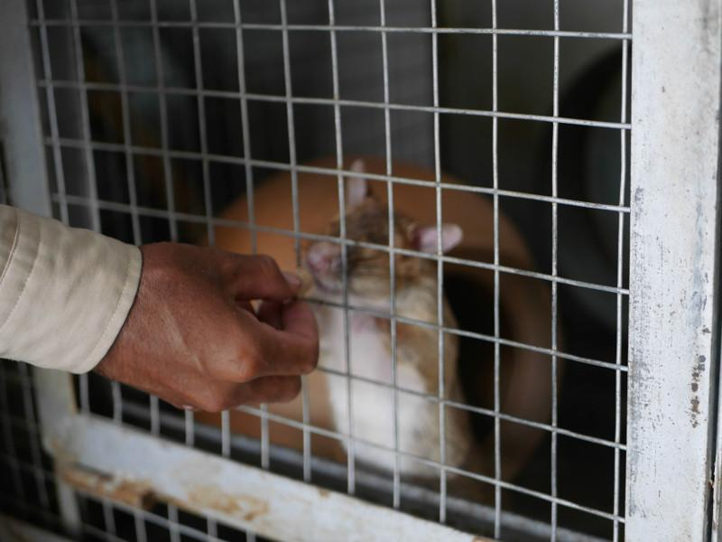
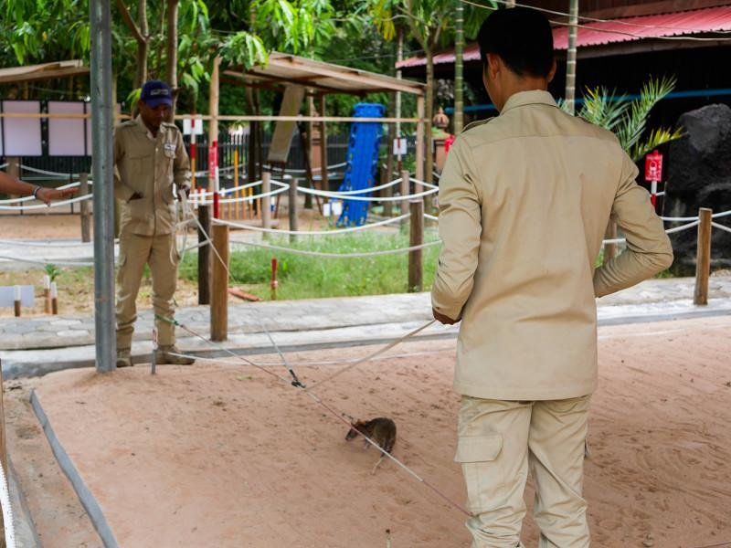
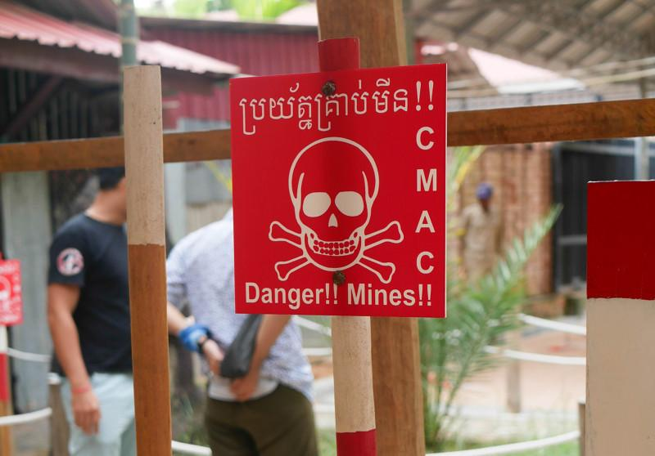
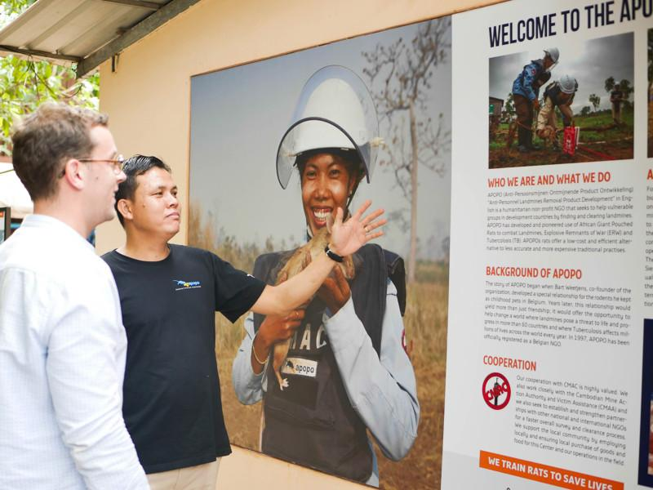

Easia Travel Head Office

Vietnam Head OfficeC/o: ATS Hotel, Suite 326 &327, 33B Pham Ngu Lao Street, Hanoi, VietnamTel: +84 24-39 33 13 62www.easia-travel.com

