THAILAND – Chiang Rai – Colors of Art
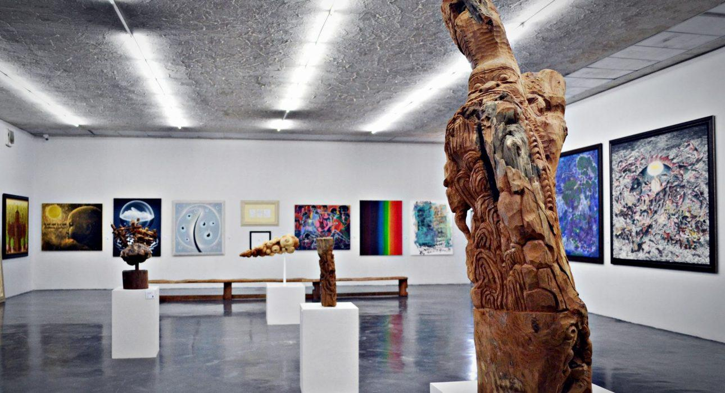

Over View

Theme
Art & Culture, Classic, Honeymoon

Country - City
Thailand - Chiang Rai

Market segment
Groups, Thematic Leisure

Price Level
$

Max pax
38

Seasonality
All Year Round

Arrival city
Chiang Rai

Departure city
Chiang Rai

Description

This full day activity gives travelers the chance to visit must-see Wat Rong Khun, the impressive and famous white temple with its captivating murals created by the now internationally renowned artist, Chalermchai Kositpipat. The next stop is the small temple Wat Rong Suea Ten, also known as the Blue Temple, created by one of Chalermchai’s students. After leaving the temples behind, it’s the perfect time to have lunch at the restaurant of Art Bridge Chiang Rai, a local art gallery where the works of local artists are on display. In the afternoon, the art tour continues with a stop near the Black House, another religious-inspired building complex. And before finishing the day, guests pay a visit to Doi Din Daeng Pottery for a quiet workshop set in green surroundings to meet artists at work, or to enjoy a drink in the relaxed surroundings.

Can be combined with
Thematic Leisure
- Chiang Rai – Evening highlights of Chiang Rai by tuk tuk

Selling points

- Easia Signature
- A full day activity to see many different sites in the vicinity of Chiang Rai City
- A visit inspired by art
- Impressive pieces of art that have their own charming or quirky styles
- To visit famous sites like the White Temple and Black House, but also less famous places like the Blue Temple, Art Bridge and Doi Din Daeng Pottery

Sustainability

Level Of The Excursion
Low - This activity impacts local community, culture and/or environment in a small but meaningful way

The Impact Of This Excursion

Social/cultural Impact
Cultural Conservation, Empowerment and education

Economic Impact
Local individual benefits, Community benefits

Additional Information

Positive impact
While this is a fairly classic way of sightseeing, the focus is on highlighting and supporting local artistic talent which benefits individuals and communities directly and indirectly.

Negative impact
There is some negative environmental impact as the excursion is done in conventional transportation causing Co² emissions.

Time And Transportation

- All the sites are within a 15-kilometer radius of Chiang Rai City Center

Photos

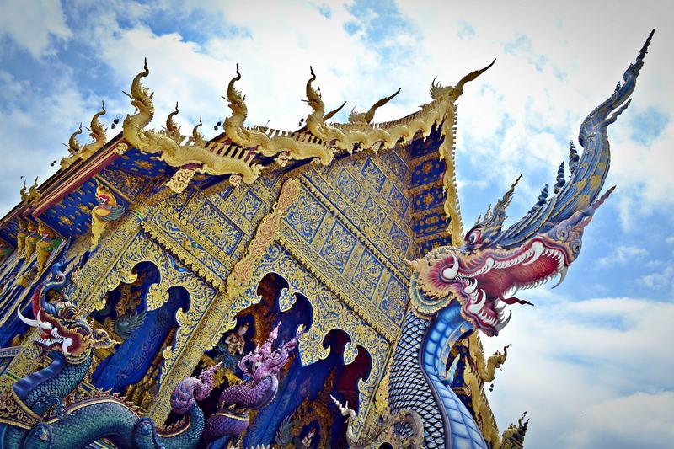
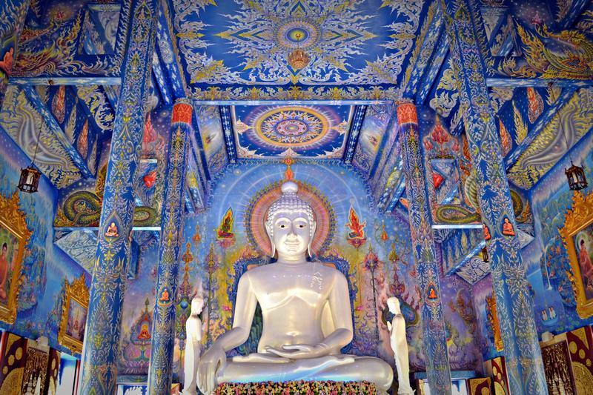
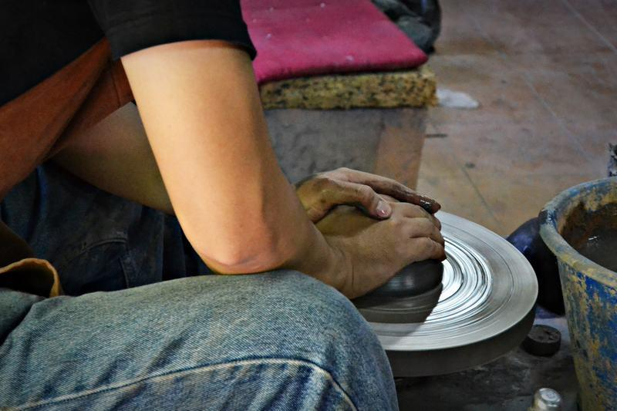
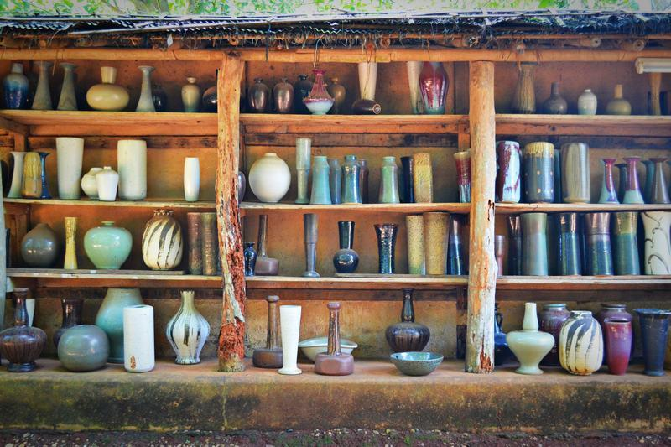
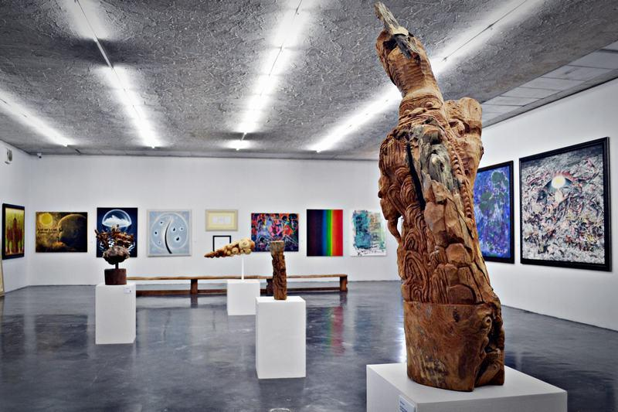
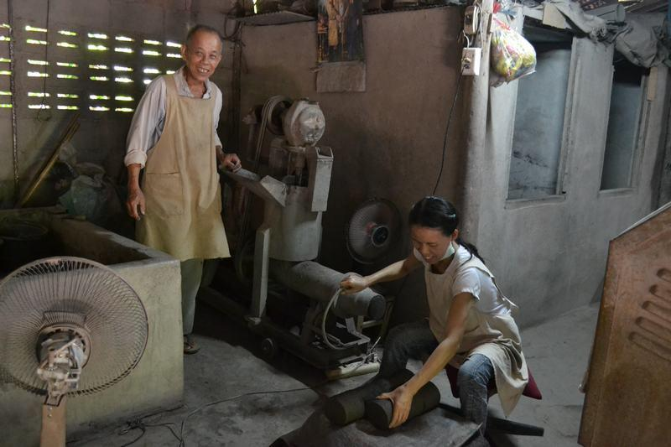

Easia Travel Head Office

Vietnam Head OfficeC/o: ATS Hotel, Suite 326 &327, 33B Pham Ngu Lao Street, Hanoi, VietnamTel: +84 24-39 33 13 62www.easia-travel.com

