LAOS – Luang Prabang – A Street Food Dinner at Night Market
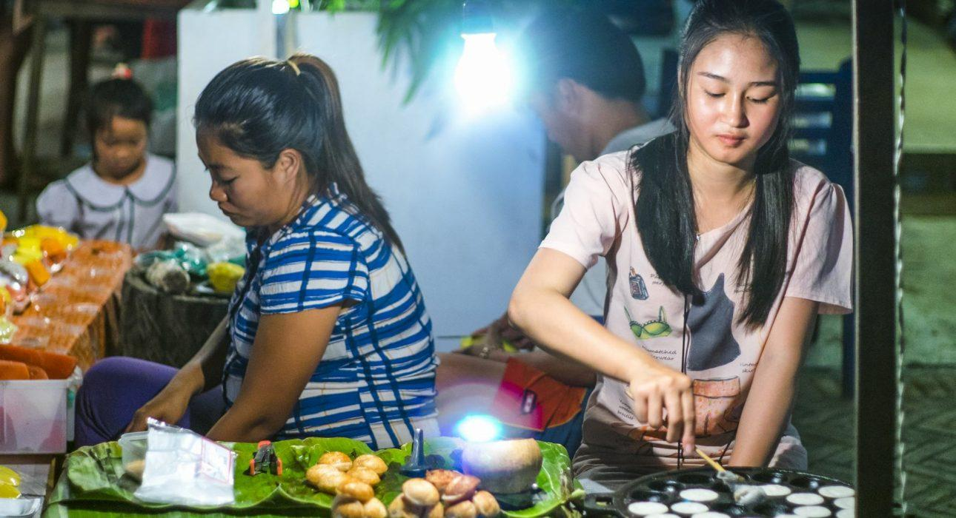

Over View

Theme
Art & Culture, Classic, Gastronomy

Country - City
Laos - Luang Prabang

Market segment
Groups, Thematic Leisure

Price Level
$$

Max pax
40 (possible to extend for specific requests)

Seasonality
All year round

Arrival city
Luang Prabang

Departure city
Luang Prabang

Description

The Night Bazaar in Luang Prabang is very popular for handmade handicrafts from the ethnic minorities. The surrounding streets are also the perfect place to try some local Laotian food and wander through the several different food stalls set up along narrow alleys to take a pick of the typical dishes and sample some of the best food Laos has to offer.

Can be combined with
Incentive
- Luang Prabang – Petanque game with locals

Selling points

- To have an opportunity to ‘’live like a local’’ and to try the typical local food
- An alternative to a classic dinner at restaurant immersing the travelers in the atmosphere of a Laotian market
- Ideal to conclude a day of activity with a ‘wow’ moment

Time And Transportation

From | To | Km | By | Duration | Road condition
Night market | Street food area | 0,1 | Walking | 1 minute | Good

Photos

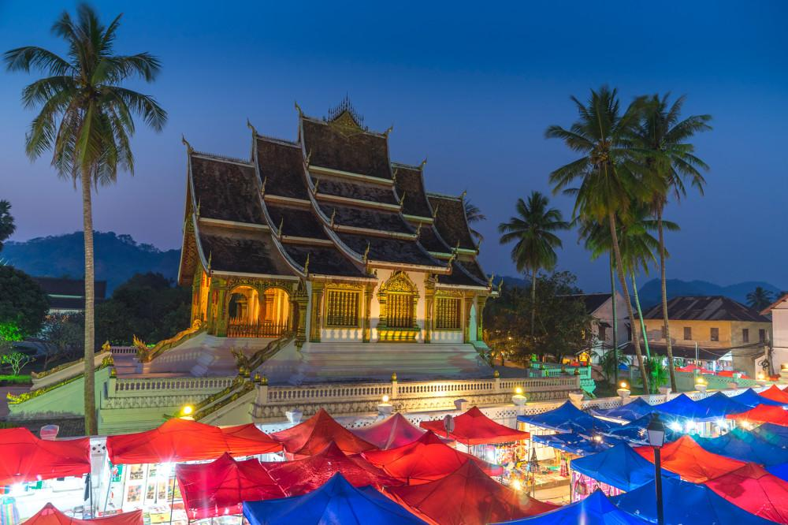
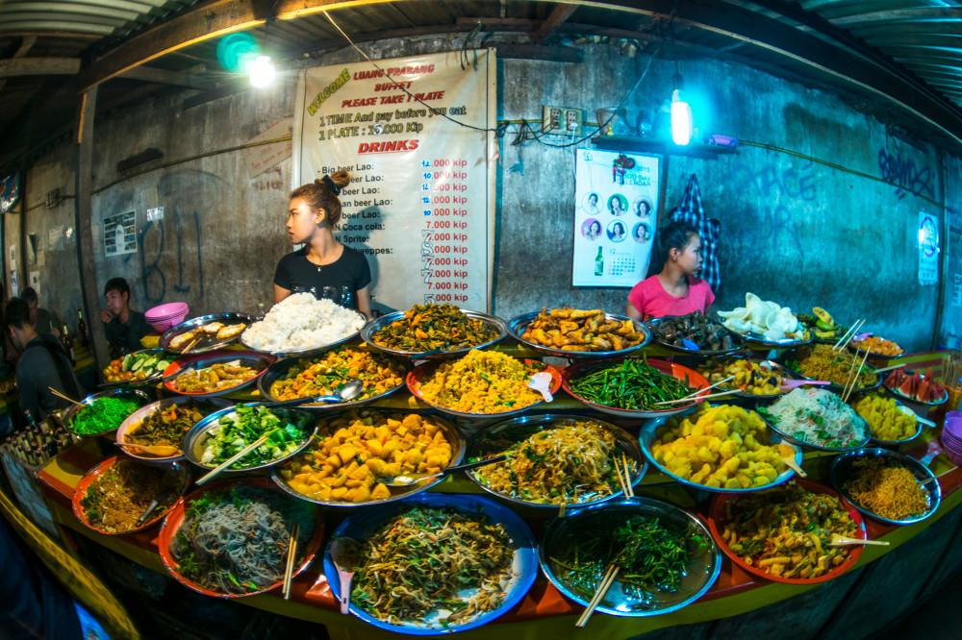
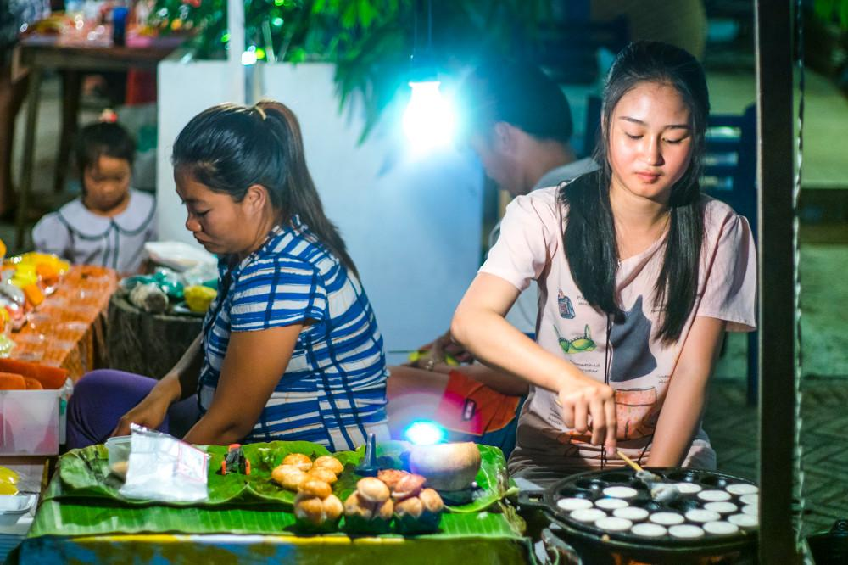
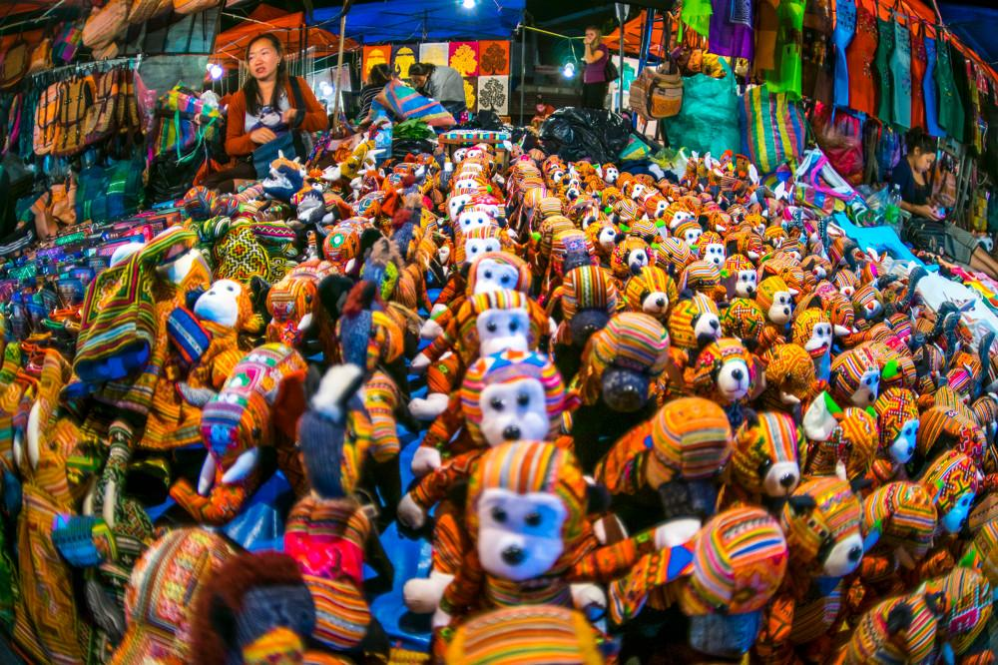
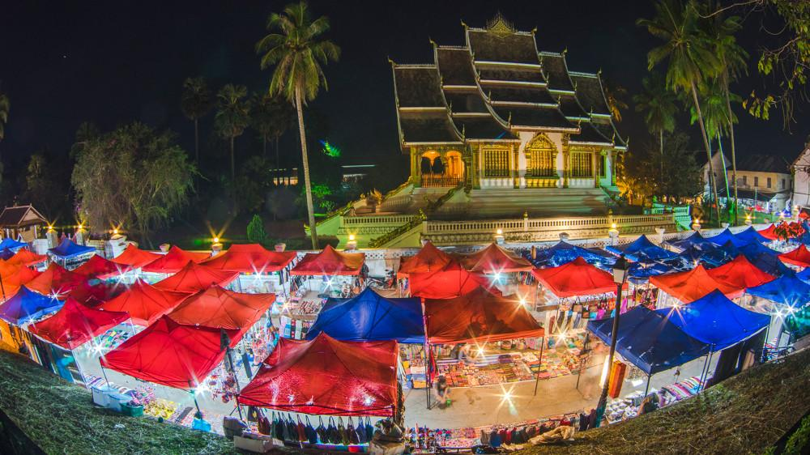

Easia Travel Head Office

Vietnam Head OfficeC/o: ATS Hotel, Suite 326 &327, 33B Pham Ngu Lao Street, Hanoi, VietnamTel: +84 24-39 33 13 62www.easia-travel.com

