MYANMAR – Bagan – Visit to Taungbi Library
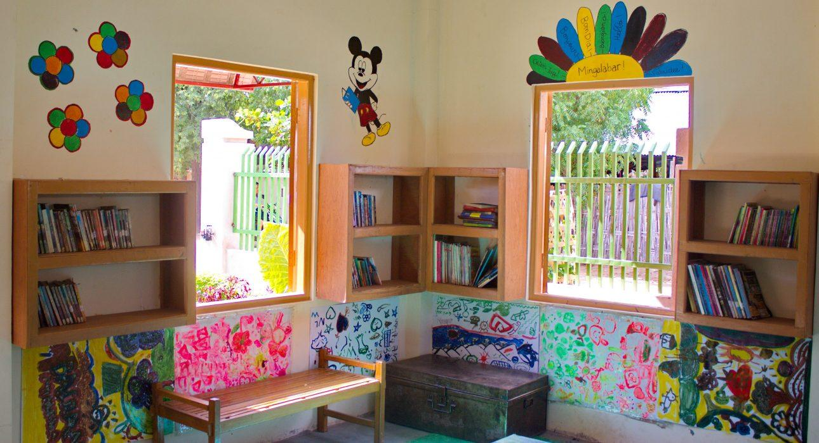

Over View

Theme
Family, Sustainable

Country - City
Myanmar - Bagan

Market segment
Groups, Thematic Leisure

Price Level
$

Max pax
50 persons

Seasonality
All Year

Arrival city
Bagan

Departure city
Yangon

Description

Taungbi Library welcomes children and adults from Taungbi village – nestled among the temples in Bagan – everyday in the afternoon from Wednesday to Sunday. This community project, created by Easia in 2016 in partnership with many sponsors, offers free and unlimited access to books and educational material for the villagers, as well as a safe space for children to read, learn, and play after school. This visit will follow the guidelines of ChildSafe to ensure the best outcomes of such visits for the children of the village.

Can be combined with
Thematic Leisure
Bagan – Discover Bagan by BikeBagan – Discover the art of Sand paintingBagan – Food Donation to the Monks

Selling points

- Participate in a small-scale project that promotes education in a village in the heart of Bagan archeological plain
- Walk around the village, meet families and discover the library where many children come after school to read, learn and play in a safe space
- A short visit which will add another dimension to your sightseeing around Bagan

Time And Transportation

From | To | Distance | By | Duration | Road condition
Old Bagan | Taung Bi village | 1.5 km | Car | 5 minutes | Good
Nyaung Oo | Taung Bi village | 9 km | Car | 25 minutes | Good
New Bagan | Taung Bi village | 6.5 km | Car | 20 minutes | Good

Photos

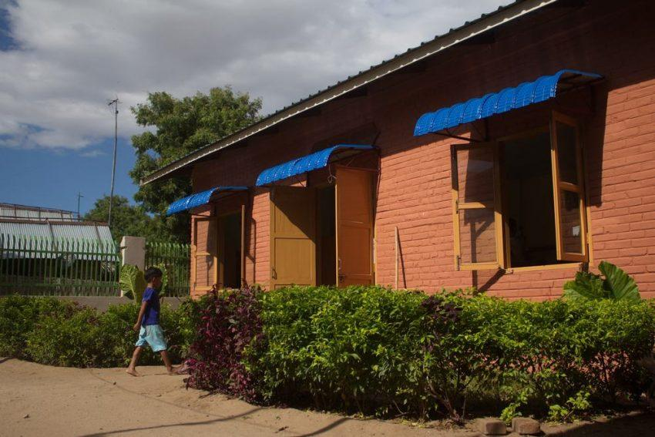
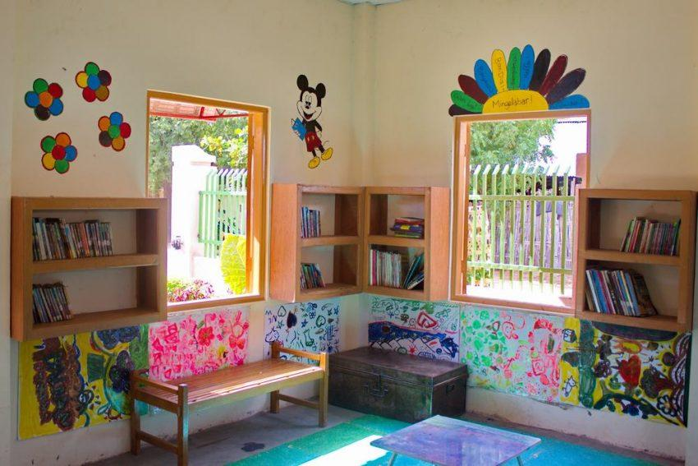
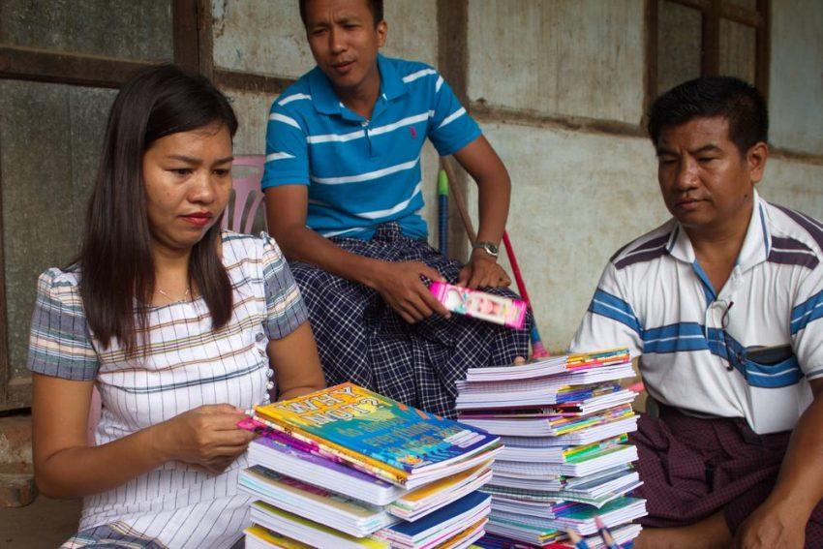
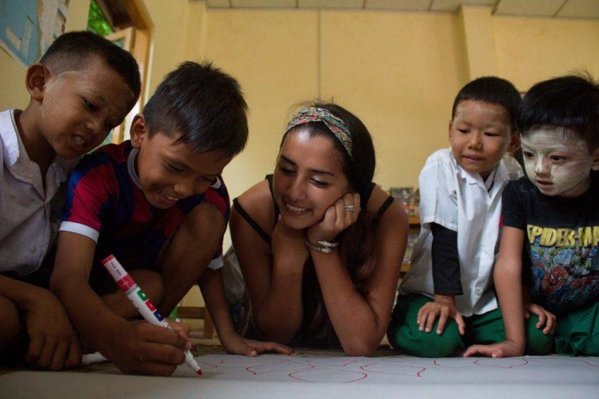
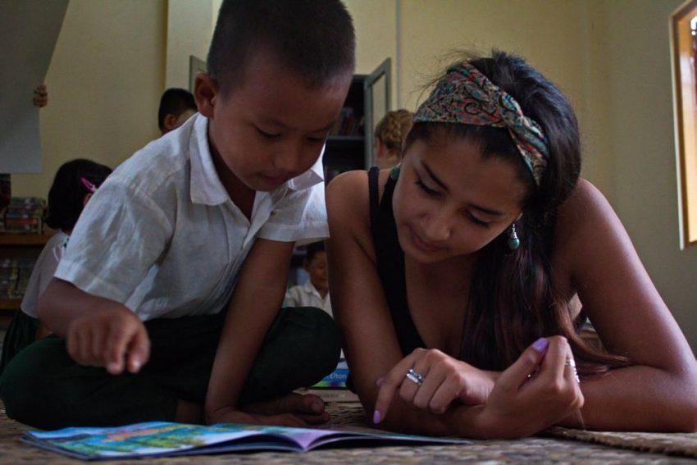
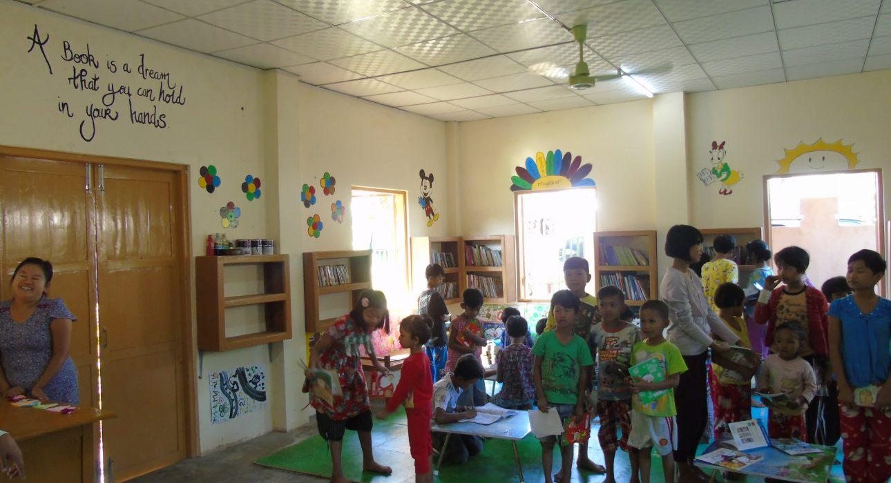

Easia Travel Head Office

Vietnam Head OfficeC/o: ATS Hotel, Suite 326 &327, 33B Pham Ngu Lao Street, Hanoi, VietnamTel: +84 24-39 33 13 62www.easia-travel.com

