LAOS – Champasak – Cycling Tour: Historical and Cultural Trails
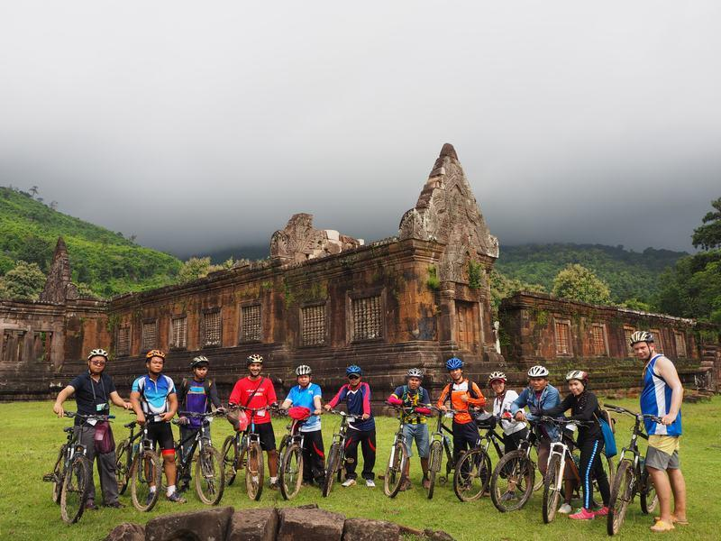

Over View

Theme
Art & Culture, Family, Sustainable

Country - City
Laos - Champasak

Market segment
Groups

Price Level
$$$$

Level of difficulties
LEVEL 1

Max pax
15

Seasonality
October to June

Arrival city
Champasak

Departure city
Champasak

Description

A full day cycling tour to explore the historical town of Champasak and its surroundings. Winding along dirt trails through traditional villages and natural settings, the tour leads to the UNESCO world heritage complex of Vat Phu, the must-to-see temple in southern Laos. The ride continues to Vat Muang Kang, the oldest temple in Champasak, and a short boat crossing to the island of Don Daeng to discover the natural richness of the landscapes, as well as the farming and fishing communities that live there.

Selling points

- A 35 kilometer ride for people who are in good physical condition and practice sport occasionally (4 to 5 hours cycling).
- A cycling tour combining historical sites and relaxing biking along a Mekong River island.
- An amazing tour to meet villagers and to discover the colors of Southern Laos.

Sustainability

Level Of The Excursion
Medium – This activity offers tangible positive contributions to the local community, culture and/or environment

The Impact Of This Excursion

Social/cultural Impact
Cultural Conservation

Economic Impact
Local individual benefits, Community benefits

Time And Transportation

From | To | Km | By | Duration | Road condition
Pakse | Don Daeng | 40 | Car | 1 hour | Good

Photos

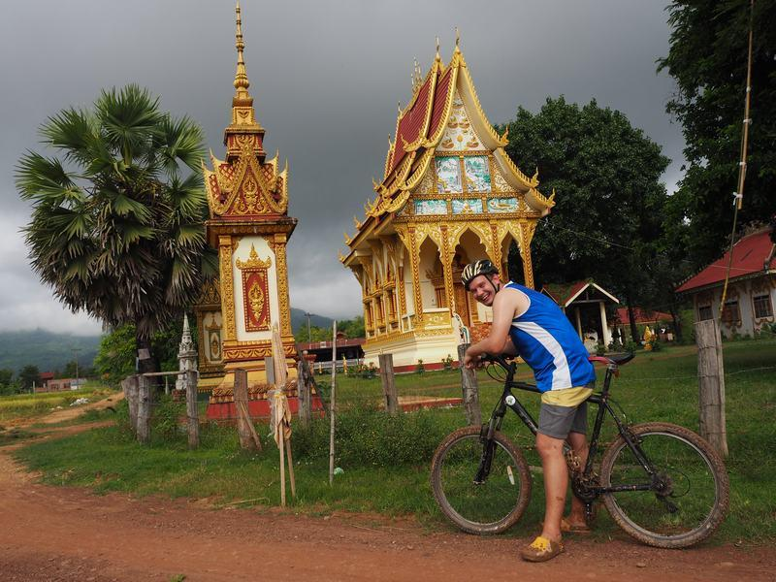

Easia Travel Head Office

Vietnam Head OfficeC/o: ATS Hotel, Suite 326 &327, 33B Pham Ngu Lao Street, Hanoi, VietnamTel: +84 24-39 33 13 62www.easia-travel.com

