THAILAND – Bangkok – Walking Along the Dragon’s Backbone
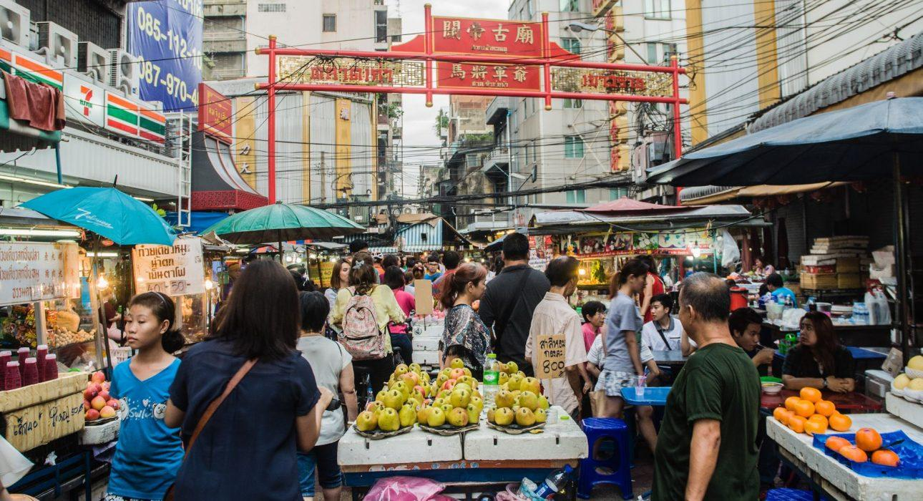

Over View

Theme
Art & Culture, Classic, Family, Honeymoon

Country - City
Thailand - Bangkok

Market segment
Groups, Thematic Leisure

Price Level
$$

Max pax
35

Seasonality
All Year Round

Arrival city
Bangkok

Departure city
Bangkok

Description

Walking along the dragon’s backbone – Bangkok’s Chinatown while discovering remarkable landmarks such as the biggest Golden Buddha in the world, Odeon Circle and the Street of Gold as well as other lesser known but none-the-less captivating places: a mosque and its peaceful graveyard, a temple and it’s ironic location where illegal gamblers pray, the prostitution temple and a temple where they can donate coffins for the poor. This walking tour is a great opportunity to see street vendors that have been operating for generations, smell the fresh food market and its plethora of exotic produce, visit some of the oldest shops in Bangkok and learn about the local community and its fascinating Chinese traditions.

Selling points

- A must-do for people who like lively neighborhoods and bustling places
- Another way to learn about the culture off the beaten paths
- An opportunity to try food that is not available elsewhere (Thai and Chinese)
- A great spot to learn what to ask for and how to order

Time And Transportation

From | To | Km | By | Duration | Road condition
Ratchawong Pier | Peiing Public School | 0,5 | Walking | 5 minutes | Good
MRT Hua Lamphong | Wat Traimit | 0,5 | Walking | 6 minutes | Good

Photos

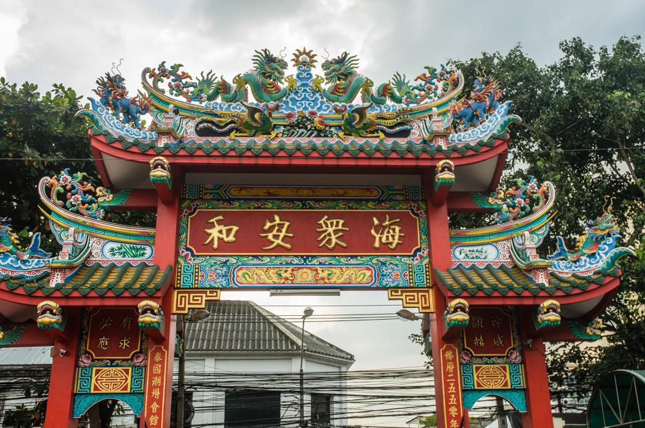
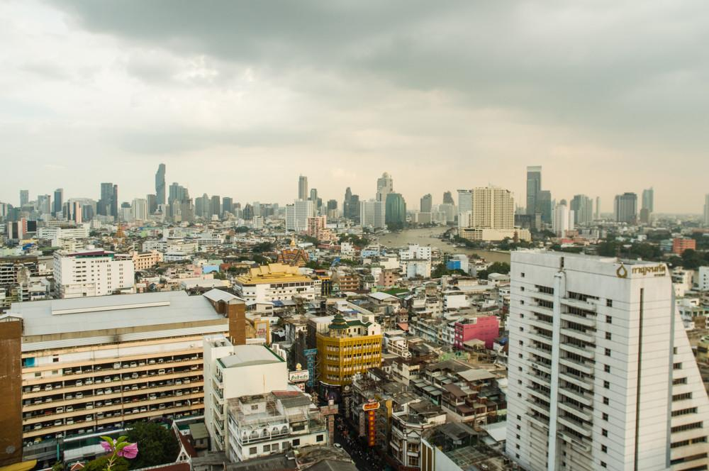
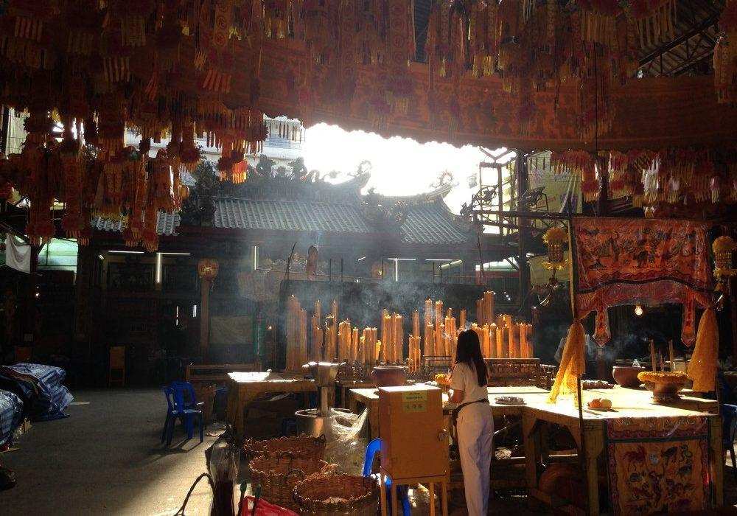
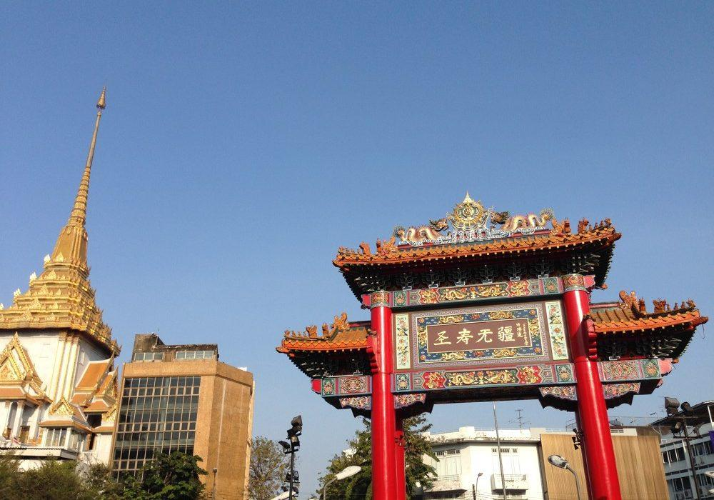
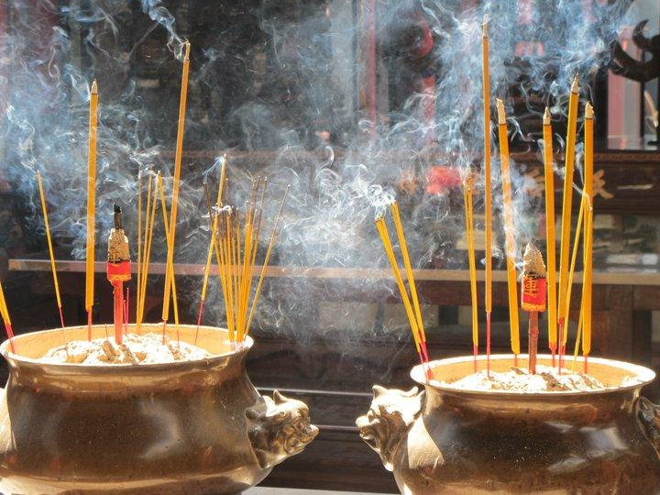
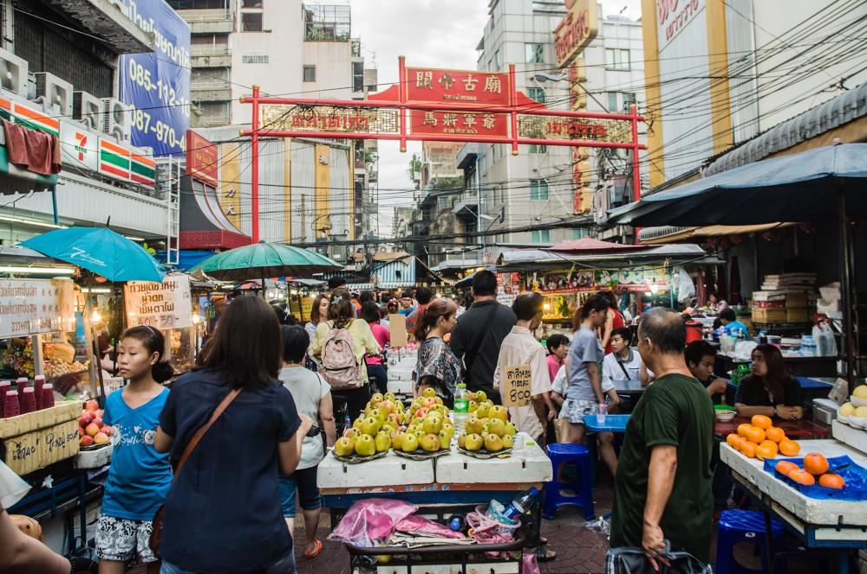

Easia Travel Head Office

Vietnam Head OfficeC/o: ATS Hotel, Suite 326 &327, 33B Pham Ngu Lao Street, Hanoi, VietnamTel: +84 24-39 33 13 62www.easia-travel.com

