THAILAND – Phitsanulok – Explore Phitsanulok Under the Moonlight by Local Transport
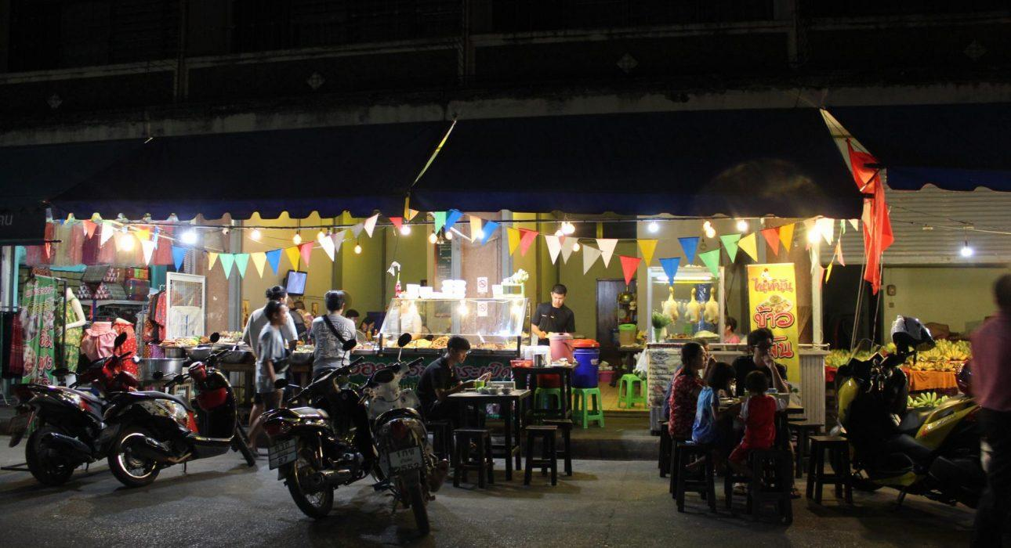

Over View

Theme
Art & Culture, Classic, Family, Gastronomy

Country - City
Thailand - Phitsanulok

Market segment
Groups, Thematic Leisure

Price Level
$$

Max pax
75

Seasonality
All Year Round

Arrival city
Phitsanulok

Departure city
Phitsanulok

Description

Phitsanulok was once an important outpost of the Ayutthaya Empire, today it is a provincial town that is mainly used as a stopover on the way to the north. However, for people who take the time to explore this local town, Phitsanulok has some interesting surprises to offer: lively evening markets with local delicacies, restaurants with “flying vegetables” and cozy floating riverside restaurants. All can be easily explored by a variety of local means of transportation like bicycle rickshaw,or a big local truck for larger groups.

Selling points

- A great way to explore a typical Thai town, try some exotic foods and enjoy a delicious dinner in a local restaurant.
- Use of traditional transportation: samlor (trishaw), or local truck
- Interactive experiences along the way like insect tasting and “flying vegetables”

Sustainability

Level Of The Excursion
Medium – This activity offers tangible positive contributions to the local community, culture and/or environment

The Impact Of This Excursion

Social/cultural Impact
Cultural Conservation, Empowerment and education

Environment Impact
Transportation

Economic Impact
Local individual benefits, Community benefits

Additional Information

Positive impacts
During the activity, guests use a local means of transportation to explore the town. The various stops along the way help to support individuals as well as the community as a whole

Negative impacts
For groups the means of transportation is motorized resulting in emission of Co².

Time And Transportation

From | To | Km | By | Duration | Road condition
Starting point | local restaurant | 6 km | local transport | 30min | Good, but sometimes crowded

Photos

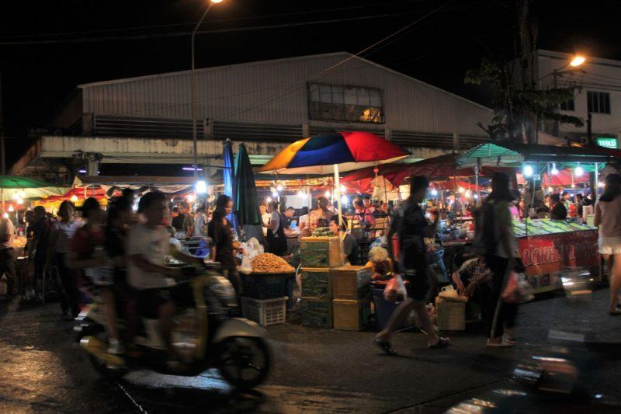
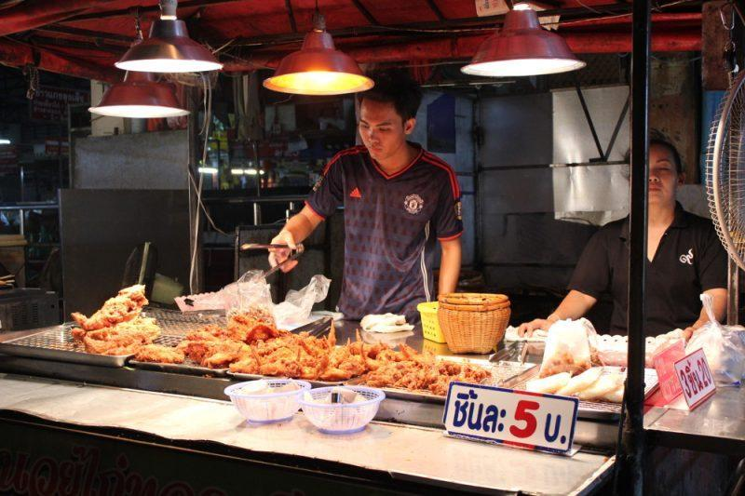
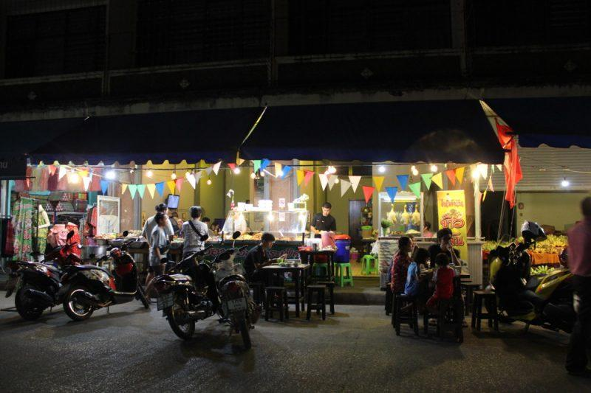
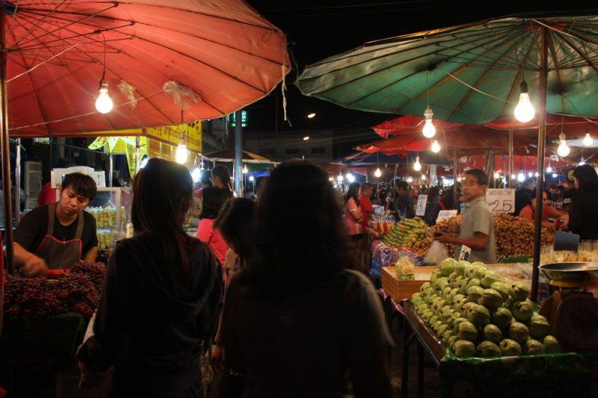
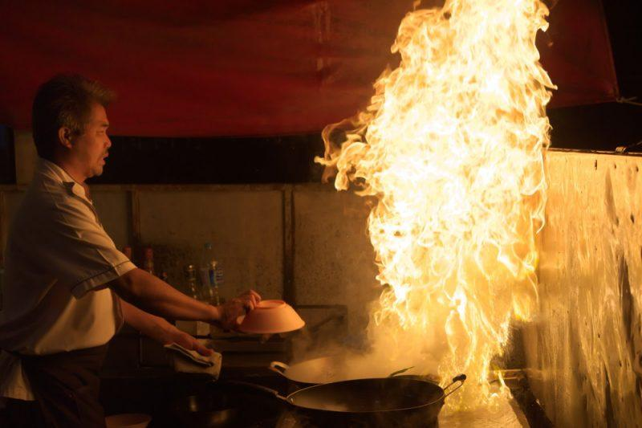
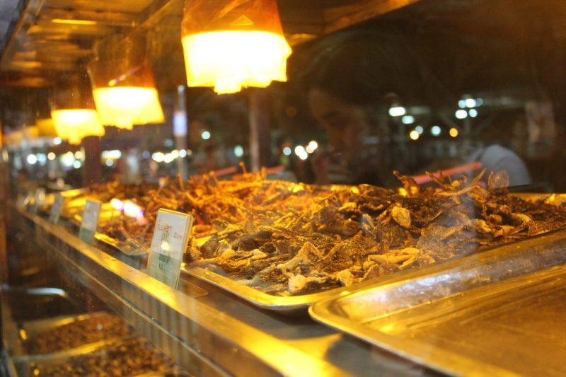

Easia Travel Head Office

Vietnam Head OfficeC/o: ATS Hotel, Suite 326 &327, 33B Pham Ngu Lao Street, Hanoi, VietnamTel: +84 24-39 33 13 62www.easia-travel.com

