THAILAND – Phrae – Cycling Tour with Local Handicraft Visits
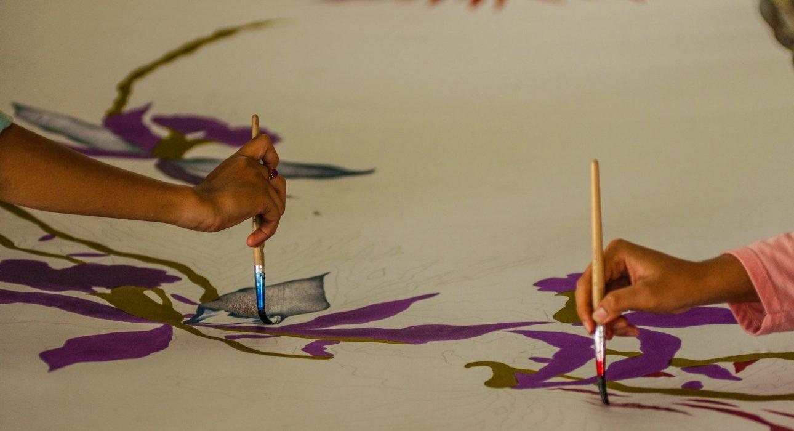

Over View

Theme
Art & Culture, Classic, Family, Honeymoon

Country - City
Thailand

Market segment
Groups, Thematic Leisure

Price Level
$$

Level of difficulties
LEVEL 1

Max pax
30

Seasonality
Possible all year round but subject to weather conditions. Best period is November until February.

Arrival city
Phrae

Departure city
Phrae

Description

The tour starts with exploring the surroundings of Phrae as well as its historical center. The area has a lot of historical significance and used to be an important trading post for teak wood. Today it is a quiet city with local communities located on the outskirts of town: the perfect place for cycling. During this tour, travelers have the opportunity to see what everyday life in a Thai town looks like while they visit local homes and workshops, where handcrafted products are made (woven hats, handmade bricks, bamboo sticky rice containers, a textile design workshop, blacksmiths, wood carvings, etc.).

Selling points

- An authentic way to experience everyday life in one of Thailand’s less-visited regions
- To escape the busy city area
- To have some peaceful moments with locals
- A surprising and worthy discovery of handcrafted products for curious travelers!
- A nice escape for family with kids over the age of 10

Sustainability

Level Of The Excursion
Medium – This activity offers tangible positive contributions to the local community, culture and/or environment

The Impact Of This Excursion

Social/cultural Impact
Cultural Conservation, Empowerment and education

Environment Impact
Transportation

Economic Impact
Local individual benefits

Additional Information

Positive impact
Guest use a bicycle which is a sustainable means of transportation. Along the way they visit small workshops which encourage locals to continue their traditional crafts

Negative impact
Not all places are committed to reducing waste and single-use plastics

Time And Transportation

From | To | Distance | By | Duration | Road condition
Phoom Thai Garden Hotel | Mae Yom Palace Hotel | 2 kilometers | Car | 5 minutes | Good
Huern Nana Boutique Hotel | Mae Yom Palace Hotel | 2 kilometers | Car | 5 minutes | Good
Mae Yom Palace Hotel | Mo Hom Village | 3,5 kilometers | Car | 5 minutes | Good

Photos

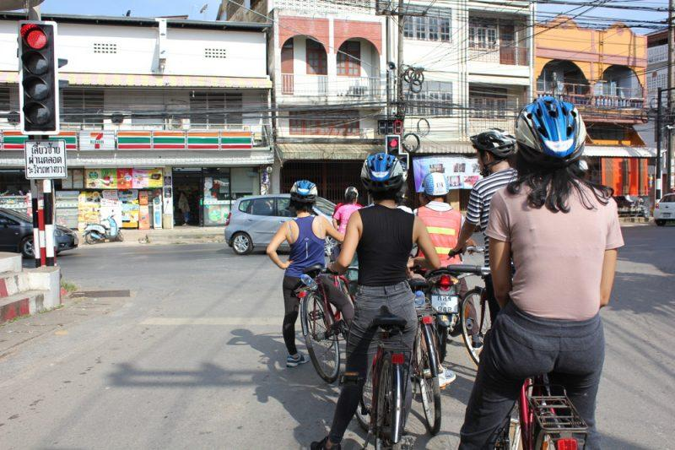
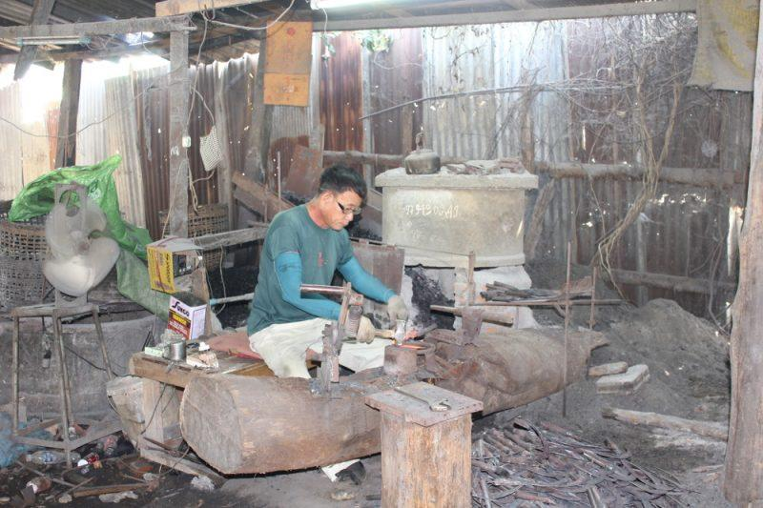
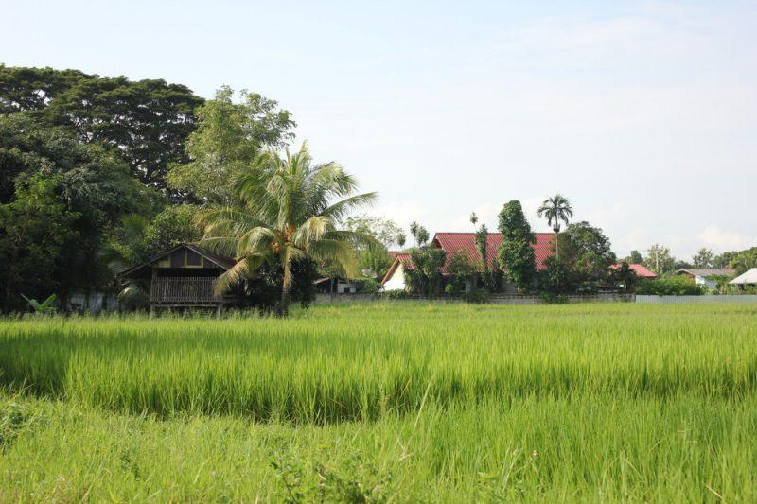
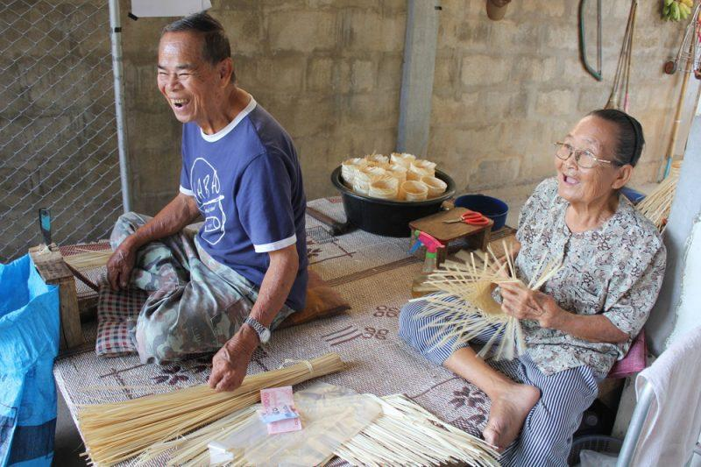
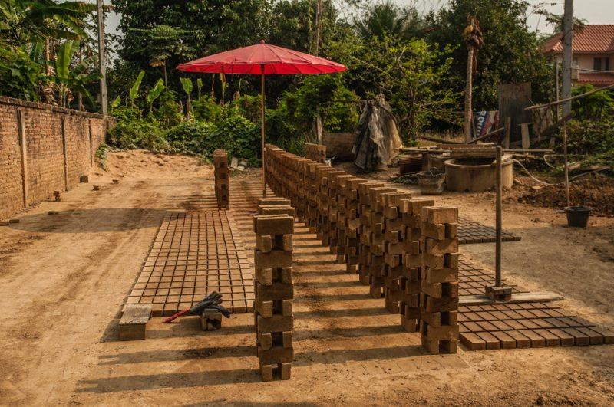
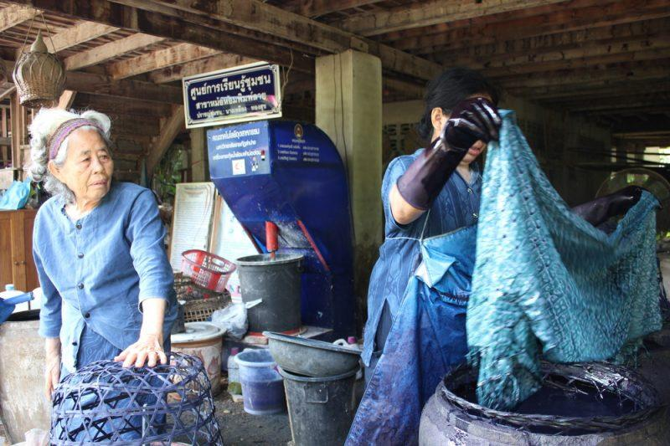

Easia Travel Head Office

Vietnam Head OfficeC/o: ATS Hotel, Suite 326 &327, 33B Pham Ngu Lao Street, Hanoi, VietnamTel: +84 24-39 33 13 62www.easia-travel.com

