THAILAND – Phuket – Bike, Boat and Beach – Koh Yao Noi Explorer
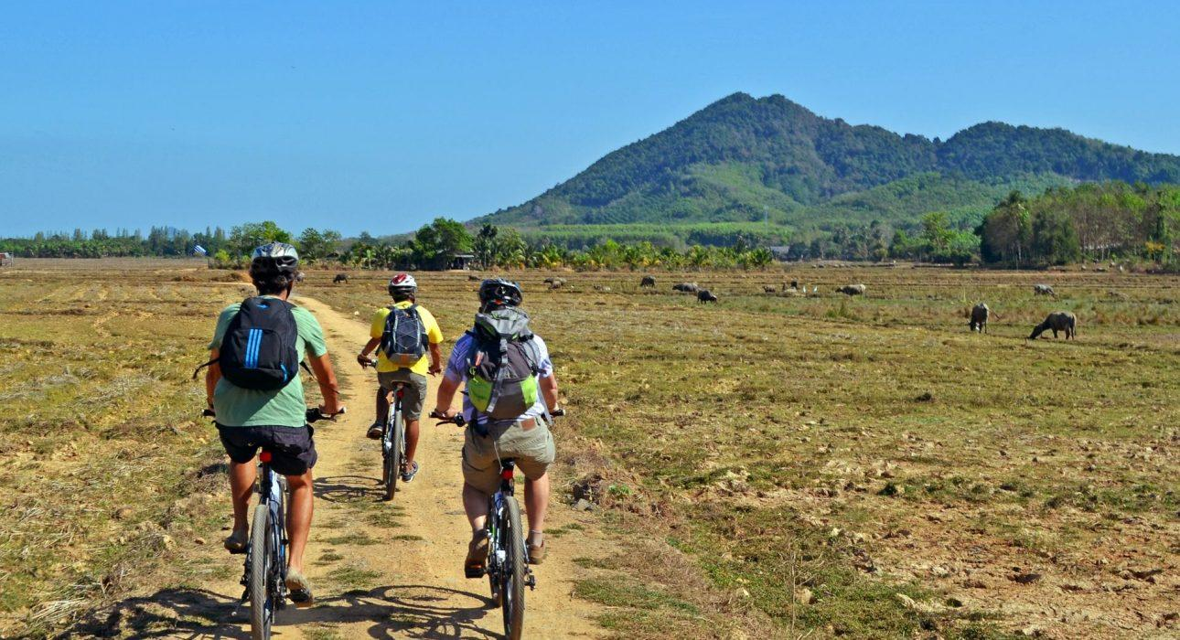

Over View

Theme
Art & Culture, Beach Stay, Classic, Family, Honeymoon

Country - City
Thailand - Phuket

Market segment
Groups, Thematic Leisure

Price Level
$$$$

Level of difficulties
LEVEL 1

Max pax
28

Seasonality
All Year Round

Arrival city
Khao Lak/Kata beach/Patong Beach/Phuket

Departure city
Khao Lak/Kata beach/Patong Beach/Phuket

Description

The tour starts with picking up travelers from their Phuket (or Khao Lak, Koh Yao Noi, Koh Yao Yai) hotel and transferring to the pier to take a boat to Koh Yao Noi. After arriving on the island there is a noticeable contrast between Phuket and this quiet place. After choosing a bicycle the first part of the cycling tour leads along the rural side of the island (on and off-road) past rice paddies, local villages and mangrove forests. Just before lunch, travelers have opportunity to board a local long-tail boat which goes to a remote beach, from here a short walk brings them to the islands’ biggest tree. Continuing the journey by boat to Koh Kudu, a small and uninhabited island, travelers have a picnic lunch on a deserted beach. After spending some time swimming and relaxing in these beautiful surroundings, it is time to return to Koh Yao Noi for some more cycling, this time with some beautiful views of Phang Nga bay in the distance. At the end of the afternoon return to Phuket and then back to the hotel.

Selling points

- A fun and active day out for travellers want to escape the crowds of busy destinations like Phuket and Khao Lak
- To see the local life on one of Thailand’s less developed islands

Sustainability

Level Of The Excursion
Medium – This activity offers tangible positive contributions to the local community, culture and/or environment

The Impact Of This Excursion

Social/cultural Impact
Cultural Conservation, Empowerment and education

Environment Impact
Transportation

Economic Impact
Local individual benefits

Additional Information

Positive impact
During the activity, guests use a local means of transportation to explore the town. The various stops along the way help to support individuals as well as the community as a whole

Negative impact
No negative

Time And Transportation

From | To | Km | By | Duration | Road condition
Kata Beach | Bang Rong Pier | 40 | Car | 1 hour | Good but crowded
Khao Lak | Bang Rong Pier | 90 | Car | 1h 30 min | Good but crowded
Patong Beach | Bang Rong Pier | 35 | Car | 45 minutes | Good but crowded
Phuket Airport | Bang Rong Pier | 17 | Car | 25 minutes | Good but crowded

Photos

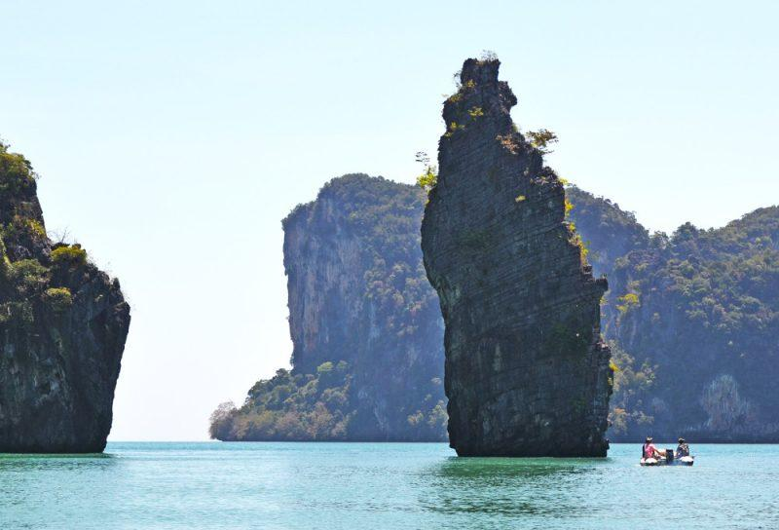
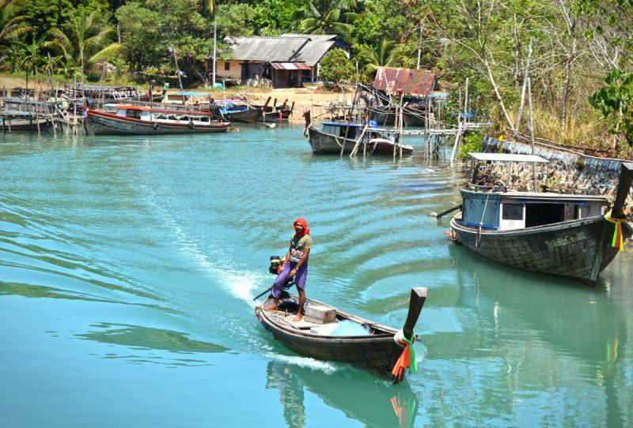
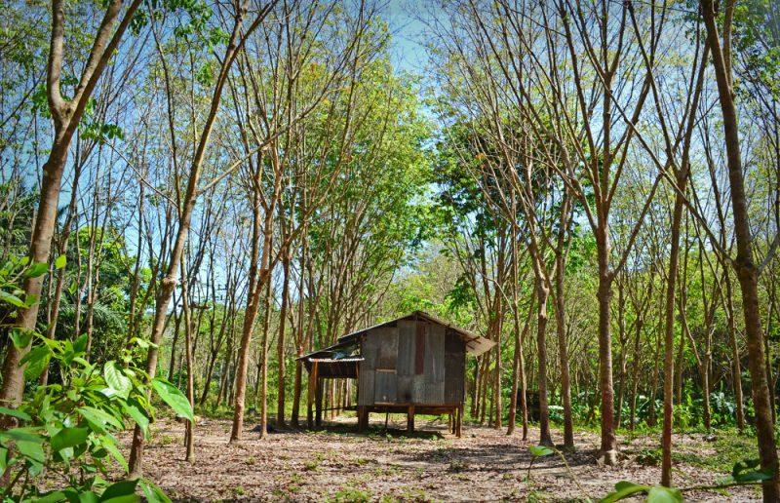
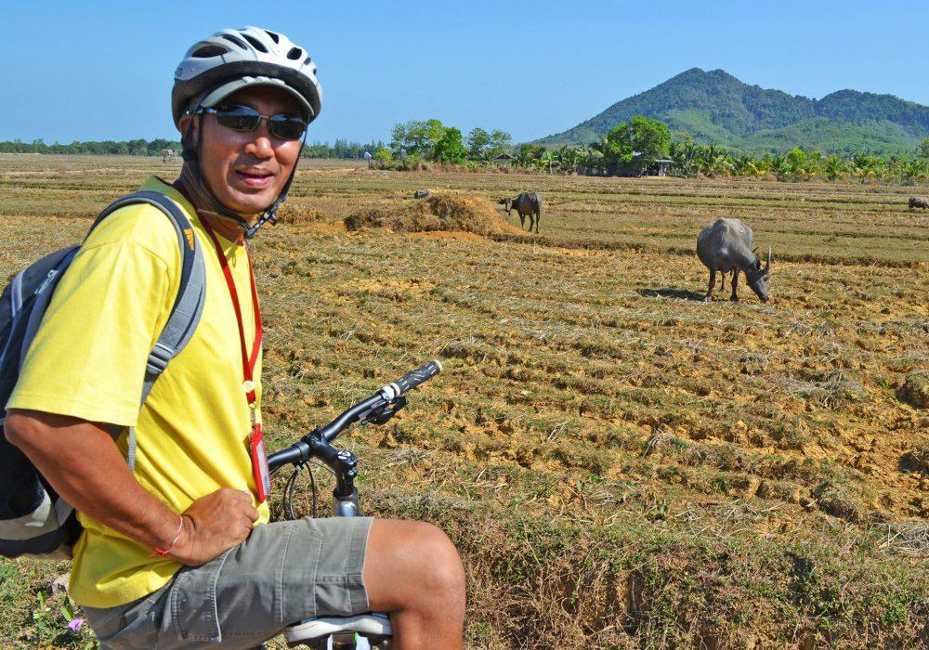
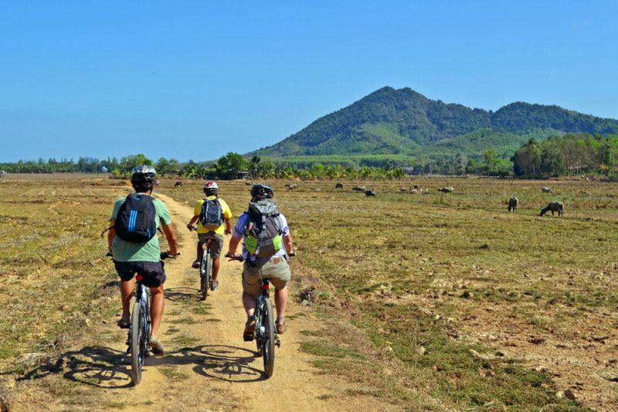
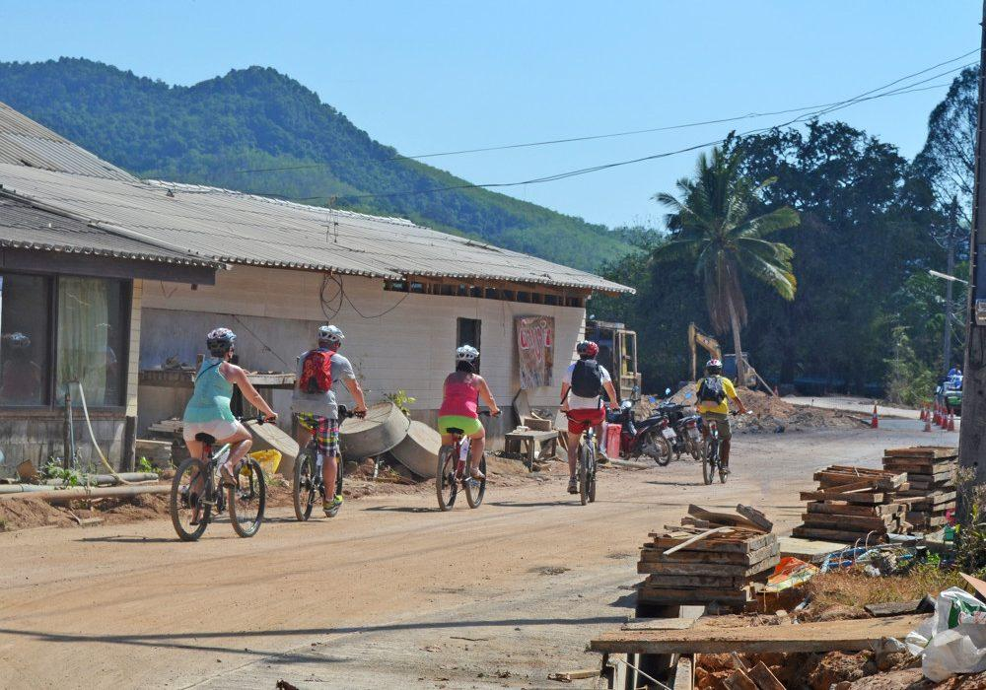

Easia Travel Head Office

Vietnam Head OfficeC/o: ATS Hotel, Suite 326 &327, 33B Pham Ngu Lao Street, Hanoi, VietnamTel: +84 24-39 33 13 62www.easia-travel.com

