THAILAND – Sukhothai – Make Your Own Amulet and Have Lunch at a Local House
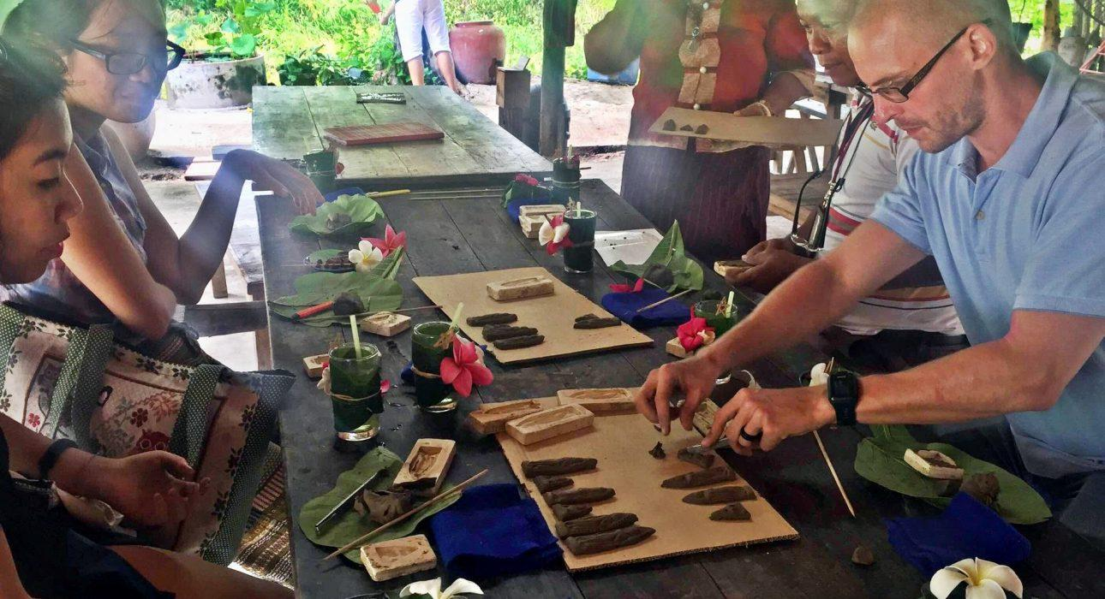

Over View

Theme
Art & Culture, Classic, Gastronomy

Country - City
Thailand - Sukhothai

Market segment
Groups, Thematic Leisure

Price Level
$$

Max pax
40

Seasonality
All year round. Ideally from Nov to Apr

Arrival city
Sukhothai / Phitsanulok

Departure city
Sukhothai / Phitsanulok

Description

Sukhothai has a rich cultural heritage and is considered the cradle of Thai civilization. This activity gives travelers the opportunity to visit the house of a local history expert. The host shares his knowledge about how ancient traditions live on to this very day and showcases his collection of ancient weapons. There is also a chance to get hands-on experience by making their own lucky charm and trying the delicious traditional “Sukhothai noodles” for lunch.

Can be combined with
Thematic Leisure
- A visit to Sukhothai Historical Park (ideally before)

Selling points

- To have private experience at a local house with an enthusiastic man who loves to share his knowledge.
- Perfect for guests who love culture and interaction with locals.

Sustainability

Level Of The Excursion
Medium – This activity offers tangible positive contributions to the local community, culture and/or environment

The Impact Of This Excursion

Social/cultural Impact
Cultural Conservation, Empowerment and education

Economic Impact
Local individual benefits

Additional Information

Positive impact
During the activity, guests learn about ancient traditions and get hands-on experience. The host is a respected member of the community who works hard at promoting and protecting Sukhothai’s heritage.

Negative impact
No negative.

Time And Transportation

From | To | Distance | By | Duration | Roadcondition
Sukhothai Center | Baan Phra Thim (amulet making) | 15 – 20 kilometers | Car | 20 – 30 minutes | Good
Sukhothai Historical Park | Baan Phra Thim (amulet making) | 4 kilometers | Car | 7 – 15 minutes | Good
Sriwilai / Legendha / Tharaburi / Treasure | Baan Phra Thim (amulet making) | 7 – 10 kilometers | Car | 7 – 15 minutes | Good
Sukhothai Heritage | Baan Phra Thim (amulet making | 45 kilometers | Car | 45 minutes | Good
Sri Satchanalai | Baan Phra Thim (amulet making) | 60 kilometers | Car | 1h to 1h 15min | Good
Phitsanuloke | Baan Phra Thim (amulet making) | 75 -90 kilometers | Car | 1h to 1h 30min | Good

Photos

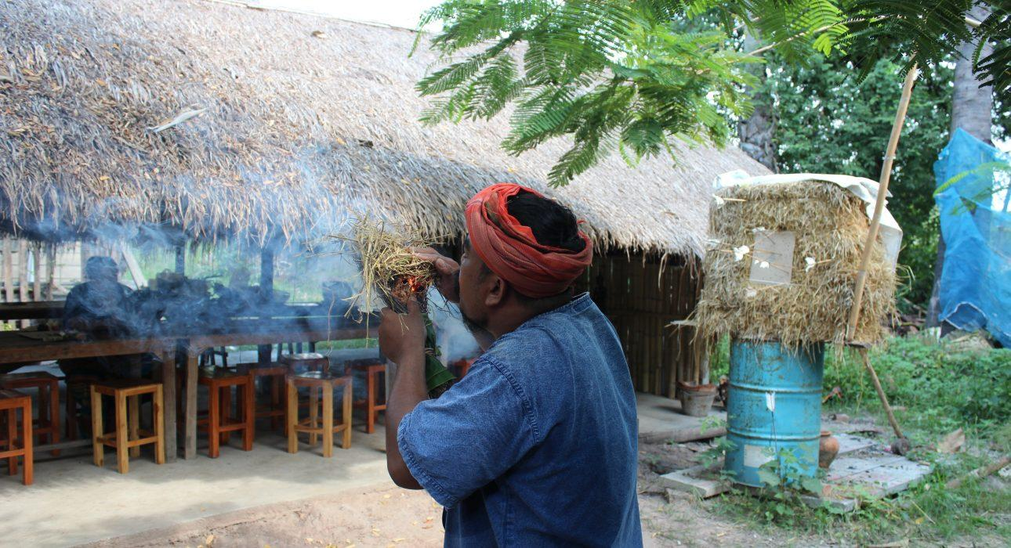
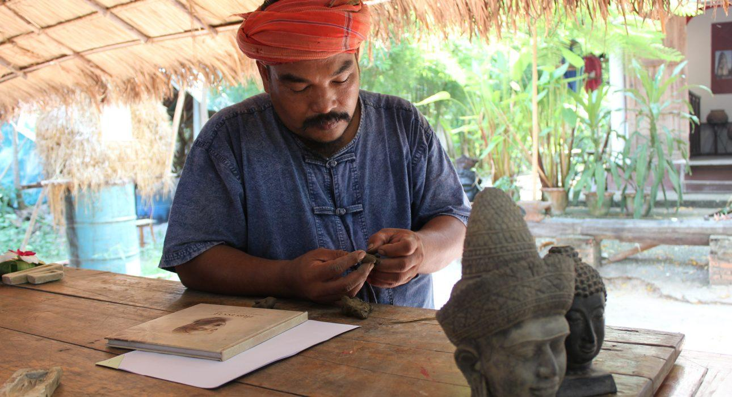
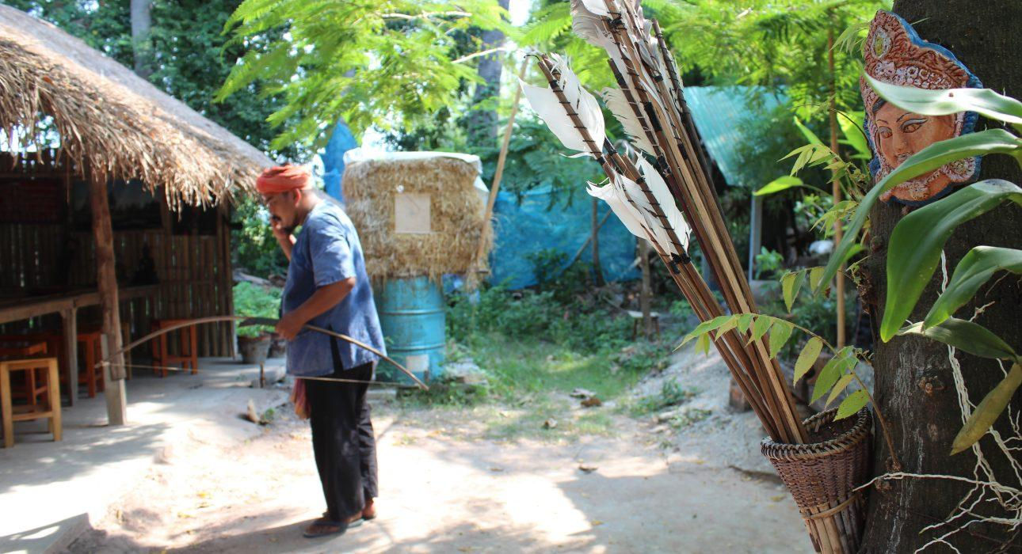
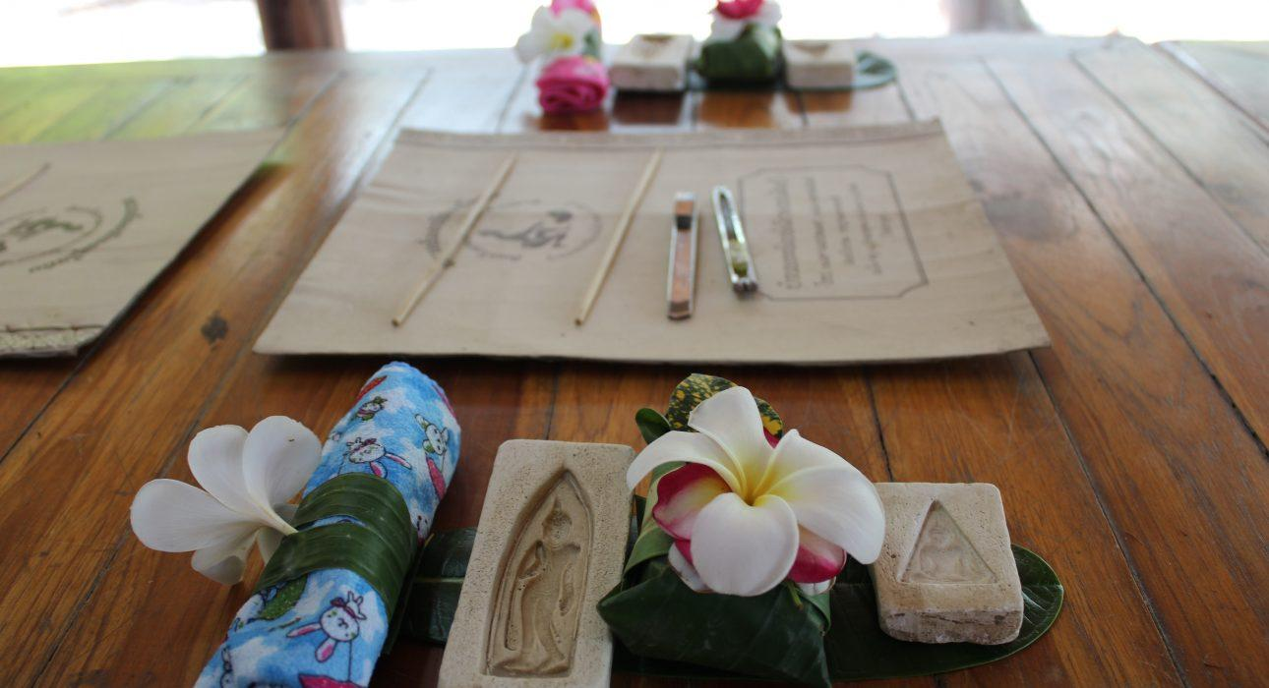
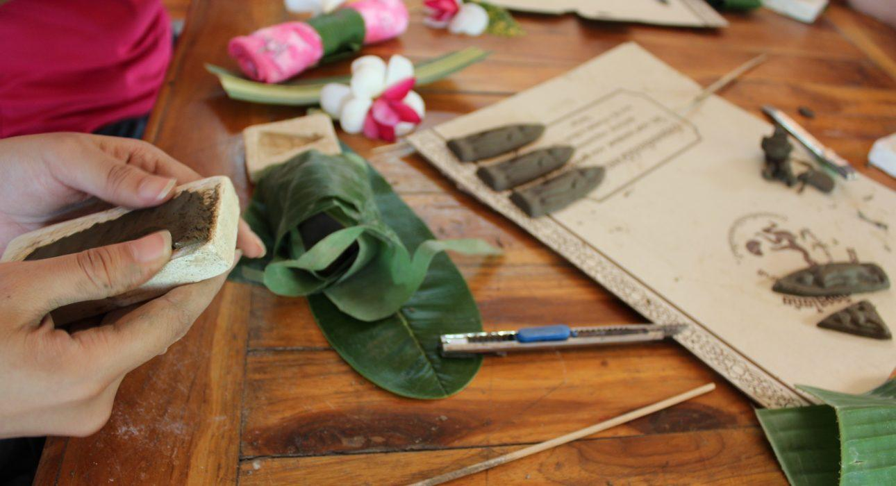
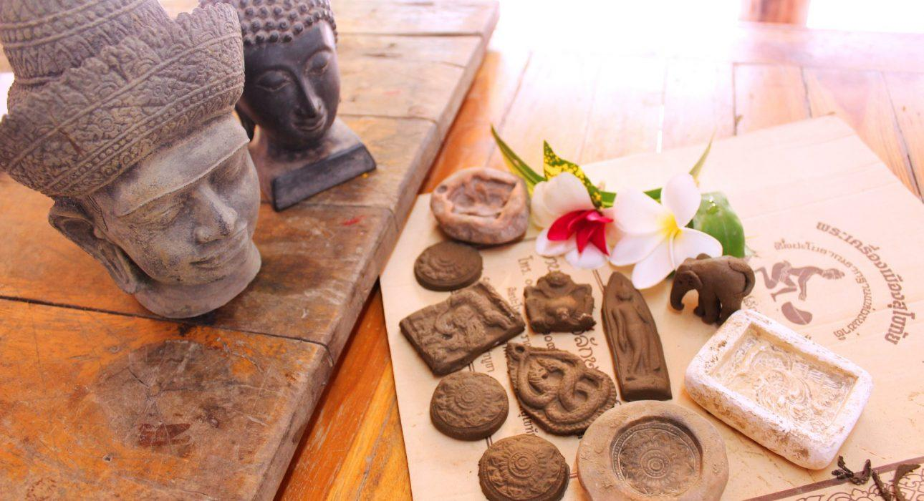

Easia Travel Head Office

Vietnam Head OfficeC/o: ATS Hotel, Suite 326 &327, 33B Pham Ngu Lao Street, Hanoi, VietnamTel: +84 24-39 33 13 62www.easia-travel.com

