THAILAND – Chiang Rai – Nature Walk with Bamboo-Cooked Lunch at Waterfall
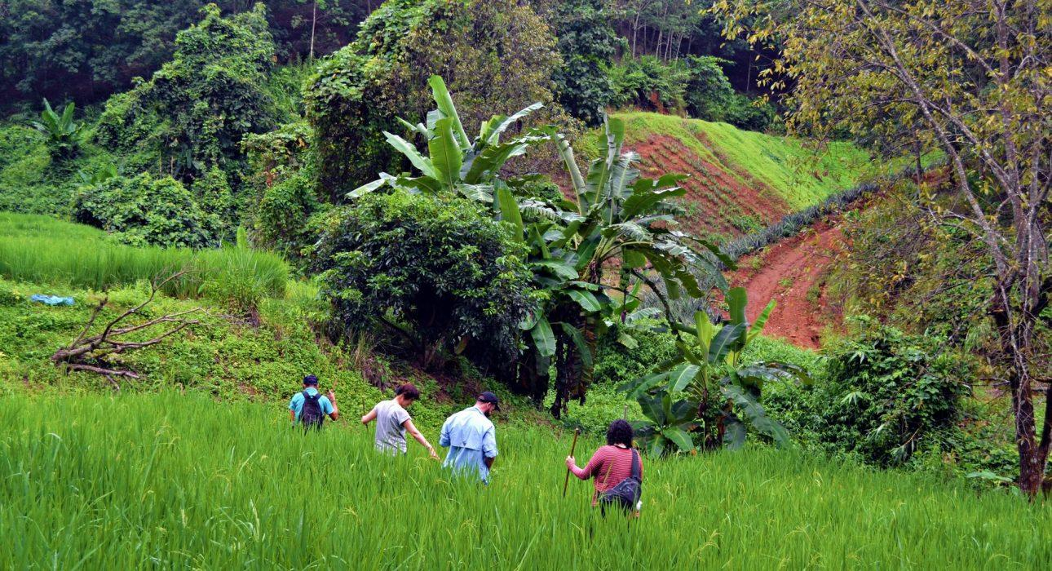

Over View

Theme
Art & Culture, Classic, Gastronomy, Honeymoon

Country - City
Thailand - Chiang Rai

Market segment
Groups, Thematic Leisure

Price Level
$$

Level of difficulties
LEVEL 1

Max pax
15

Seasonality
All Year Round

Arrival city
Chiang Rai

Departure city
Chiang Rai

Description

The activity starts with entering in a little bit more about the culture and customs of this hill tribe minority and then set off on an easy nature walk through the surrounding forests and plantations. Passing rice fields, pineapple trees, and rubber plantations, the local hill tribe guides is a wonderful way to go to a local waterfall where is the perfect stop to enjoy a picnic lunch in beautiful natural surroundings. A delicious lunch over an open fire using nothing but natural materials like bamboo and banana leaves as the utensils is absolutely an unforgettable experience to see how versatile nature can be!Level 1Distance and duration : 4 kilometers – approximately 2 hoursElevation difference: less than 150 meters

Can be combined with
Thematic Leisure
- Chiang Rai – Evening highlights of Chiang Rai by tuk tuk

Selling points

- To provide a different activity far off city for travelers who love nature
- To propose an Ingenious, original cooking method with bamboo
- To experience cook and eat with the sounds of nature
- An Easy hike of 4 kilometers through forests and plantations

Sustainability

Level Of The Excursion
High – This activity strongly supports local communities and/or helps preserve the culture and environment

The Impact Of This Excursion

Social/cultural Impact
Cultural Conservation, Empowerment and education, Involving minorities

Environment Impact
Waste/plastic packaging, Transportation, National parks

Economic Impact
Local individual benefits

Additional Information

Positive impacts
The activity takes places in an area inhabited by minorities and is organized by members of the local community. It creates the opportunity for them to show their traditional way of life and share it with guests, bringing income to the hosts.

Negative impacts
No negative

Sensitive character
The activity involves ethnic minorities who are vulnerable to exploitation and whose culture is at risk of disappearing. The activity is always organized with a local member of the community to make sure the community benefits from the activity and cultural traditions are respected.

Time And Transportation

From | To | Km | By | Duration | Road condition
Baan A-Pha Pattana | Huy Mae Sai Waterfall | 3 | Car | 10 minutes | Not so good (Some parts are in good condition but some are rough)
Chiang Rai city | Baan A-Pha Pattana | 19 | Car | .30 minutes | Good

Photos

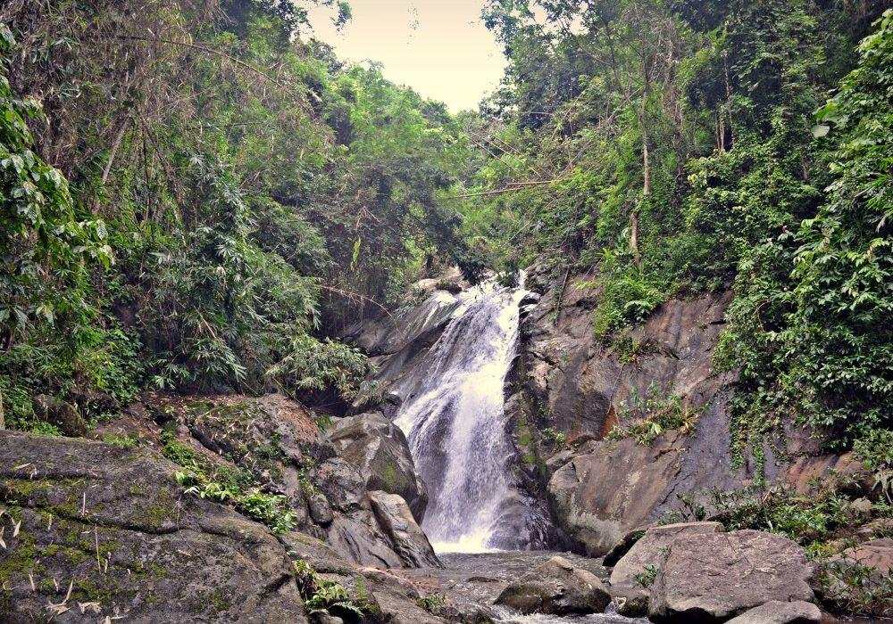
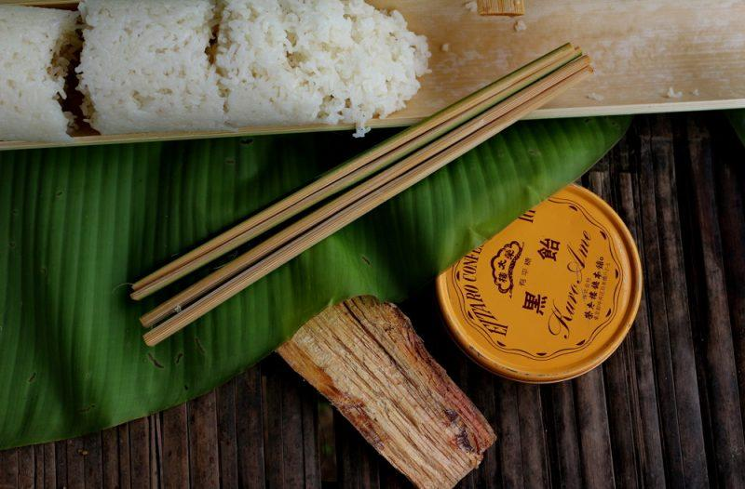
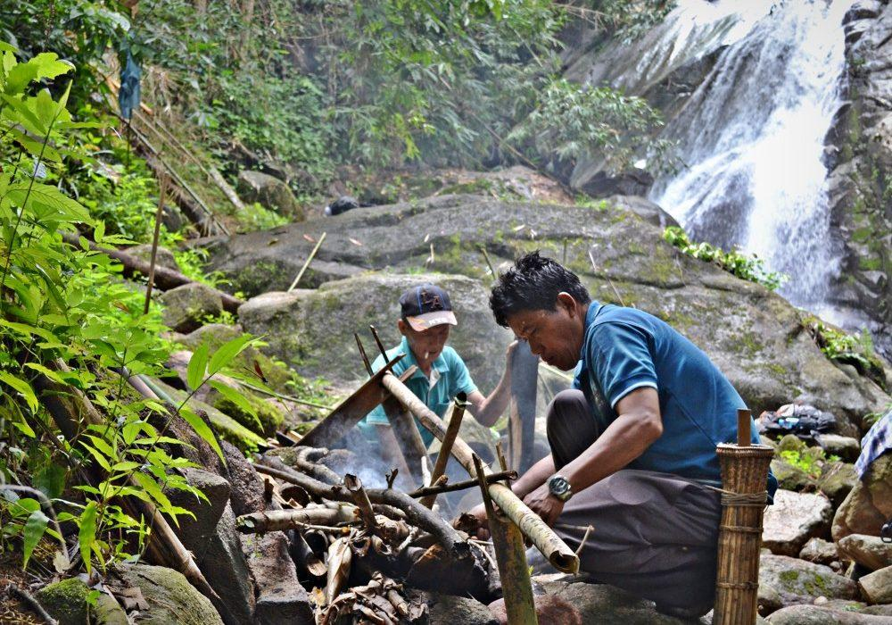
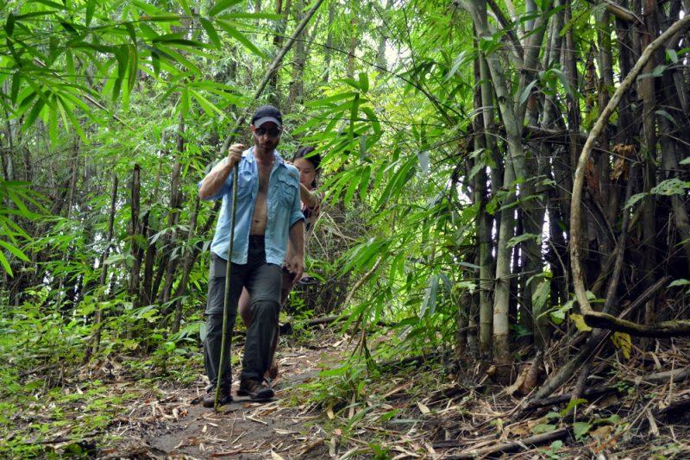
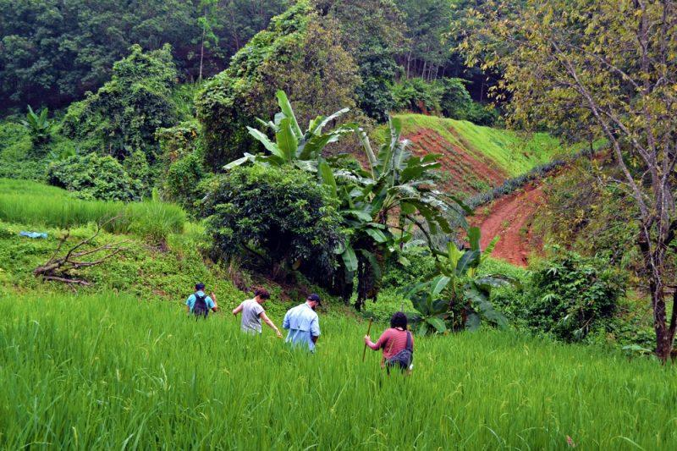
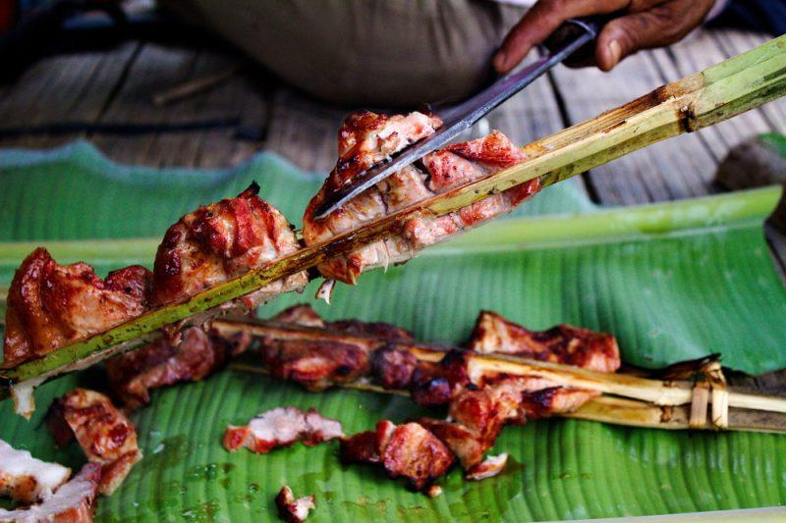

Easia Travel Head Office

Vietnam Head OfficeC/o: ATS Hotel, Suite 326 &327, 33B Pham Ngu Lao Street, Hanoi, VietnamTel: +84 24-39 33 13 62www.easia-travel.com

