THAILAND – Chiang Mai – Chiang Mai from a Different Perspective
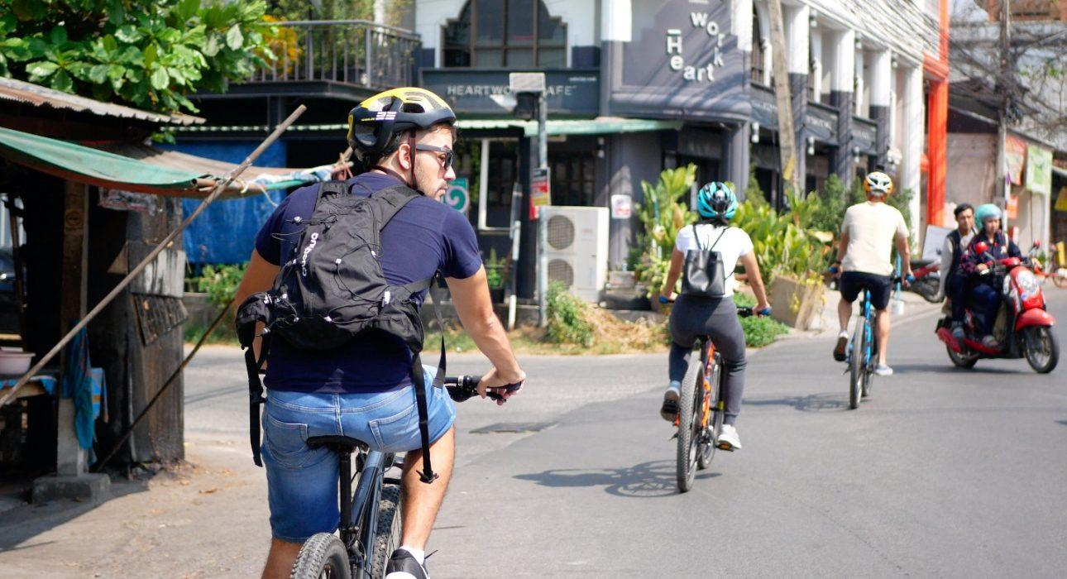

Over View

Theme
Art & Culture, Classic, Honeymoon

Country - City
Thailand - Chiang Mai

Market segment
Thematic Leisure

Price Level
$$$

Level of difficulties
LEVEL 1

Max pax
7

Seasonality
All Year Round

Arrival city
Chiang Mai

Departure city
Chiang Mai

Description

The tour starts with heading away from the busy road and into the Wat Sri Suphan area, known for its silversmiths and the Silver Temple in the South of Chiang Mai Gate, then visiting Thippanet market, famous among locals as the most important trading center for amulets and other religious charms. It is a great opportunity to get along some small alleyways south of the city, pass through one of the least visited areas, where many of the hill-tribe people who come to the city hold high hopes of making good money. This neighborhood provides a stark contrast to the luxury hotels and trendy restaurants found elsewhere in the city. Then travelers takes a chance to cycle along remnants of the city’s ancient wall towards the Muang Mai Market. This open air market is Chiang Mai’s biggest market, spanning several blocks and is busy 24/7. Locals come here to buy fresh produce straight from the farmers, and it’s the perfect spot to observe local life, as well as to refresh oneself with some fresh fruit and coconut water. The final stop is to Thapae Gate and into the historical city center to explore some of the back alleys and visit some of Chiang Mai’s highlights, including Wat Chedi Luang and the Three Kings Monument.

Can be combined with
Thematic Leisure
- Chiang Mai – Half day Pantawan cooking class

Selling points

- A cycling tour through famous sights with interesting and rarely visited areas of Chiang Mai
- Perfect for people who do not have a lot of time but want a genuine perspective and experience of the city
- To discover the diversity of culture, history and local life of Chiang Mai
- For cycling and experienced lovers since some parts of the journey are busy with traffic

Sustainability

Level Of The Excursion
Medium – This activity offers tangible positive contributions to the local community, culture and/or environment

The Impact Of This Excursion

Social/cultural Impact
Cultural Conservation, Empowerment and education

Environment Impact
Transportation

Economic Impact
Local individual benefits, Community benefits

Additional Information

Positive impacts
This activity shows known and unknown areas of Chiang Mai city by using a bicycle as means of transportation. It focuses on culture and crafts as well as some main highlights. Stops along the way bring economic benefits to the visited areas.

Negative impacts
No negative

Time And Transportation

From | To | Km | By | Duration | Road condition
Bike Rental Shop | Doi Suthep Temple | 17,5 | Car | 30 minutes | Good but crowded
Chiang Mai Plaza Hotel | Bike Rental Shop | 1,5 | Car | 5 minutes | Good but crowded
The Park Hotel | Bike Rental Shop | 3 | Car | 10 minutes | Good but crowded

Photos

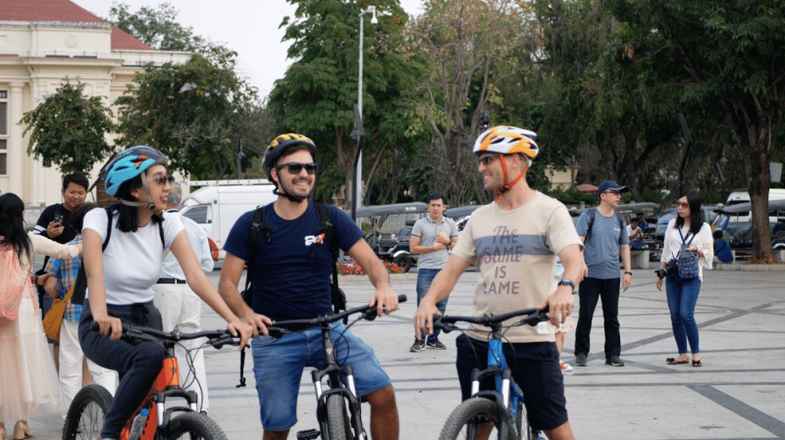
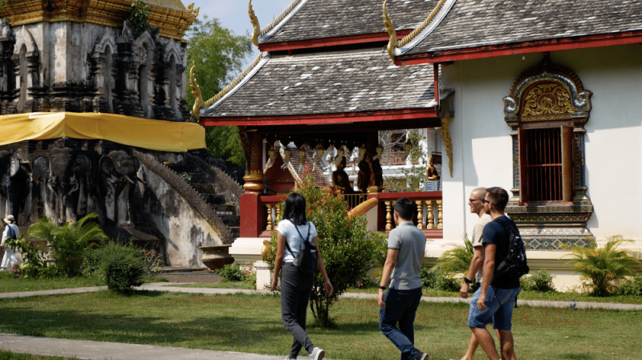
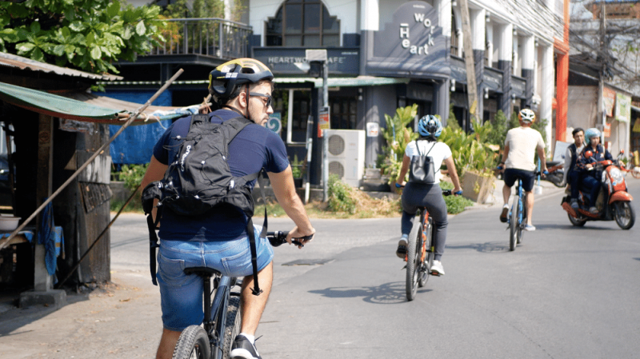
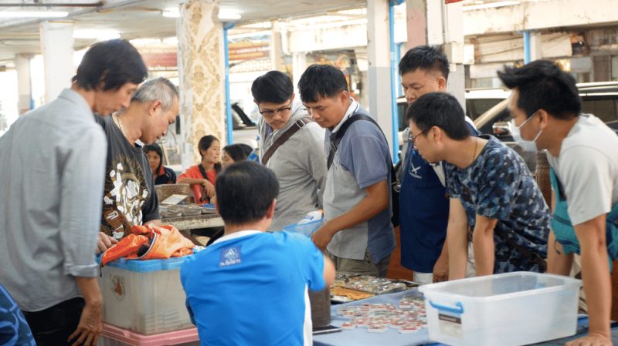
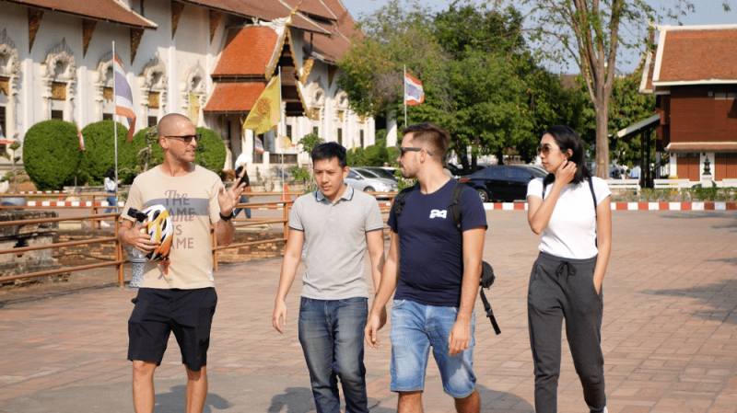
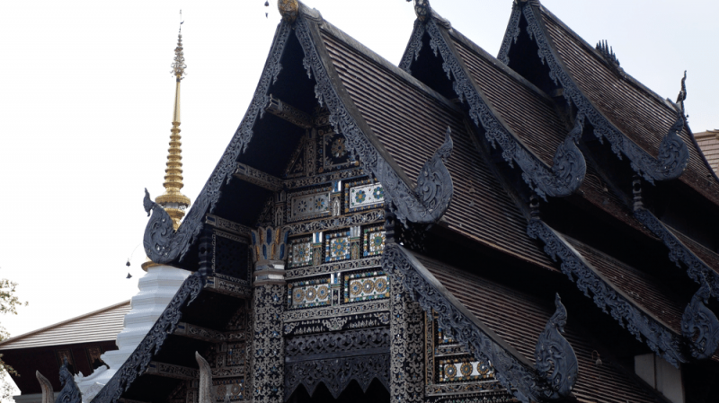

Easia Travel Head Office

Vietnam Head OfficeC/o: ATS Hotel, Suite 326 &327, 33B Pham Ngu Lao Street, Hanoi, VietnamTel: +84 24-39 33 13 62www.easia-travel.com

