CAMBODIA – Siem Reap – Participate in the Local Village Life
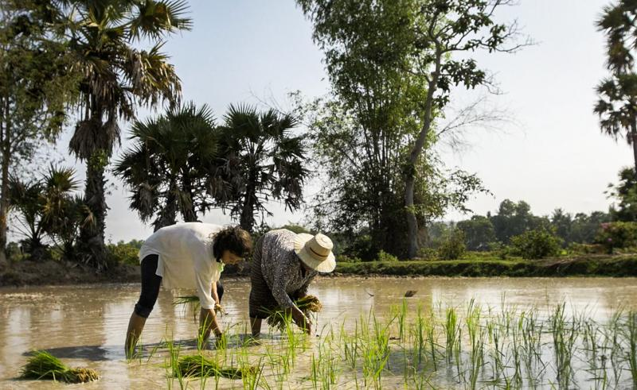

Over View

Theme
Art & Culture, Classic, Family, Gastronomy, Sustainable

Country - City
Cambodia - Siem Reap

Market segment
Groups, Thematic Leisure

Price Level
$$

Max pax
50

Seasonality
All year round but preference for September-February.

Arrival city
Siem Reap

Departure city
Siem Reap

Description

Experience the authentic Cambodian countryside by visiting multiple local farming villages and witness typical local activities in this remarkable country-side experience. Your travelers will have the chance to actively participate in the creation of local products all while engaging and getting up-close with the welcoming villagers and their unique & traditional farming lifestyle.Participants will enjoy making their own traditional breakfast by discovering and helping in the different stages of producing hand-made rice noodles. Once they’ve created their own rice noodles they will have the opportunity to enjoy their breakfast together with the family.Second stop will be to another village that specialises in producing ‘bamboo sticky rice’ as well as harvesting fresh coconuts. Participants will have the chance to take assist in the preparation of these delicious Cambodian snacks while sipping on a fresh coconut.Along the way, travelers will be able to explore various road-side stalls producing regional palm sugar where the local families will be happy to explain more about how they process the typical Cambodian sugar palm in many different ways.The last stop will lead to a village house where the local family operates a small business creating palm leaf handicrafts as a source of income. Participants are invited to join in and make a unique handcrafted item themselves which will be theirs to keep and take home as a very personal souvenir from Cambodia!

Can be combined with
Thematic Leisure
- Siem Reap – “Phare, The Cambodian Circus” Show in Siem Reap
- Siem Reap – Bokator School (Khmer Martial Art)
- Siem Reap – Picnic Lunch in a Secret Temple
Incentive
- Siem Reap – Bokator School (Khmer Martial Art)
- Siem Reap – Sala Bai Restaurant
Groups
- Siem Reap – “Phare, The Cambodian Circus” Show in Siem Reap
- Siem Reap – Bokator School (Khmer Martial Art)
- Siem Reap – Sala Bai Restaurant

Selling points

- To have deep insights into local culture, crafts and products
- Active participating to the different product creation
- To engage with the local people and walk through a local village

Sustainability

Level Of The Excursion
Medium – This activity offers tangible positive contributions to the local community, culture and/or environment

The Impact Of This Excursion

Social/cultural Impact
Cultural Conservation, Empowerment and education

Economic Impact
Local individual benefits, Community benefits

Additional Information
Positive impact: This tour create interaction with local community helping them to promote their traditions.

Time And Transportation

- Transfer from city by car/tuk tuk will take around 30-45 mins to reach the place

Photos

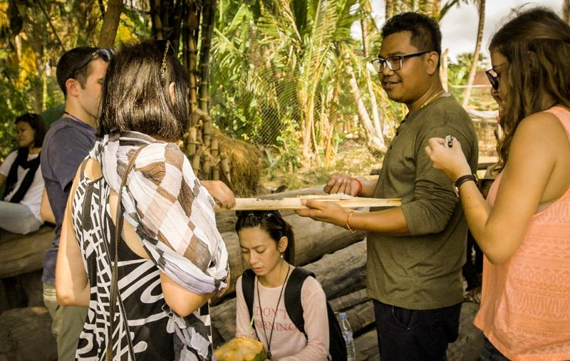
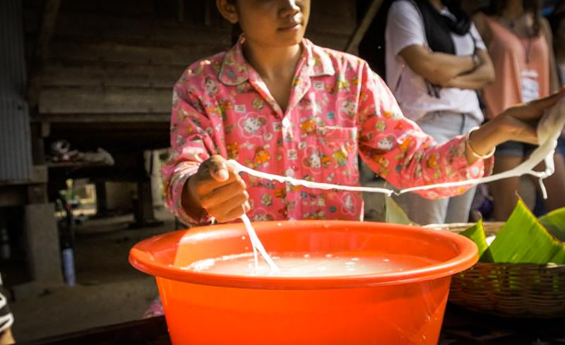

Easia Travel Head Office

Vietnam Head OfficeC/o: ATS Hotel, Suite 326 &327, 33B Pham Ngu Lao Street, Hanoi, VietnamTel: +84 24-39 33 13 62www.easia-travel.com

