THAILAND – Chiang Mai – Nature, Waterfalls and Hill Tribes – a Day at Doi Inthanon
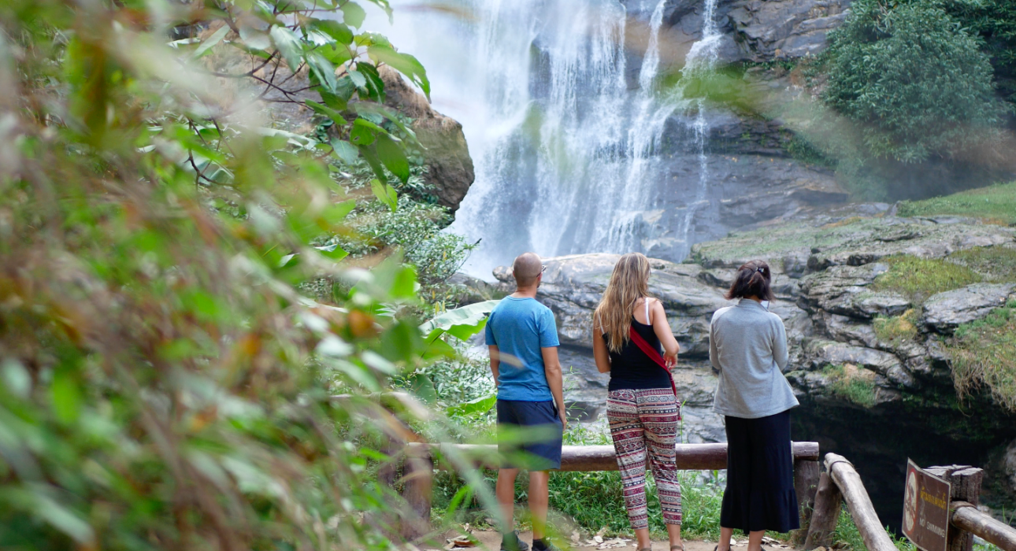

Over View

Theme
Art & Culture, Classic, Family, Honeymoon

Country - City
Thailand - Chiang Mai

Market segment
Groups, Thematic Leisure

Price Level
$$$$

Level of difficulties
LEVEL 0

Max pax
32

Seasonality
All Year Round

Arrival city
Chiang Mai

Departure city
Chiang Mai

Description

Spending a day in Doi Inthanon National Park, famous for its cool climate, lush vegetation, numerous waterfalls, various hill tribe villages and Thailand’s highest point (at 8415 feet) is a fantastic way to see another side of Thailand – the wild side!With a naturally cool environment and manicured gardens, Doi Inthanon is a paradise for nature lovers and perfect for hiking to catch stunning views of distant, misty mountains. Epic waterfalls are an added highlight to the National Park, as well as peaceful temples nestled high up in the mountainous landscape. The vegetation is breathtaking, and one may even spot a few colorful butterflies and songbirds along the way. The park is located only about an hour’s drive from the city, but the environment is like an entirely different world. It’s a fantastic opportunity to see some amazing vistas, beautiful waterfalls green nature trails, to taste locally grown coffee and let guests meet some of the Karen hill tribes that live on the mountain slopes.

Can be combined with
Thematic Leisure
- Chiang Mai – Evening highlights of Chiang Rai by tuk tuk

Selling points

- To witness the magical King and Queen twin pagodas
- To behold the striking cascading waters of Wachirathan Waterfall
- To see spectacular views of lush, green forests
- To visit the summit of Doi Inthanon, the highest mountain in Thailand

Sustainability

Level Of The Excursion
Medium – This activity offers tangible positive contributions to the local community, culture and/or environment

The Impact Of This Excursion

Social/cultural Impact
Cultural Conservation, Empowerment and education, Involving minorities

Environment Impact
National parks

Economic Impact
Local individual benefits, Community benefits

Additional Information

Positive impacts
The activity takes guests into a National Park, the entrance fees contribute to the management and conservation of the natural resources. They will also participate in community based activities with local indigenous people which supports their community and promotes their traditional culture.

Negative impacts
No negative

Sensitive character
The activity involves ethnic minorities who are vulnerable to exploitation and whose culture is at risk of disappearing. The activity is always organized with a local member of the community to make sure the community benefits from the activity and cultural traditions are respected.

Time And Transportation

From | To | Km | By | Duration | Road condition
Chiang Mai city | National Park entrance | 70 | Bus | 1 hour 15 minutes | Good but crowded
National Park entrance | Highest point | 40 | Bus | 45 minutes | Good

Photos

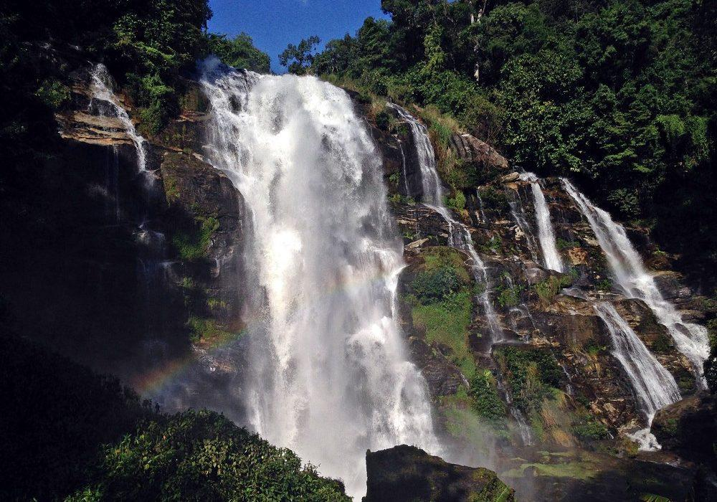
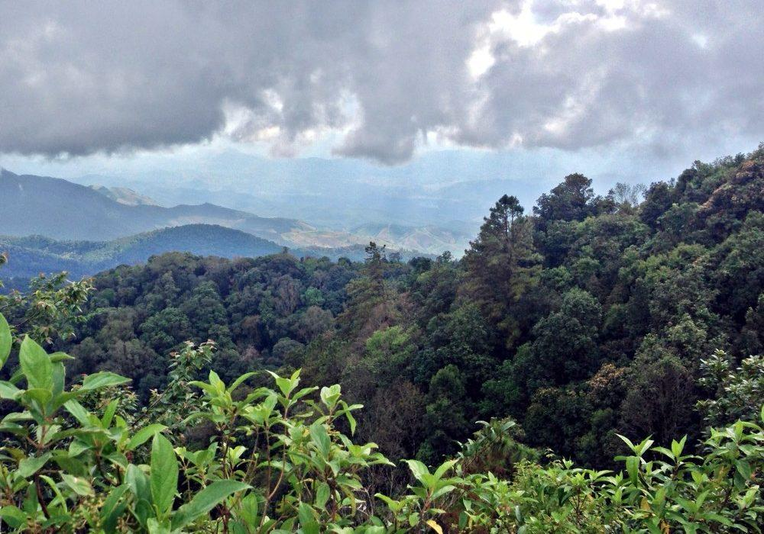
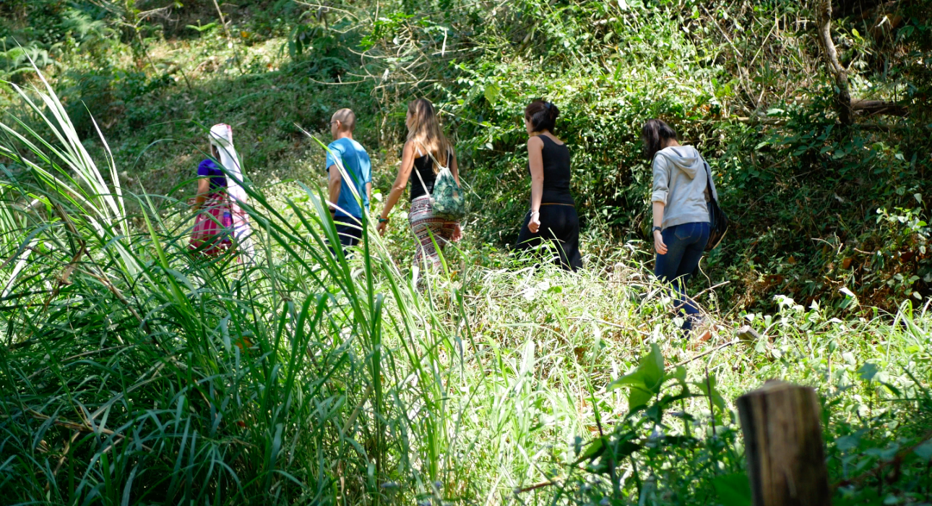
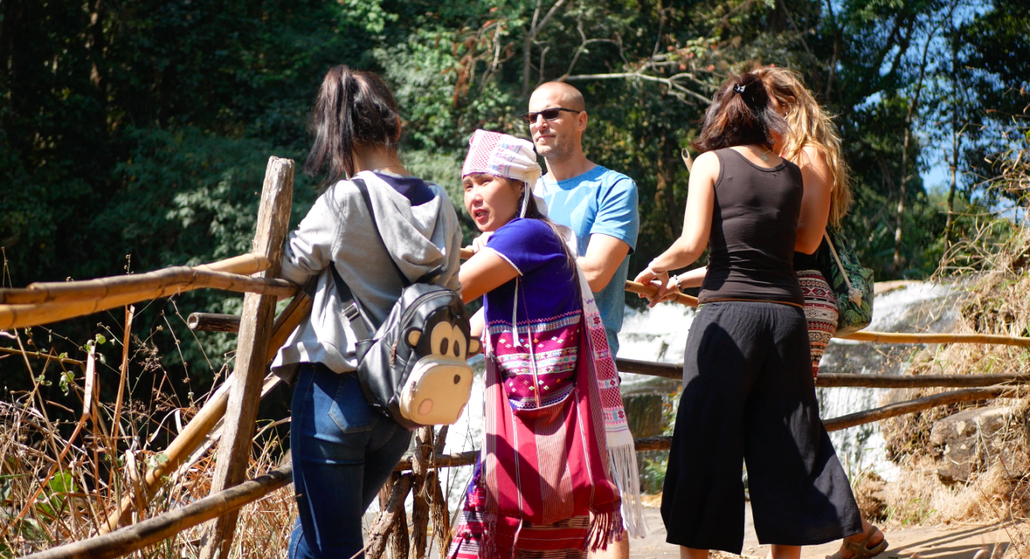
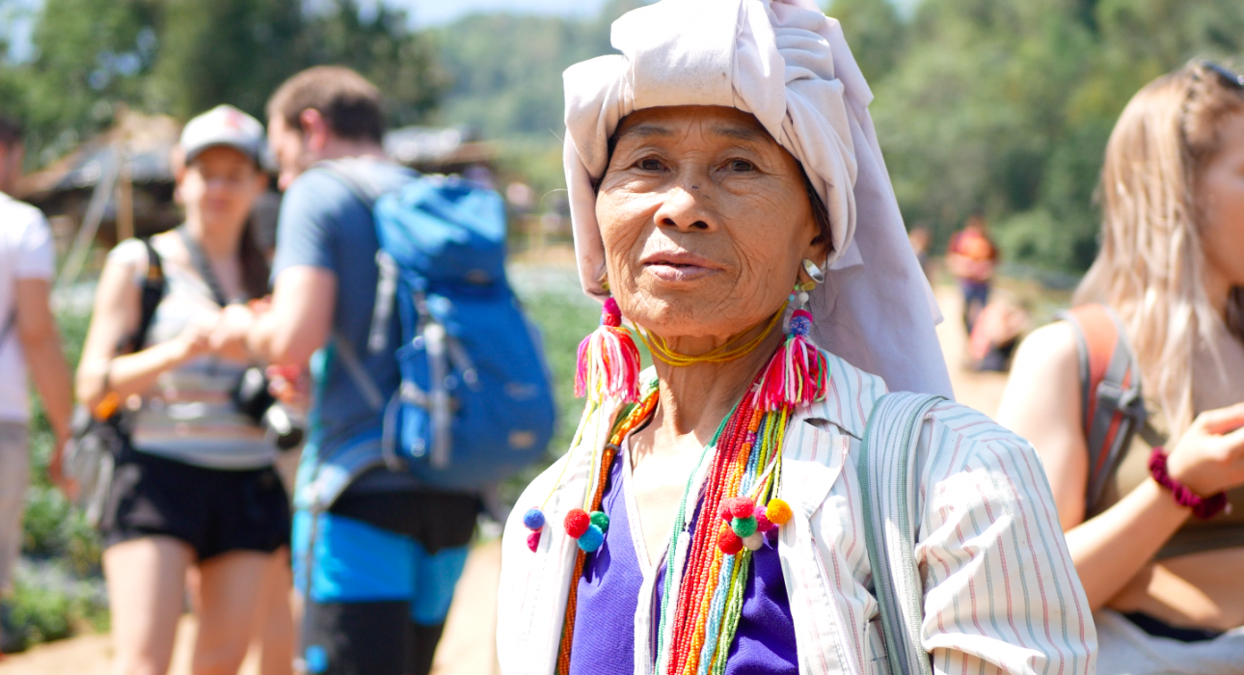
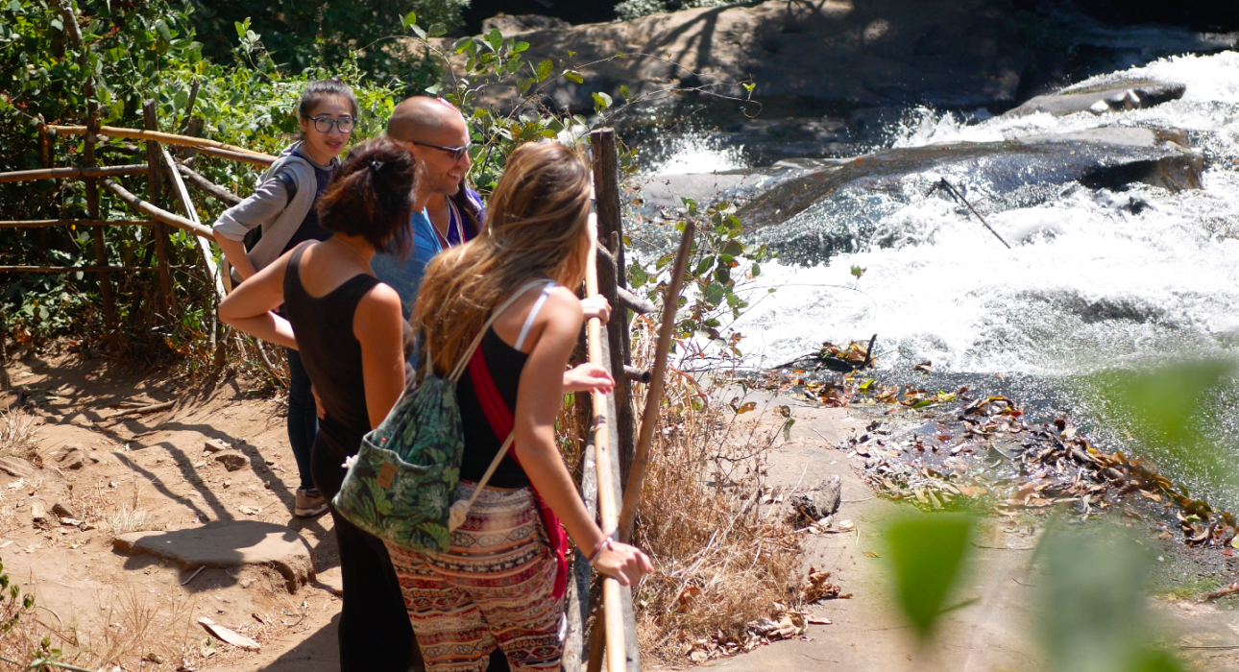
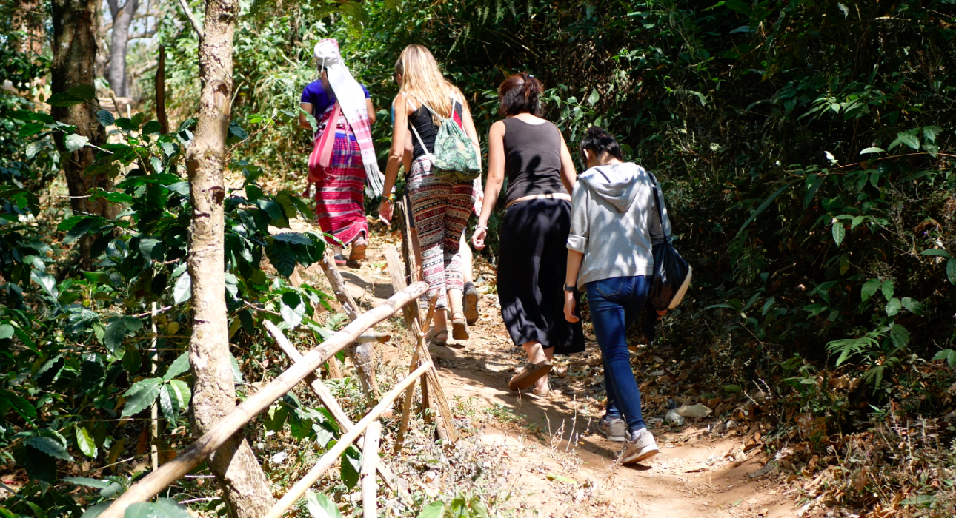
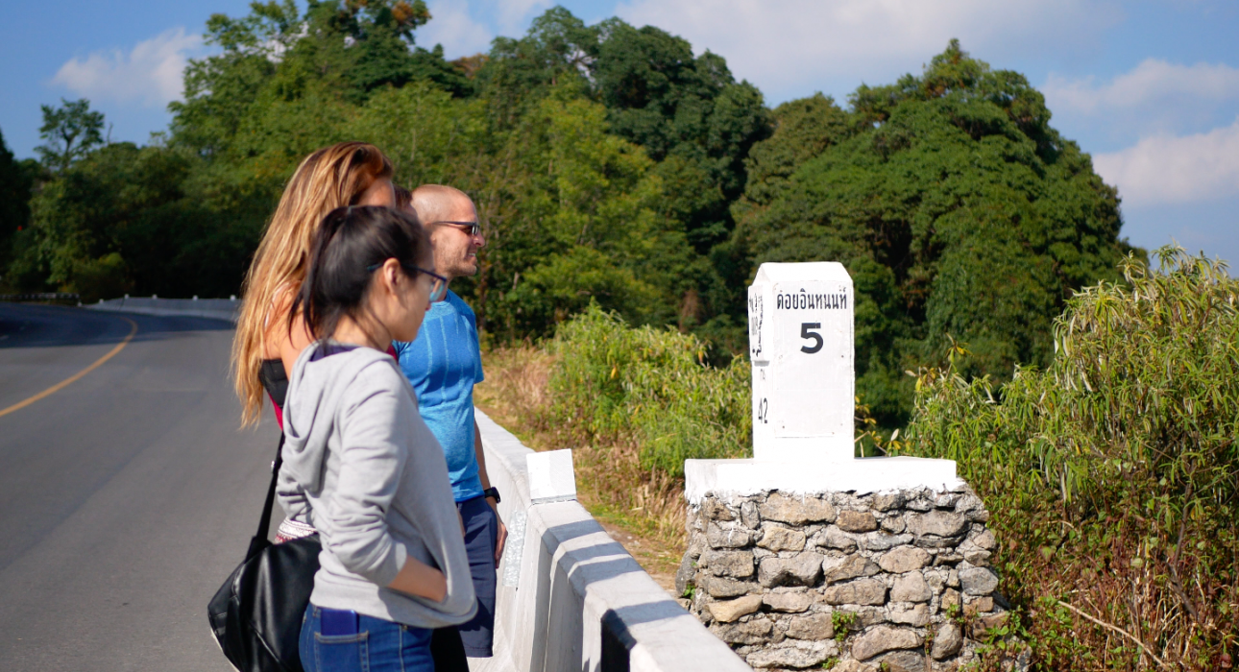

Easia Travel Head Office

Vietnam Head OfficeC/o: ATS Hotel, Suite 326 &327, 33B Pham Ngu Lao Street, Hanoi, VietnamTel: +84 24-39 33 13 62www.easia-travel.com

