THAILAND – Chiang Mai – One Day Agriculture and Coffee Experience at a Black Lahu Village
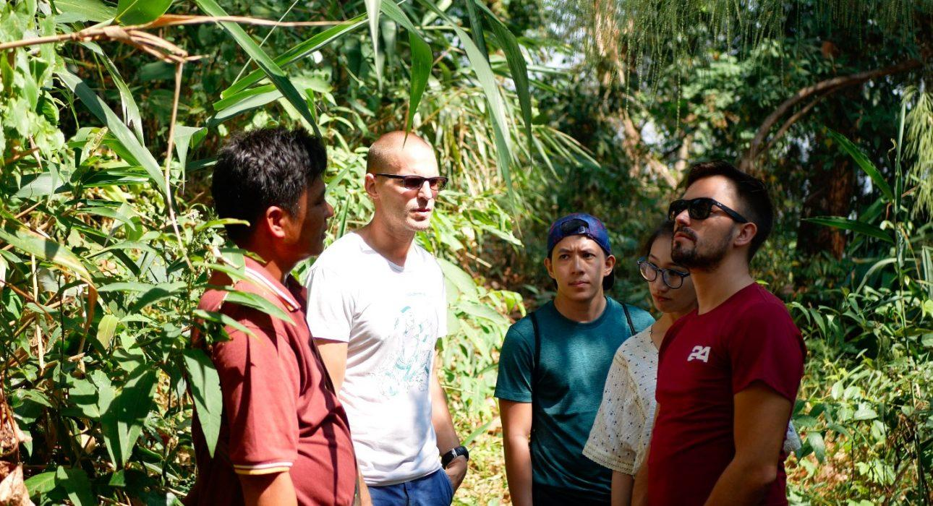

Over View

Theme
Art & Culture, Classic, Sustainable

Country - City
Thailand - Chiang Mai

Market segment
Thematic Leisure

Price Level
$$$$

Max pax
9

Seasonality
All year round (except a period around Chinese New Year)

Arrival city
Chiang Mai

Departure city
Chiang Mai

Description

The mountains of Northern Thailand are home to various hill tribe minorities, many of whom face difficulties preserving their culture and identity in an ever-evolving world. This trip entails traveling to a Lahu Sheleh village and a nearby coffee farm, rarely visited by tourists. This is the perfect activity for an authentic experience in a hill tribe village, while at the same time promoting sustainability and preserving the environment dedicated to organic agriculture. The visits is as interactive as possible without disturbing the regular village and farm life. Lunch is served at a local house and consists of various vegetarian dishes.

Selling points

- To enjoy a day away from the hustle and bustle of the city
- To get inside tips from a local
- To lend a hand on the farm by roasting coffee beans
- To visit Lahu Sheleh community to chat about their history
- Get to take home organic coffee as a souvenir

Sustainability

Level Of The Excursion
Medium – This activity offers tangible positive contributions to the local community, culture and/or environment

The Impact Of This Excursion

Social/cultural Impact
Cultural Conservation, Homestays, Involving minorities

Environment Impact
Waste/plastic packaging

Economic Impact
Local individual benefits, Community benefits

Additional Information

Positive impacts
The activity takes place is centered around an organic coffee farm which takes active measures to reduce waste and preserve the environment. It also involves exploring an ethnic village which is done by a member of the community, bringing income to the community while also giving incentive to preserve traditions.

Negative impacts
No negative

Sensitive character
The activity involves ethnic minorities who are vulnerable to exploitation and whose culture is at risk of disappearing. The activity is always organized with a local member of the community to make sure the community benefits from the activity and cultural traditions are respected.

Time And Transportation

From | To | Km | By | Duration | Road condition
Chiang Mai city | Doi Mod/Suan Lahu | 90 | Minivan | 1h 45 min | Good but mountainous
Doi Mod/Suan Lahu | Chiang Rai city | 130 | Minivan | 2 hours | Good but mountainous
Doi Mod/Suan Lahu | Mae Kachan hot springs | 13 | Minivan | 25 minutes | Narrow and mountainous

Photos

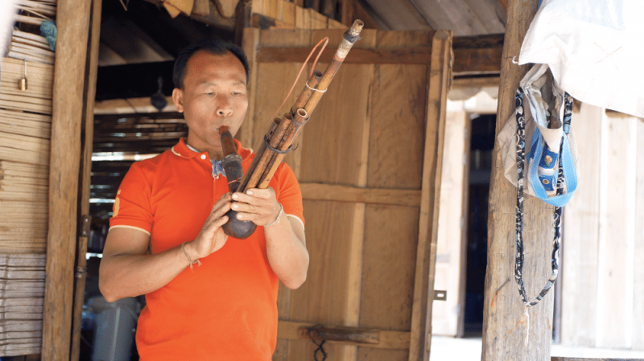
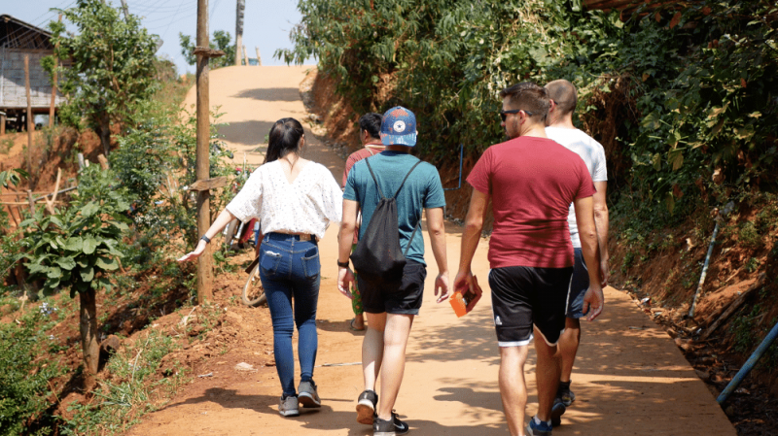
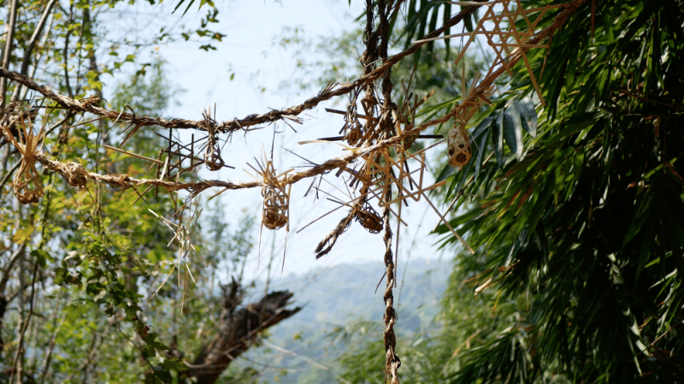
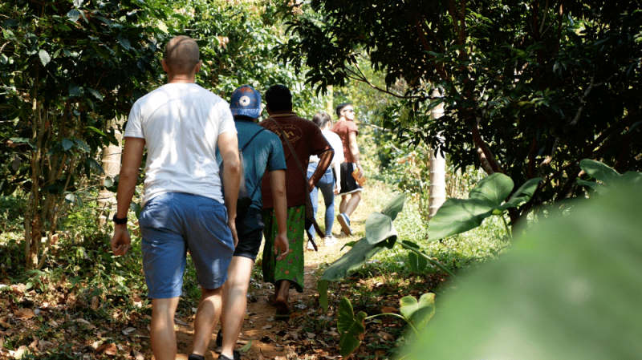
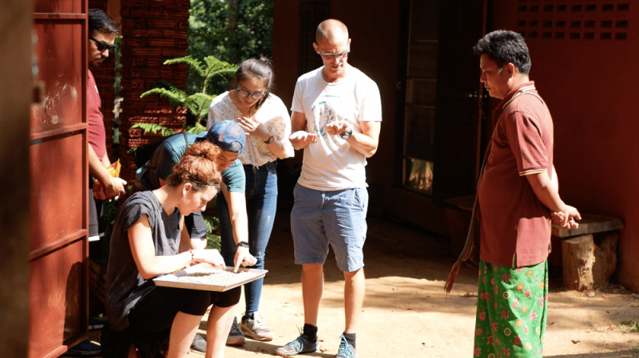

Easia Travel Head Office

Vietnam Head OfficeC/o: ATS Hotel, Suite 326 &327, 33B Pham Ngu Lao Street, Hanoi, VietnamTel: +84 24-39 33 13 62www.easia-travel.com

