CAMBODIA – Siem Reap – “Phare, The Cambodian Circus” Show
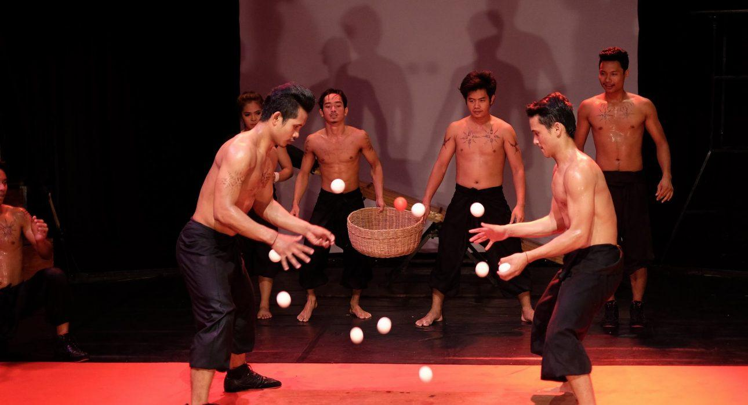

Over View

Theme
Art & Culture, Classic, Family, Sustainable

Country - City
Cambodia - Siem Reap

Market segment
Groups, Thematic Leisure

Price Level
$$

Max pax
300pax for public show, 40pax for private show

Seasonality
All year round

Arrival city
Siem Reap

Departure city
Siem Reap

Description

An excellent alternative to Apsara Dance shows, “Phare, The Cambodian Circus” gives a real insight into Cambodian history and culture and is ideal for all age groups. It is energetic and thrilling and shows a vibrant side of Cambodia.Phare, The Cambodian Circus, is the only circus in Cambodia that offers a daily theatrical performance. This one-hour-long show starts daily. They have several shows which guarantee a beautiful mix of humor and drama. Each performance aims to give the audience a genuine insight into the modern artistic stage, with each story deeply revealing a piece of Khmer history, from the Khmer Rouge period to the contemporary issues of Khmer society. But all are worth a visit!Phare Ponleu Selpak is an NGO based in Battambang. It was founded in 1994 to provide artistic training to poor, young Cambodians. Furthermore, this organization offers a classical Primary to High School education for underprivileged children. The PPS Association began as a visual arts school and then a library, a child development center, and eventually added a social and health care center. Nowadays, this Circus School performs in Battambang as well as nationally and internationally.

Can be combined with
Thematic Leisure
Incentive
- Siem Reap – Participate in the Local Village Life
- Siem Reap – An adventurous Apsara Hunt through the quiet Temples of Angkor
Groups
- Siem Reap – Meet Cambodia’s little heroes
- Siem Reap – Spend time with local fisherman at Tonle Sap Lake, Kampong Kleang

Selling points

- To have real insight into Cambodian history and culture, ideal for all age groups.
- To enjoy performances are executed with professionalism by talented young performers.
- This show unveils the issues in contemporary, modern or ancient Cambodia, using very little spoken language.
- Private show available for high profile clients.

Sustainability

Level Of The Excursion
High – This activity strongly supports local communities and/or helps preserve the culture and environment

The Impact Of This Excursion

Social/cultural Impact
Cultural Conservation, Empowerment and education

Economic Impact
Local individual benefits, Community benefits

Additional Information
Positive impact: Phare, The Cambodian Circus is one of Cambodia’s most innovative social enterprise models. Profits generated through ticket, refreshment, merchandise and private performance sales support the free education, professional arts training and social support programs of Phare Ponleu Selpak in Battambang.

Time And Transportation

From | To | Km | By | Duration | Road condition
Circus Show | Siem Reap city center | 2 | Car / Bus | 10 minutes | Good

Photos

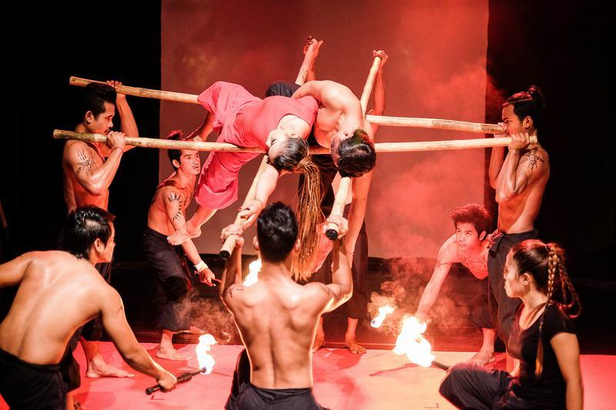
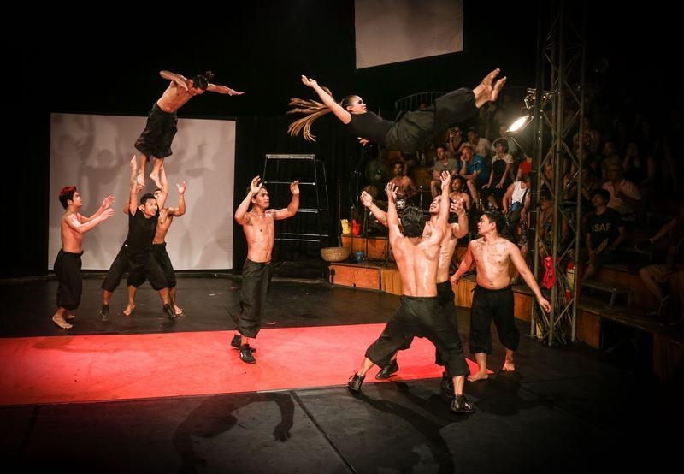
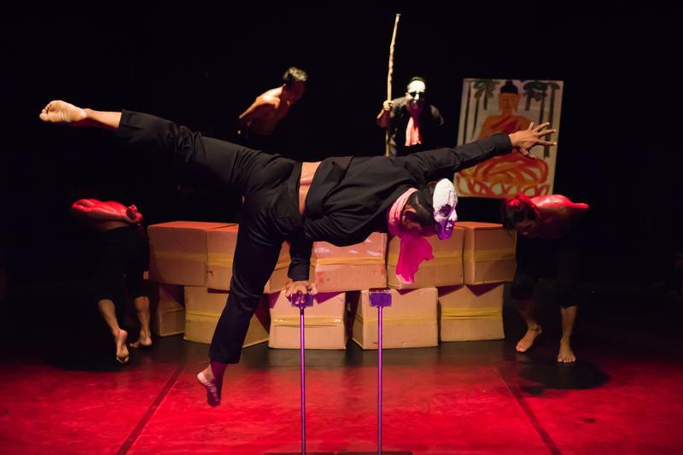
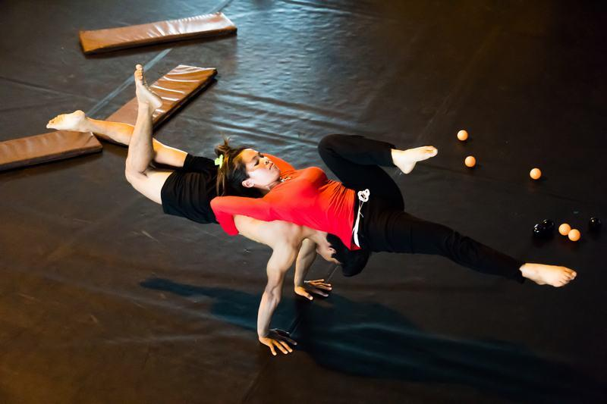
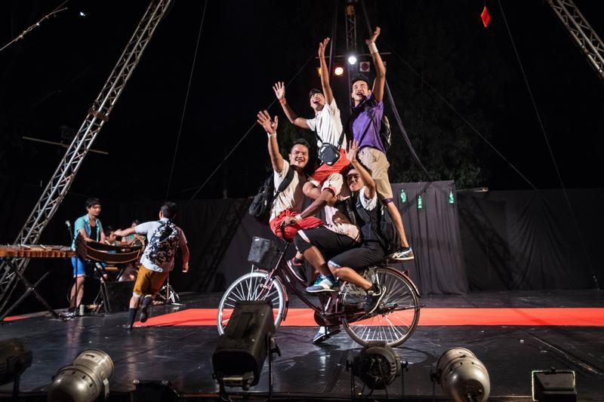
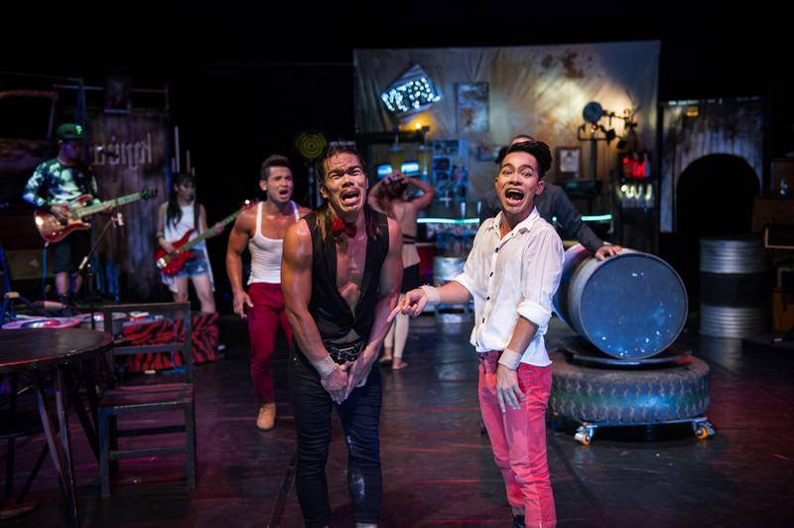
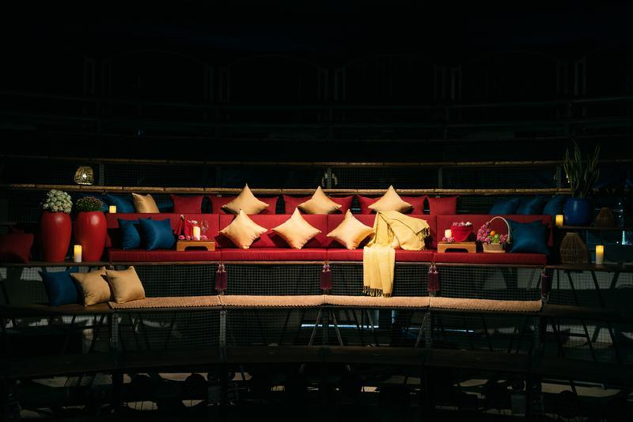
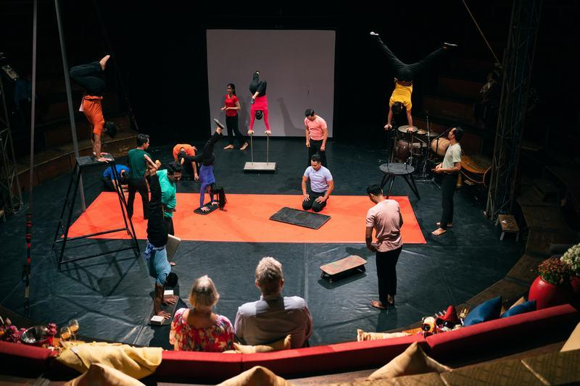
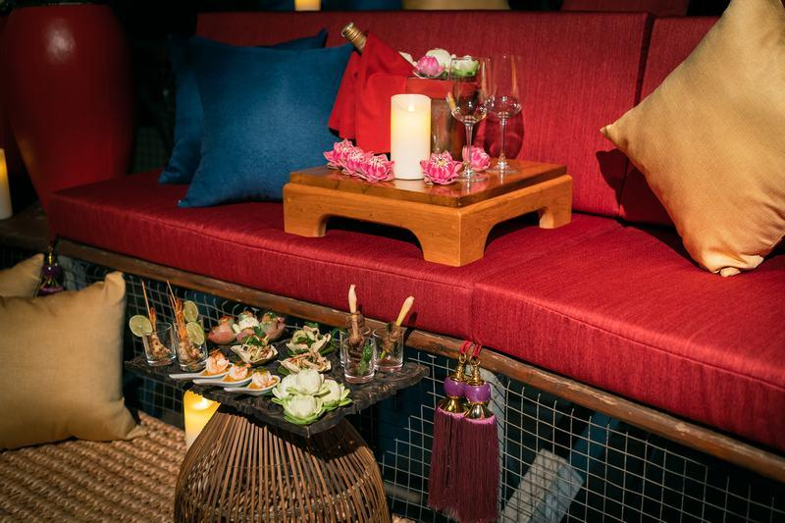
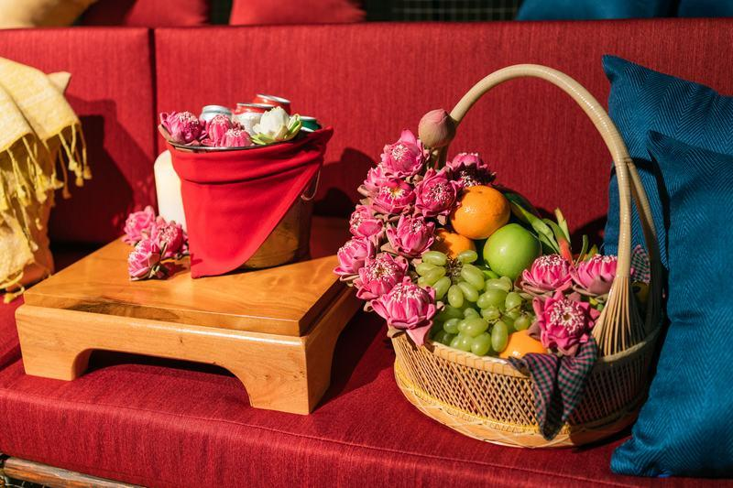

Easia Travel Head Office

Vietnam Head OfficeC/o: ATS Hotel, Suite 326 &327, 33B Pham Ngu Lao Street, Hanoi, VietnamTel: +84 24-39 33 13 62www.easia-travel.com

