CAMBODIA – Siem Reap – Khmer Family Day
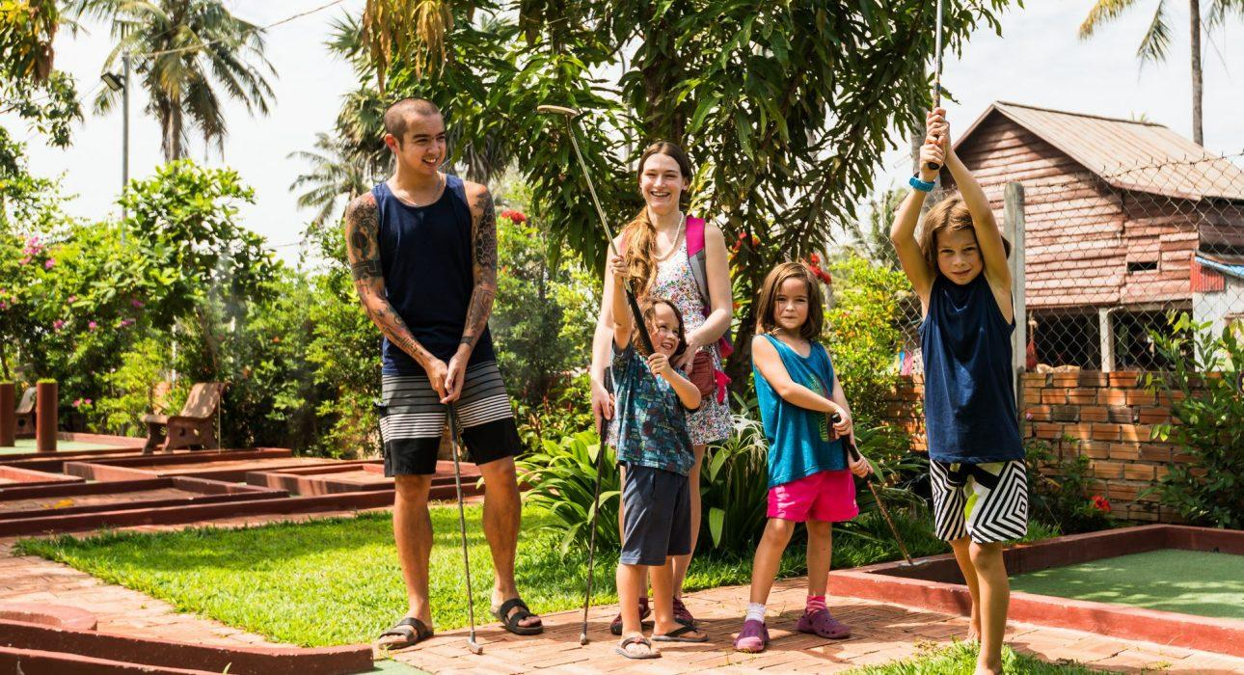

Over View

Theme
Art & Culture, Classic, Family, Gastronomy, Sustainable

Country - City
Cambodia - Siem Reap

Market segment
Thematic Leisure

Price Level
$$$

Max pax
20

Seasonality
All year round

Arrival city
Siem Reap

Departure city
Siem Reap

Description

The activity gives the opportunity to experience local activities, as well as unique and unforgettable family moments and to exceed guests’ expectations of Cambodia in all sorts of wonderful, genuine ways. What would a Khmer family do during their free time? Together with rice fields, stops alongside beautiful lakes, and visiting a bustling fun-fair street, this family day offers playful activities and local discovery, but also a relaxing day spent far away from the regular, touristy places and a chance to live like a local!

Can be combined with
Thematic Leisure
- Siem Reap – Meet Cambodia’s little heroes
- Siem Reap – Bokator School (Khmer Martial Art)
- Siem Reap – Spend time with local fisherman at Tonle Sap Lake, Kampong Kleang

Selling points

- To get away from touristy places
- To propose a good mix between experiencing local activities and discovering places which are frequented by locals
- To have wonderful memories for the whole family!

Sustainability

Level Of The Excursion
Medium – This activity offers tangible positive contributions to the local community, culture and/or environment

The Impact Of This Excursion

Social/cultural Impact
Cultural Conservation, Empowerment and education

Economic Impact
Local individual benefits, Community benefits

Additional Information
Positive impact: This activity bringing income to many different local stores included local restaurant.Moreover, it is an attractive and fun activity especially for kids.

Time And Transportation

FROM | TO | DISTANCE | BY | DURATION | ROAD CONDITION
Siem Reap Center | Mini Golf | 6 km | car | 20 mins | Good
Mini Golf | Tonteng Knai Temple | 14 km | car | 30 mins | Good
Tonteng Knai Temple | Drave Kot | 14 km | car | 30 mins | Good
Drave Kot | Balloon ride | 20 km | car | 45 mins | Good
Balloon ride | 60 road | 8 km | car | 20 mins | Good

Photos

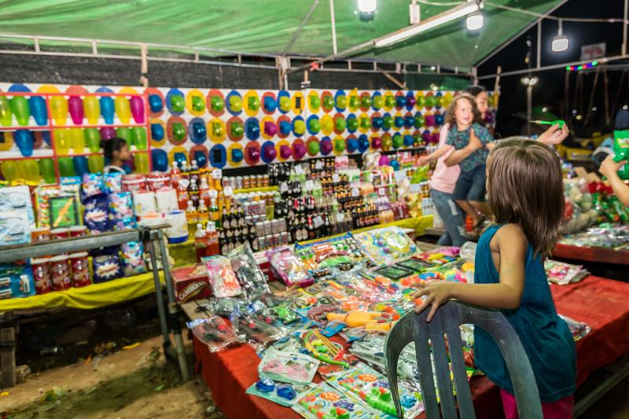
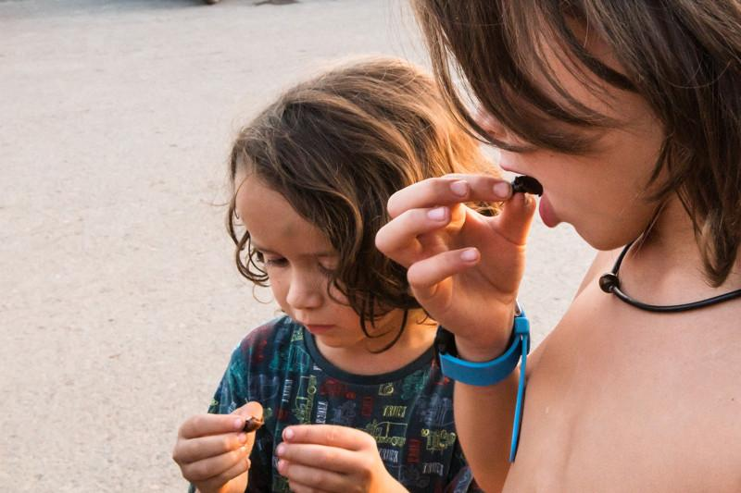
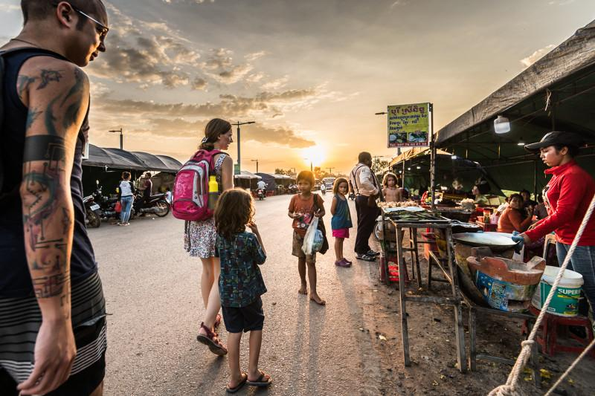
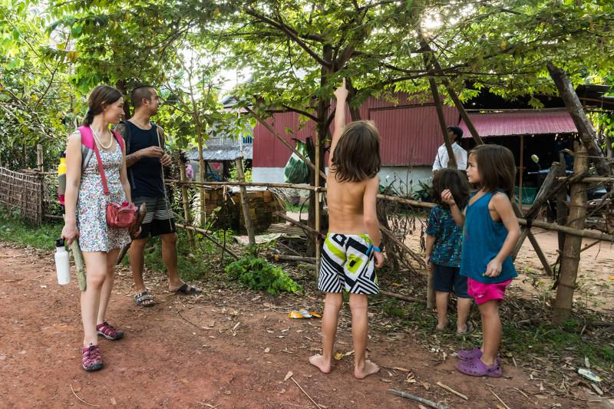
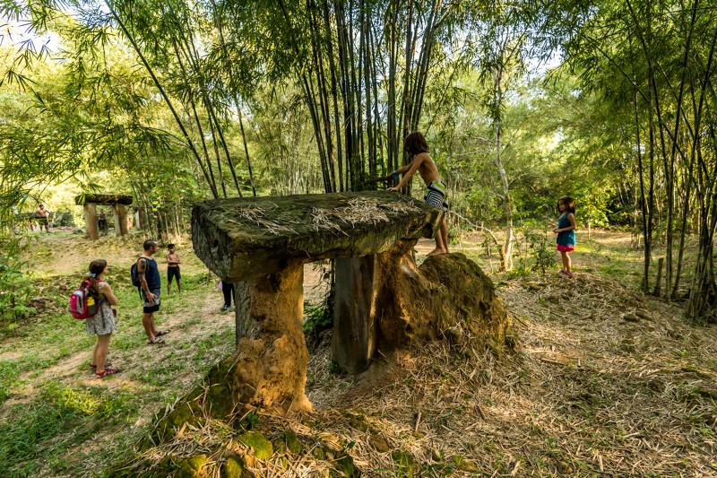
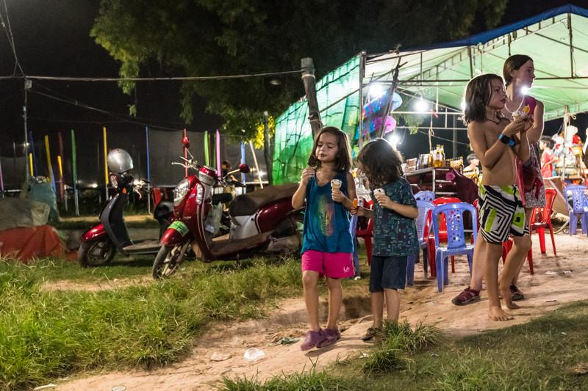

Easia Travel Head Office

Vietnam Head OfficeC/o: ATS Hotel, Suite 326 &327, 33B Pham Ngu Lao Street, Hanoi, VietnamTel: +84 24-39 33 13 62www.easia-travel.com

