CAMBODIA – Siem Reap – Visit the Theam’s Gallery, Cambodia’s Most Famous Artist
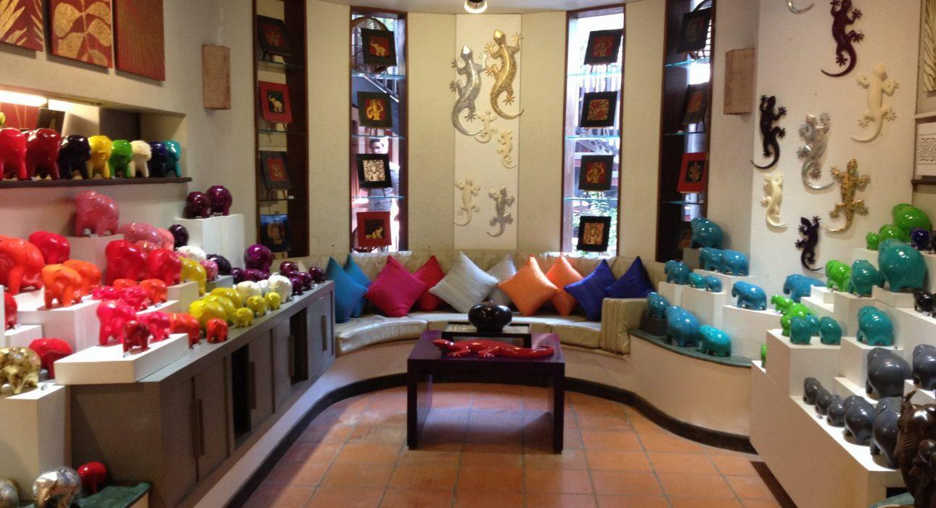

Over View

Theme
Art & Culture, Classic, Family, Sustainable

Country - City
Cambodia - Siem Reap

Market segment
Groups, Thematic Leisure

Price Level
$$

Max pax
25 pax per visit; 300 pax per private cocktail; 260 pax for dinner arrangement

Seasonality
All Year Round

Arrival city
Siem Reap

Departure city
Siem Reap

Description

This activity gives the opportunity to visit to the gallery of Mr. Theam, a talented artist and designer, who carries on Cambodia’s rich artistic traditions.At his studio, Mr. Theam teaches about Khmer culture through art and the efforts being made to keep their traditions alive in the next generation of artisans. Theam returned to Cambodia in 1995 after studying in France for several years at the Ecole Boule and Ecole des Beaux Arts in Paris. For over 10 years, he was the artistic director of “Artisans d’Angkor,” a Cambodian arts and crafts company dedicated to the revival and preservation of Cambodian traditional knowledge.Theam’s house is truly an artist’s studio; it includes a workshop and a gallery in which his collections are displayed. Above all, the studio welcomes artist apprentices trained by Theam himself. Here, young Cambodian artists can acquire an understanding of traditional Cambodian aesthetics and culture.Theam’s work is defined by nature in transformation, infused with the Khmer culture, and contributes to the revival of Cambodian life after decades of war and silence. His contemporary creations, imbued with Khmer influence, give birth to some wonderful artefacts, such as customized elephants originating from Kompong Chhnang, customized meditation statues, and triptychs.

Selling points

- Theam’s gallery is a small and elegant personal art gallery, displaying Cambodia’s most famous artist’s paintings and sculptures, complete with a tranquil garden for drinks and dining
- To understand how ancient traditions are kept alive in the modern world
- To propose a visit to the artist’s studio & workshop

Sustainability

Level Of The Excursion
Medium – This activity offers tangible positive contributions to the local community, culture and/or environment

The Impact Of This Excursion

Social/cultural Impact
Cultural Conservation, Empowerment and education

Economic Impact
Local individual benefits, Community benefits

Additional Information
Positive impact: This activity support a talented artist to keep his heritage of art to stay alive in the modern world while providing jobs & incomes to local people.

Time And Transportation

From | To | Km | By | Duration | Road Condition
City Center | Art Gallery | 5 | Car/Minivan | 10 minutes | Good

Photos

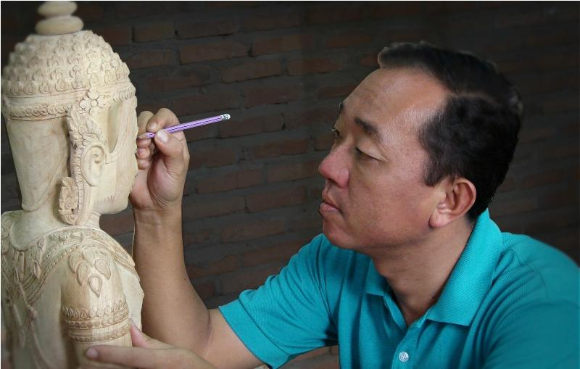
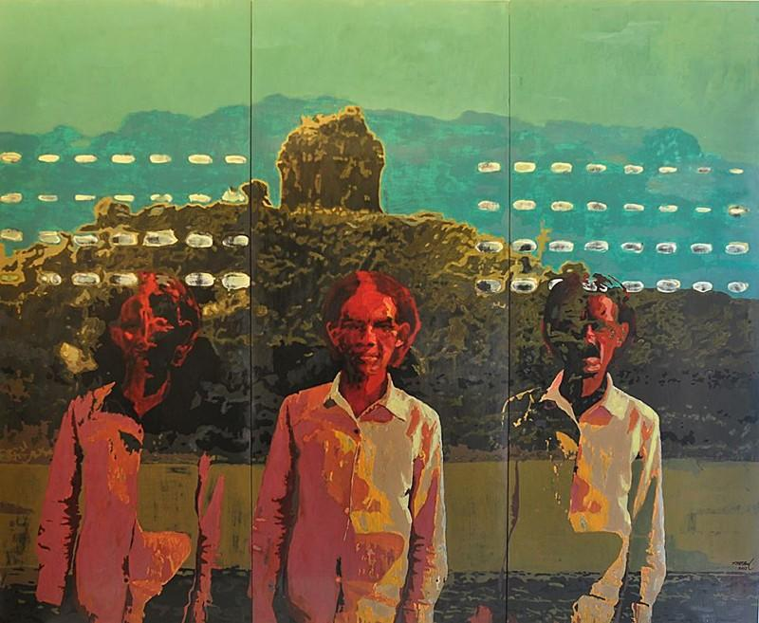
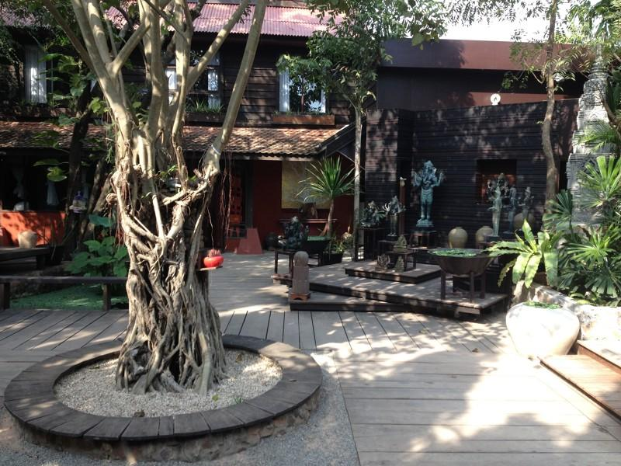
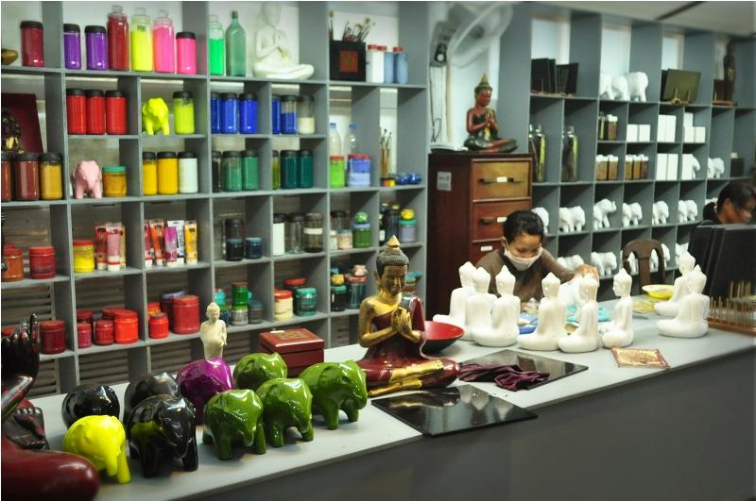
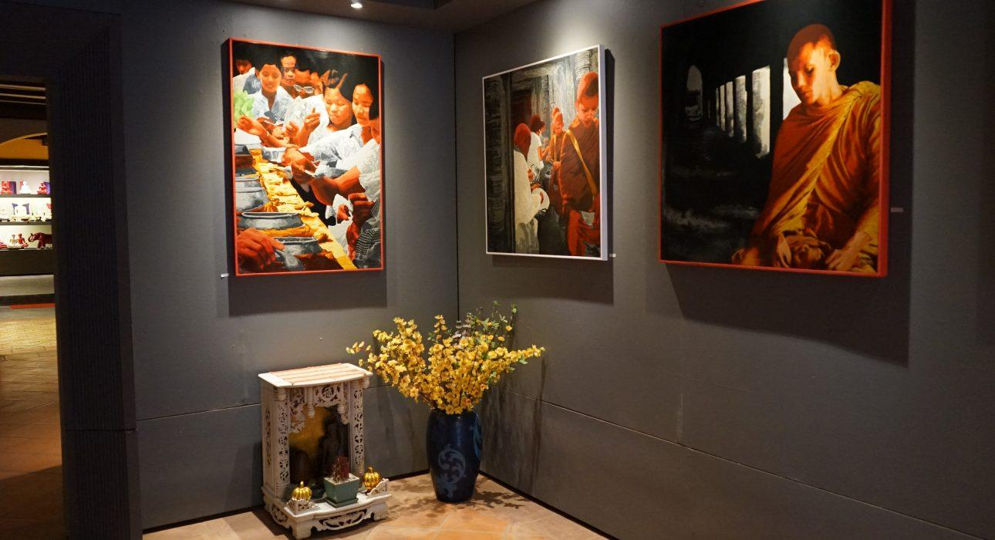
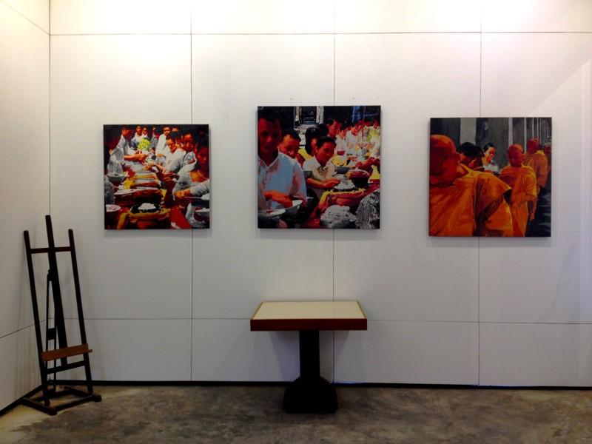

Easia Travel Head Office

Vietnam Head OfficeC/o: ATS Hotel, Suite 326 &327, 33B Pham Ngu Lao Street, Hanoi, VietnamTel: +84 24-39 33 13 62www.easia-travel.com

