LAOS – Luang Prabang – Rice Cultivation at a Lao Farm
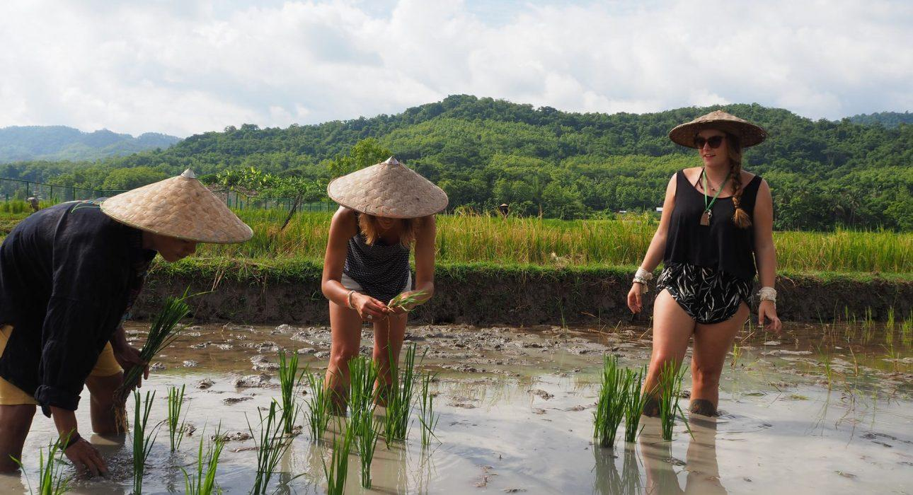

Over View

Theme
Art & Culture, Classic, Family, Gastronomy

Country - City
Laos - Luang Prabang

Market segment
Groups, Thematic Leisure

Price Level
$$

Level of difficulties
LEVEL 1

Max pax
20 (possible to extend to 35 by splitting in smaller groups)

Seasonality
All year round

Arrival city
Luang Prabang

Departure city
Luang Prabang

Description

The farmers of the Living Land will teach visitors everything they need to know about the 13 stages of growing rice, including the selection of the best grains, the rigorous preparation of the rice field, to the planting of the rice, the harvest and eventually the processing. They will also demonstrate how to make rice flour and travelers will have the chance to sample products made of rice. It is also an opportunity to learn how the farmers make the tools they need and to discover how they weave bamboo to make the special baskets for cooking the rice. Afterwards, there is a visit to the organic vegetable garden to learn about the various vegetables and aromatic plants grown on the farm and the cultivation methods used to grow them.

Can be combined with
Thematic Leisure
- LAOS – Luang Prabang – Visit Kuang Sy Waterfall
- LAOS – Luang Prabang – Buffalo Dairy Farm

Selling points

- Rice is a national staple in Laos, and this activity gives travelers the chance to become more intimate with the local culture and way of life.
- Enjoy the beautiful, rolling mountains and rural scenery just outside of Luang Prabang.
- Gain knowledge while enjoying a dynamic farming workshop.

Sustainability

Level Of The Excursion
Low - This activity impacts local community, culture and/or environment in a small but meaningful way

The Impact Of This Excursion

Social/cultural Impact
Cultural Conservation, Empowerment and education

Economic Impact
Local individual benefits, Community benefits

Time And Transportation

From | To | Km | By | Duration | Road condition
Luang Prabang | Rice farm | 7 | Car / Bus | 20 minutes | Fair

Photos

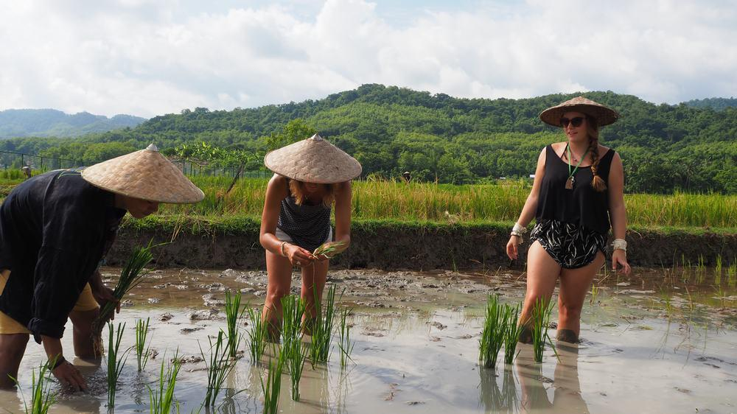
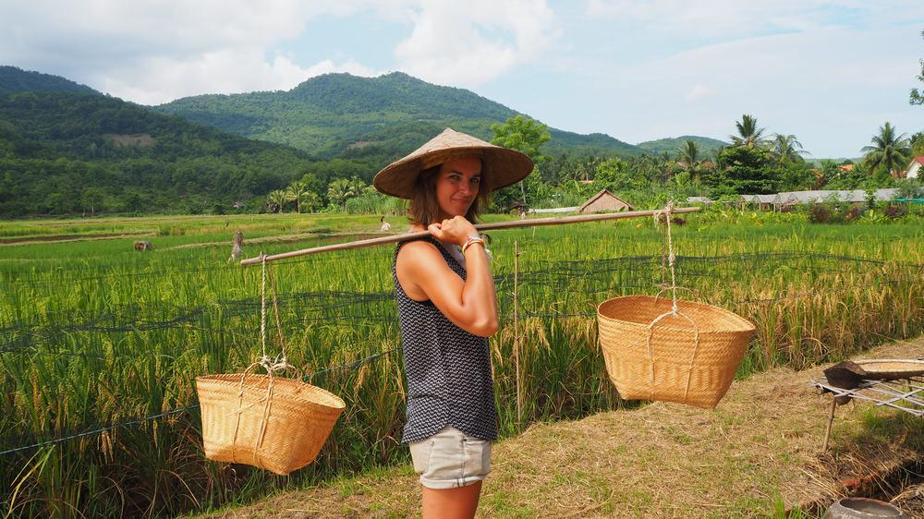
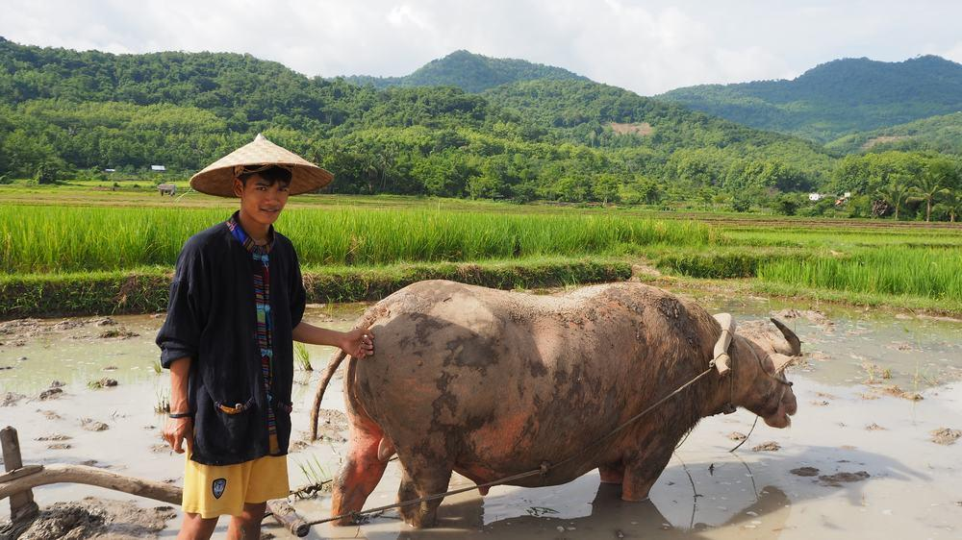
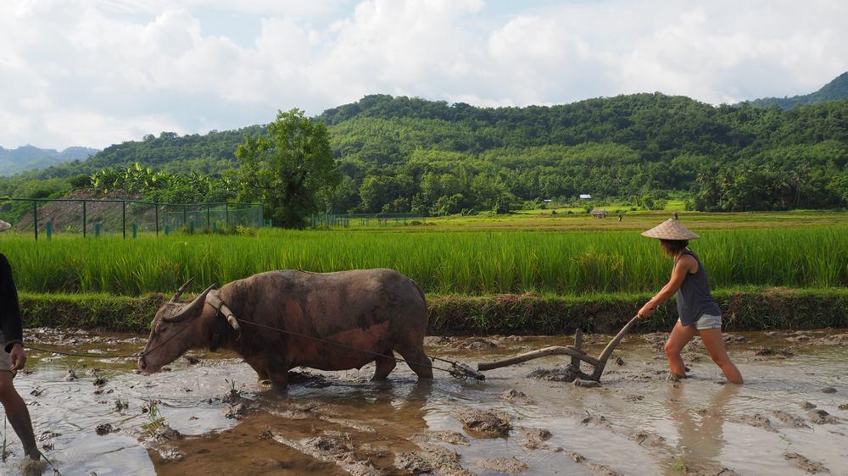
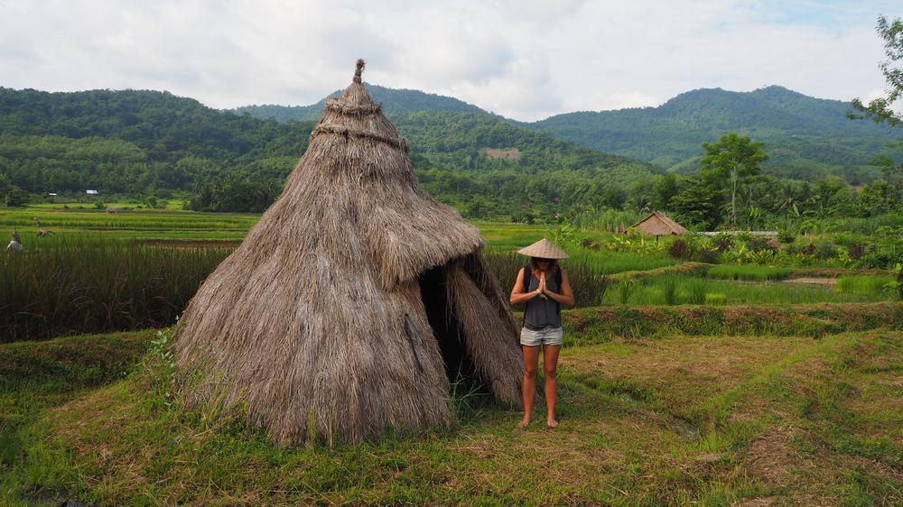
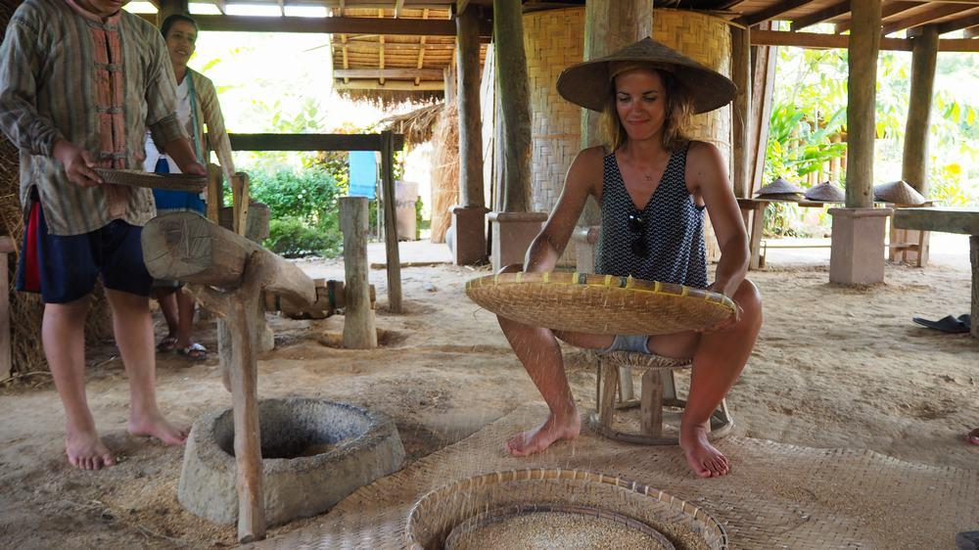

Easia Travel Head Office

Vietnam Head OfficeC/o: ATS Hotel, Suite 326 &327, 33B Pham Ngu Lao Street, Hanoi, VietnamTel: +84 24-39 33 13 62www.easia-travel.com

