CAMBODIA – Siem Reap – Bokator School (Khmer Martial Art)
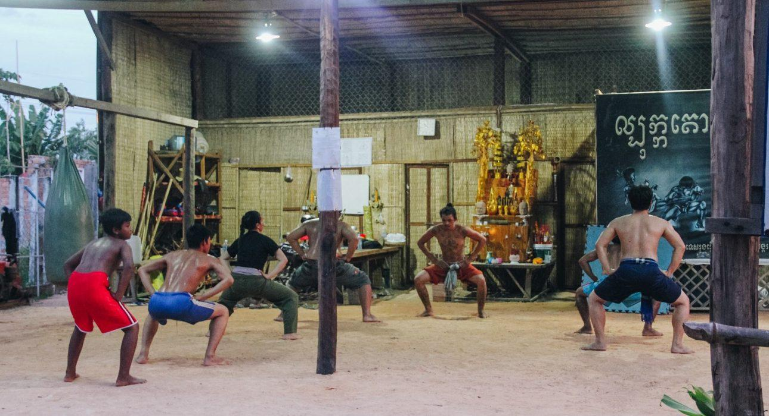

Over View

Theme
Art & Culture, Classic, Family, Sustainable

Country - City
Cambodia - Siem Reap

Market segment
Groups, Thematic Leisure

Price Level
$$

Max pax
60

Seasonality
All year round

Arrival city
Siem Reap

Departure city
Siem Reap

Description

Bokator is a Khmer martial art that combines close hand-to-hand combat, ground techniques, and weapons, and it’s one of the oldest existing fighting systems in Cambodia. It is believed that an early form of Bokator was the close quarter combat system used by the great and powerful armies of the majestic Angkor empire that existed 1000 years ago. Spending an hour at Kun Bokator school to try out this unique Khmer experience in a special workshop with a professional teacher is an extremely hands-on way of learning about Cambodian culture. Travellers have not only tried out an ancestral martial art but also learn more about the Cambodian culture and fighting techniques of their ancient armies.

Can be combined with
Thematic Leisure
- Siem Reap – Participate in the Local Village Life
- Siem Reap – Meet Cambodia’s little heroes
- Siem Reap – “Phare, The Cambodian Circus” Show in Siem Reap
Incentive
- Siem Reap – Participate in the Local Village Life
- Siem Reap – “Phare, The Cambodian Circus” Show in Siem Reap
Groups
- Siem Reap – Participate in the Local Village Life
- Siem Reap – Meet Cambodia’s little heroes
- Siem Reap – “Phare, The Cambodian Circus” Show in Siem Reap

Selling points

- To have a chance to learn about Bokator as an ancient martial art and an essential part of Cambodia’s cultural heritage.
- To admire a skilful presentation by young students of the school.
- To actively take part in the workshop and learn a few martial arts techniques yourself

Sustainability

Level Of The Excursion
Medium – This activity offers tangible positive contributions to the local community, culture and/or environment

The Impact Of This Excursion

Social/cultural Impact
Cultural Conservation, Empowerment and education

Economic Impact
Local individual benefits, Community benefits

Additional Information
Positive impact: This activity is to preserve the Khmer martial art KUN BOKATOR represents an important part of Cambodian culture and the fighting techniques of ancient armies as well as to provide direct income to the artist.

Time And Transportation

From | To | Km | By | Duration | Road condition
Siem Reap | Bokator School | 2 | Tuk tuk | 10 minutes | Good

Photos

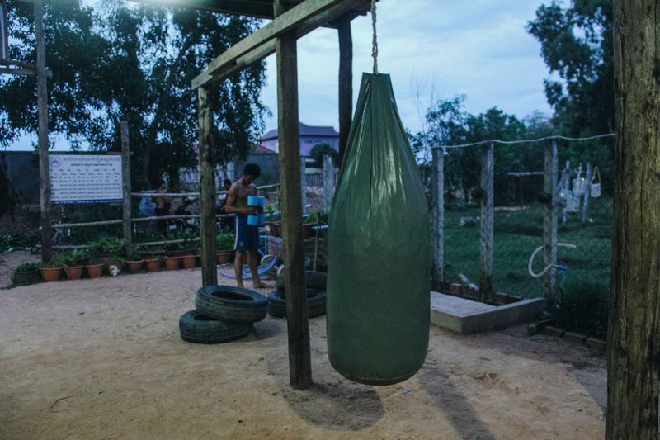
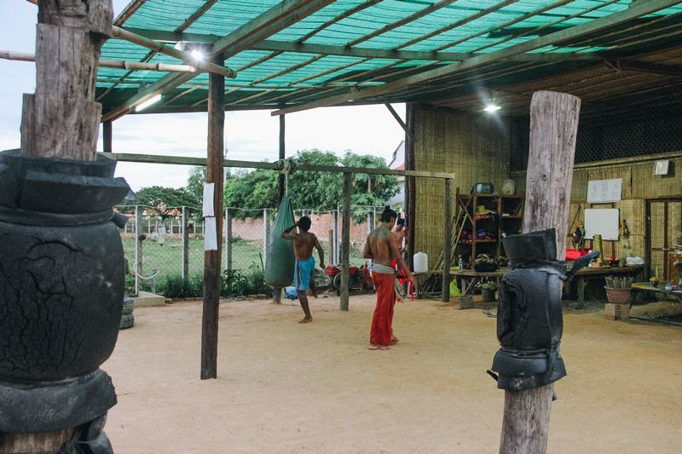
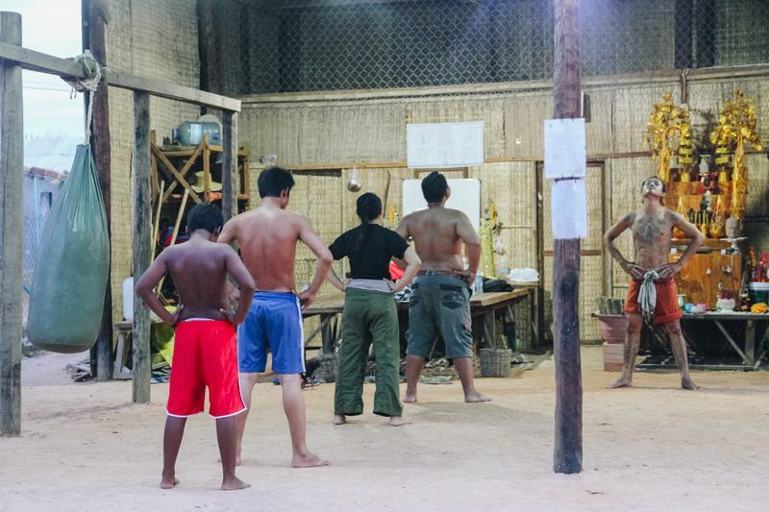
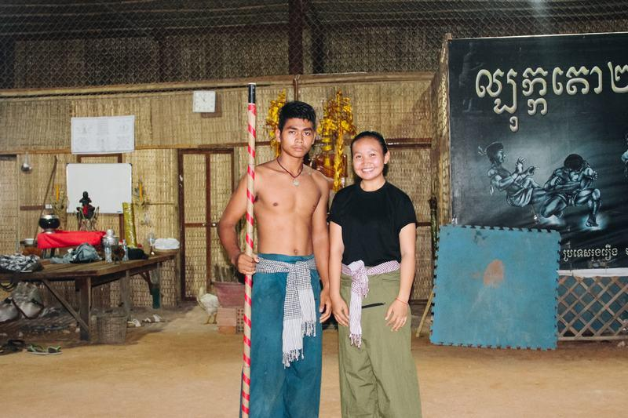
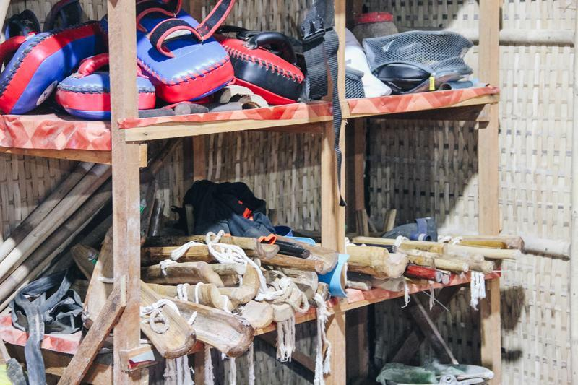
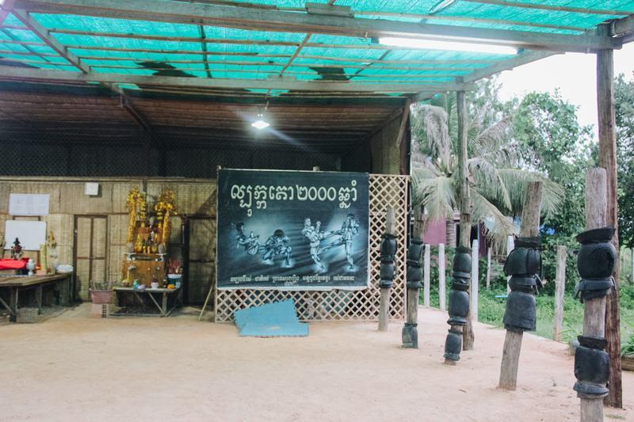

Easia Travel Head Office

Vietnam Head OfficeC/o: ATS Hotel, Suite 326 &327, 33B Pham Ngu Lao Street, Hanoi, VietnamTel: +84 24-39 33 13 62www.easia-travel.com

