CAMBODIA – Siem Reap – Meet the Sacred Dancers of Angkor
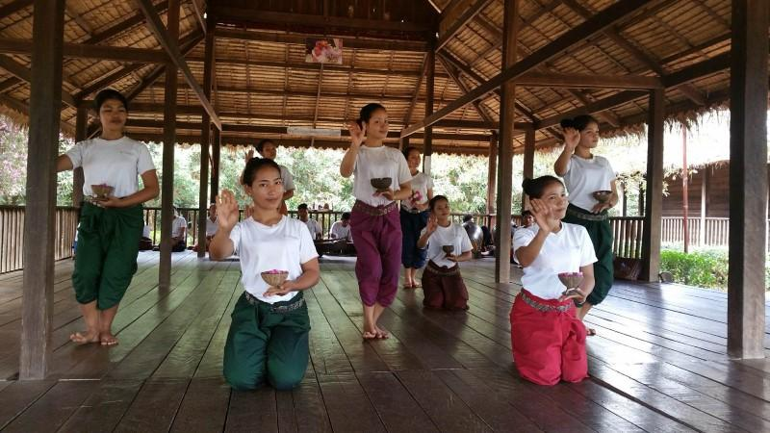

Over View

Theme
Art & Culture, Classic, Sustainable

Country - City
Cambodia - Siem Reap

Market segment
Thematic Leisure

Price Level
$$$$

Max pax
20

Seasonality
All Year Round

Arrival city
Siem Reap

Departure city
Siem Reap

Description

Let the spirituality of the Sacred Dancers Angkor School carry away. This activity allows immersing in a spiritual environment to learn and practice the Original Sacred Dance of the Angkor period.The school is in a beautiful and green location in the middle of three sacred areas – the Banteay Srei Temple, the Kbal Spean Mountain, and Phnom Dei Mountain- which create a spiritual and illuminating atmosphere.Here, students learn the real discipline it takes to perform the ancient Khmer traditional dance, with a lot of dedication and connection to the religion. Each dance is an echoing “prayer” for blessings upon the land, the environment, and the people. The children who are part of it are invited to learn and love the arts of dance and music and are encouraged to excel, not to make money.

Selling points

- To experience the only dance class in Siem Reap, supported by Princess Buppha Devi, daughter of the late King-Father Norodom Sihanouk and half-sister to King Norodom Sihamoni
- To learn and practice with the students part of the meditation and the dance
- To undergo an exclusive and spiritual experience
- To support a charitable project of 14 villages in the Banteay Srey District.
- To contribute a donation for the conservation of Cambodian heritage.

Sustainability

Level Of The Excursion
High – This activity strongly supports local communities and/or helps preserve the culture and environment

The Impact Of This Excursion

Social/cultural Impact
Cultural Conservation, Empowerment and education

Additional Information
Positive impact: Supporting a prestigious school recognized by the Royal family of Cambodia which only works on donation basis. To preserve the Khmer traditional dance, here, students learn the real discipline it takes to perform the ancient Khmer traditional dance, with a lot of dedication and connection to the religion.

Time And Transportation

From | To | Km | By | Duration | Road condition
Old market | Sacred dancers of Angkor school | 40 | Car | 1 hour | Good

Photos

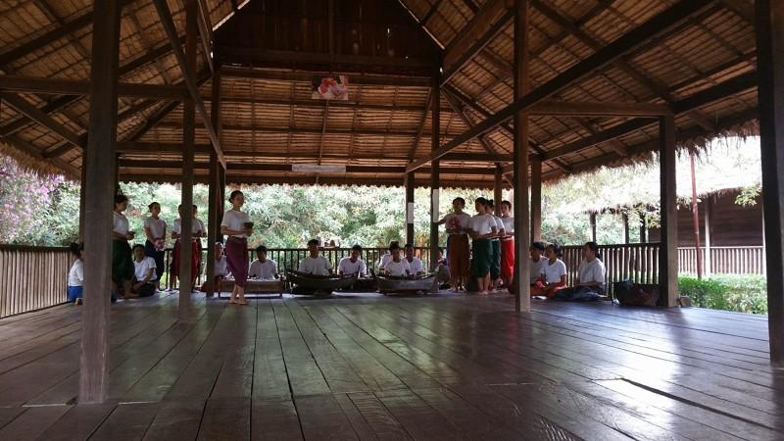
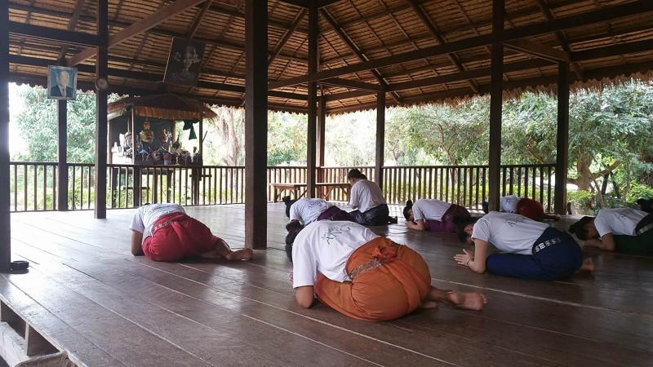
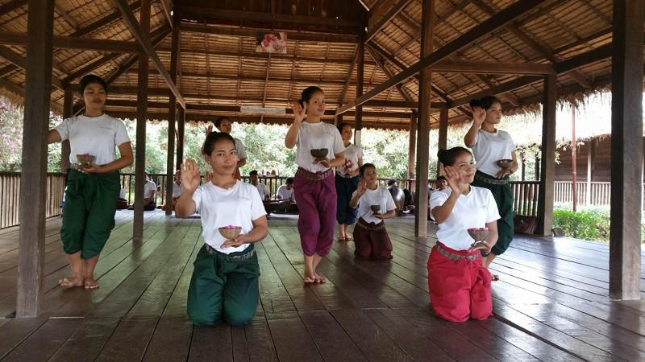

Easia Travel Head Office

Vietnam Head OfficeC/o: ATS Hotel, Suite 326 &327, 33B Pham Ngu Lao Street, Hanoi, VietnamTel: +84 24-39 33 13 62www.easia-travel.com

