CAMBODIA – Kep – Tropical Island Hideaway
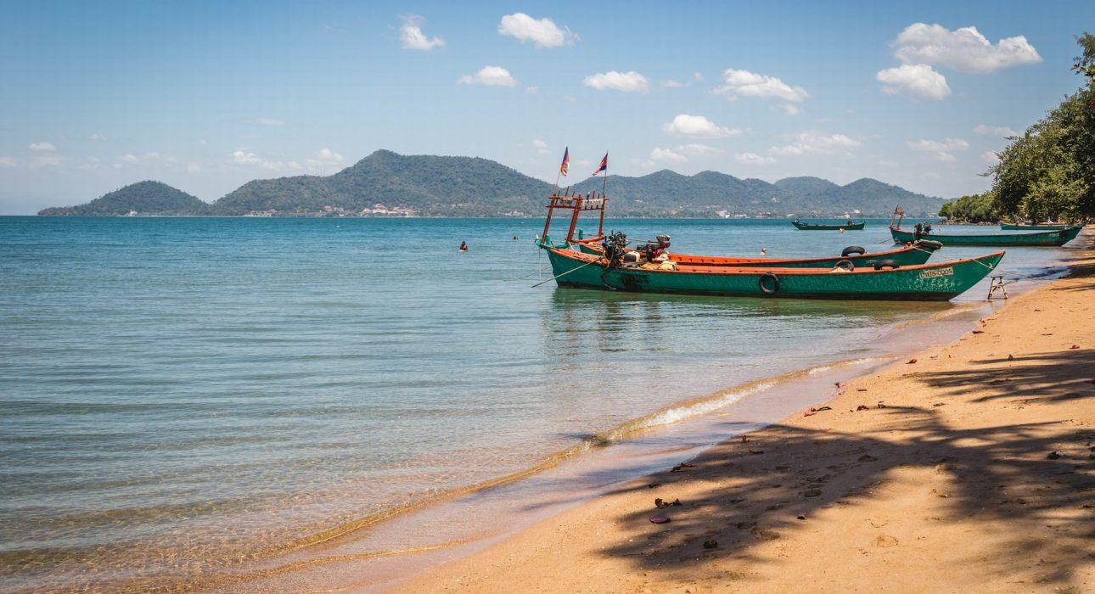

Over View

Theme
Beach Stay, Family, Honeymoon, Sustainable, Wellness

Country - City
Cambodia - Kep

Market segment
Groups, Thematic Leisure

Price Level
$$$$

Level of difficulties
LEVEL 0

Max pax
40pax

Seasonality
All Year Round but preferable from November to May

Arrival city
Kep / Kampot

Departure city
Kep / Kampot

Description

Tropical Island excursion (High-end)On this exclusive tour, guests will cruise for around 45 minutes aboard a local private boat to a small island where they can relax in a peaceful atmosphere and feast on a freshly caught seafood BBQ prepared by an on-site chef while enjoying this remote environment, sitting on the beach, enjoying the sun, or snorkeling in the shallow waters, while the guide and local chef prepare a BBQ feast of fresh seafood, served in a beautiful setting right on the beach.Settled peacefully, guests can enjoy the surroundings and tropical atmosphere before cruising back to the mainland.
Tropical Island excursion (Deluxe)On this unique tour, you will cruise for around 45 minutes aboard a local private boat and discover the Kep archipelago’s seabed by snorkeling above corals and colorful fishes. Chill in the warm water before enjoying a fish and seafood BBQ prepared on the boat. Take the time to explore the island, its traditional fisherman village, and the daily life of its inhabitants.Finish the day by cruising back to the mainland.
Koh Tonsay (Standard)In the morning, embark on a local boat and cruise for around 30 minutes to the small and serene island of Koh Tonsay to indulge in and relax on its beautiful beach.Also referred to as “Rabbit Island,” this little gem allows guests to enjoy cold drinks and fresh seafood in a local restaurant, relax on the beautiful beach, have a refreshing swim, and enjoy a day far away from the crowds. In the early afternoon, meet the boat again to return to Kep.

Selling points

Tropical Island High-end:
- Private tour designed to match any expectations by creating a feeling of exclusivity and luxury
- A great option to ensure relaxation, far from the tourist hot spots
- Delicious BBQ on the beach with a high-end set-up
- Free flow of sparkling wine & beer
Tropical Island Deluxe :
- A great option to ensure a tropical discovery, far from the tourist hot spots
- Discovery of snorkeling spots & local life on fishermen’s island
- Delicious BBQ on the boat with Rosé wine or beer
Koh Tonsay Standard:
- The best option for an island visit in Kep (more privacy, since not many tourists visit this island)
- This island is very easy to access; just a 30-minute boat ride to get to the island
- Flexible timing, from 4 to 7 hours (depending on guests’ needs)
- Good activity for an extra day visit in Kep

Sustainability

Level Of The Excursion
Medium – This activity offers tangible positive contributions to the local community, culture and/or environment

The Impact Of This Excursion

Environment Impact
Transportation

Economic Impact
Local individual benefits

Additional Information
Positive impact: support local businesses such as boats, restaurants, and local tour guides.

Time And Transportation

Photos

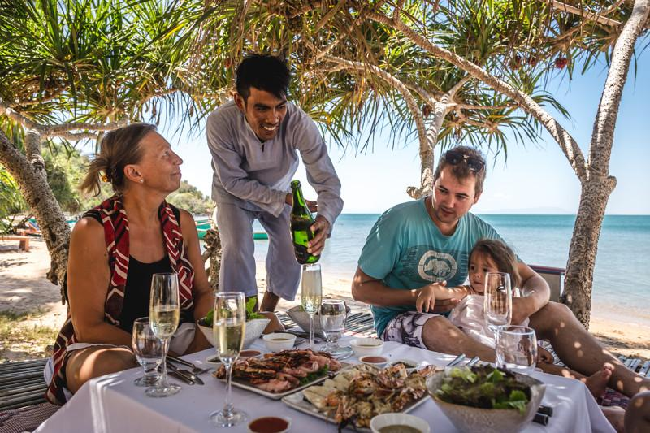
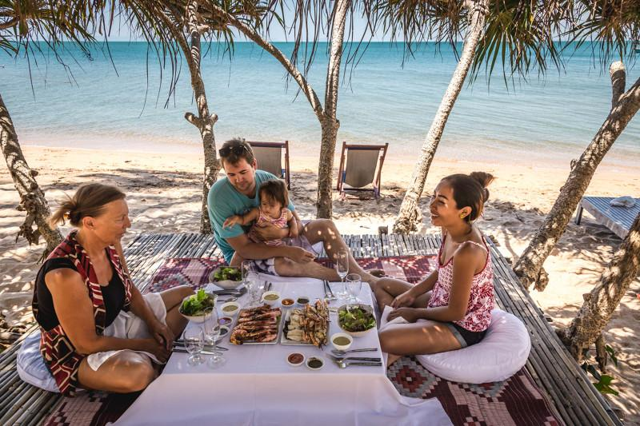
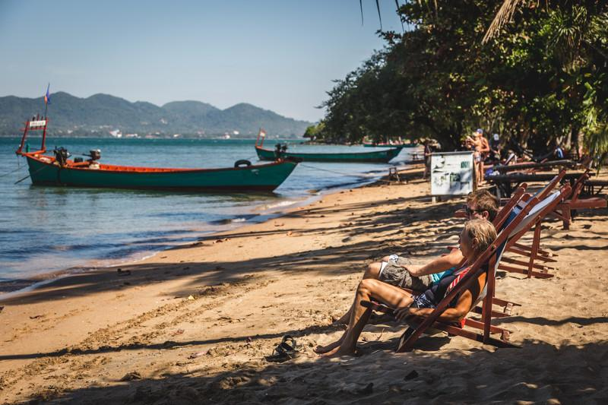
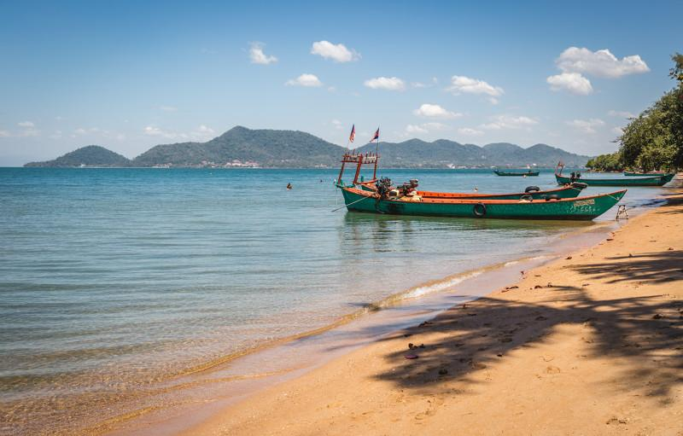
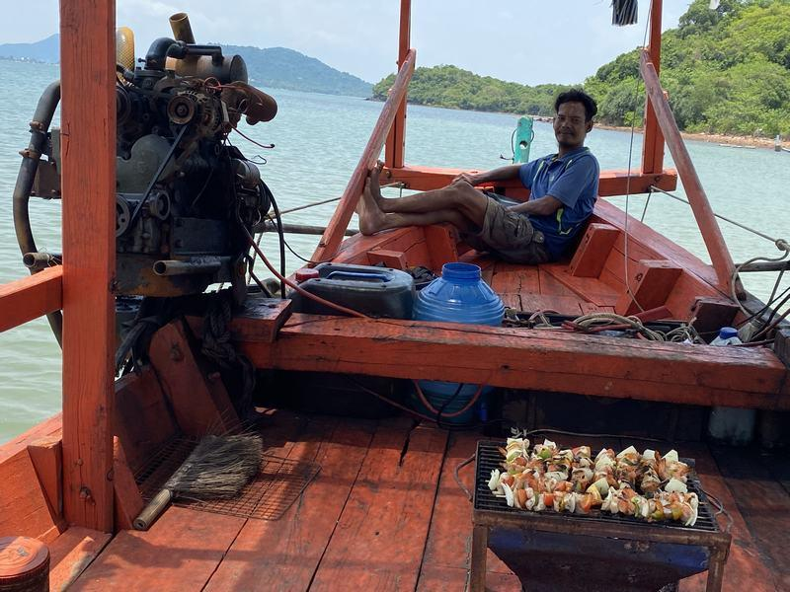
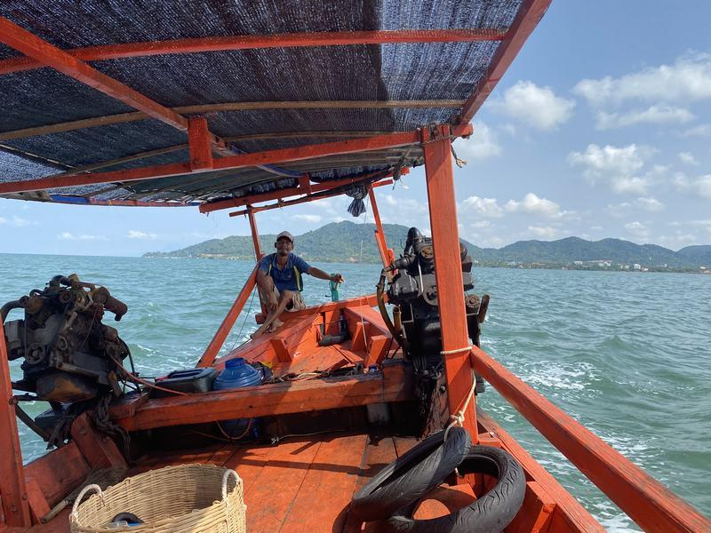
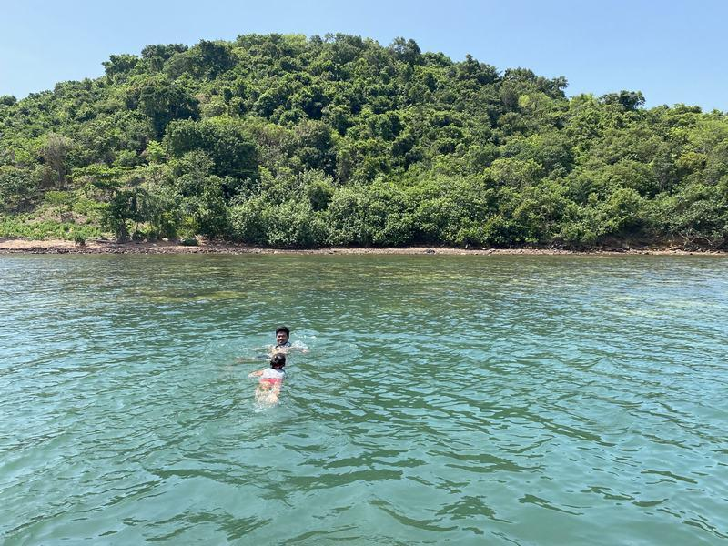
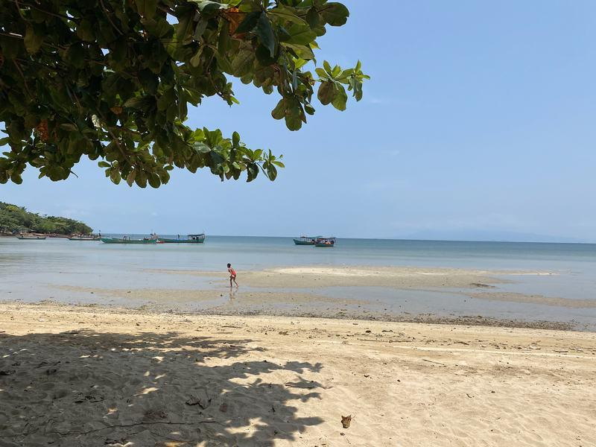

Easia Travel Head Office

Vietnam Head OfficeC/o: ATS Hotel, Suite 326 &327, 33B Pham Ngu Lao Street, Hanoi, VietnamTel: +84 24-39 33 13 62www.easia-travel.com

