CAMBODIA – Experience the Cambodian Train
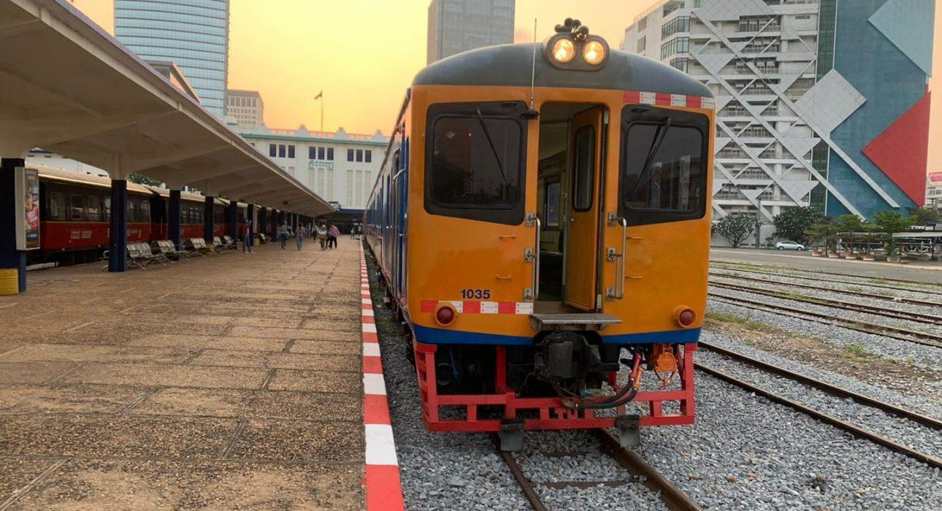

Over View

Theme
Art & Culture, Classic, Sustainable

Country - City
Cambodia - Kampot - Phnom Penh

Market segment
Groups, Thematic Leisure

Price Level
$

Level of difficulties
LEVEL 0

Max pax
140

Seasonality
All year round

Arrival city
It can be Phnom Penh, Kep, Kampot, Sihanoukville or Battambang based on destination chosen

Departure city
It can be Phnom Penh, Kep, Kampot, Sihanoukville or Battambang based on destination chosen

Description

Without a passenger railway network for many years, following the renovation of the old French colonial railway tracks, a new and exciting way to travel in Cambodia is available: A journey that brings a unique, nostalgic touch to a program like taking a train in Cambodia is now something considered special and unique!The tour offers an opportunity to travel along some of the most beautiful scenic vistas of Cambodia and afford deep insights into Cambodian people’s local lives. Passing tranquility through the sleepy rural landscapes, this leisurely journey is genuinely a mini-adventure that guests won’t forget to the train’s rhythm!

Selling points

- The old French colonial railway tracks are renovated, and now it is an exciting way to travel in Cambodia.
- To experience from the bustling capital to Kep, Kampot, Sihanoukville, or Battambang by train.
- A journey brings a unique, nostalgic touch to a program
- The trip comes with incredible sights, rural charm, and interaction with the locals.

Sustainability

Level Of The Excursion
Medium – This activity offers tangible positive contributions to the local community, culture and/or environment

The Impact Of This Excursion

Social/cultural Impact
Cultural Conservation

Environment Impact
Transportation

Economic Impact
Local individual benefits

Additional Information
Positive impact: Eco-friendly transportation if compare to normal transportation.

Time And Transportation

From | To | Km | By | Duration | Road Condition
Phnom Penh city center | Train station in Phnom Penh | 4km | Car | 10 minutes | Good
Train station in Kep | Kep Center | 15km | Tuk Tuk | 30 minutes | Good
Train station in Kampot | Kampot Center | 4km | Tuk Tuk | 10 minutes | Good
Train station in Sihanouk ville | Sihanoukville Center | 12km | Car | 25 minutes | Good
Train station in Battambang | Battambang Center | 4km | Tuk Tuk | 10 minutes | Good

Photos

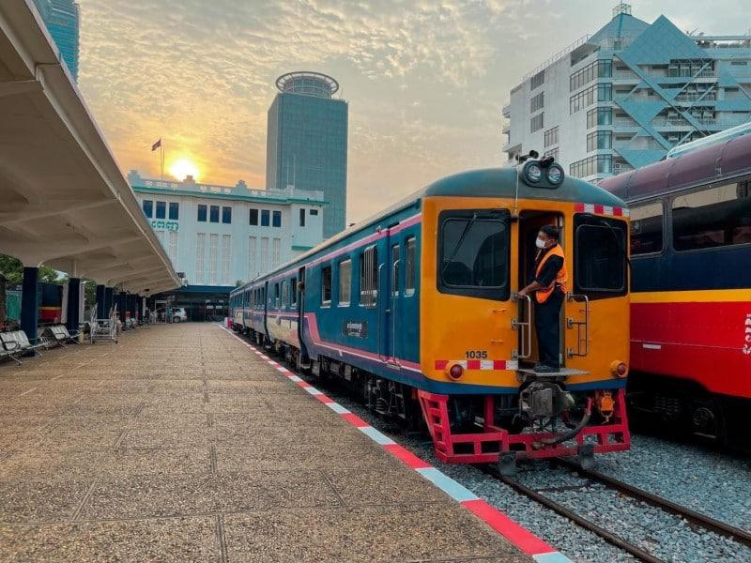
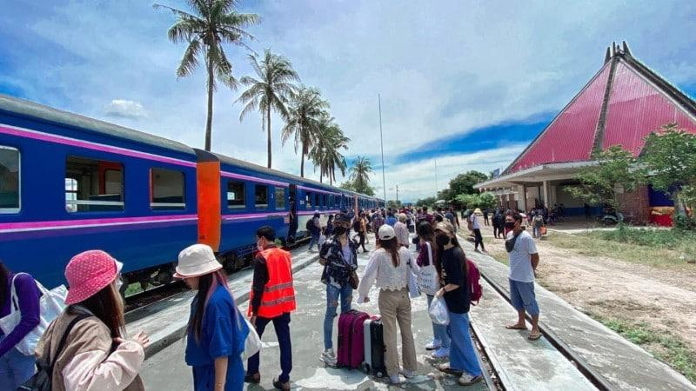
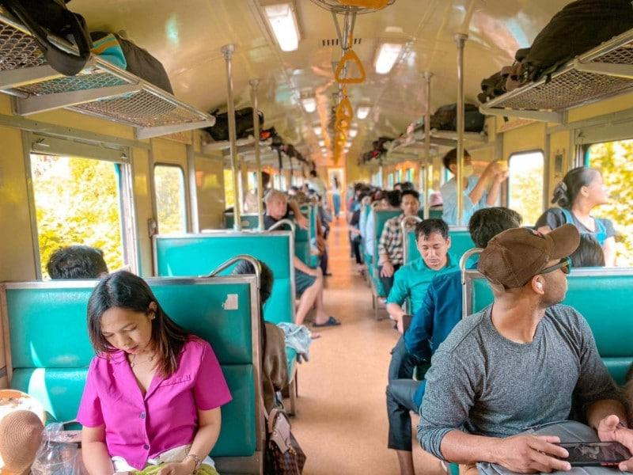
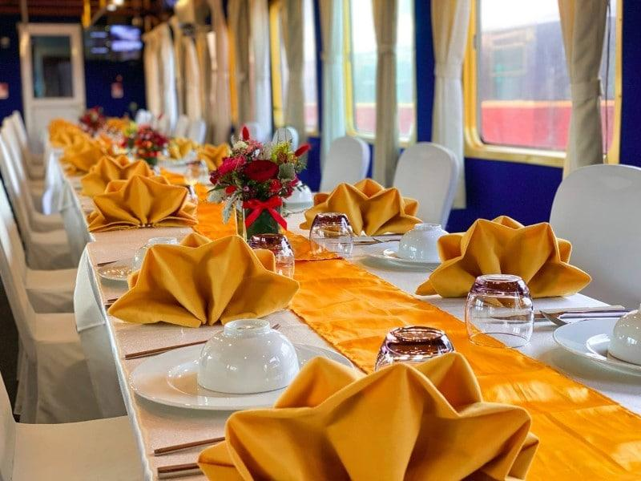
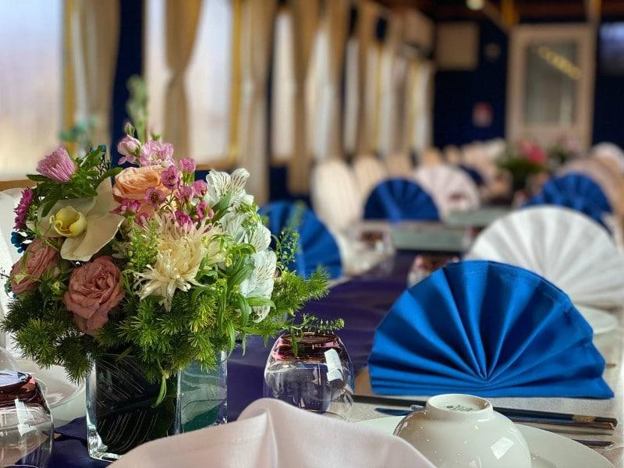
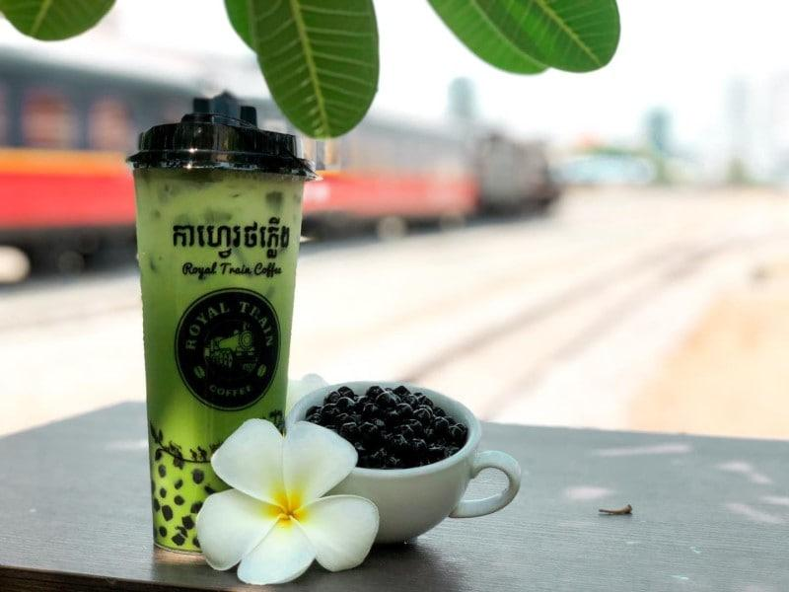
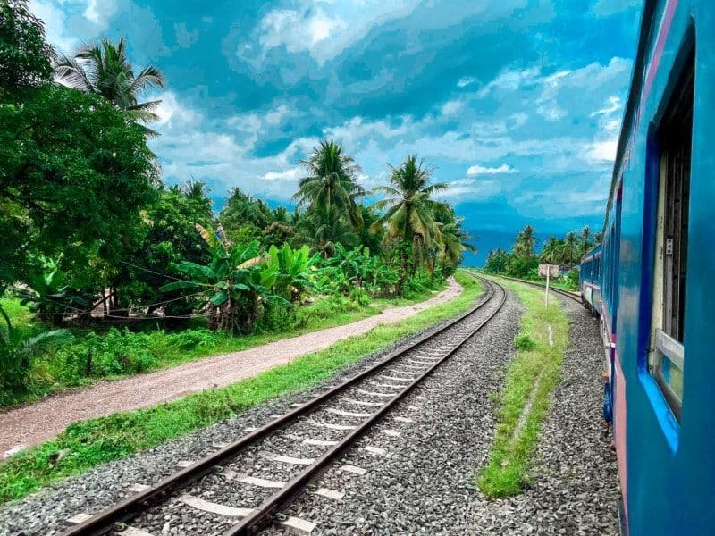
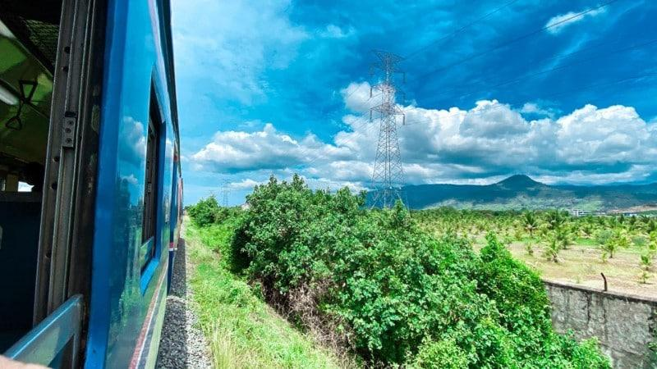
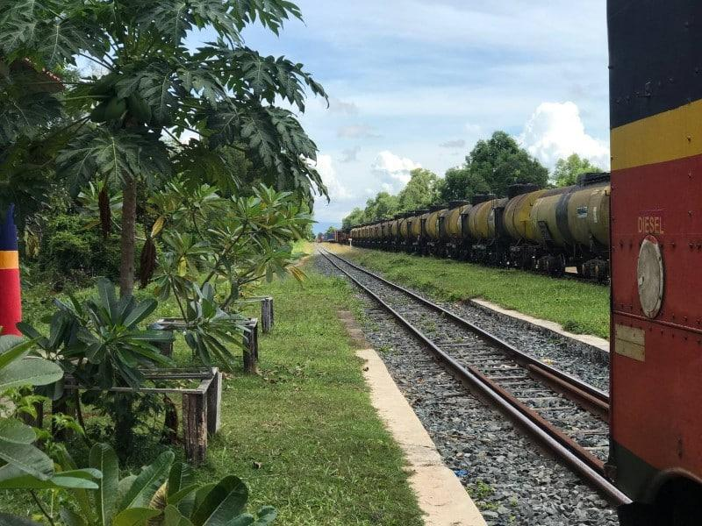
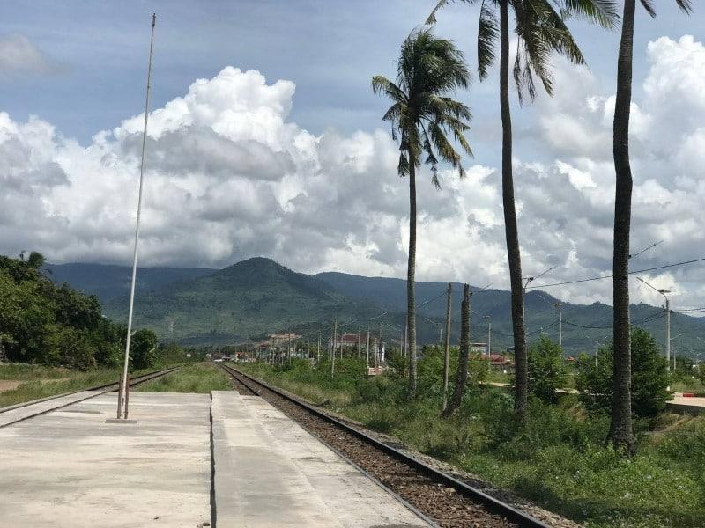
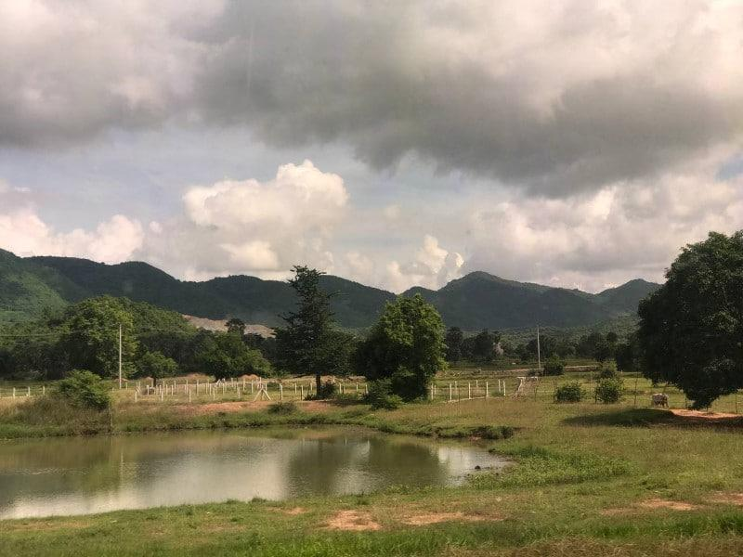

Easia Travel Head Office

Vietnam Head OfficeC/o: ATS Hotel, Suite 326 &327, 33B Pham Ngu Lao Street, Hanoi, VietnamTel: +84 24-39 33 13 62www.easia-travel.com

