THAILAND – Chiang Mai – Support a Good Cause by Painting an Elephant
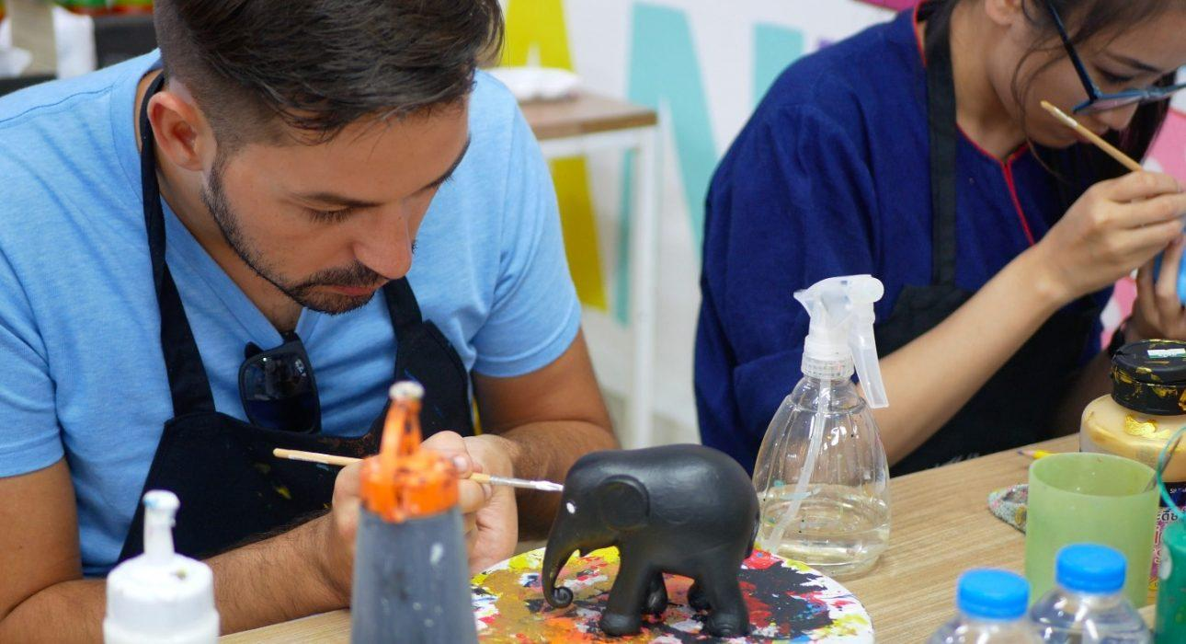

Over View

Theme
Art & Culture, Classic, Family, Sustainable

Country - City
Thailand - Chiang Mai

Market segment
Thematic Leisure

Price Level
$$$

Max pax
24

Seasonality
All Year Round

Arrival city
Chiang Mai

Departure city
Chiang Mai

Description

The activity starts with learning about the history of the conservation project and how they link art with business, and how elephant conservation fits into the equation at one of the Elephant Parade workshop locations. Under the supervision of the Elephant Parade staff, guests have the opportunity to customize a resin miniature elephant statue to their own liking, or copy an existing design by famous designers. Not only does this activity support a good cause, guests also have a unique and stylish souvenir to take home from their Thailand trip that demonstrates their commitment to environmental conservation. Besides that, it’s an absolutely unforgettable moment to see the professional production process from start to finish at the Elephant Parade Land in Chiang Mai.

Can be combined with
Thematic Leisure
- Chiang Mai – Experience the traditional Lanna lifestyle with a local family

Selling points

- To join an art workshop and paint your own Elephant Parade replica elephant and maybe become one of the exhibition’s artists if your work is put on display!
- To learn about Elephant Parade’s worldwide journey with internationally renowned artists and celebrities
- To learn about Asian elephants and the work The Asian Elephant Foundation are doing to save these magnificent but endangered animals
- To learn about the importance of elephant conservation

Sustainability

Level Of The Excursion
Low - This activity impacts local community, culture and/or environment in a small but meaningful way

The Impact Of This Excursion

Social/cultural Impact
Empowerment and education

Economic Impact
Local individual benefits

Additional Information

Positive impacts
Participating in this activity raises awareness and educates about the situation of elephants in Thailand. Part of the income is also used to support projects and charities related to the topic

Negative impacts
No negative

Time And Transportation

From | To | Distance | By | Duration | Road condition
Chiang Mai Airport | Elephant Parade Land (Chiang Mai) | 20 kilometers | Car | 30 minutes | Good
Elephant Parade Land (Chiang Mai) | Doi Suthep temple | 30 kilometers | Car | 1 hour | Good, but crowded
Elephant Parade River City (Bangkok) | Grand Palace | 5 kilometers | Car / Boat | 30 minutes | Good but crowded
Elephant Parade River City (Bangkok) | Siam Square | 3,5 kilometers | Car | 20 minutes | Good but crowded

Photos

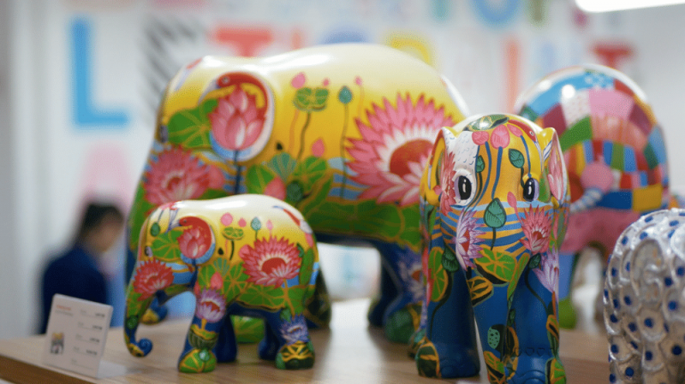
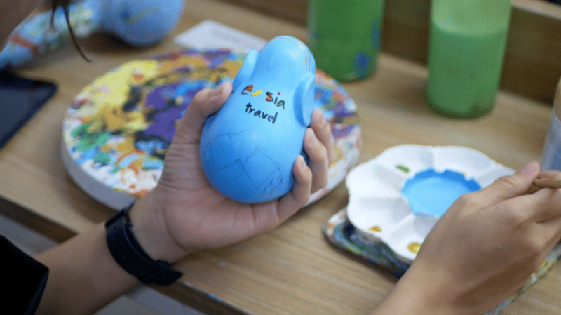
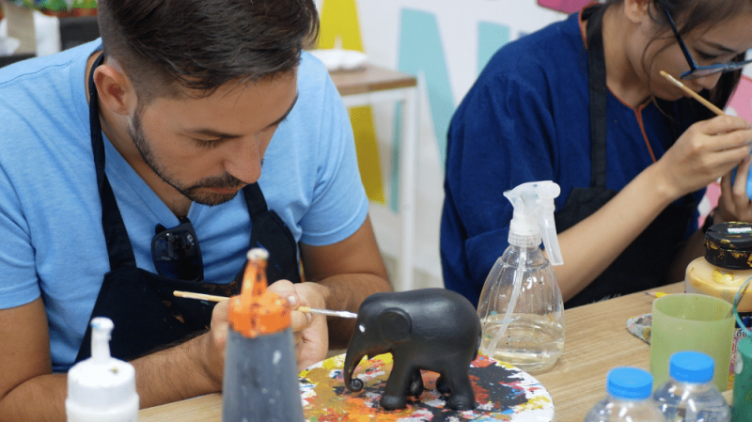
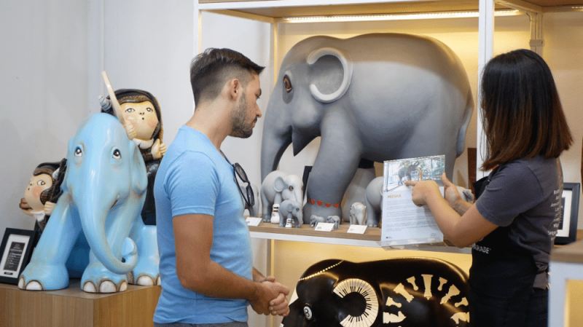
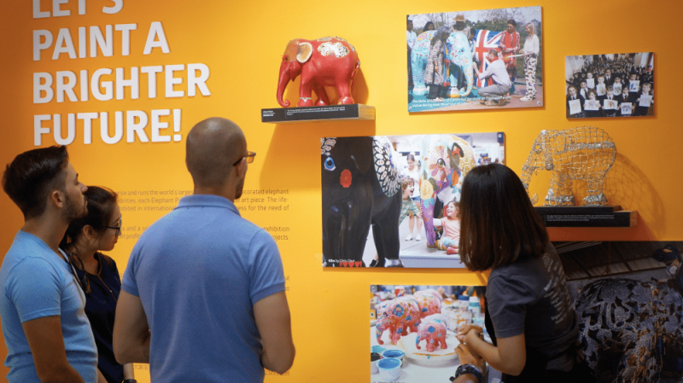

Easia Travel Head Office

Vietnam Head OfficeC/o: ATS Hotel, Suite 326 &327, 33B Pham Ngu Lao Street, Hanoi, VietnamTel: +84 24-39 33 13 62www.easia-travel.com

