CAMBODIA – Siem Reap – Kayaking on Tonle Sap lake
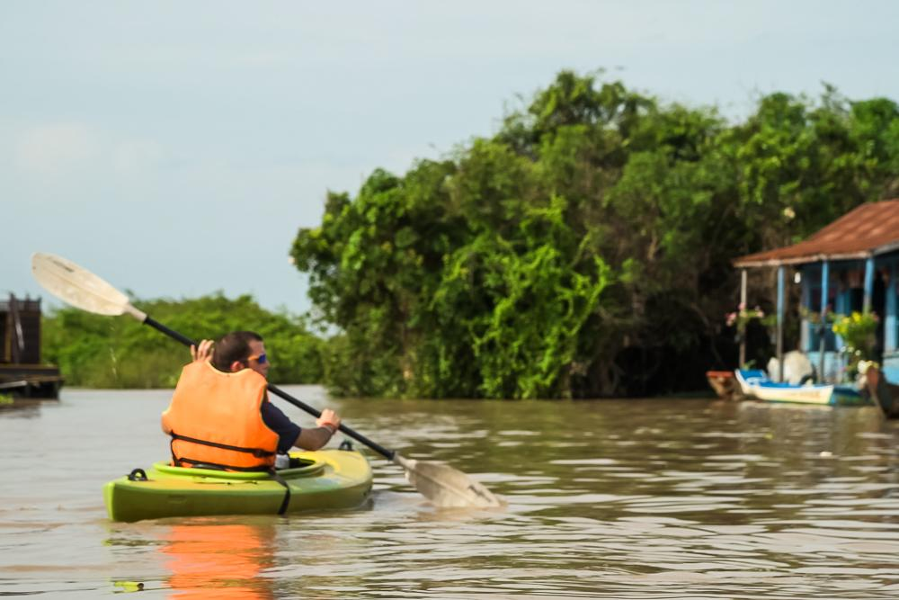

Over View

Theme
Art & Culture, Family, Sustainable

Country - City
Cambodia - Siem Reap

Market segment
Groups, Thematic Leisure

Price Level
$$$

Level of difficulties
LEVEL 1

Max pax
20

Seasonality
August - January

Arrival city
Siem Reap

Departure city
Siem Reap

Description

This half-day tour allows you to discover beautiful Cambodian landscapes untouched by tourism. It’s also an excellent way to interact with the local people, learn about their lifestyle, and visit one of the many floating villages on the great Tonle Sap Lake, the largest lake in Southeast Asia.This half-day tour allows you to discover beautiful Cambodian landscapes untouched by tourism.The tour starts with a 30-minute trip to the boat pier, where a local boat will bring travelers to the starting point, and a local guide will be waiting with the kayaks ready. After a safety briefing, travelers will gently start to kayak through the authentic Mechrey floating village, meet the local villagers, and learn about their daily lives.Afterward, guests stop for a snack on a floating house, tasting some local food, before proceeding to the massive and wide-open Tonle Sap Lake, where they glimpse the incredible scenery, rare vegetation, and birds.The activity can be done in the morning or afternoon.Single and twin kayaks are available to make it easier for parents to do the activity with their children.
Level: 1
Distance and duration of kayaking: 2 hours
Transportation:
1 hour – trip from the town to the boat pier
1 hour – return trip from boat pier to starting point / Local boat back up during the kayaking
Note: No previous Kayaking experience is needed.

Selling points

- To enjoy the natural Cambodian landscapes and fauna on Tonle Sap, away from bustling Siem Reap
- To experience and learn about the daily life of Khmer people, whose lives revolve around the water
- To offer fun activity which allows guests to see beautiful landscapes in the countryside
- To learn about the authentic lifestyle of the inhabitants of a floating village

Time And Transportation

From | To | Km | By | Duration | Road condition
Siem Reap | Mechrey | 27 | Car/bus | 60 minutes | Good
Mechrey | Siem Reap | 27 | Car/bus | 60 minutes | Good

Photos

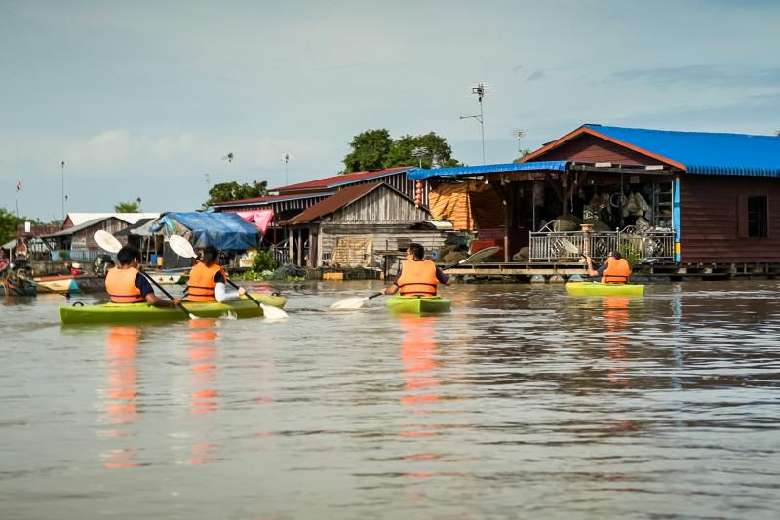
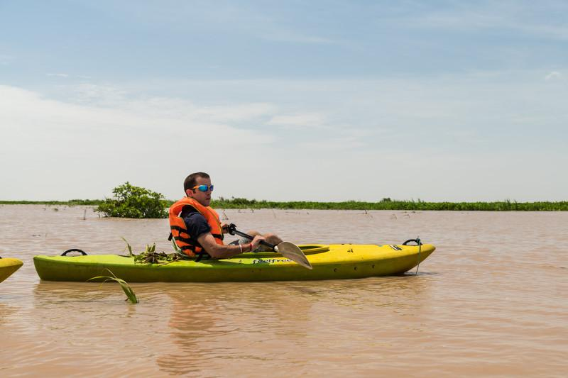
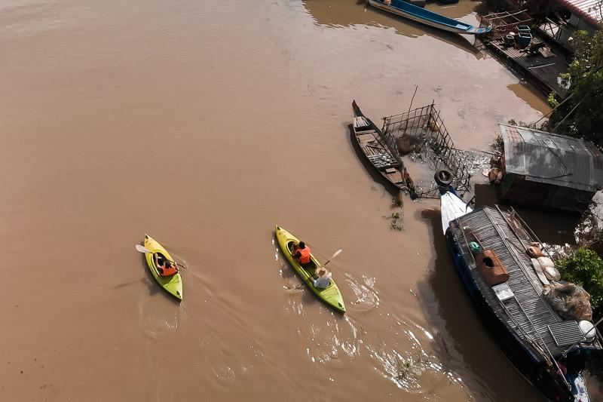
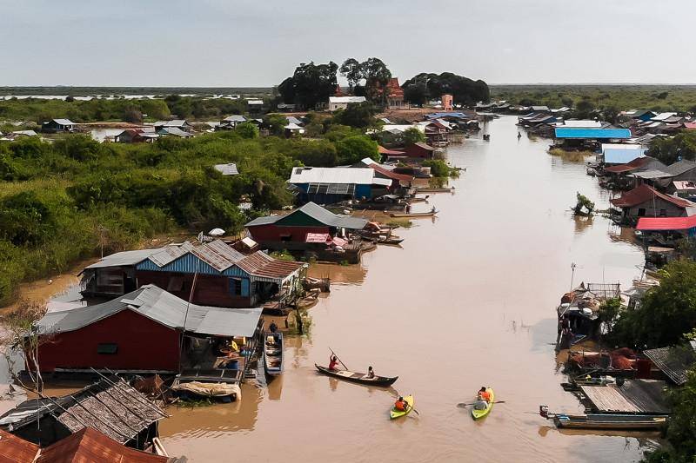
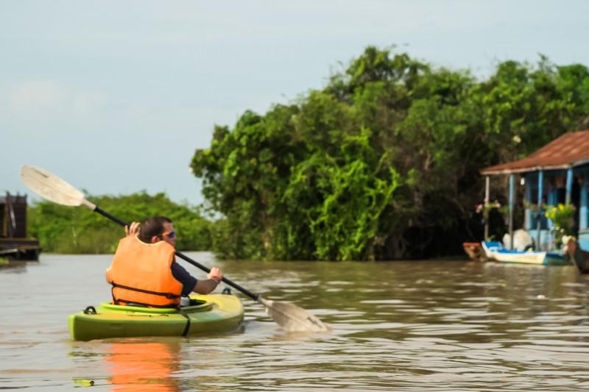

Easia Travel Head Office

Vietnam Head OfficeC/o: ATS Hotel, Suite 326 &327, 33B Pham Ngu Lao Street, Hanoi, VietnamTel: +84 24-39 33 13 62www.easia-travel.com

