VIETNAM – Hanoi -Enjoy a Royal Performance: The Lion Dance
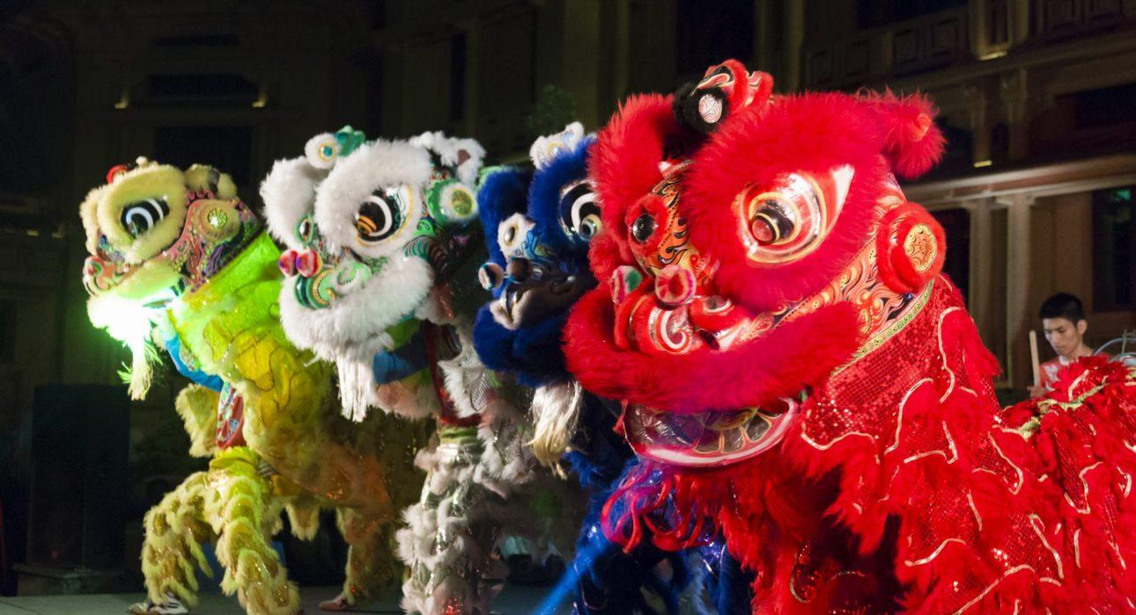

Over View

Theme
Art & Culture, Classic, Family, Honeymoon

Country - City
Vietnam - Hanoi

Market segment
Groups, Thematic Leisure

Price Level
$$

Max pax
400

Seasonality
All Year Round

Arrival city
Hanoi

Departure city
Hanoi

Description

- The Lion Dance is an ancient tradition originating from China that combines costume art, performance and Kung-fu inspired acrobatics. The performance artists, two in each costume, mimic the animal’s moves to the rhythm of a drum, cymbals and a gong. This magical and symbolical performance, which has existed for millennia, requires the dancers to train for several years to reach the level of coordination and dexterity required to create the illusion.
- Originally, the Lion Dance show was a form of royal entertainment executed solely in Hue in the Forbidden City, the lion symbolizing wealth, prosperity and happiness. Little by little, this art has spread through the whole country, but it is only performed for holidays and special occasions such as the mid-autumn festival and the lunar New Year (Tet). We offer a unique opportunity to enjoy a private performance with the rhythm of the drums, the beautiful colours of the costumes, and the striking realism of these half-real, half-fantasy lions.

Can be combined with
Thematic Leisure
- Hanoi – A stroll in the Old Quarter of Hanoi

Selling points

- A stunning show to discover this traditional art of Vietnam
- A lively performance with music, dancers & costumes
- The show is private

Time And Transportation

From | To | Km | By | Duration | Road condition
History Museum | Hoan Kiem Lake | 1 | Walking | 10 minutes | Good
Kim Lien Pagoda | Hoan Kiem Lake | 4 | Car | 20 minutes | Good

Photos

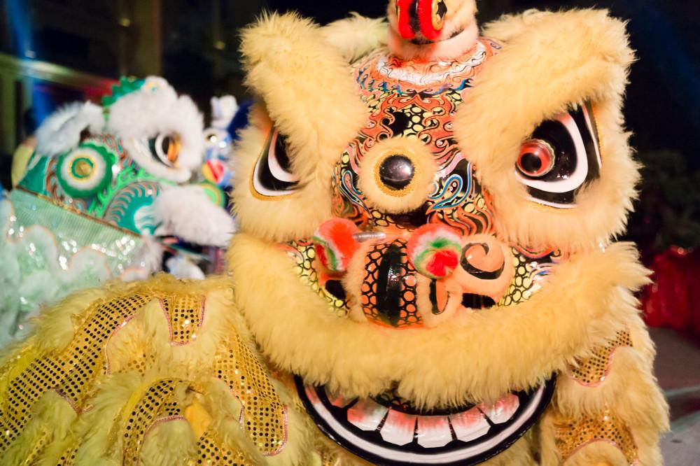
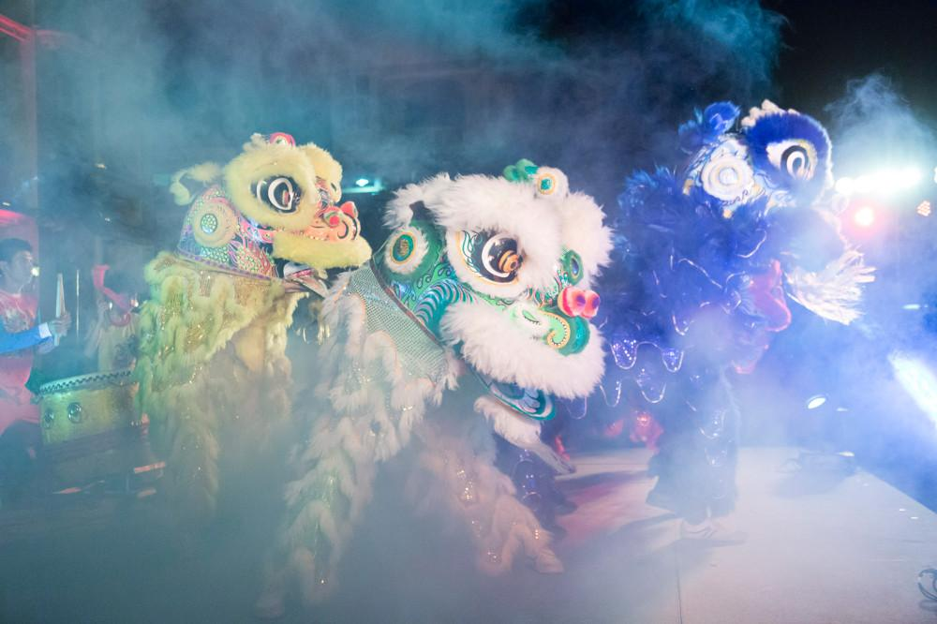
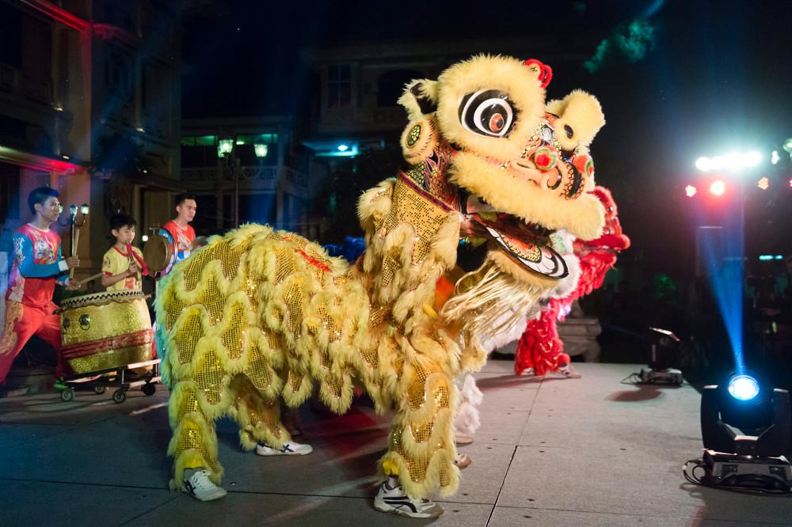
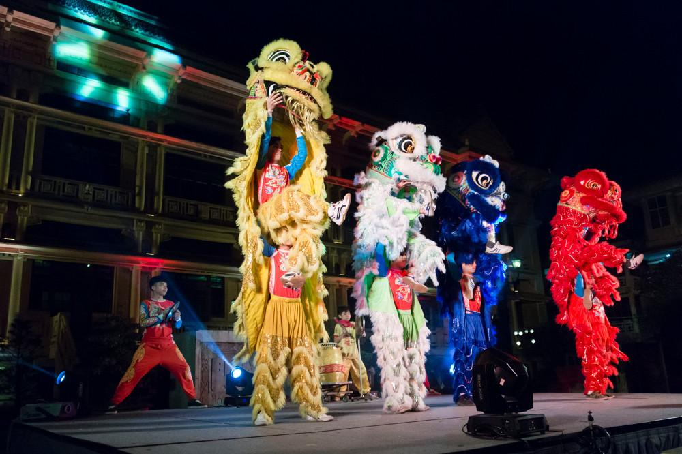
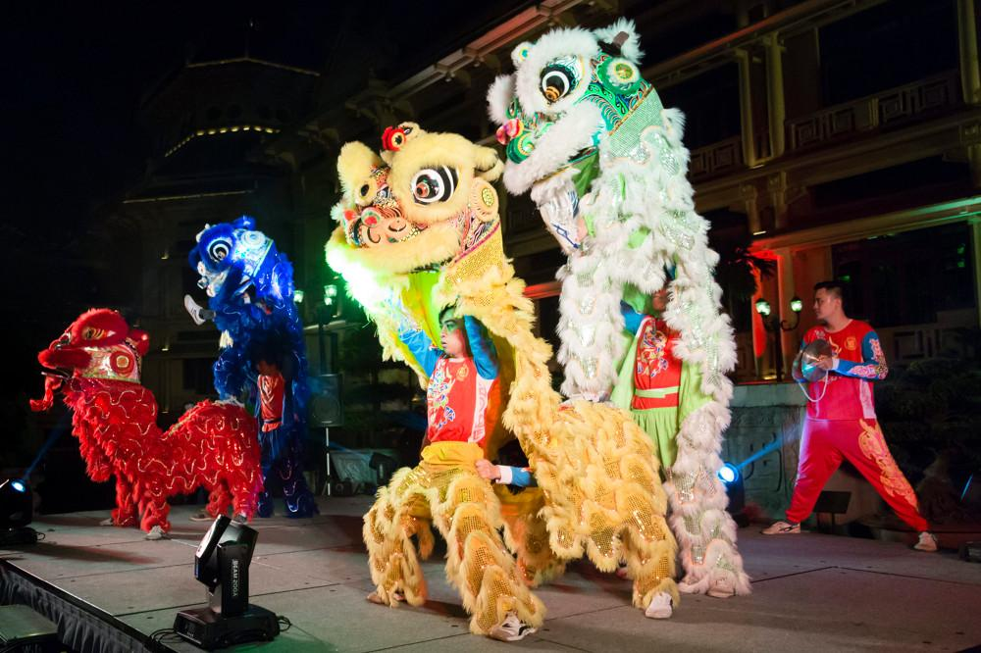

Easia Travel Head Office

Vietnam Head OfficeC/o: ATS Hotel, Suite 326 &327, 33B Pham Ngu Lao Street, Hanoi, VietnamTel: +84 24-39 33 13 62www.easia-travel.com

