VIETNAM – Hoi An – Countryside Bike Ride Around Duy Vinh Island
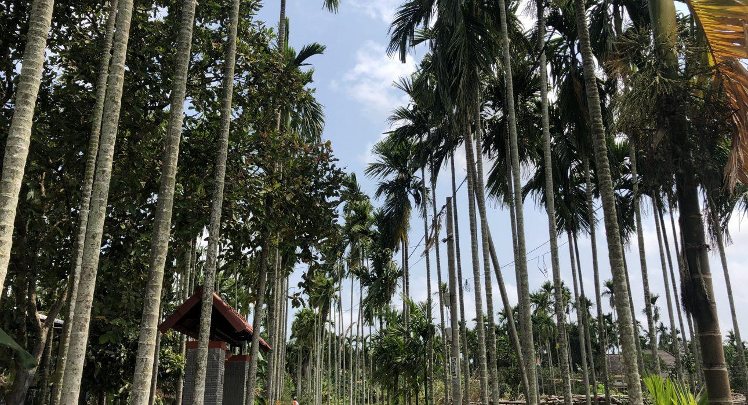

Over View

Theme
Art & Culture, Classic, Family, Gastronomy, Sustainable

Country - City
Vietnam - Hoi An

Market segment
Groups, Thematic Leisure

Price Level
$$

Level of difficulties
LEVEL 0

Max pax
70 (without lunch), 30 (with lunch)

Seasonality
From May to August for rush harvest, otherwise the dry season is recommended (January/September).

Arrival city
Hoi An

Departure city
Hoi An

Description

This excursion offers a cycling tour through the countryside of Hoi An, an opportunity to see its most charming spots and meet locals when pedaling around tranquil Duy Vinh Island. Exploring the traditional craft villages will also give travelers the opportunity to observe how locals create hand-made products to earn a living. They will end the tour with a cruise along the beautiful Thu Bon River.

Can be combined with
Thematic Leisure
- Hoi An – Dinner on the bamboo raft
- Hoi An – Discover Hoi An Street Food
- Hoi An – Private Yoga or Tai Chi Lesson

Selling points

- Cycling through villages to get a glimpse into the daily life of locals
- Discover beautiful landscapes along the way
- Meet local people and learn about their traditions and culture
- Discover local handicraft techniques

Sustainability

Level Of The Excursion
Medium – This activity offers tangible positive contributions to the local community, culture and/or environment

The Impact Of This Excursion

Social/cultural Impact
Empowerment and education, Homestays

Economic Impact
Community benefits

Additional Information
Positive Impact:This activity is made mainly by cycling in the countryside, with several stops including one for drinks at a local family home who have limited sources of income. Negative Impact:The return journey is made using a local boat with an old engine.

Time And Transportation

From | To | Distance | By | Duration | Road conditions
Tra Nhieu pier | Hoi An | 8 kilomters | Boat | 45 minutes | Good
Danang | Hoi An | 30 kilometers | Car | 50 minutes | Good

Photos

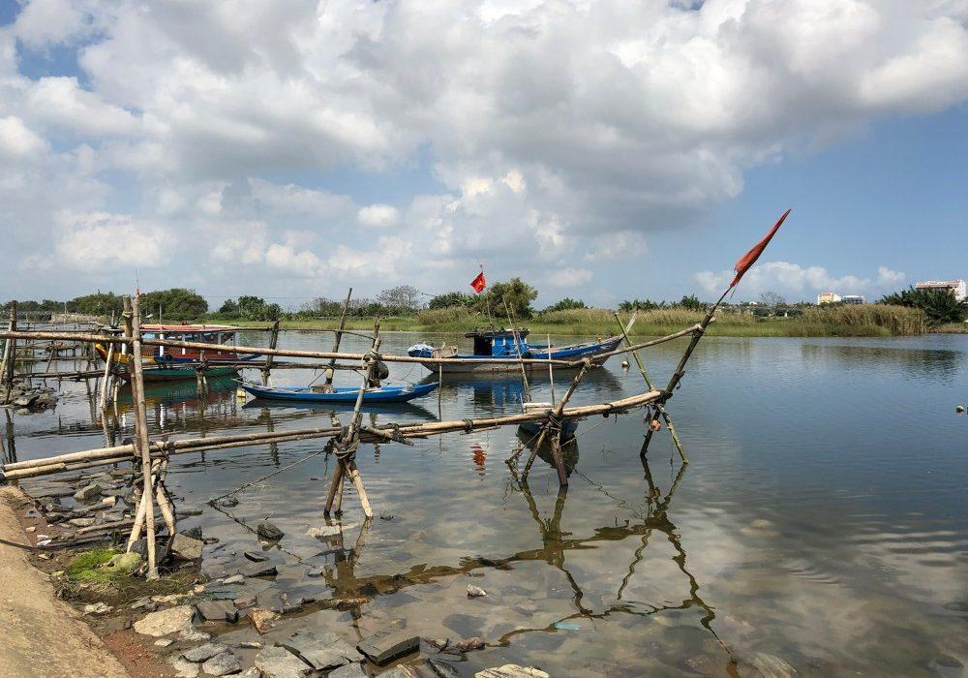
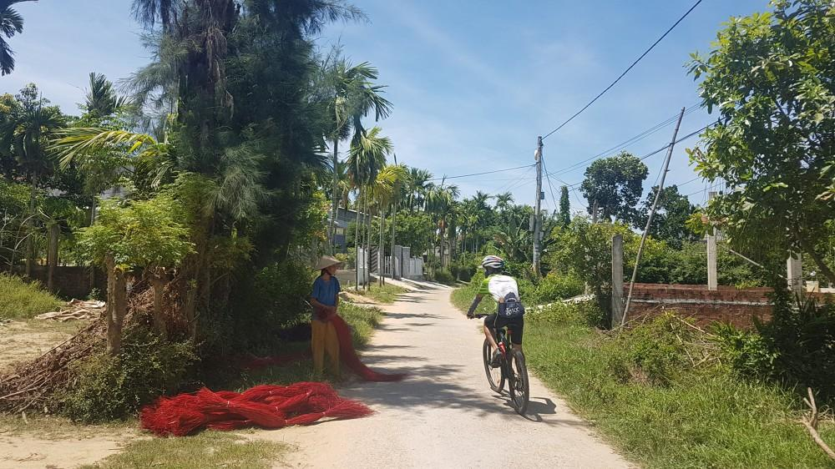
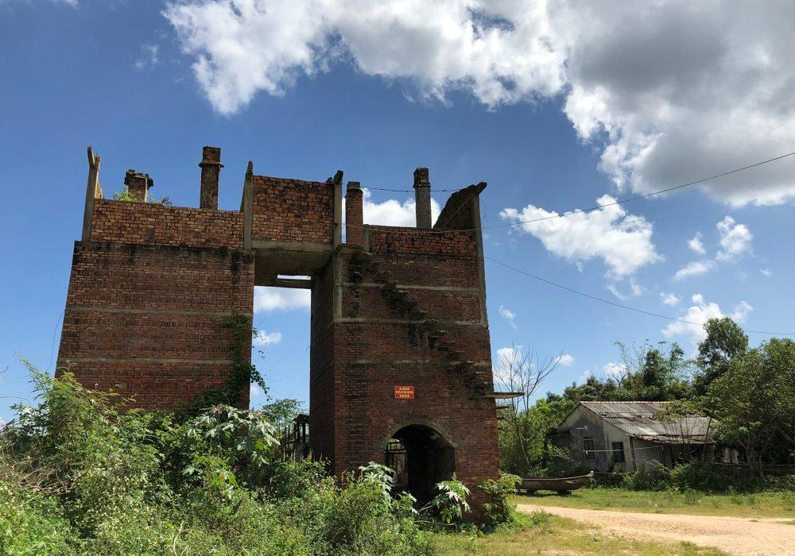
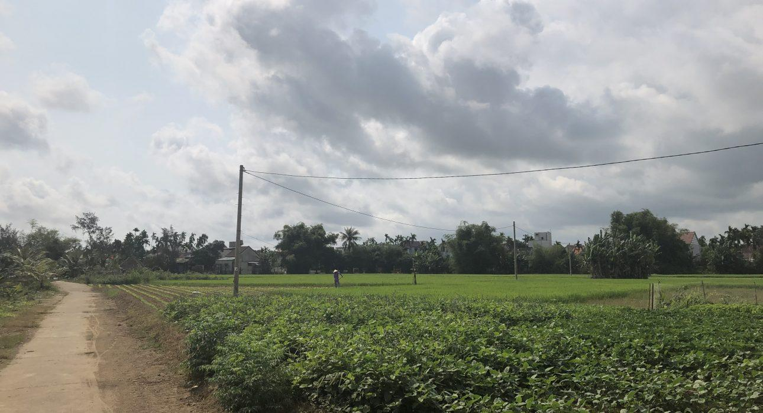
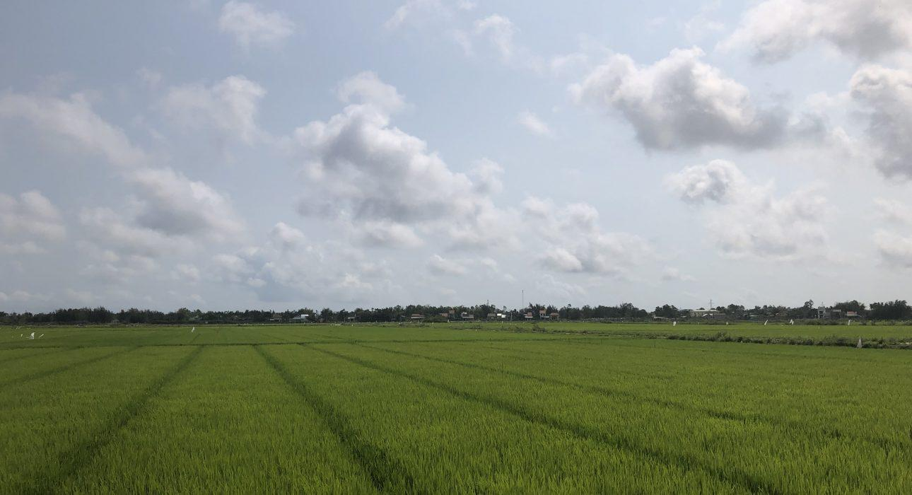
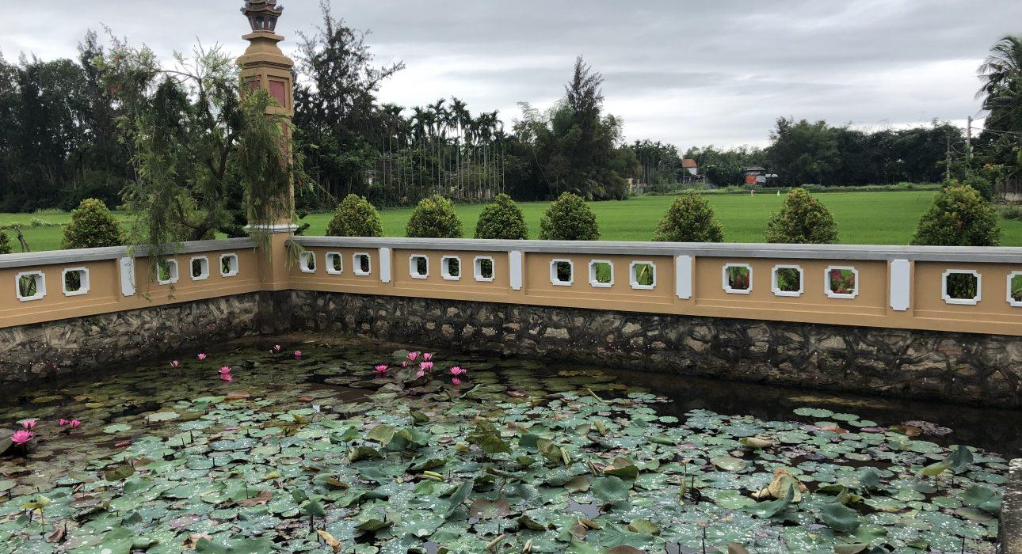
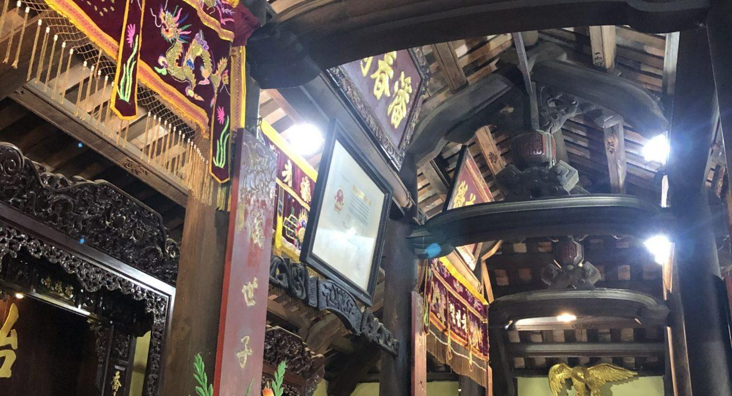
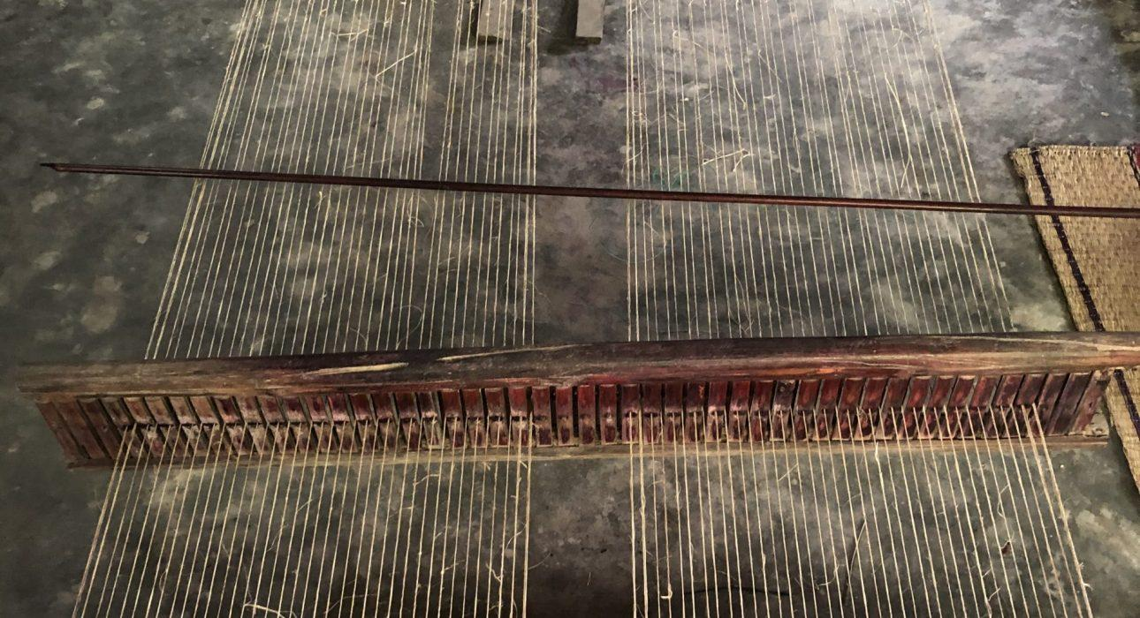
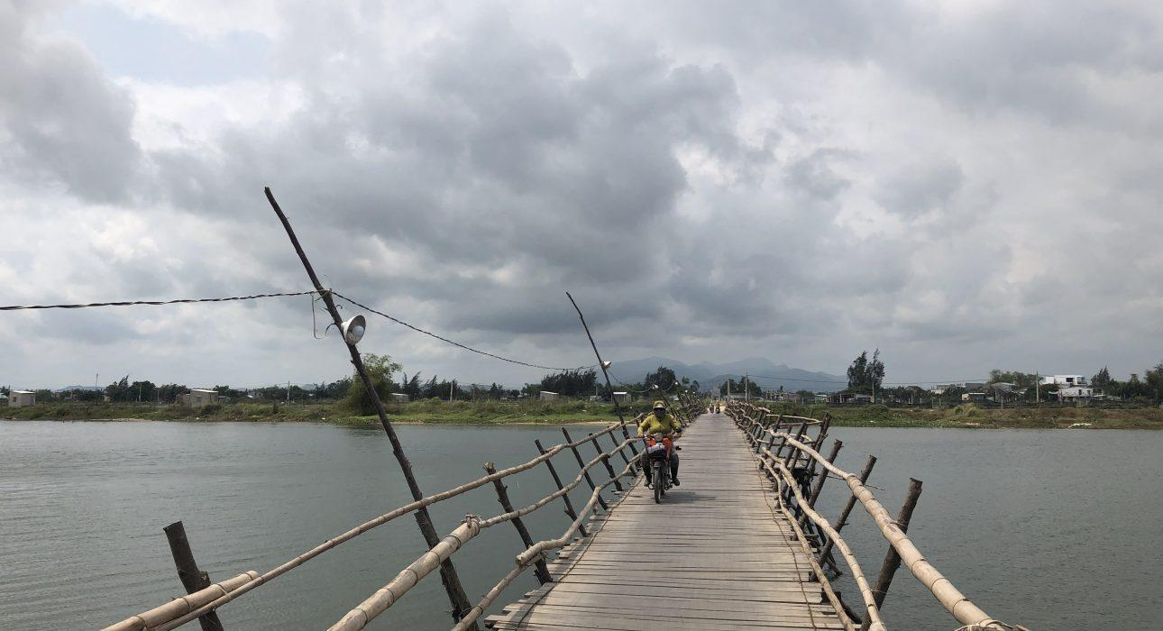

Easia Travel Head Office

Vietnam Head OfficeC/o: ATS Hotel, Suite 326 &327, 33B Pham Ngu Lao Street, Hanoi, VietnamTel: +84 24-39 33 13 62www.easia-travel.com

