LAOS – Vang Vieng – Hike to Pha Ngeun Peak
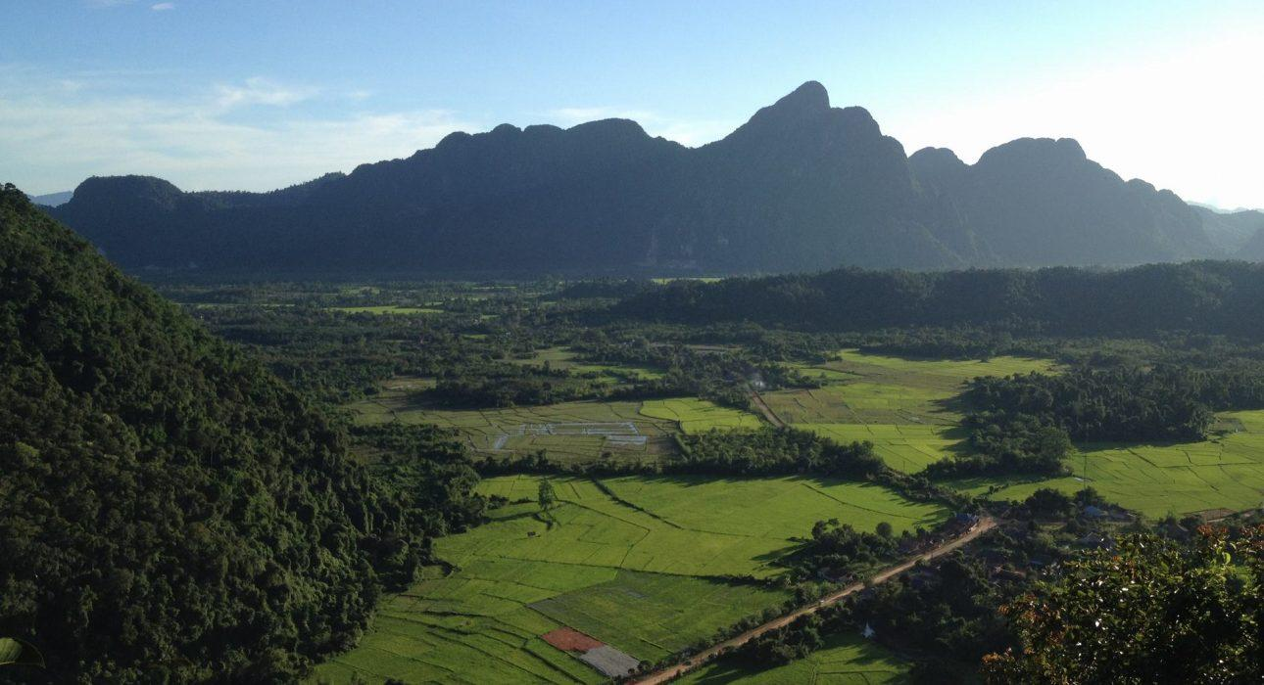

Over View

Theme
Classic

Country - City
Laos - Vang Vieng

Market segment
Thematic Leisure

Price Level
$$

Level of difficulties
LEVEL 1

Max pax
15

Seasonality
All Year Round

Arrival city
Vang Vieng

Departure city
Vang Vieng

Description

After a drive of 3 kilometers across the Nam Song River from Vang Vieng, a short walk leads to the foot of Pha Ngeun Peak. Then, the hike into the beautiful natural environment begins. The scenery is typical of the countryside surrounding Vang Vieng – jagged limestone peaks and mountains entirely covered with forest. A steep uphill climb (45 minutes to 1 hour) will be rewarded at the top by a dramatic view of the area – a 360-degree panorama of rice fields, forests and limestone peaks stretching all the way to the horizon. After a rest at the sala, from where one can contemplate the vista, the walk continues for about 40 minutes back down the mountain.

Can be combined with
Thematic Leisure
- Vang Vieng – Caving & Hiking in the surroundings
- Vang Vieng – Vang Vieng from Above
- Vang Vieng – Pony Trekking

Selling points

- To offer the most picturesque view of the natural landscapes around Vang Vieng.
- The sala at the top is a nice place to have a rest after the climbing.
- Good maintenance of the trail by the villagers.
- The entire trail is shaded by trees.

Time And Transportation

From | To | Km | By | Duration | Road condition
Vang Vieng Town | Pha Ngeun Peak | 3 | Songtheo | 15 minutes | Good

Photos

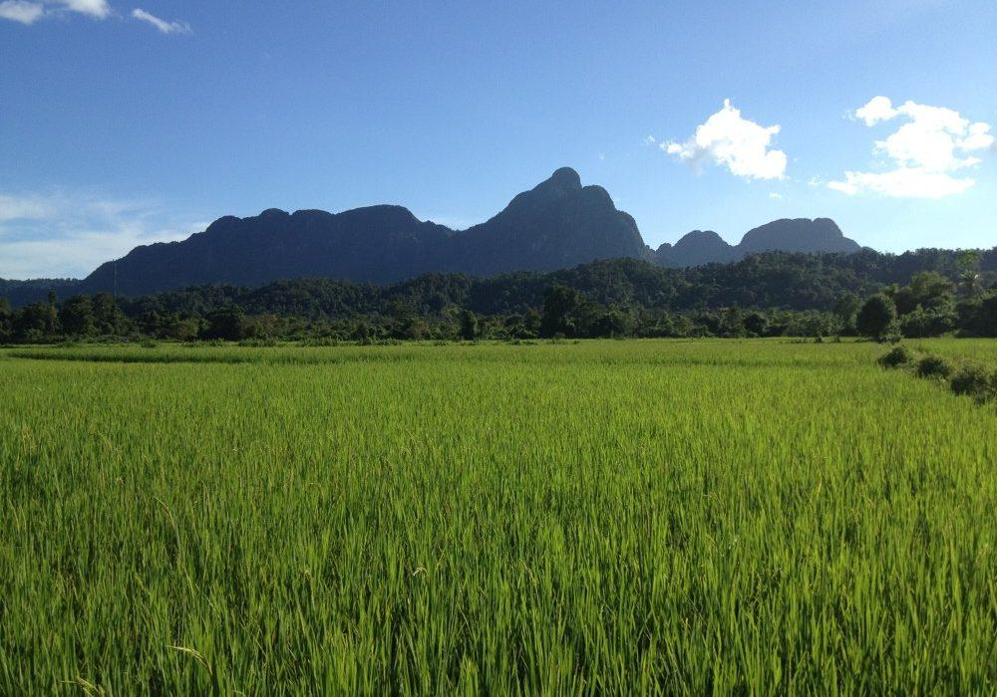
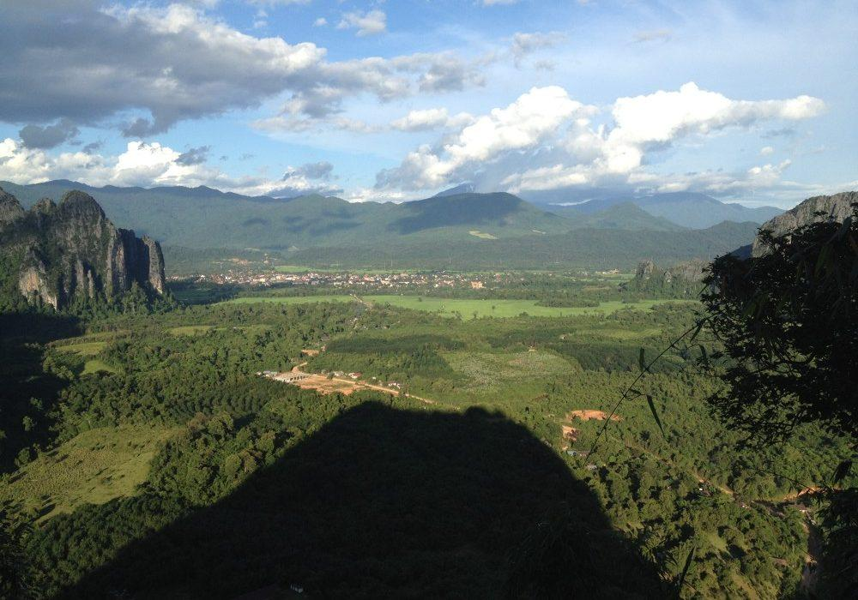
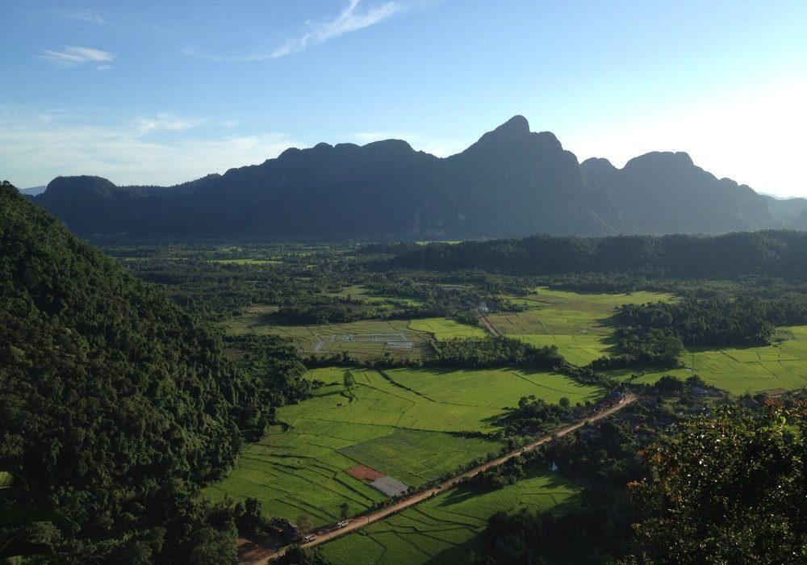
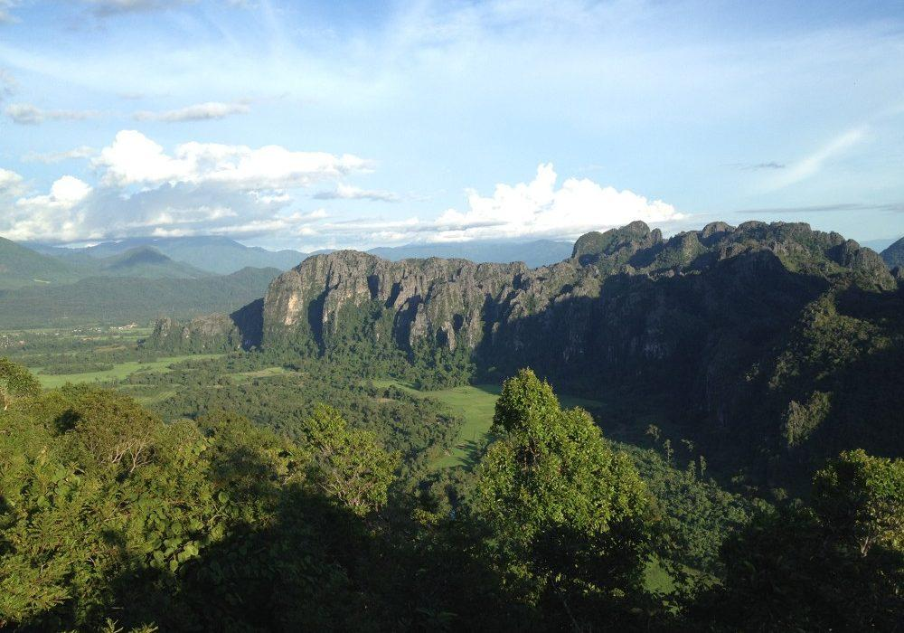
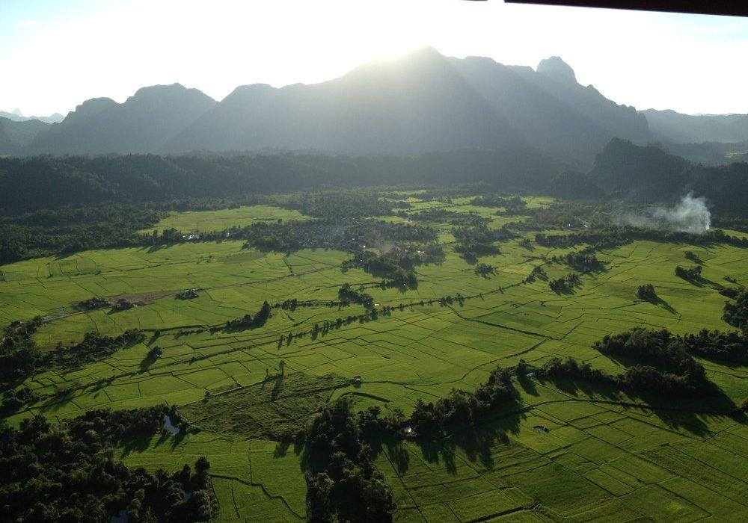
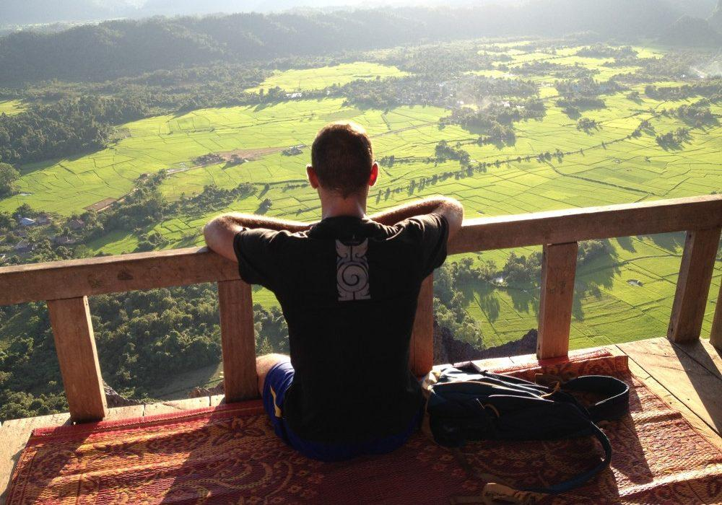

Easia Travel Head Office

Vietnam Head OfficeC/o: ATS Hotel, Suite 326 &327, 33B Pham Ngu Lao Street, Hanoi, VietnamTel: +84 24-39 33 13 62www.easia-travel.com

