LAOS – Luang Prabang – E-Mountain Bicycle Experience
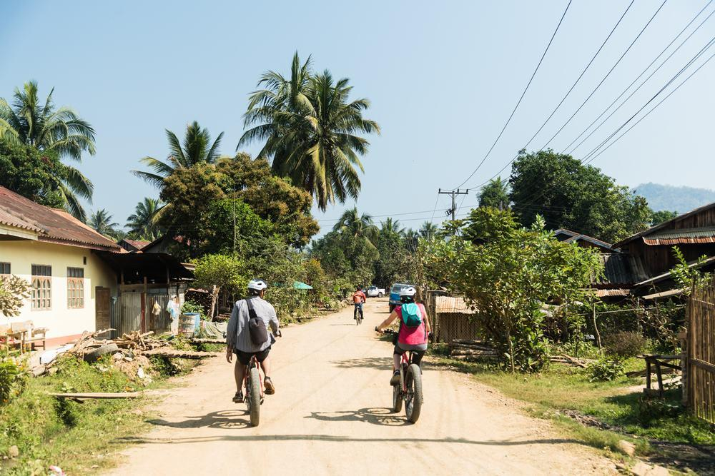

Over View

Theme
Art & Culture, Classic, Family, Sustainable

Country - City
Laos - Luang Prabang

Market segment
Thematic Leisure

Price Level
$$$$

Level of difficulties
LEVEL 2

Max pax
10

Seasonality
All Year Round

Arrival city
Luang Prabang

Departure city
Luang Prabang

Description

Chateau Orientale is located only 14 kilometers outside Luang Prabang and is the hub for this activity. Upon arrival, there is a short technical briefing. Travelers are assisted in picking out their E-mountain bicycle, which provides the key to enjoying stunning jungle views and experiencing traditional Khmu villages while barely breaking a sweat! The full-day option follows two off-road loops through jungles and villages and across several rivers before reaching Tad Sae Waterfall. A lunch stop at a hidden jungle waterfall or at the resort’s restaurant breaks up the journey. The half-day option follows a shorter loop along unpaved roads and jungle trails and ends with a delightful elephant encounter on the banks on the Nam Khan River – they love to be hand-fed bananas and have water splashed over them!Level:1-2There are 7 tour options available:
- Half-day E-mountain Bicycle and Elephant Experience – approximately 23 kilometers (3h) cycling
- Full-day E-mountain Bicycle Experience – approximately 42 kilometers (5h) cycling
- Half-day E-mountain Bicycle Experience (Beginner) – approximately 17 kilometers (2h30 minutes) cycling
- Half-day E-mountain Bicycle Experience (Intermediate) – approximately 23 kilometers (2h30 minutes) cycling
- Half-day E-mountain Bicycle and Kayaking/SUP Experience – approximately 17 kilometers (2h30 minutes) cycling and 5 kilometers (30-40 minutes) kayaking.
- Half-day Kayaking and Waterfall Adventure – approximately 10 kilometers (1h30 minutes-2 hours) kayaking
- Full-day E-mountain Bicycle and Kayaking/SUP Experience with an Elephant Encounter – approximately 40 kilometers (5h) cycling and 5 kilometers (30-40 minutes) kayaking.
- Private E-mountain Bicycle Hire

Selling points

- To experience more than usual on a day of touring by taking advantage of the E-mountain bicycle’s auxiliary motor.
- Enjoy a delicious lunch to unwind after the activity while overlooking the river and mountains.
- Travel through traditional Khmu villages-the Khmu are one of over 50 ethnic groups that make up the social fabric of Laos.
- Get up close and friendly to elephants in a sustainable manner.

Sustainability

Level Of The Excursion
Medium – This activity offers tangible positive contributions to the local community, culture and/or environment

The Impact Of This Excursion

Social/cultural Impact
Cultural Conservation

Environment Impact
Involving Wildlife

Economic Impact
Local individual benefits

Time And Transportation

From | To | Km | By | Duration | Road Condition
Night Market | Ban Xieng Lom | 15 | Car | 30 minutes | Good

Photos

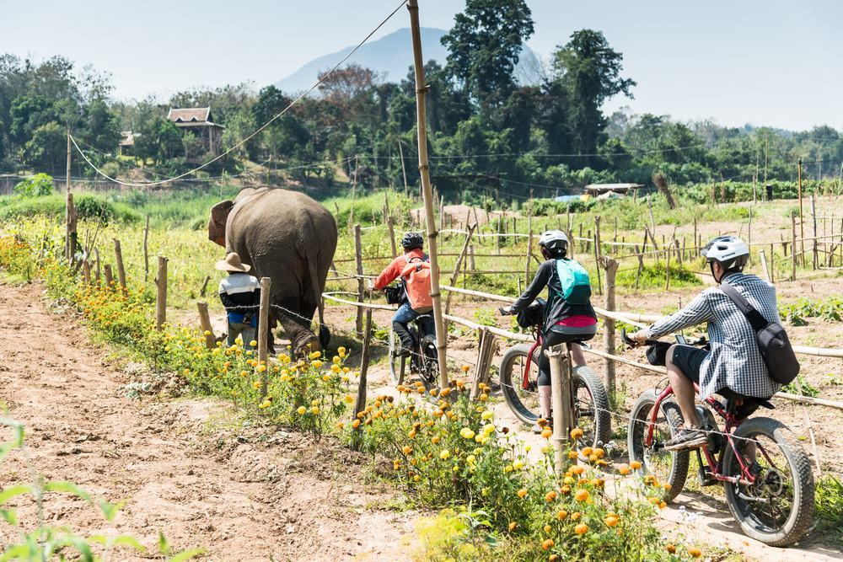
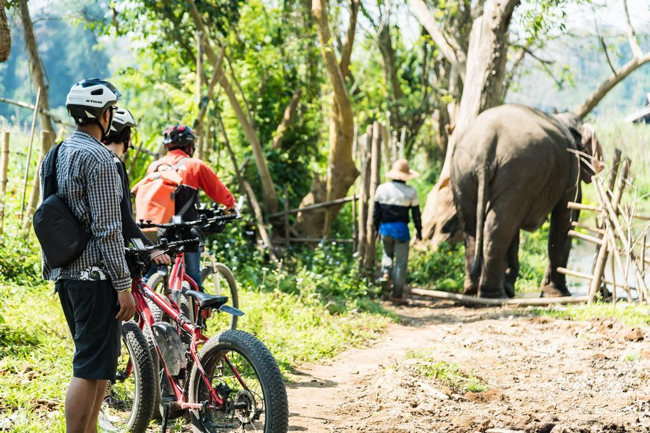
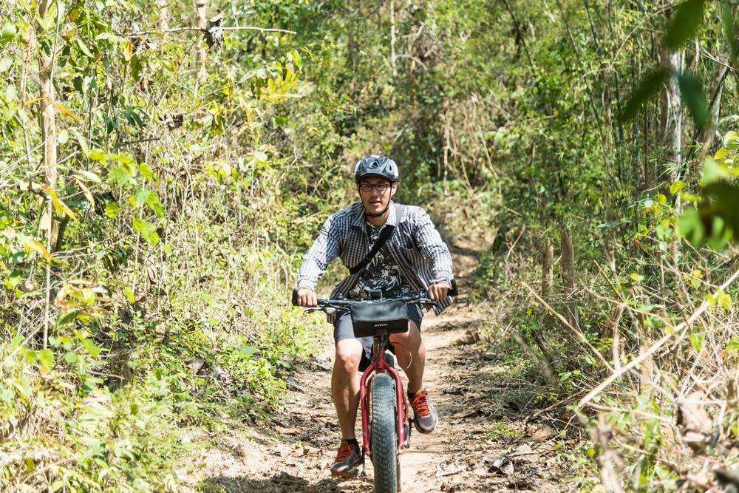
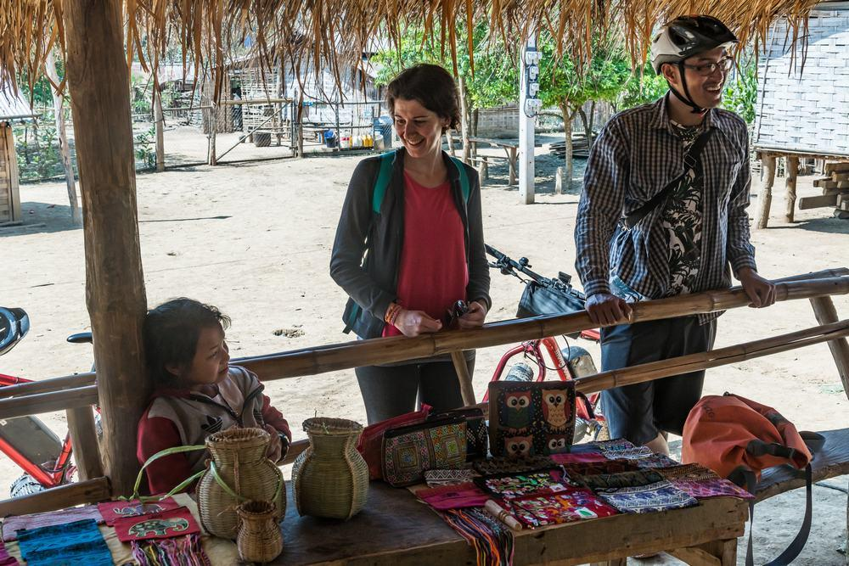
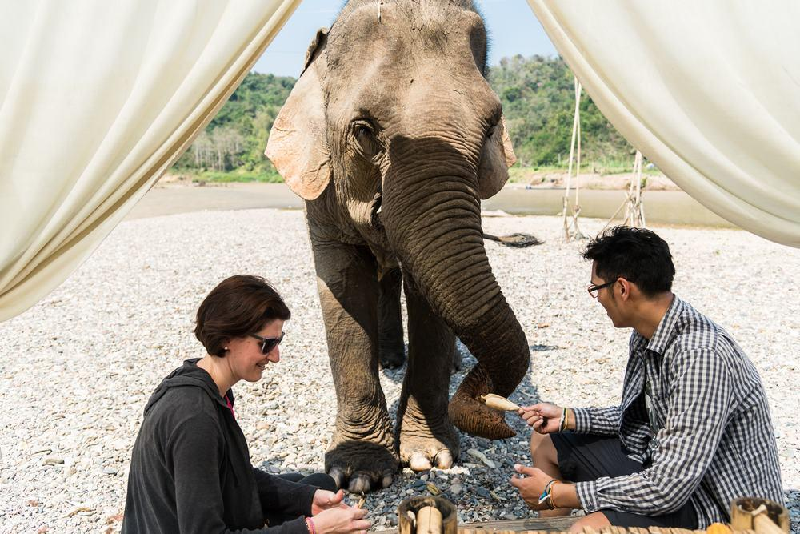

Easia Travel Head Office

Vietnam Head OfficeC/o: ATS Hotel, Suite 326 &327, 33B Pham Ngu Lao Street, Hanoi, VietnamTel: +84 24-39 33 13 62www.easia-travel.com

