VIETNAM – Ho Chi Minh City – Jeep tour Saigon by Night
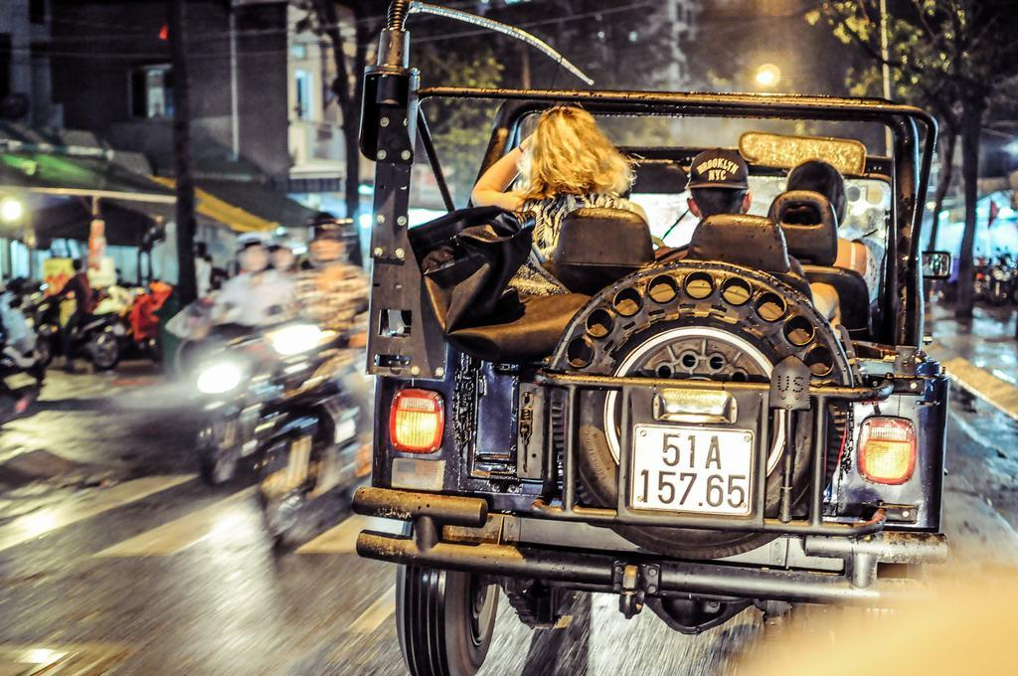

Over View

Theme
Classic, Family, Honeymoon

Country - City
Vietnam - Ho Chi Minh City

Market segment
Groups, Thematic Leisure

Price Level
$$$$

Max pax
20

Seasonality
All Year Round

Arrival city
Ho Chi Minh City

Departure city
Ho Chi Minh City

Description

The activity starts at the end of the afternoon – a perfect time to see the sun setting. This experience gives a chance to drive around the city as it illuminates and witness moments in the lives of the city’s inhabitants by stopping at several local restaurants to sample authentic food. On a Jeep at night, Ho Chi Minh City becomes an entirely different and vibrant experience.

Can be combined with
Thematic Leisure
- VIETNAM – Ho Chi Minh City – Visiting Cu Chi Tunnels
- VIETNAM – Ho Chi Minh City – Visit the tumultuous capital of the South
- VIETNAM – Ho Chi Minh City – Water Puppets Show in Saigon

Selling points

- Have a really great way to discover the city in the evening, when the temperature is cooler.
- The Jeep is authentic and comfortable; the streets are lively; the food is delicious and authentic.
- To enjoy series of unforgettable moments.

Time And Transportation

From | To | Kilometer | By | Duration | Road condition
Saigon Opera House | War Remnants Museum | 2 kilometers | Car | 10 minutes | Good

Photos

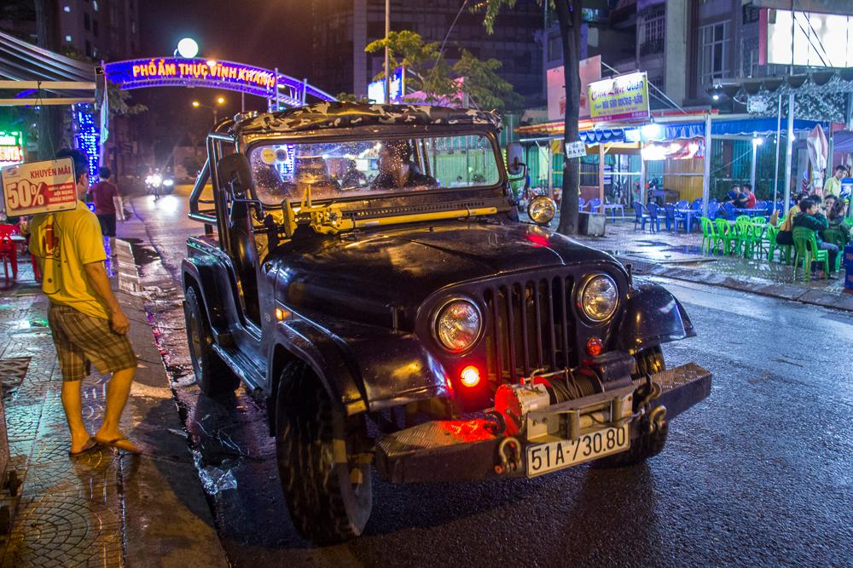
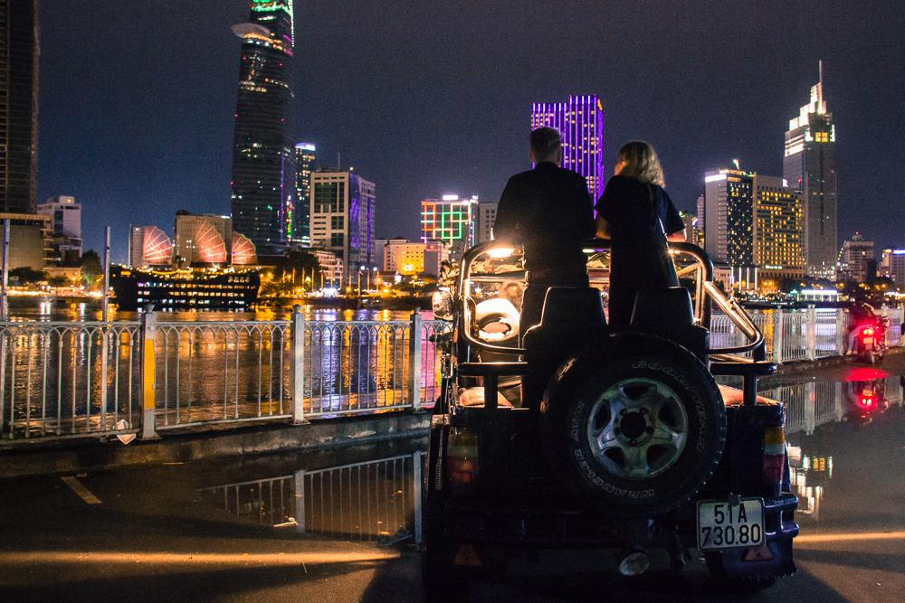
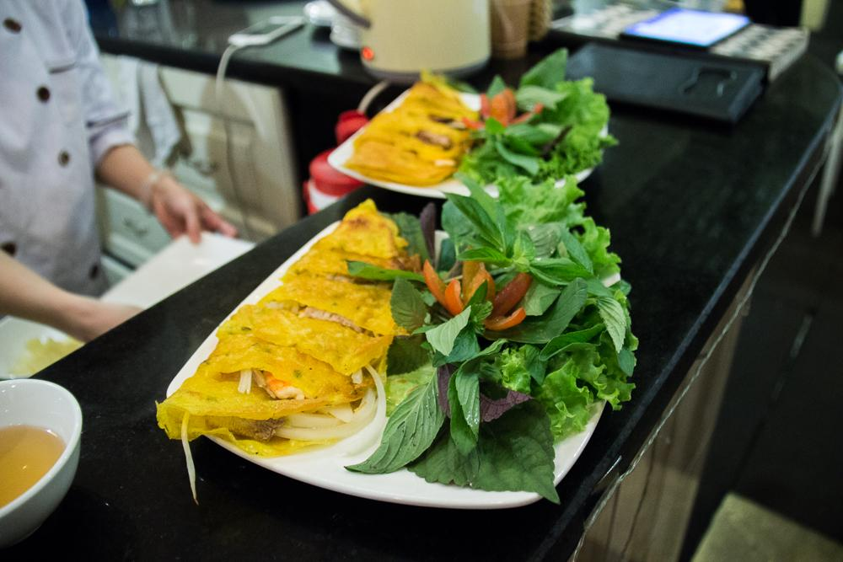
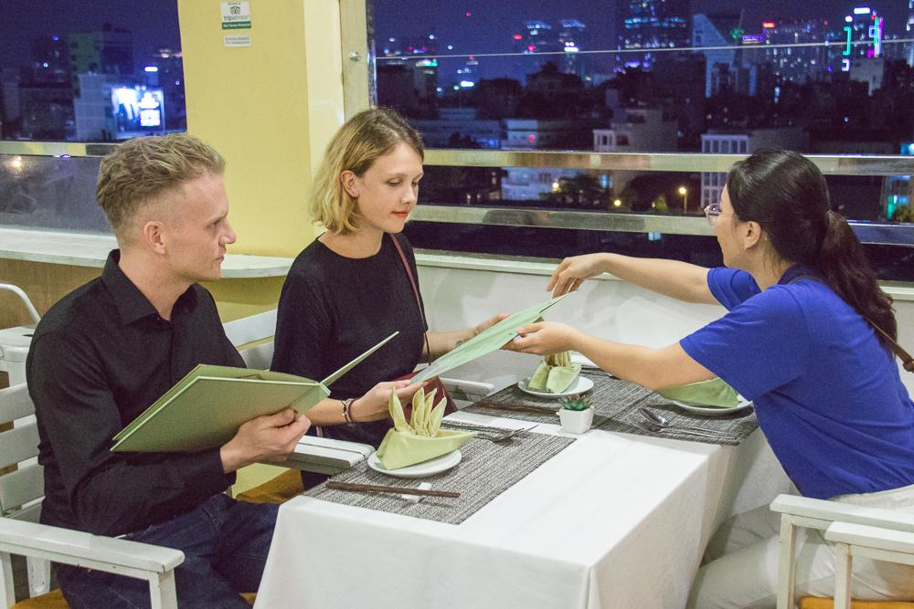
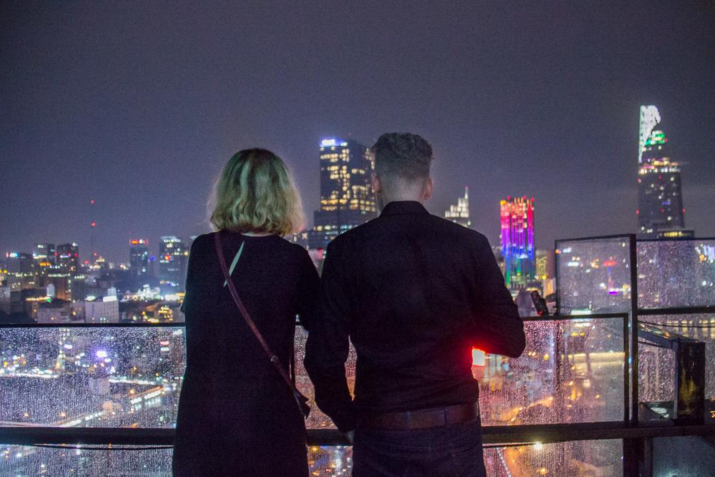

Easia Travel Head Office

Vietnam Head OfficeC/o: ATS Hotel, Suite 326 &327, 33B Pham Ngu Lao Street, Hanoi, VietnamTel: +84 24-39 33 13 62www.easia-travel.com

