VIETNAM – Ho Chi Minh City – Ho Chi Minh City by Night on a Vespa
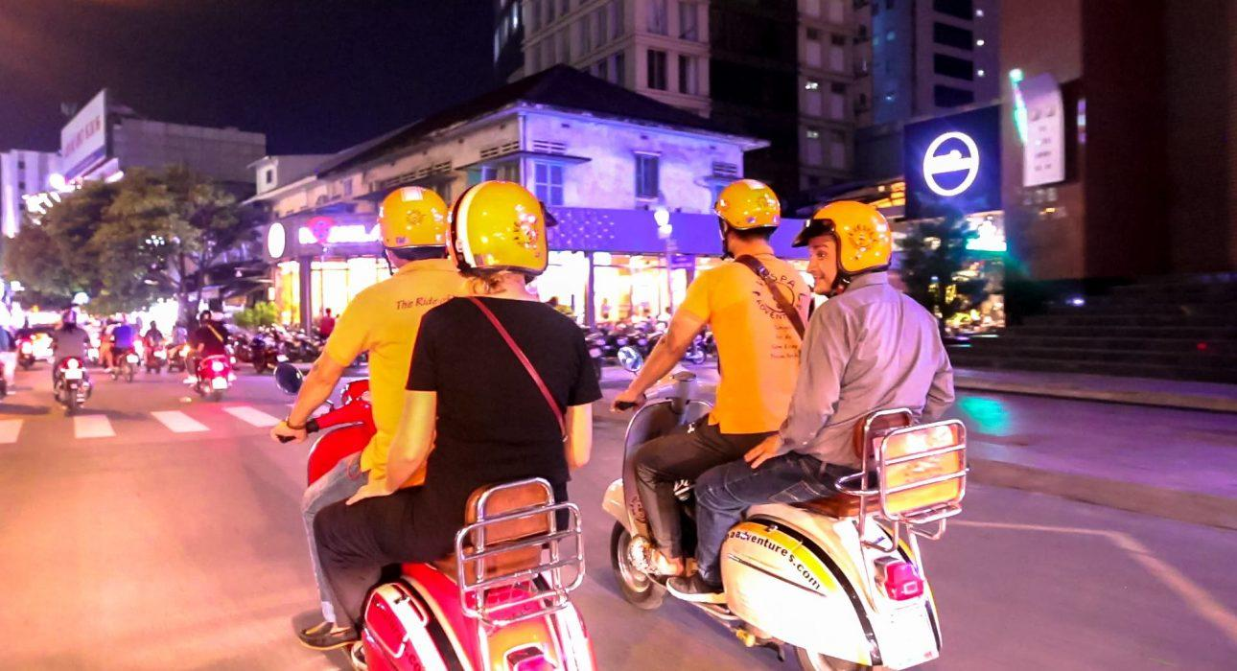

Over View

Theme
Art & Culture, Classic, Family, Gastronomy, Honeymoon

Country - City
Vietnam - Ho Chi Minh City

Market segment
Groups, Thematic Leisure

Price Level
$$$$

Max pax
30

Seasonality
All Year Round

Arrival city
Ho Chi Minh City

Departure city
Ho Chi Minh City

Description

This tour offers the opportunity to meet local people after work, dining out and experience the nightlife activities. In addition to seeing some highlights in Ho Chi Minh city in the dark. Included in the tour is the chance to enjoy some of the unique and authentic food offering that can be found in some local restaurants. A tour to discover Saigon’s beauty at night from the back seat of a Vespa scooter.

Can be combined with
Thematic Leisure
- VIETNAM – Ho Chi Minh City – Visit the tumultuous capital of the South
- VIETNAM – Ho Chi Minh City – Explore District 5 in Depth

Selling points

- To try local food with music make an unforgettable night
- To experience different feeling during the night
- To be easily included into any day activity

Sustainability

Level Of The Excursion
Low - This activity impacts local community, culture and/or environment in a small but meaningful way

The Impact Of This Excursion

Social/cultural Impact
Cultural Conservation, Empowerment and education

Economic Impact
Community benefits

Additional Information
Positive Impact:This activity has a positive impact in terms of generating income for people in Ho Chi Minh (staff making sure the activity goes well, drivers, guides, etc.), it also bring income to various business in Ho Chi Minh City (restaurants & bars mainly). Negative Impact:The activity uses Vespa motorcycles, which produce high carbon emissions.

Time And Transportation

- Pick up time from the hotel from 18:00

Photos

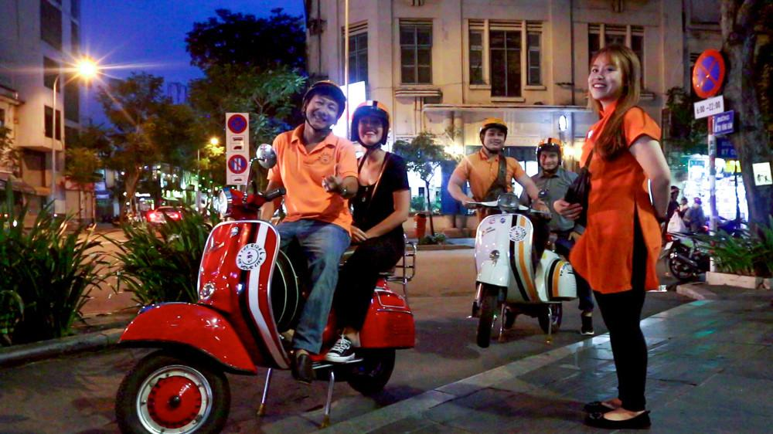
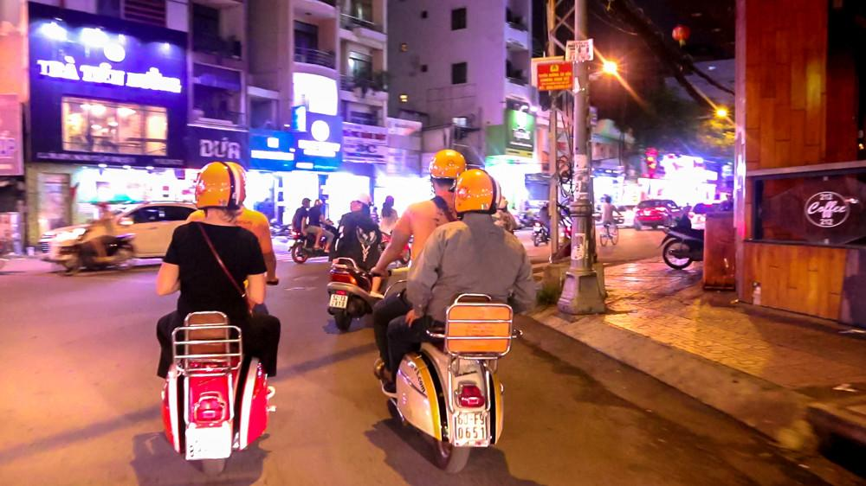
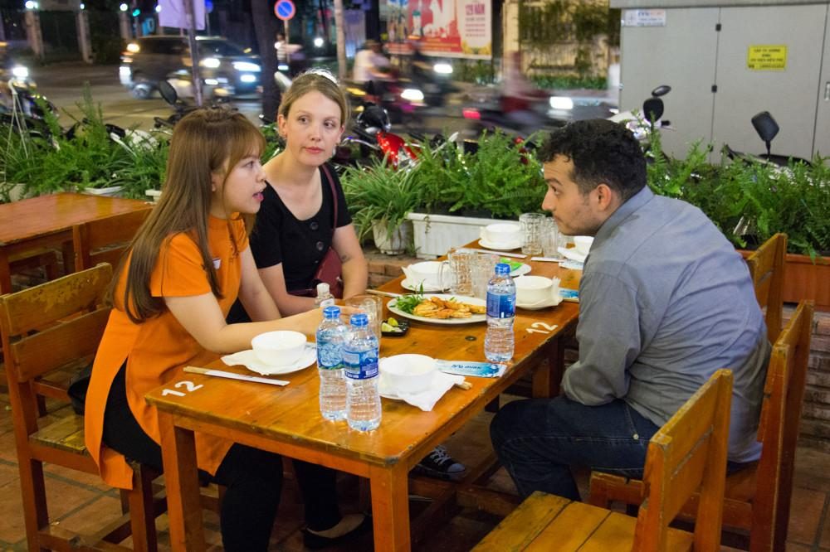
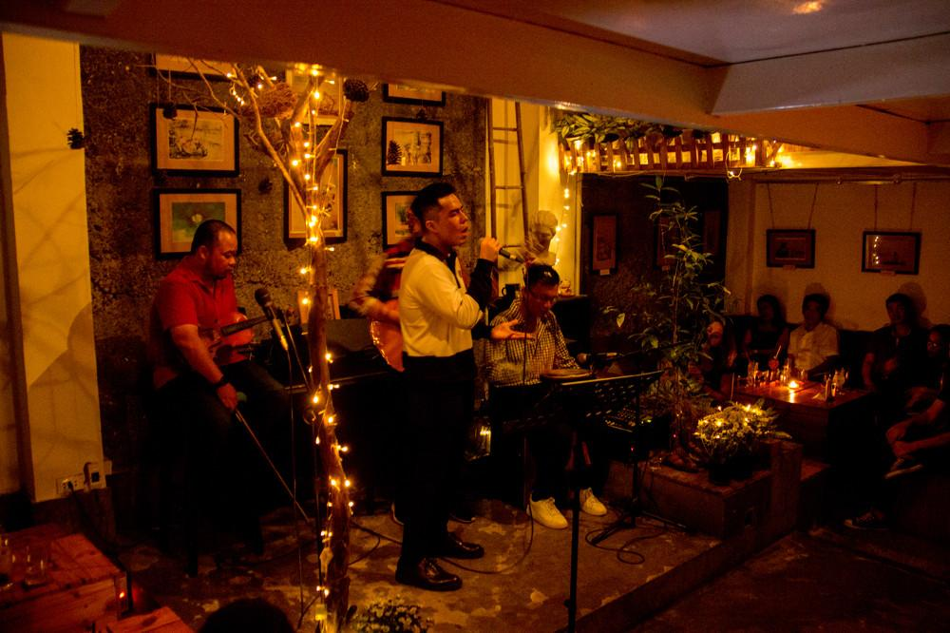
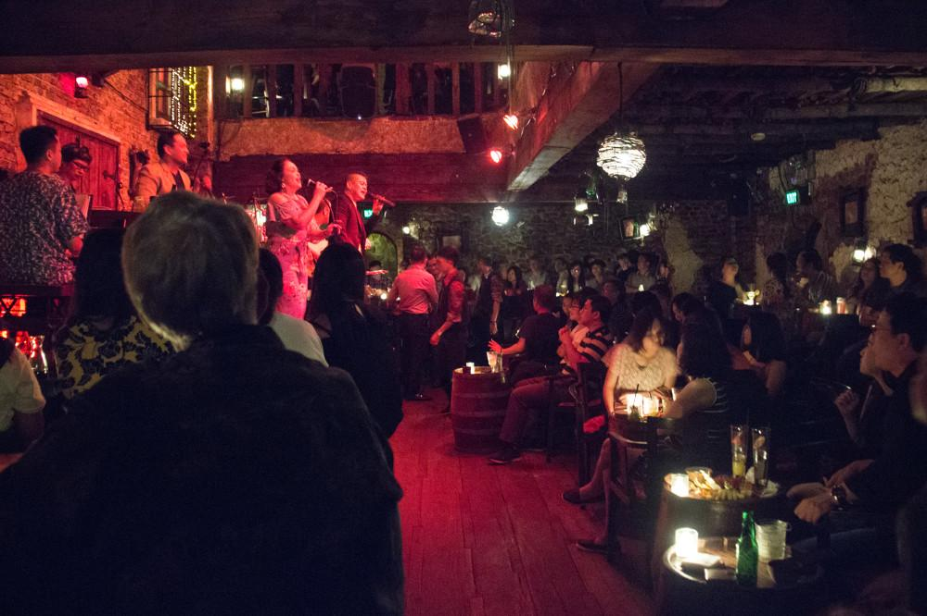

Easia Travel Head Office

Vietnam Head OfficeC/o: ATS Hotel, Suite 326 &327, 33B Pham Ngu Lao Street, Hanoi, VietnamTel: +84 24-39 33 13 62www.easia-travel.com

