VIETNAM – Ho Chi Minh City – Attend the Show “the Mist” at Ho Chi Minh City Opera House
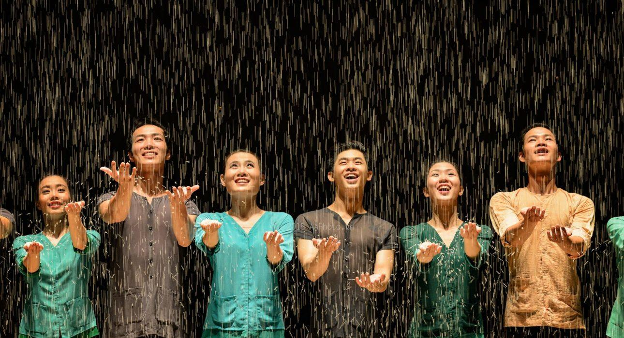

Over View

Theme
Art & Culture, Classic, Family, Honeymoon, Sustainable

Country - City
Vietnam - Ho Chi Minh City

Market segment
Groups, Thematic Leisure

Price Level
$$$

Max pax
440

Seasonality
All Year Round

Arrival city
Ho Chi Minh City

Departure city
Ho Chi Minh City

Description

A collaboration between the AO Show and local dance company, Arabesque, The Mist, depicts the cycles of Vietnamese rural life. Choreographer Nguyen Tan Loc has brought together contemporary dance sequences (a rarity in Vietnam) with scenes, objects, and aesthetics that are unequivocally Vietnamese. The performance focuses on daily life in the countryside, like going to the market, husking rice, and tending to the rice fields. Unlike the AO Show Saigon, The Mist caters to a more mature audience and is performed accompanied to live contemporary music.It includes the following scenes:
- Going to the fields: Farmers go to the area in the early morning.
- Pagoda’s fragrance: A religious space of Vietnamese culture.
- Night: A storm of sentiments and the innermost feelings of wisdom.
- Harvest Time: The joy of a bumper crop
- Silk: The love and desire of a farmer couple.
- Rice: The fruit of the farmers’ hard work
Some of the best moments during the show are the ones that involve the audience. For instance, visitors are given wooden clappers (commonly used to stir rice) to join in the festivities during scenes of celebration. Sometimes the dancers even move the performance from the stage to the auditorium seats.

Selling points

- The show is an impressive performance.
- A great display of contemporary, professional dance.
- It takes place in the impressive venue of the Saigon Opera House

Sustainability

Level Of The Excursion
Medium – This activity offers tangible positive contributions to the local community, culture and/or environment

The Impact Of This Excursion

Social/cultural Impact
Cultural Conservation, Empowerment and education

Economic Impact
Community benefits

Additional Information
Positive Impact:This activity provides support to an art theater, while (more importantly) it also provides direct income to the artists. This show also helps to maintain traditional music & instruments, as well as indirectly supporting the people who make the instruments (without demand, a lot of instrument manufacturers simply abandon the craft).

Time And Transportation

From | To | Kilometer | By | Duration | Road condition
Saigon Center Post Office | Saigon Opera House | 500 meter | Walking | 10 minutes | Good
Ben Thanh Market | Saigon Opera House | 750 meter | Walking | 15 minutes | Good

Photos

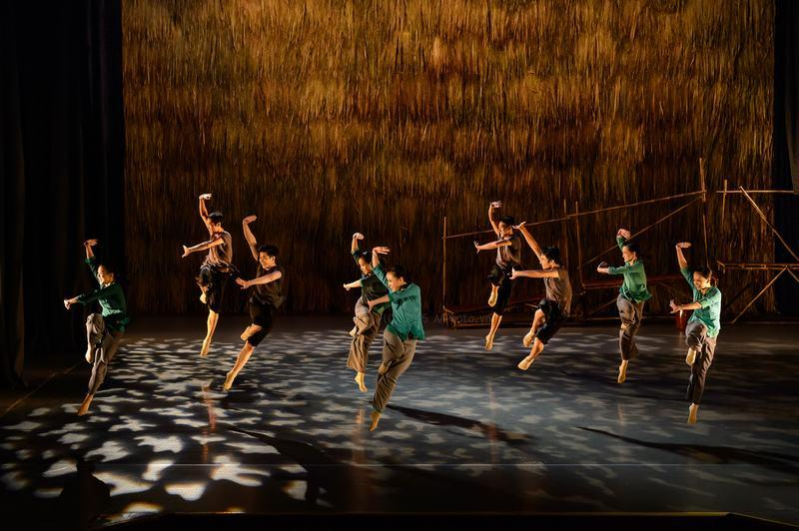
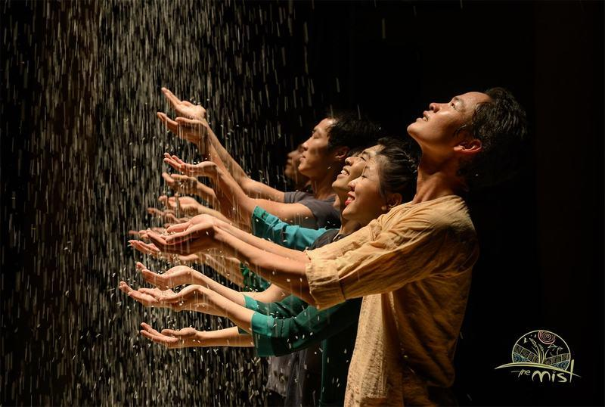
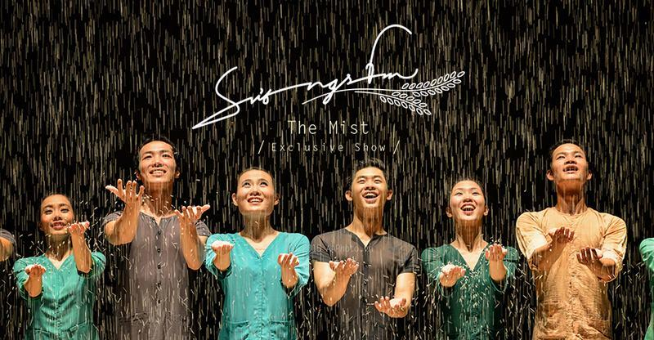
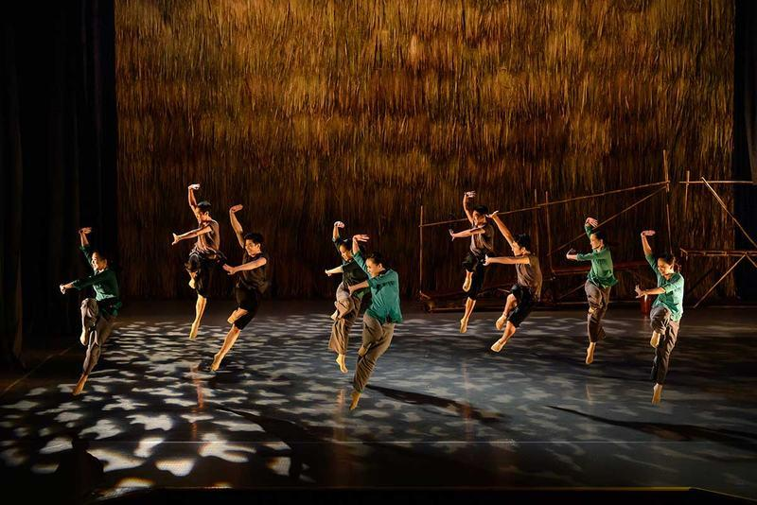
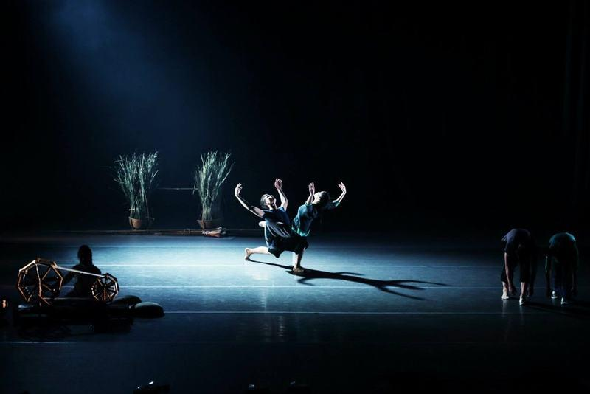
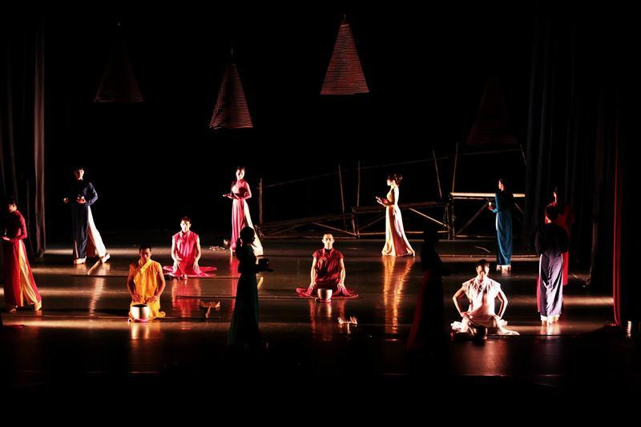
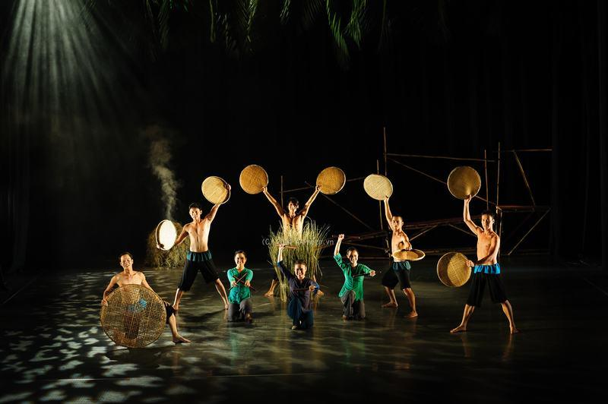
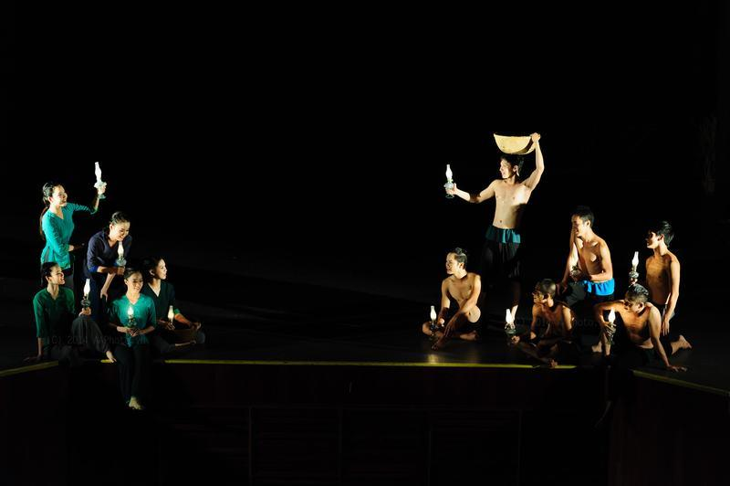

Easia Travel Head Office

Vietnam Head OfficeC/o: ATS Hotel, Suite 326 &327, 33B Pham Ngu Lao Street, Hanoi, VietnamTel: +84 24-39 33 13 62www.easia-travel.com

