VIETNAM – Hanoi – Photography Tour: On the Tracks of Hanoi
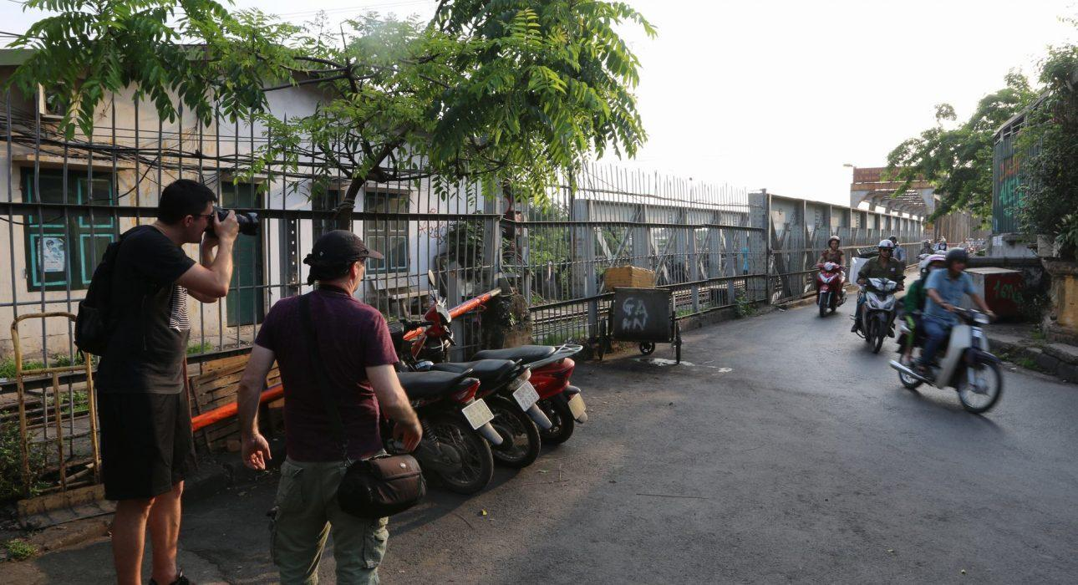

Over View

Theme
Art & Culture, Classic

Country - City
Vietnam - Hanoi

Market segment
Thematic Leisure

Price Level
$$$$

Max pax
5

Seasonality
All year long

Arrival city
Hanoi

Departure city
Hanoi

Description

A photography tour is a great opportunity to explore Hanoi at sunrise, heading to the bustling markets, quiet railway stations and small cafes as the city wakes up. Following an experienced photographer, the tour gives your guests a chance to learn more about the art of photography. Depending on your guests’ level, the photographer will adapt the tour, focusing more on the understanding of shutter speed, aperture, and ISO for beginners or on how to create a story with pictures for the most experienced ones. Different versions of the photography tours are available, focusing on the famous Long Bien bridge and market, or following Hanoi’s famous railway tracks.

Selling points

- A well-designed photography tour that allows guests to explore some of Hanoi’s most photogenic places during the golden hours
- An experienced photographer able to adapt to all type of photographers willing to learn more about their cameras and focusing on telling a story with a picture.
- Guests bring back some amazing pictures from Hanoi.

Sustainability

Level Of The Excursion
Low - This activity impacts local community, culture and/or environment in a small but meaningful way

The Impact Of This Excursion

Environment Impact
Transportation

Additional Information
Positive:This activity is conducted purely on foot around the Old Quarter of Hanoi.

Time And Transportation

Depending on the tour chosen, the tour usually starts from 04:30 to 05:30.

Photos

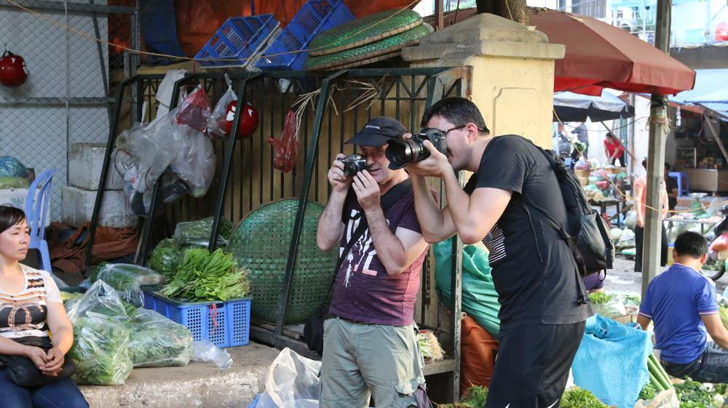
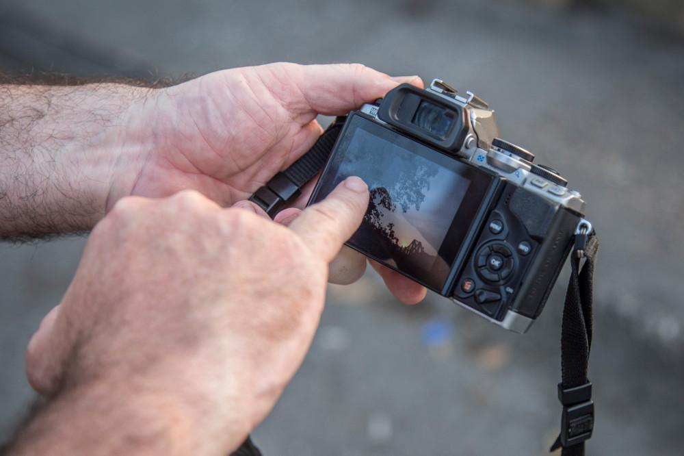
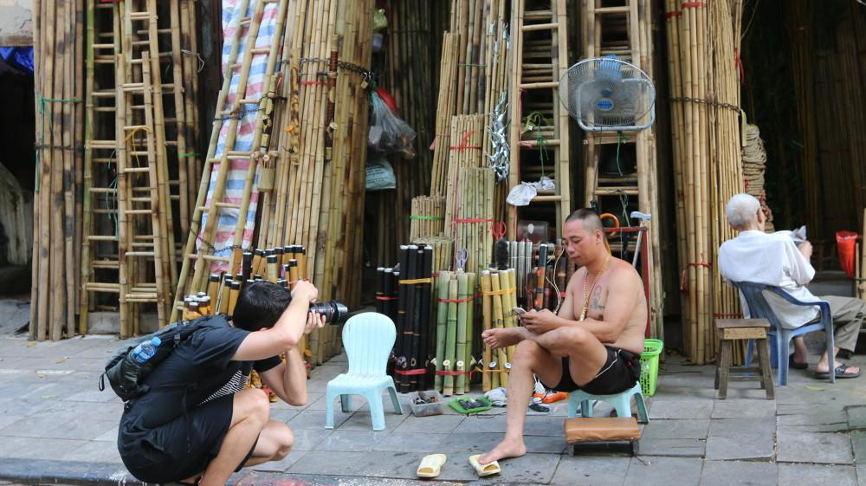
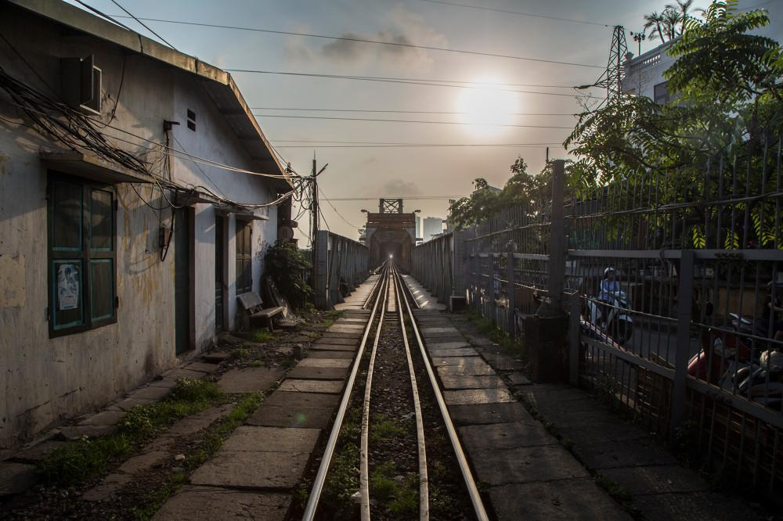
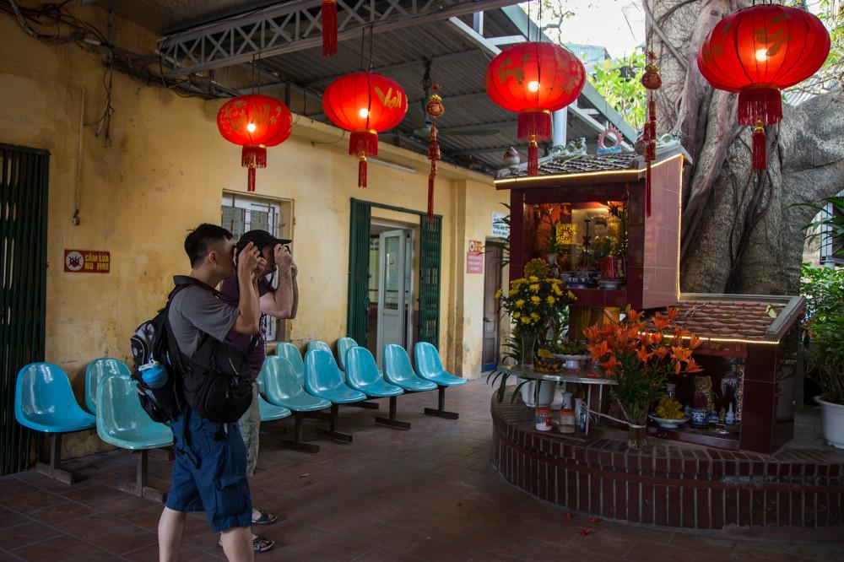
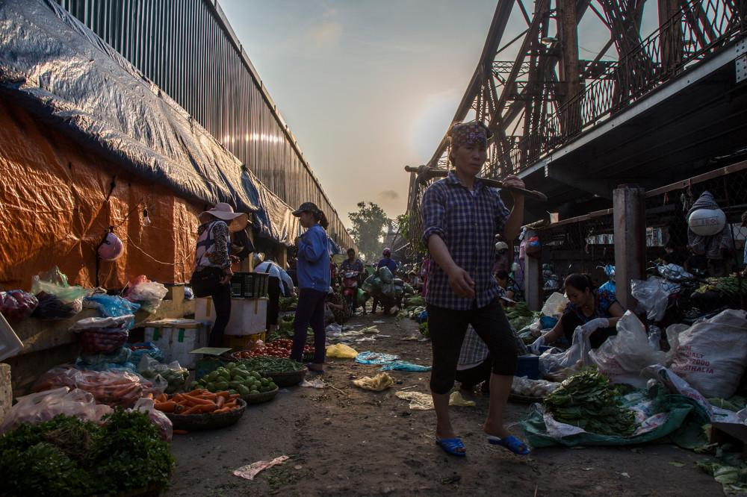

Easia Travel Head Office

Vietnam Head OfficeC/o: ATS Hotel, Suite 326 &327, 33B Pham Ngu Lao Street, Hanoi, VietnamTel: +84 24-39 33 13 62www.easia-travel.com

