VIETNAM – Hoi An – Private Yoga or Tai Chi Lesson
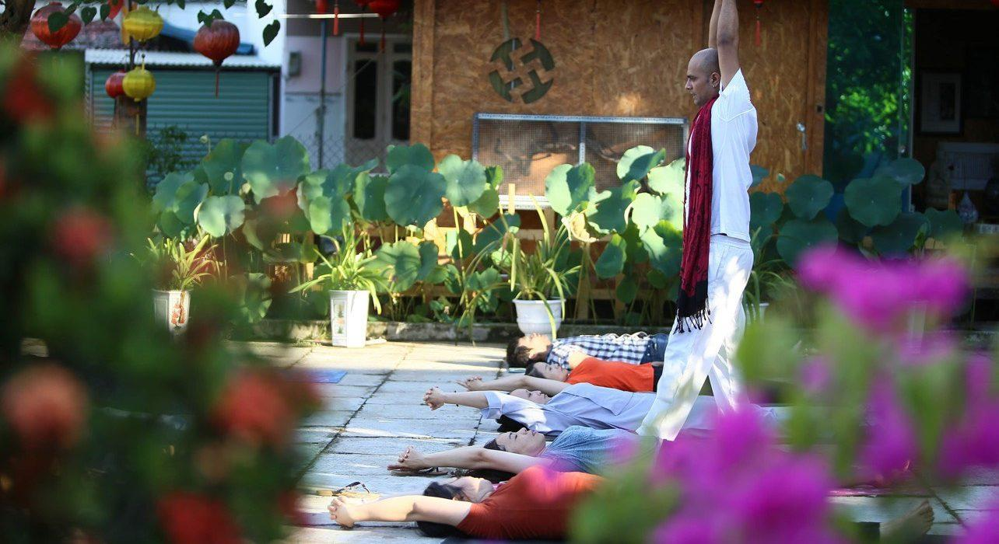

Over View

Theme
Beach Stay, Classic, Honeymoon, Wellness

Country - City
Vietnam - Hoi An

Market segment
Groups, Thematic Leisure

Price Level
$$

Max pax
20

Seasonality
All year round in the studio , Beach or Rice field session depending on the weather

Arrival city
Hoi An

Departure city
Hoi An

Description

The perfect way to get full-body wellness is to literally stretch the stress away during an exclusive yoga or tai chi session! In this session, guests develop personal well-being and unite mind, body, and spirit with a professional instructor over a private, 75-minute session. This is a fantastic opportunity to find peace and energize the body for the rest of the day.The courses, depending on the weather, take place in either morning or afternoon, when one can enjoy the sunset or sunrise near the beach, the rice fields, or the Yoga Studio itself.The yoga and Tai Chi lessons are best done early in the morning, giving guests the chance to spend time exploring the charming city of Hoi An and its countryside during the day. Catering to everyone from beginners to experts, the yoga and Tai Chi teachers adapt their courses to the skills of the participants.

Can be combined with
Thematic Leisure
- Hoi An – Reaching Out Teahouse
- Hoi An – Make your own lantern
- Hoi An – Wellness and Lunch River Cruise
Groups
- Hoi An -Experience a cooking class with a local chef in Tra Que
- Hoi An – Wander through a UNESCO World Heritage listed Village
Active

Selling points

- To practice yoga in a serene environment
- Different type of yoga provided : Hatha, Ashtanga, Gentle, Vinyasa – All Levels.
- To get the positive benefits of the activity: uniting mind, body, and spirit
- A first introduction or practice the traditional Tai-Chi art: Recharge the body in a natural way
- A great addition to a visit to Hoi An
- Instructors are all yoga alliance certified and qualified after 200 hours of English-speaking training

Sustainability

Level Of The Excursion
Low - This activity impacts local community, culture and/or environment in a small but meaningful way

The Impact Of This Excursion

Economic Impact
Local individual benefits

Additional Information
Positive Impact:The activity provides income to local teachers.

Time And Transportation

FROM | TO | DISTANCE | DURATION | BY | ROAD CONDITION
Nomad Yoga | Hoi An center | 4.5 kilometers | 11 minutes | Car | Good

Photos

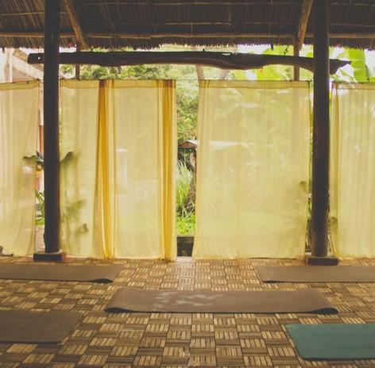
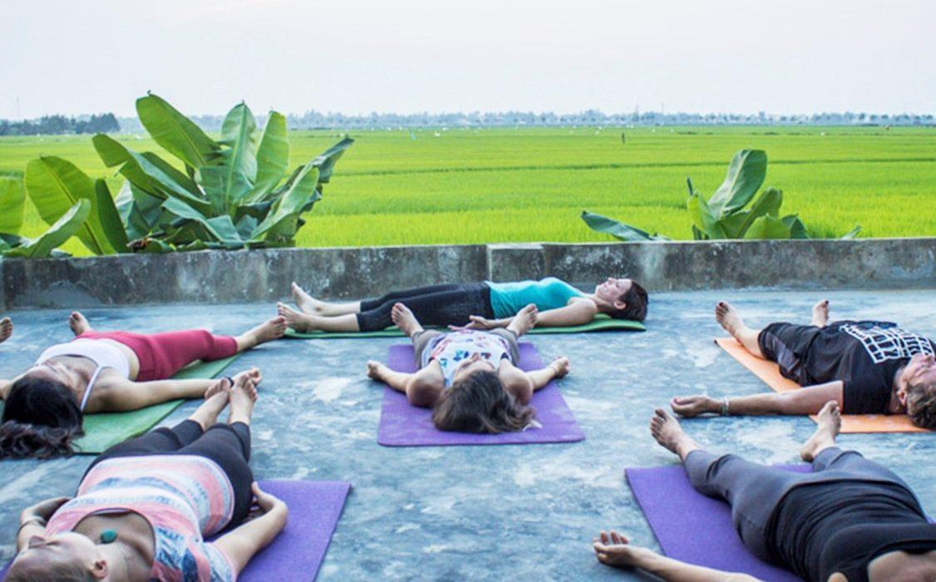
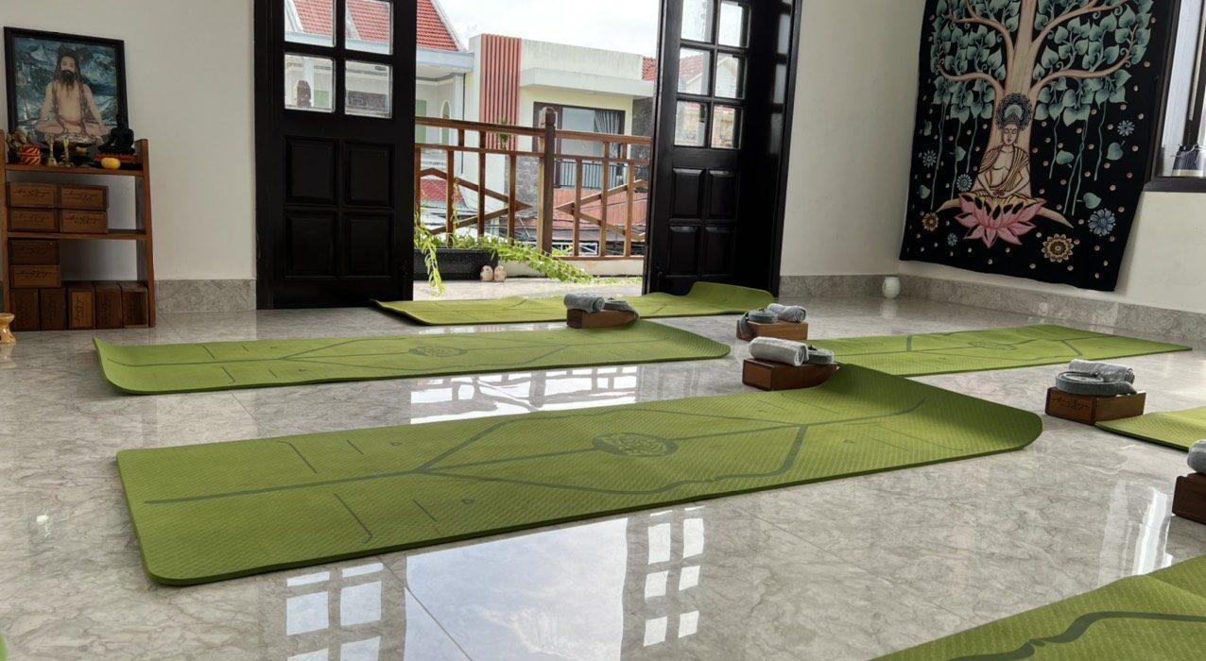
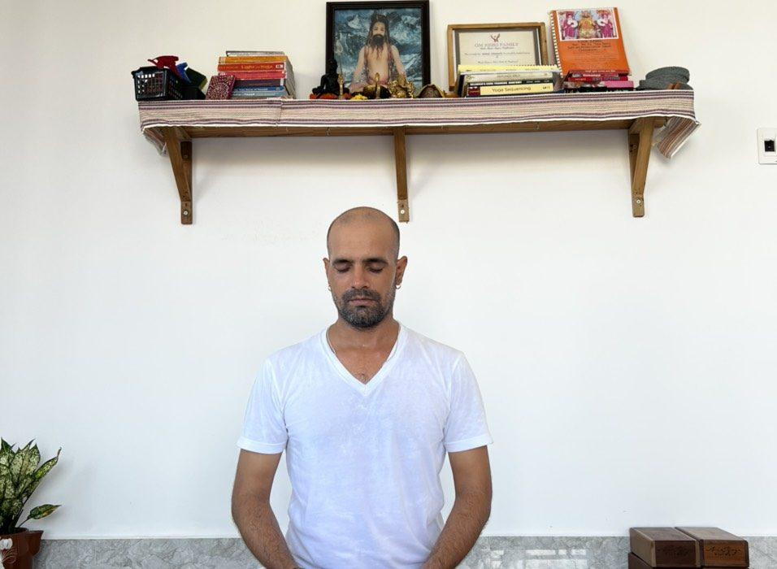
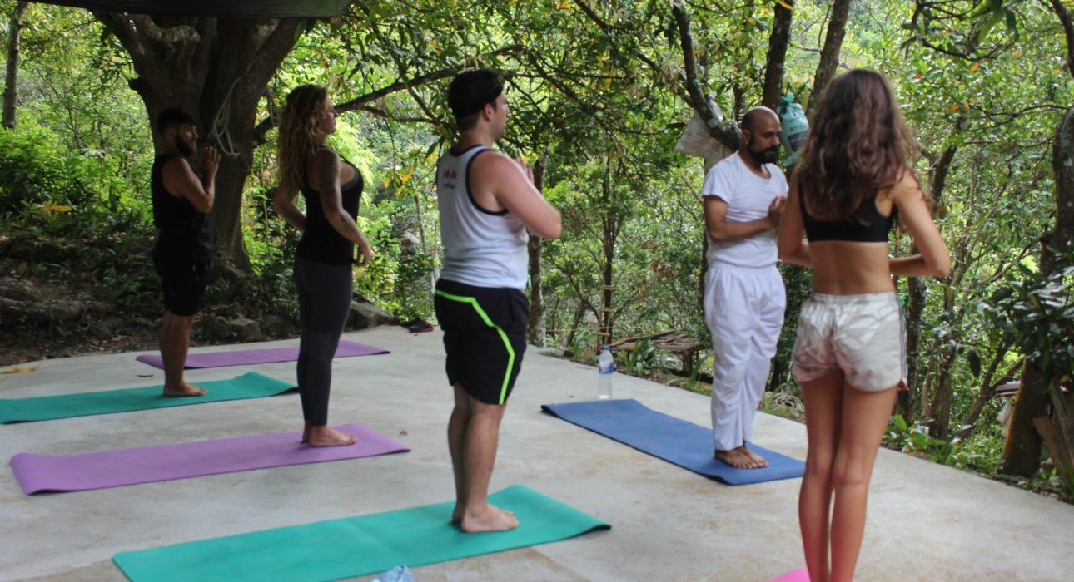

Easia Travel Head Office

Vietnam Head OfficeC/o: ATS Hotel, Suite 326 &327, 33B Pham Ngu Lao Street, Hanoi, VietnamTel: +84 24-39 33 13 62www.easia-travel.com

