VIETNAM – Hanoi – Meeting with a Journalist
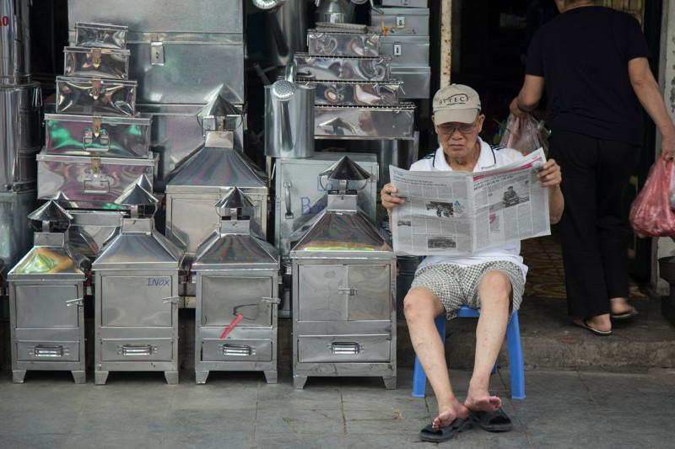

Over View

Theme
Art & Culture, Classic

Country - City
Vietnam - Hanoi

Market segment
Thematic Leisure

Price Level
$$

Max pax
8

Seasonality
All year long

Arrival city
Hanoi

Departure city
Hanoi

Description

This meeting offers the opportunity to meet and talk with a local journalist in Vietnam. The discussion topics are driven by the traveler’s curiosity about the country, the economy, the changes in society, etc. The one-hour dialogue will take place in a local cafe to add an extra touch of authenticity to the experience.

Selling points

- An exciting meeting to discuss with a local journalist for French-speaking travelers
- The best way to ask all the questions about the country
- Easy to include in Hanoi

Time And Transportation

The meeting is usually organized after the journalist’s working day, which means it will begin around 17:30 – 18:00

Photos

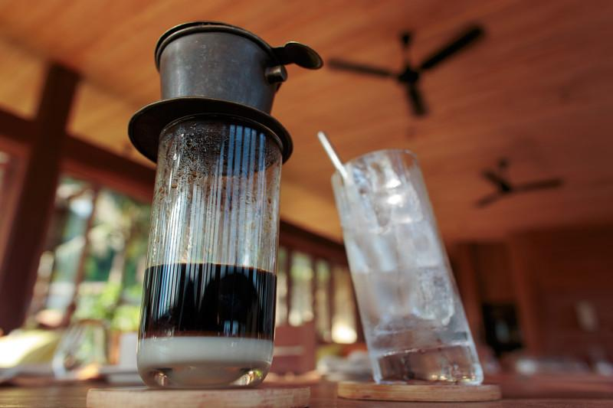
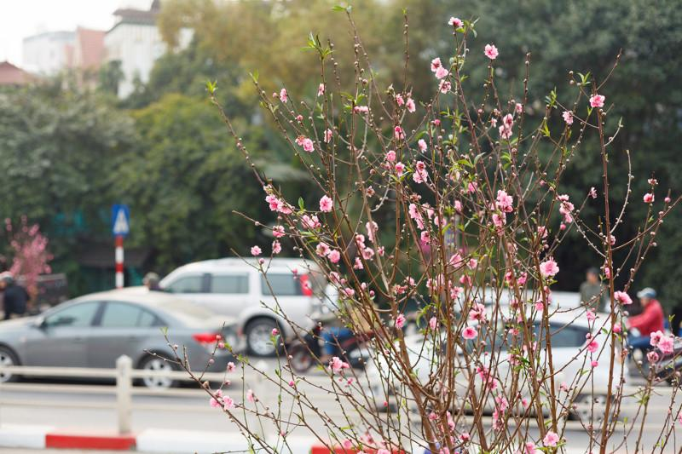
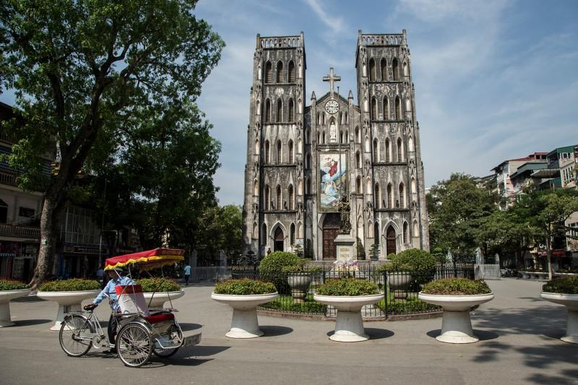
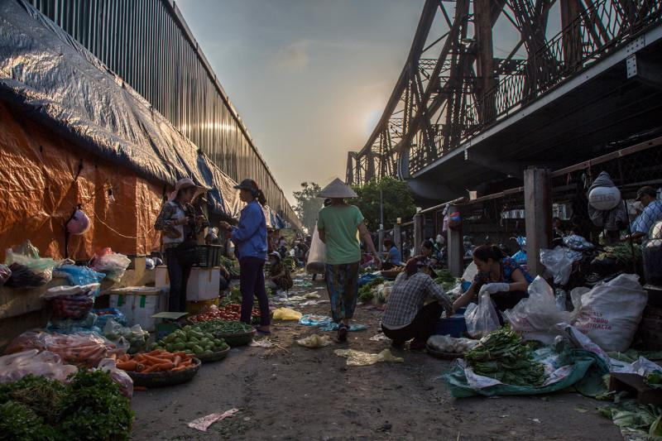

Easia Travel Head Office

Vietnam Head OfficeC/o: ATS Hotel, Suite 326 &327, 33B Pham Ngu Lao Street, Hanoi, VietnamTel: +84 24-39 33 13 62www.easia-travel.com

