VIETNAM – Hoi An – My Son Sanctuary by Bicycle
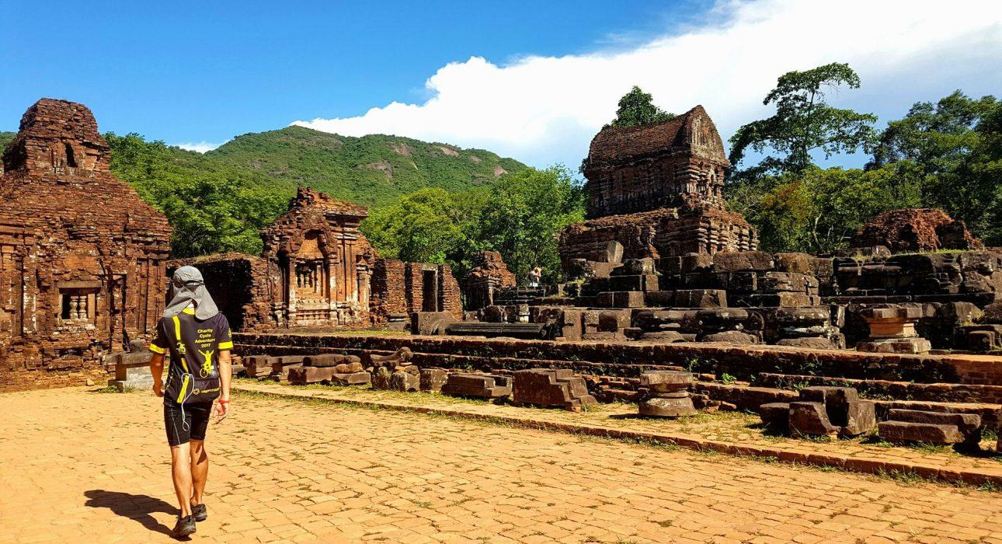

Over View

Theme
Art & Culture, Beach Stay, Classic, Sustainable

Country - City
Vietnam - Hoi An

Price Level
$$

Level of difficulties
LEVEL 2

Max pax
15

Seasonality
All year around, rainy season from September to December

Arrival city
Hoi An

Departure city
Hoi An

Description

This tour was designed for travelers to discover the incredible My Son sanctuary, a complex of Hindu temples of the ancient Champa kingdom, on a tranquil, rural cycling excursion, as well as Hoi An’s beautiful countryside and local people.My Son (“The beautiful mountain”) is the most important archaeological site in the center of Vietnam involving the Cham culture. Dating from the 4th to the 13th century, the Cham civilization’s 70-building complex was contemporary with the Khmer civilization, which makes My Son as important as the sites of Angkor in Cambodia, Borobudur in Indonesia, or Bagan in Burma for Vietnamese culture and history. Level: 2Distance and duration of cycling: 40 kilometers – about 5 hours (including stops and visits)Terrain: Manly paved roads, with some off-road paths through local villagesTransportation: Full day back-upTransport – My Son – Hoi An – 40 kilometers – 1 hour

Can be combined with
Thematic Leisure
- Hoi An – Sunset cocktail cruise on the Thu Bon river
- Hoi An – Reaching Out teahouse

Selling points

- Visit My Son, a complex of ruined Hindu temples listed as a UNESCO World Heritage Site
- A great opportunity to seehand-crafted, wooden furniture
- Try out rice making in a local house
- Encounter and have genuine interactions with local people
- A very pleasant, one-way, 40-kilometer ride

Sustainability

Level Of The Excursion
Medium – This activity offers tangible positive contributions to the local community, culture and/or environment

The Impact Of This Excursion

Environment Impact
Transportation

Economic Impact
Local individual benefits

Additional Information
Positive Impact:This activity is conducted on bicycles all. During the tour, travelers will learn about local culture (Champa Kingdom of My Son) as they cycle along small paths to reach the temples. Several stops in local shops are planned along the way.

Time And Transportation

From | To | Kilometers | By | Duration | Road conditions
My Son Sanctuary | Hoi An | 40 kilometers | Car | 1 hour | Good

Photos

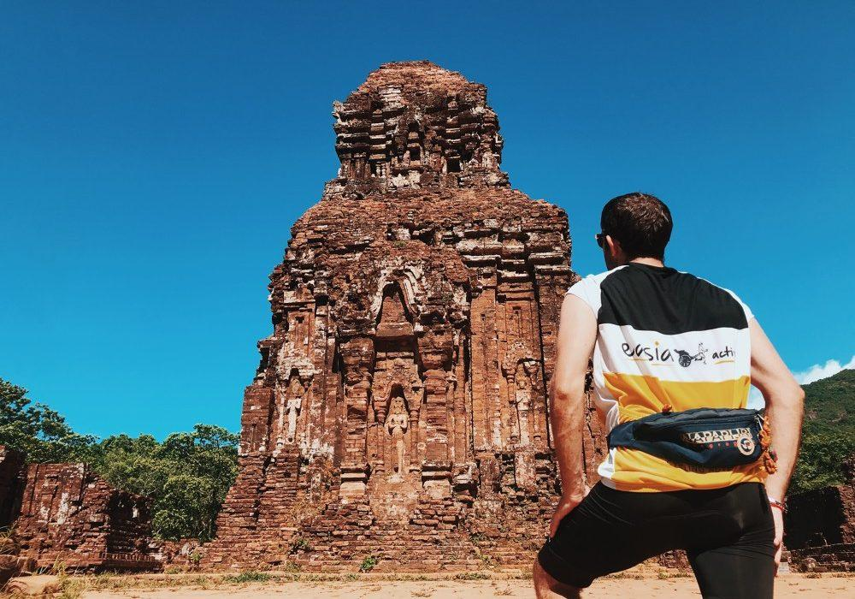
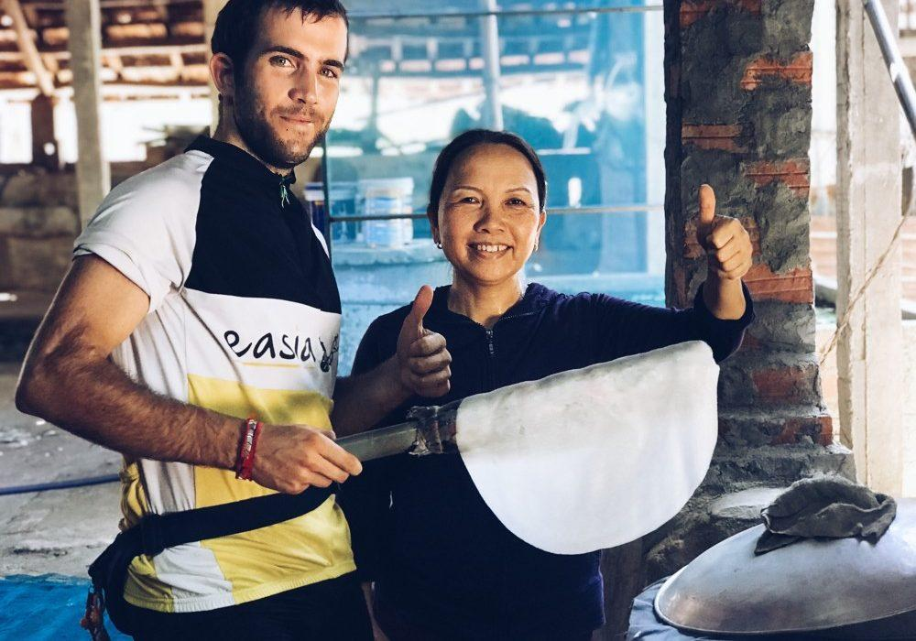
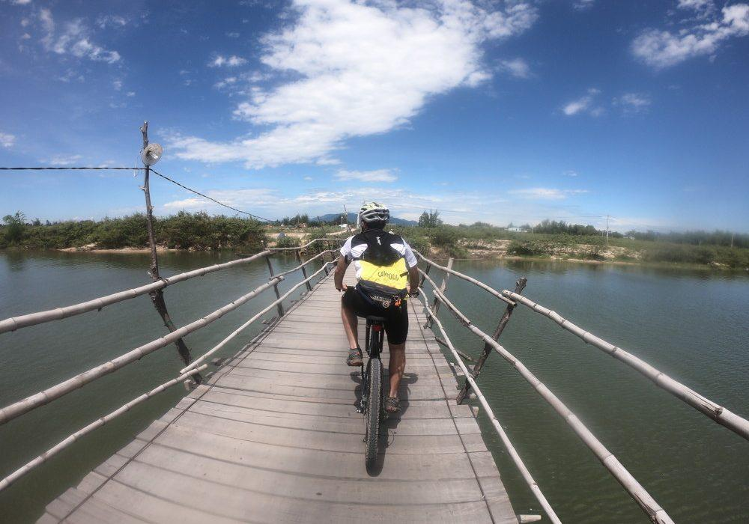
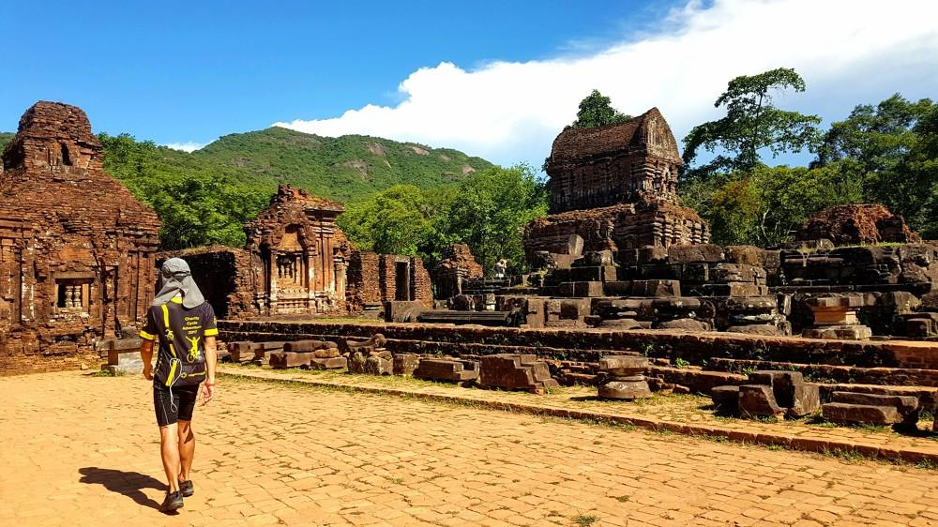
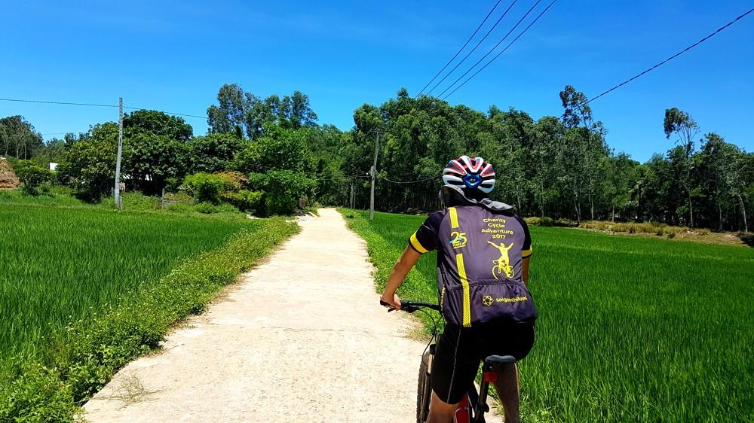
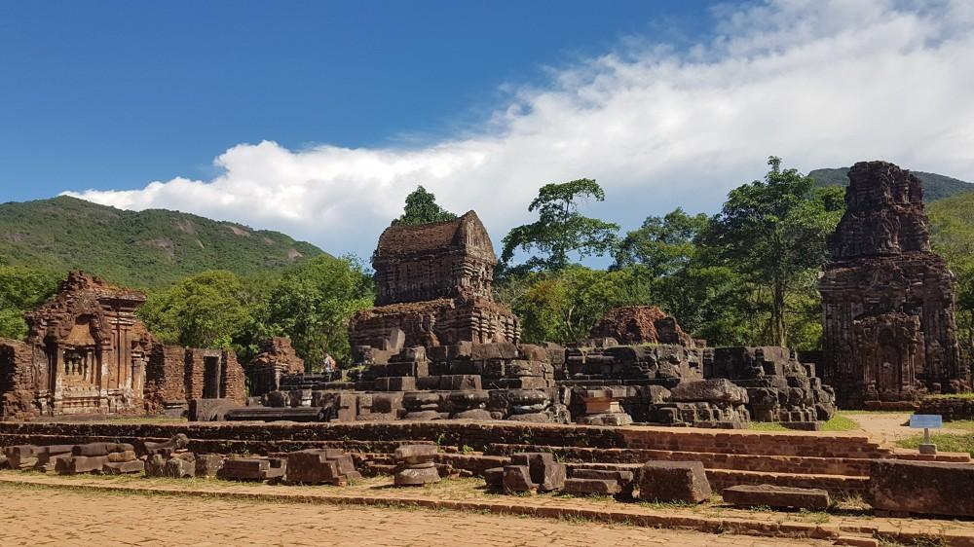

Easia Travel Head Office

Vietnam Head OfficeC/o: ATS Hotel, Suite 326 &327, 33B Pham Ngu Lao Street, Hanoi, VietnamTel: +84 24-39 33 13 62www.easia-travel.com

