VIETNAM – Hanoi – Hands-on Vietnamese Cooking Class by the River
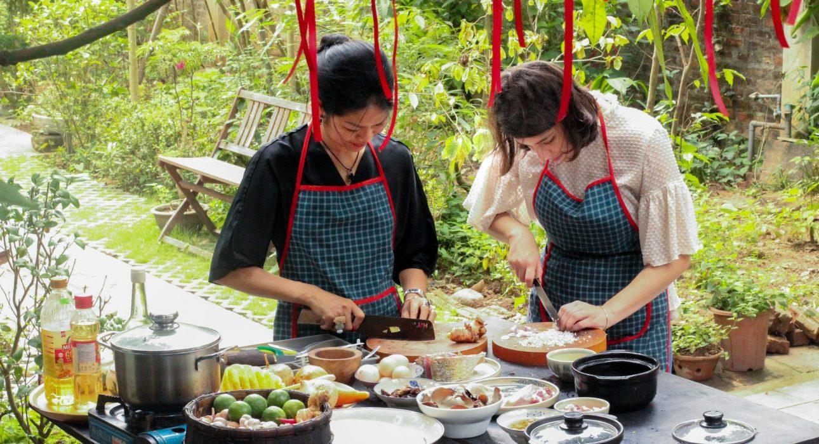

Over View

Theme
Art & Culture, Classic, Family, Gastronomy, Honeymoon, Sustainable

Country - City
Vietnam - Hanoi

Market segment
Groups, Thematic Leisure

Price Level
$$$

Max pax
15

Seasonality
All year long

Arrival city
Hanoi

Departure city
Hanoi

Description

A cooking class isn’t just a great way to learn how to cook some of the most famous dishes of northern Vietnam, but also to discover the wide varieties of Vietnamese food and culture. This cooking class starts with a visit to a market or to a local garden to learn about the vegetables, before starting to prepare northern Vietnam’s most authentic local dishes. By the end, guests will have made a delicious lunch for themselves to enjoy, and will take home the knowledge of northern Vietnamese recipes!

Selling points

- A cooking class is the best way to learn about Vietnamese food and culinary culture
- Hands-on cooking class: not only to learn about Vietnamese cuisine, but also to cook and enjoy the dishes
- The cooking class is located in a local house, outside of Hanoi’s Old Quarter, in a spacious Indochina styled villa with a green garden and an invaluable view to Duong river.

Sustainability

Level Of The Excursion
High – This activity strongly supports local communities and/or helps preserve the culture and environment

The Impact Of This Excursion

Social/cultural Impact
Cultural Conservation

Economic Impact
Community benefits

Additional Information
Positive Impact:This activity helps to maintain the gastronomy of Vietnam and the traveler to learn about it. It also provides direct income to the owner of the cooking class, with an in-depth experience at the house of the chef. The activity will also provide direct income to the sellers at the local market, since the travelers will go with the chef to purchase ingredients prior to cooking.

Time And Transportation

From | To | Kilometer | By | Duration | Road condition
Opera House | Tam Cuisine | 7 | car | 15 minutes | good
Hanoi Airport | Tam Cuisine | 25 | car | 30 minutes | good

Photos

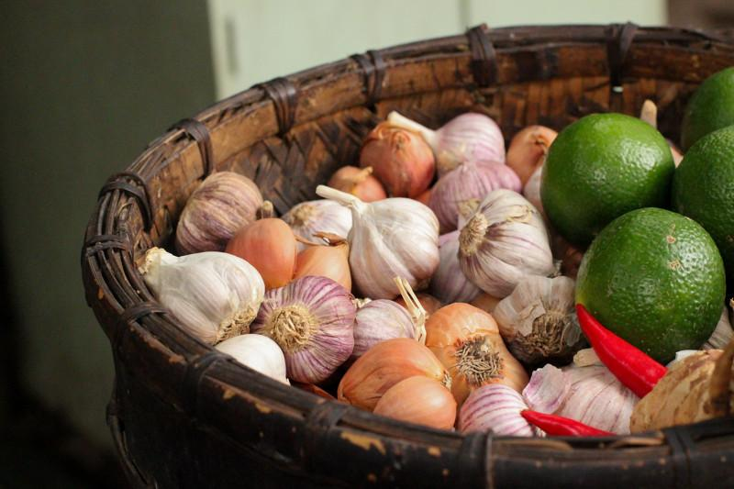
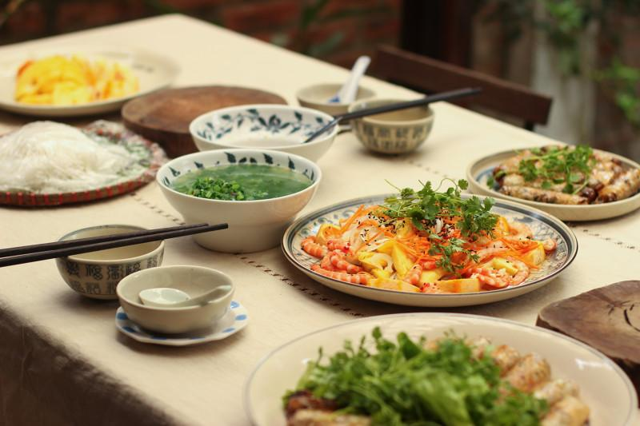
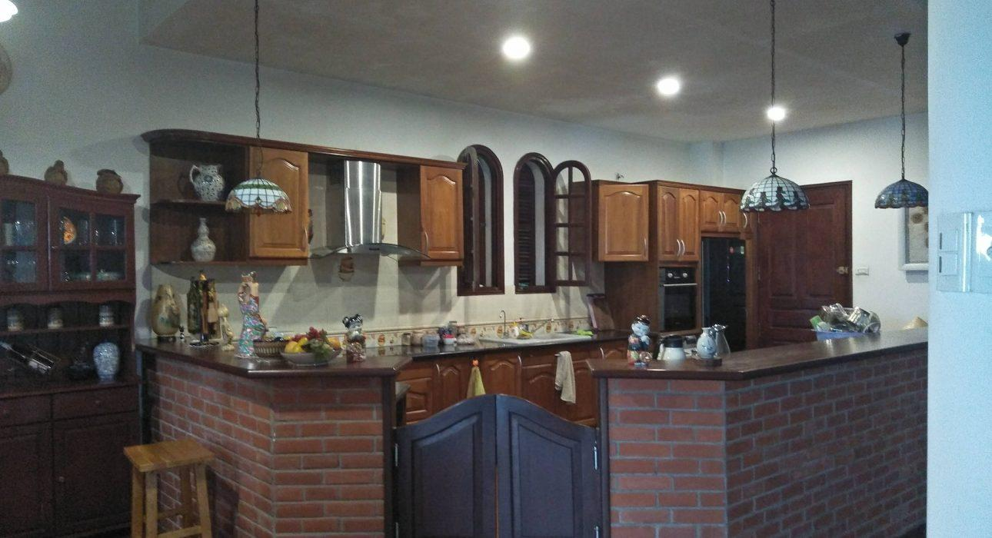
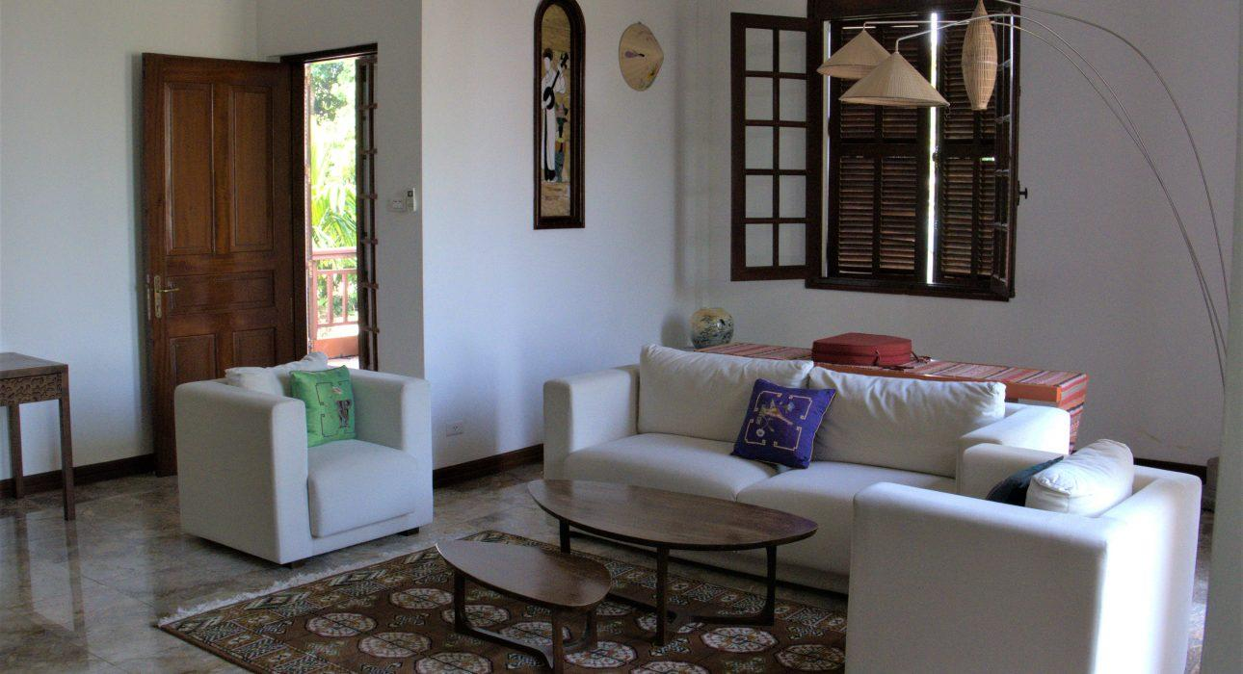
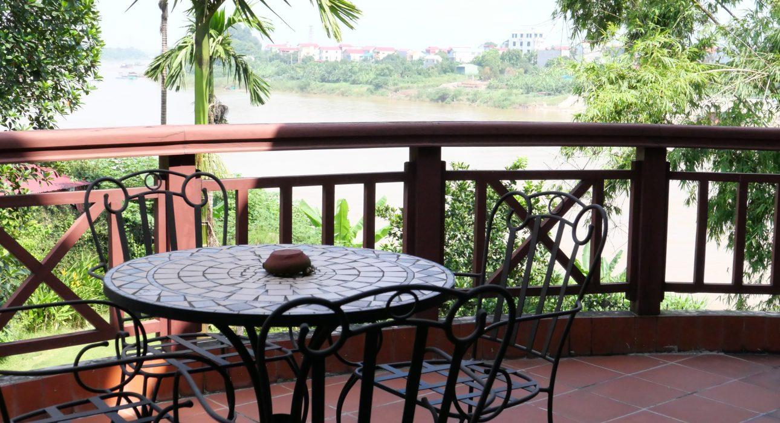
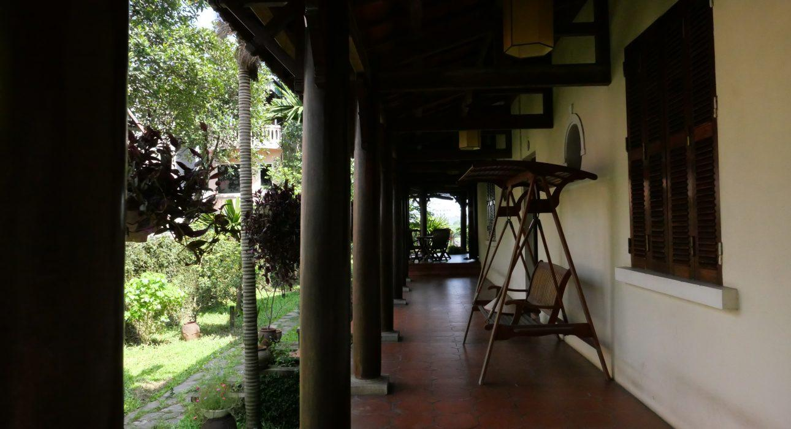
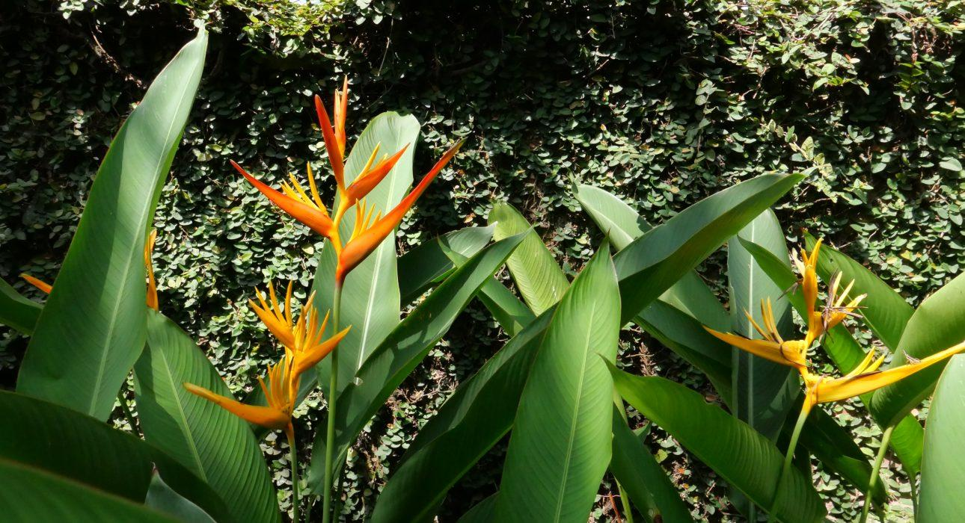
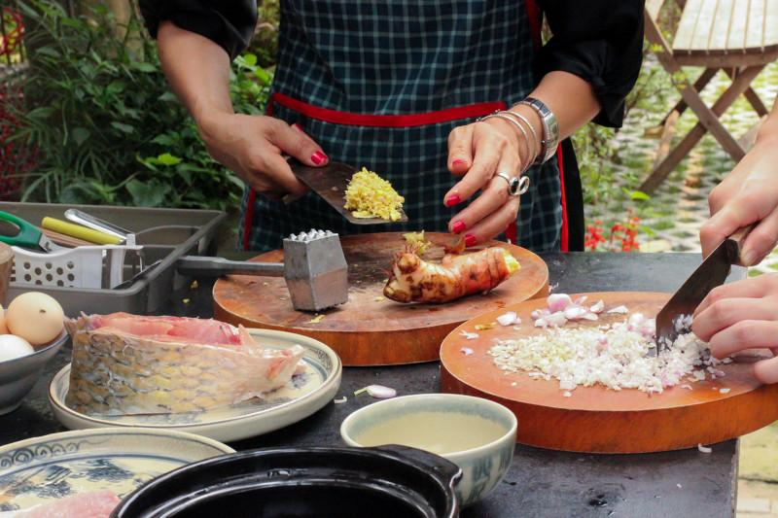

Easia Travel Head Office

Vietnam Head OfficeC/o: ATS Hotel, Suite 326 &327, 33B Pham Ngu Lao Street, Hanoi, VietnamTel: +84 24-39 33 13 62www.easia-travel.com

