CAMBODIA – Siem Reap – Attend a Divine Performance of the Sacred Dancers of Angkor
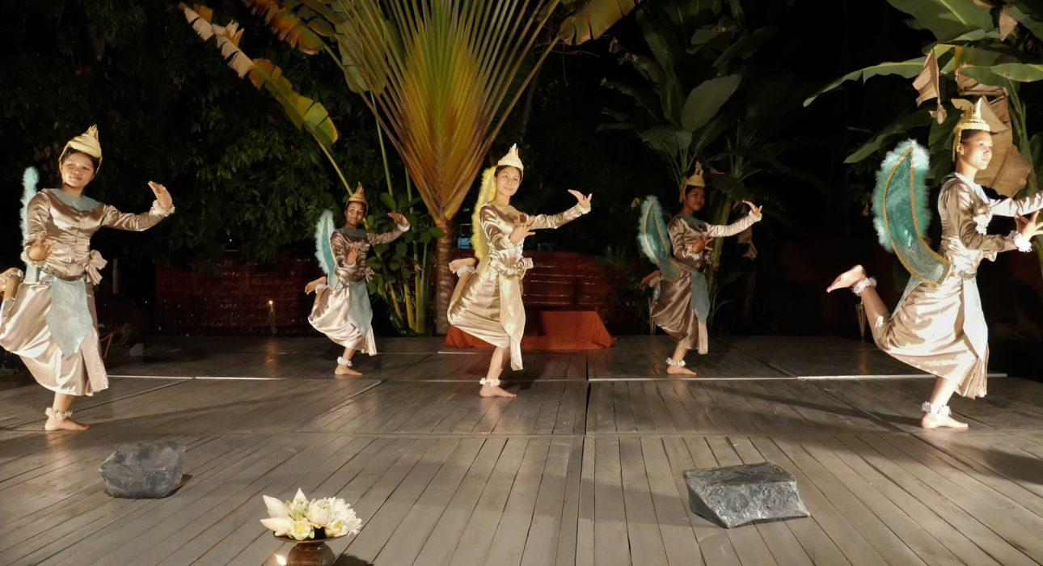

Over View

Theme
Art & Culture, Classic, Family, Sustainable

Country - City
Cambodia - Siem Reap

Market segment
Groups, Thematic Leisure

Price Level
$$

Level of difficulties
LEVEL 0

Max pax
40

Seasonality
Every Wednesday & Sunday

Arrival city
Siem Reap

Departure city
Siem Reap

Description

Spectators, prepare to be carried away by the spirituality of the Sacred Dancers of Angkor. This deeply spiritual performance is a remarkable display of the ancient Classical Khmer Ballet. The performance represents over 10 years of devotion and practice to the vast repertoire of Khmer classical ballet techniques. Dancers refine their precision and perfect synchronization according to the rhythm and the sacredness of the original divine gestures.

Selling points

- Experience the only performance of this kind in Cambodia & Siem Reap, supported by the Cambodian Princess Buppha Devi, daughter of the late King-Father Norodom Sihanouk and half-sister to King Norodom Sihamoni.
- Undergo a solemn and spiritual experience through the intangible legacy of the classical Khmer ballet.
- It is the only performance in Siem Reap where every dancer performs with total passion and dedication to the perfection and traditions of this centuries-old art
- Varied styles and dance forms were performed faithfully to the original ancestral costume, each one drawing from the rich cultural heritage of the Khmer people.

Sustainability

Level Of The Excursion
High – This activity strongly supports local communities and/or helps preserve the culture and environment

The Impact Of This Excursion

Social/cultural Impact
Cultural Conservation, Empowerment and education

Economic Impact
Local individual benefits, Community benefits

Additional Information
Positive impact: Supporting a prestigious school recognized by the Royal family of Cambodia which only works on donation basis. To preserve the Khmer traditional dance, here, students learn the real discipline it takes to perform the ancient Khmer traditional dance, with a lot of dedication and connection to the religion.

Time And Transportation

FROM | TO | KM | BY | DURATION | ROAD CONDITION
City Center | Divine Sala | 2,5 | Car/tuk tuk | 5-10 minutes | Good

Photos

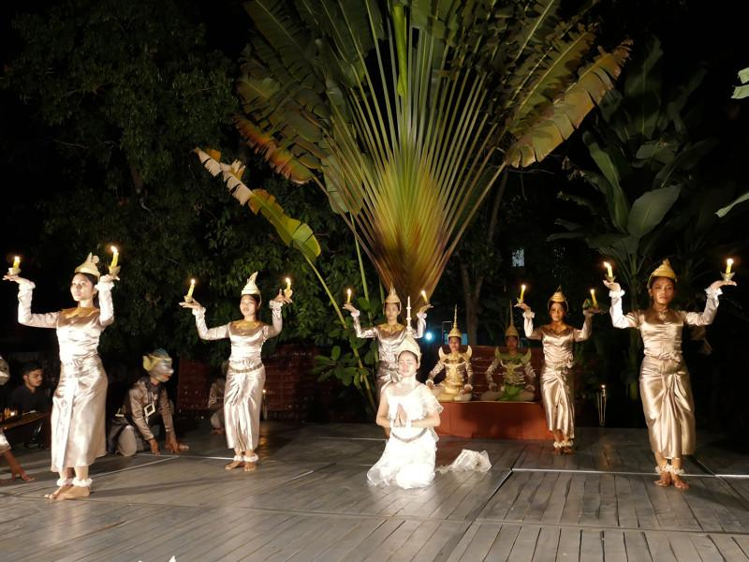
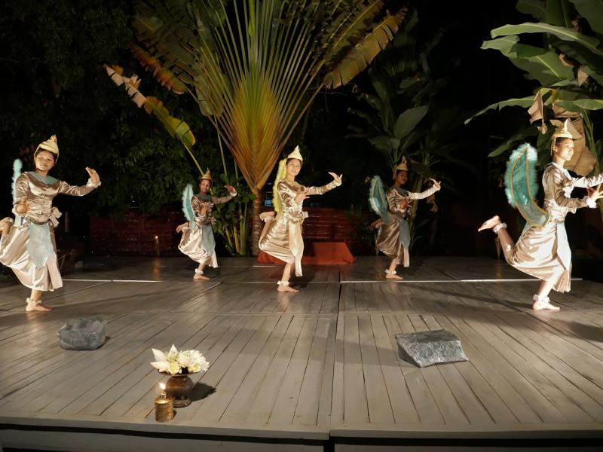
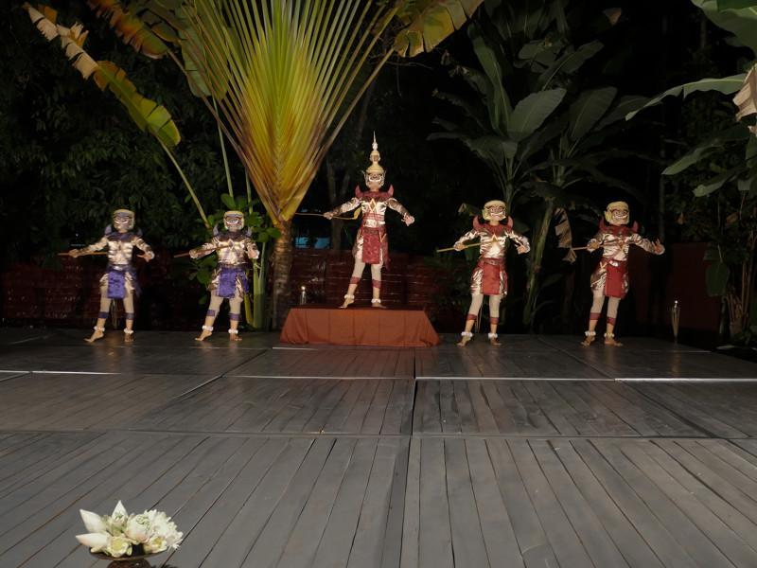
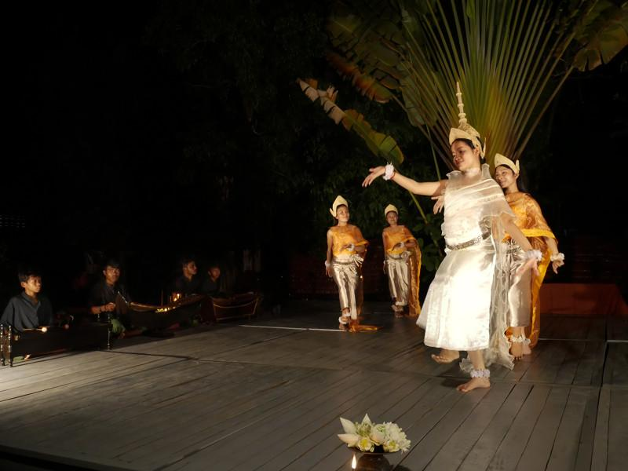
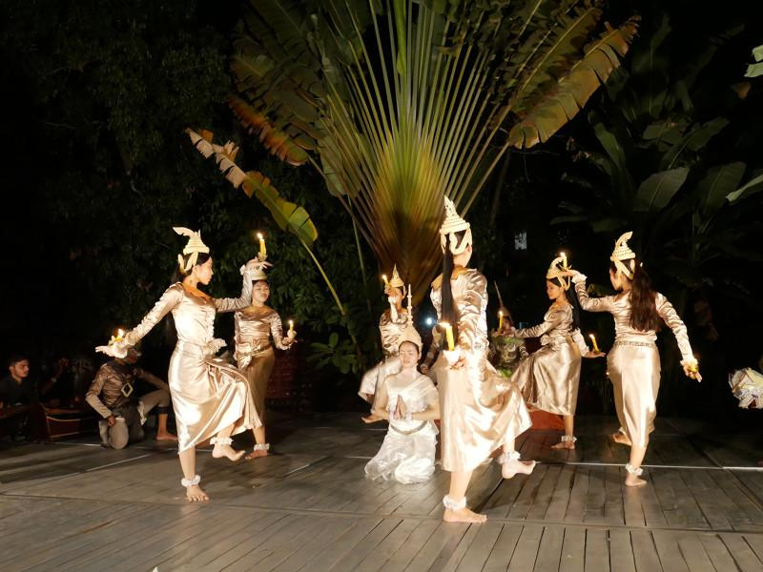
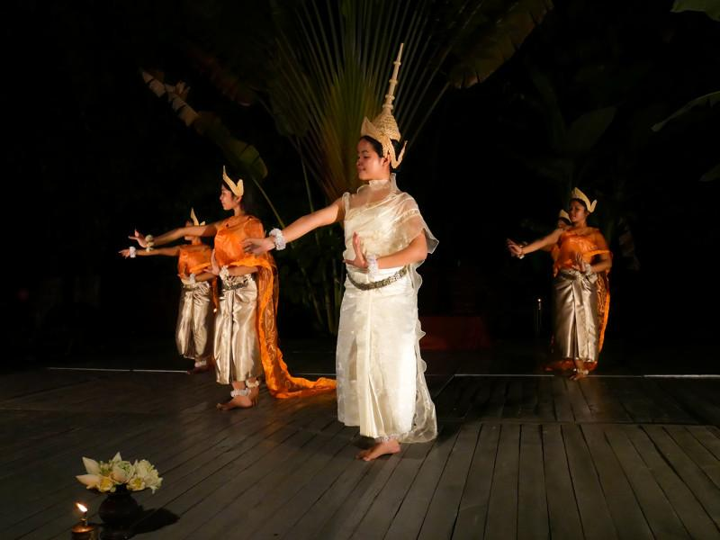

Easia Travel Head Office

Vietnam Head OfficeC/o: ATS Hotel, Suite 326 &327, 33B Pham Ngu Lao Street, Hanoi, VietnamTel: +84 24-39 33 13 62www.easia-travel.com

